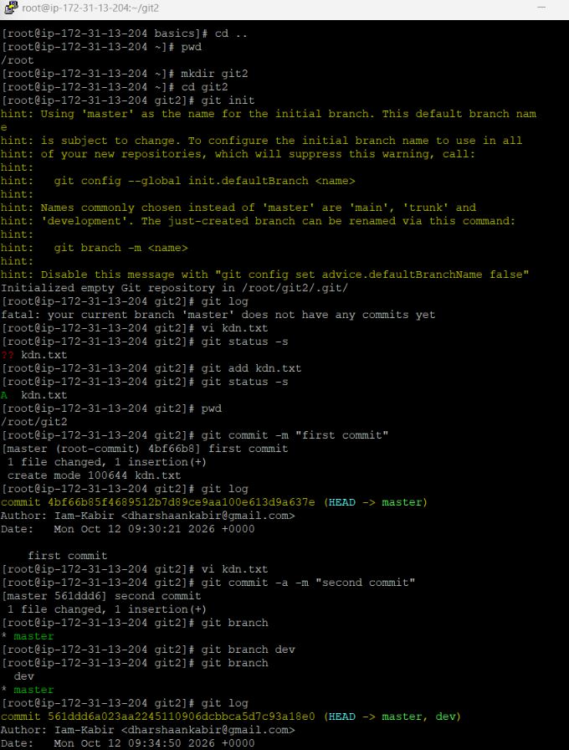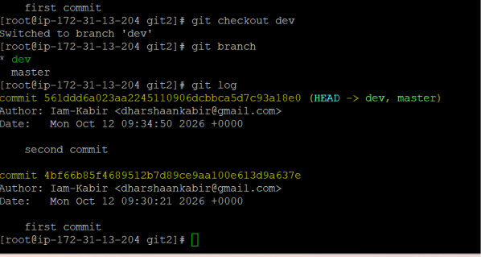

Fast Forward Merge
Merge -> Conflict
Rebase
Cherry pick

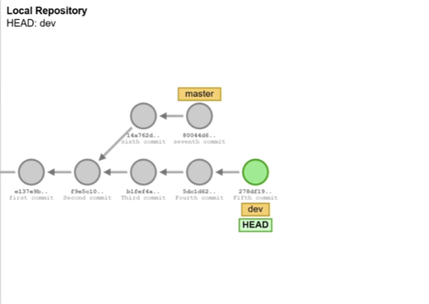
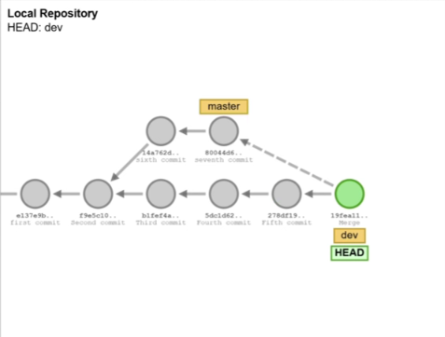
Merge commit
Rebase
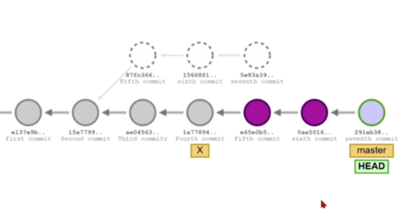
Before rebase
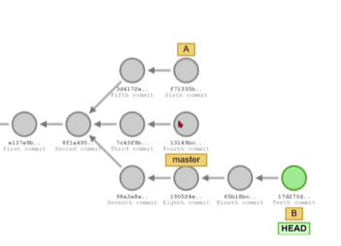
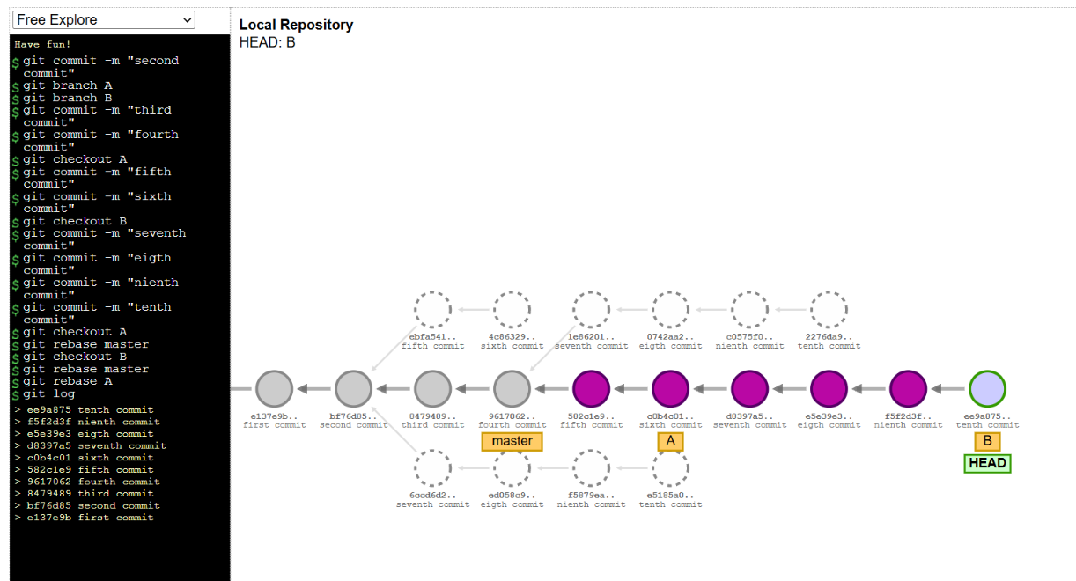
Cherry picking
Making a copy of any commit
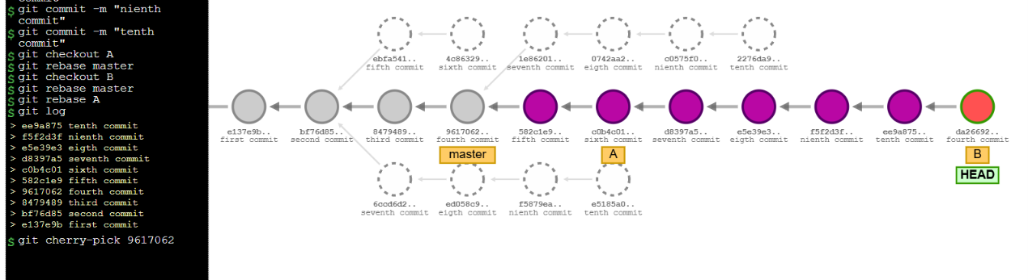

Merge conflict
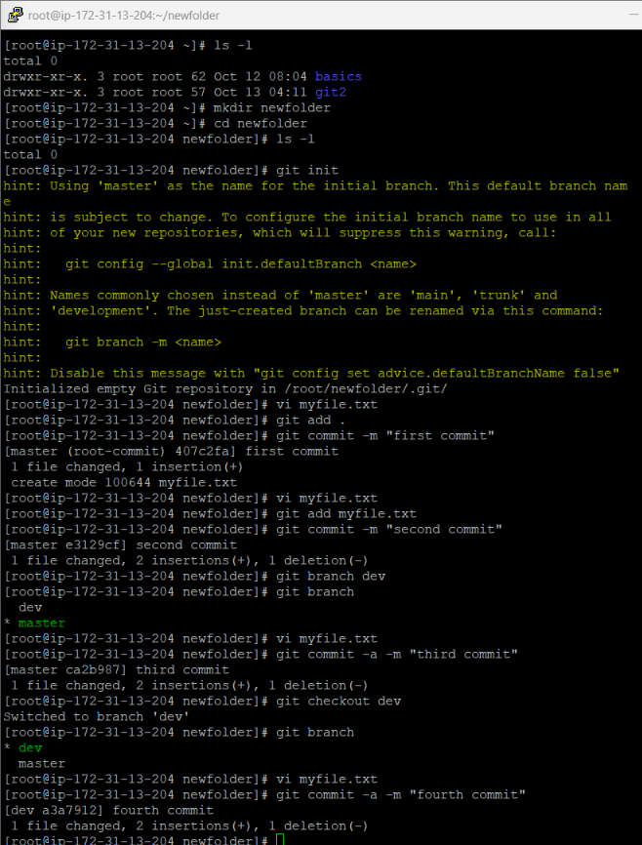

Conflict commands
git config --global core.editor vim
git config --global core.compression 2
git config --global diff.tool vimdiff
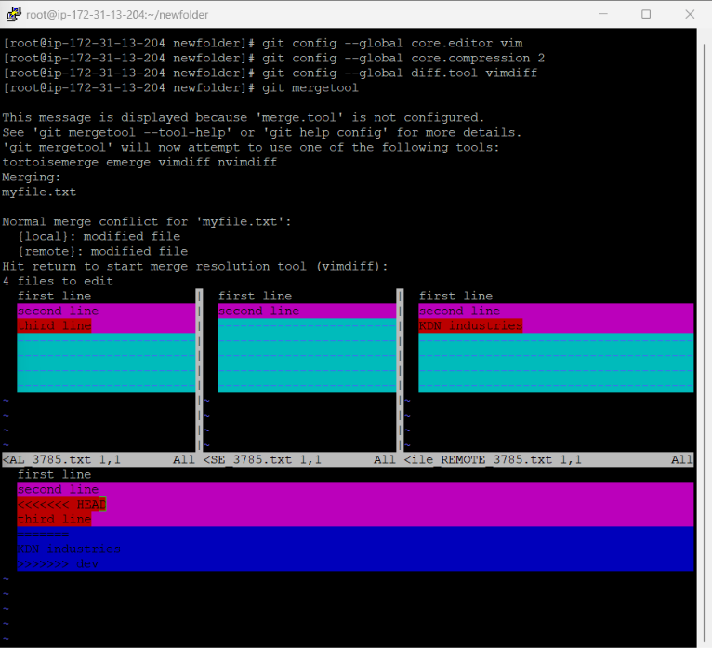
We want to click enter after that vimdiff want opened
We want to give [ctrl + shift + w] for making any changes
https://gist.github.com/karenyyng/f19ff75c60f18b4b8149
