Slave and Declarative Pipeline

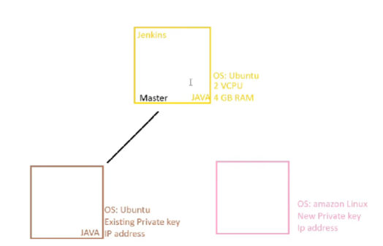

In Ec2 Meachine they have the public key
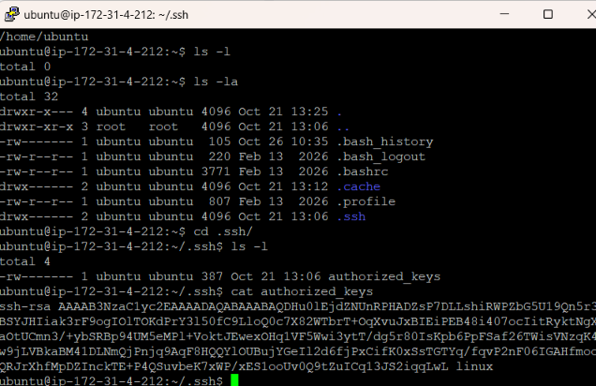
And they gave private key to user.
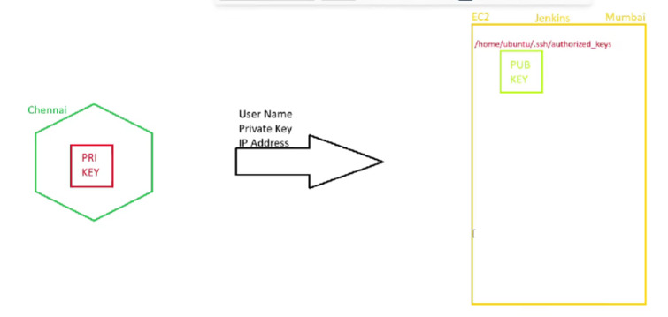
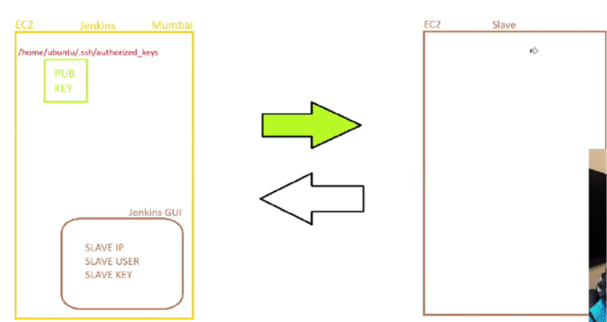
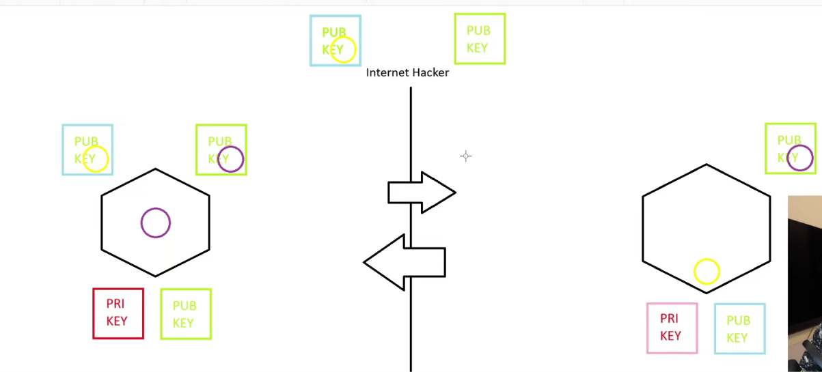
The concept of private and public key is manily useful in while hacker trying to theft the data instead we only share lock (pub key) , but we have our respective key (private key) , by a encryption method we will share the data in that lock (public key).

For connecting the master ec2 meachine to slave ec2 meachine we want to generate a public and private key by puttygen or by using ssh-keygen inside the master ec2 meachine.
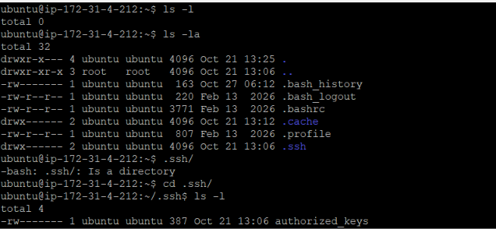
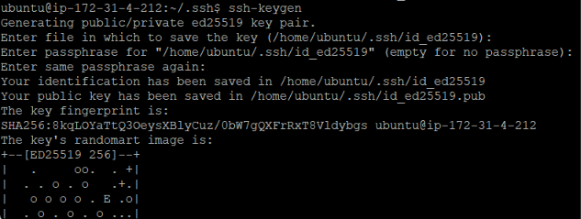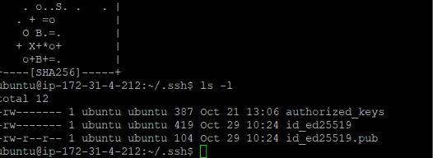
But by using of shh-keygen It will create a ed encrypted key instead of ppx file.
For now we using same key for both master and slave ec2 meachine
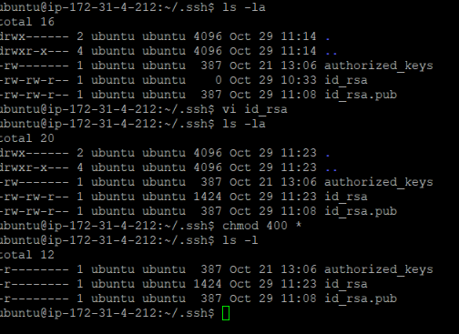
For that we want to give [ chmod 400 *] is the linux command to give only read access.

For connecting with slave ec2 meachine

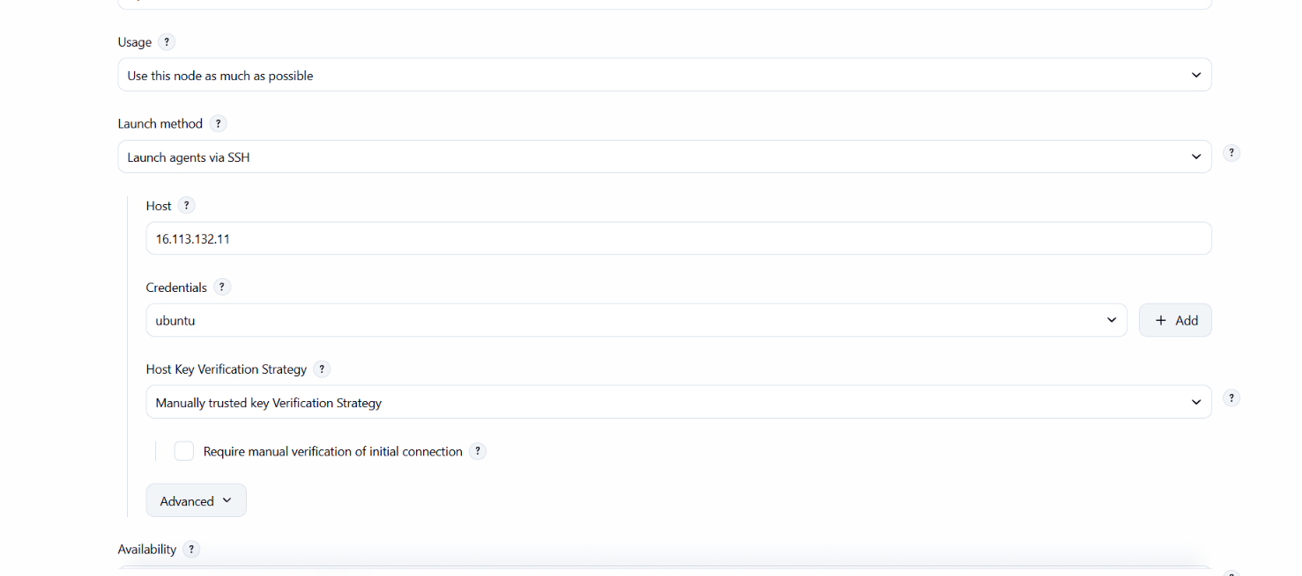
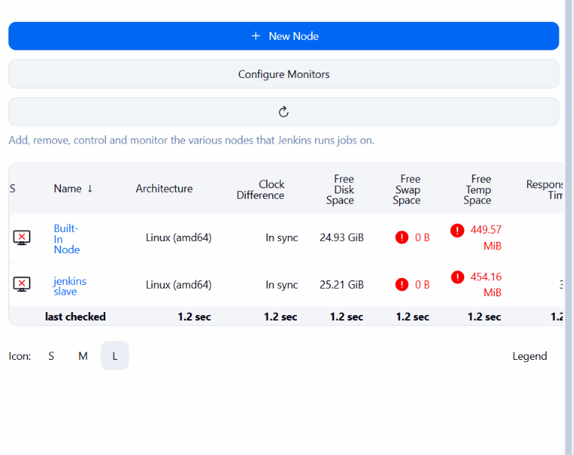by this we connected it with slave meachine
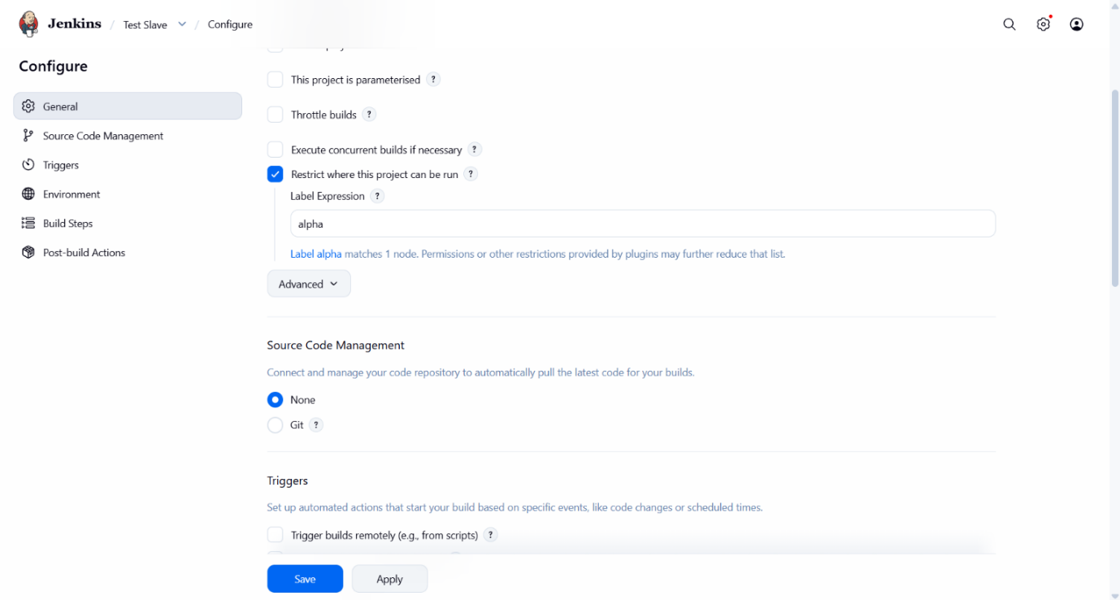
For running a slave meaching we wan tto use this label


