Git pull vs fetch vs clone
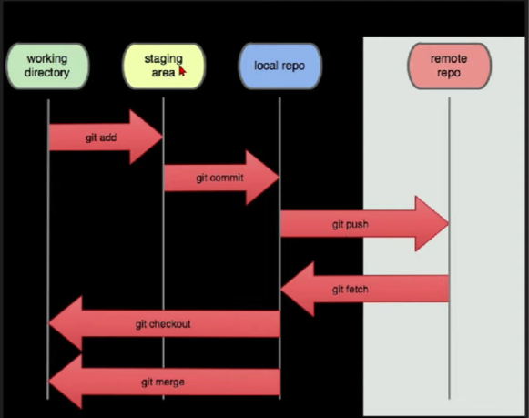
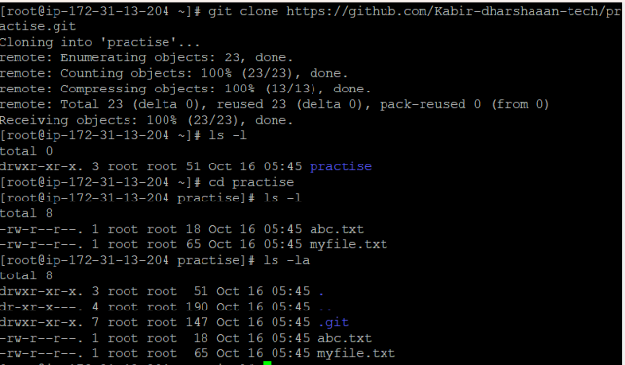
Git clone , Git fetch , Git pull

Git pull => git fetch + git merge

Git reset --hard
Git reset --mixed
Git reset --soft
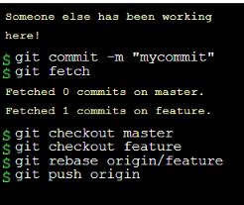
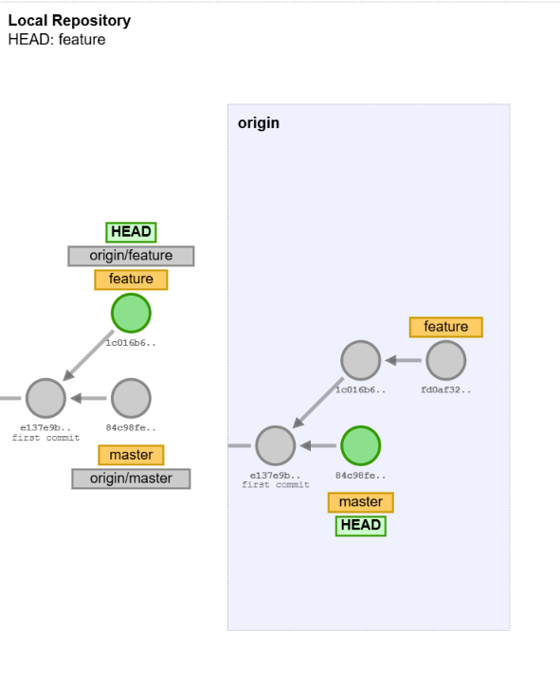
At first in my local storage I have my commits which I done but in github my friend done new changes but without knowin that I commited new things in a new commit.
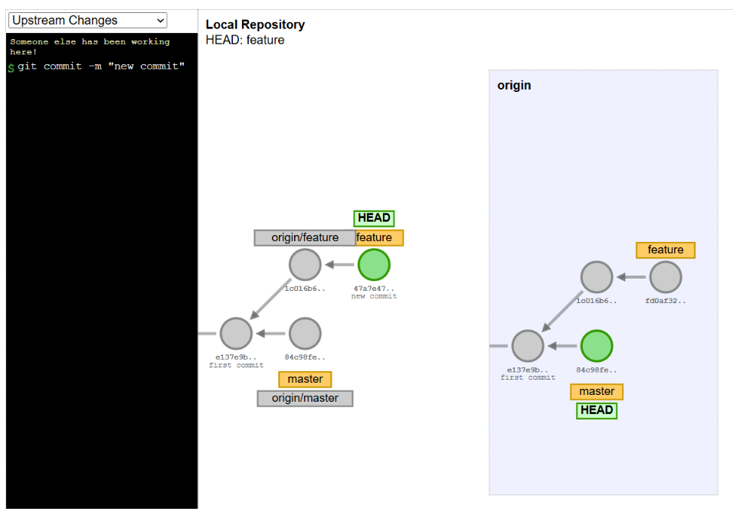
For solve that mistake we can use git rebase origin/(commit name)
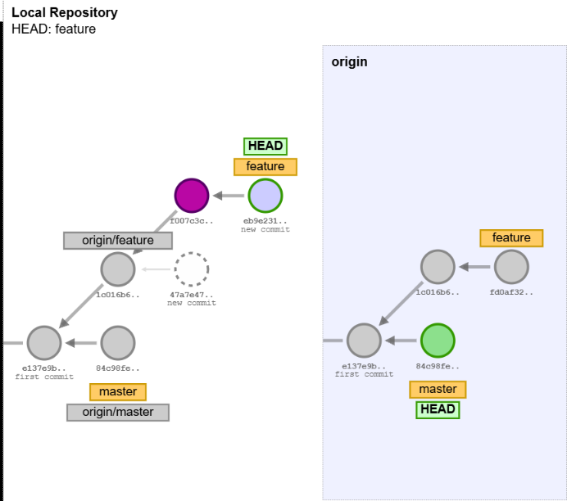
After this we can push the correct code to the github

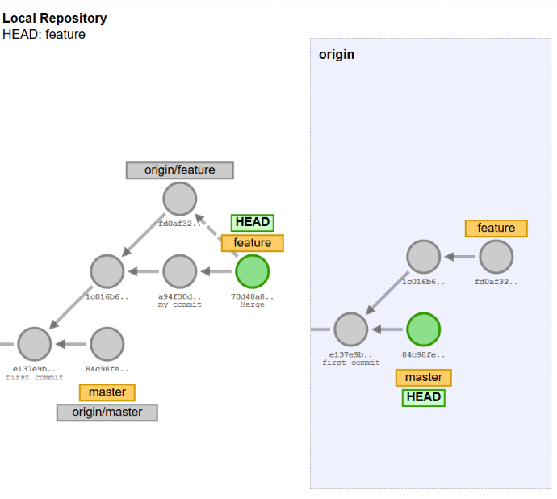

Deleting the commit
In this we want to use git reset HEAD~(the no of commit u want to delete form the head)
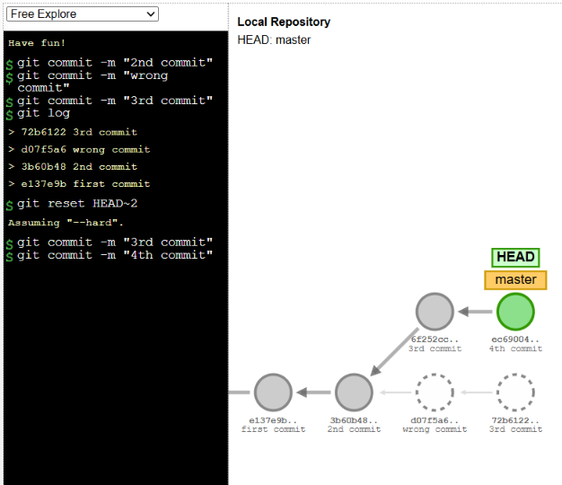

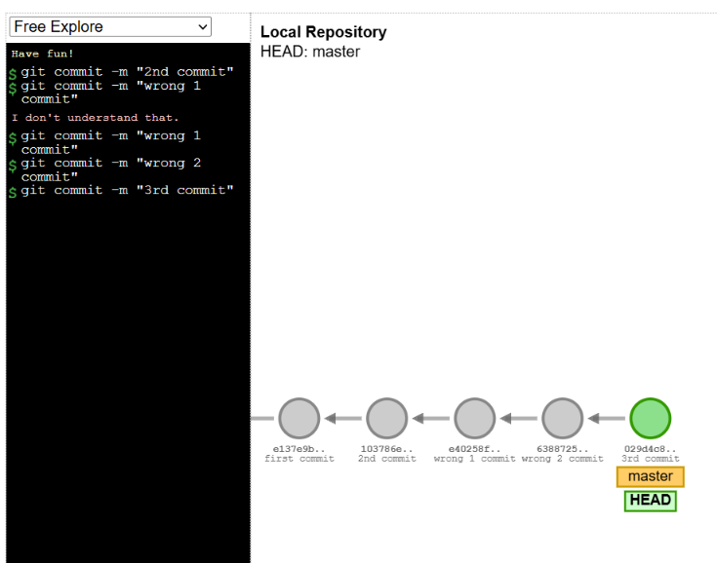
If we done many wrong commits instead of deleting that commits we can use revert to copy the correct code in the previous commits before the wrong commits into a new commit
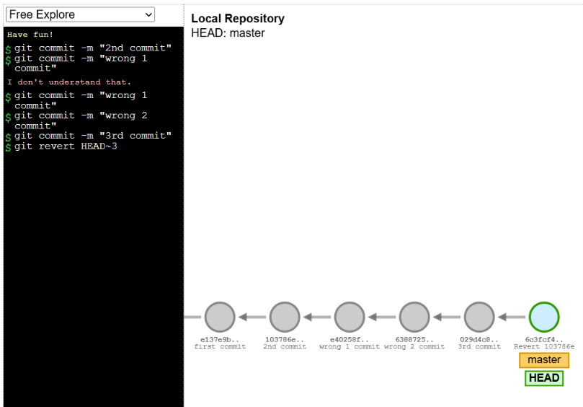

For recovering the deleted commit
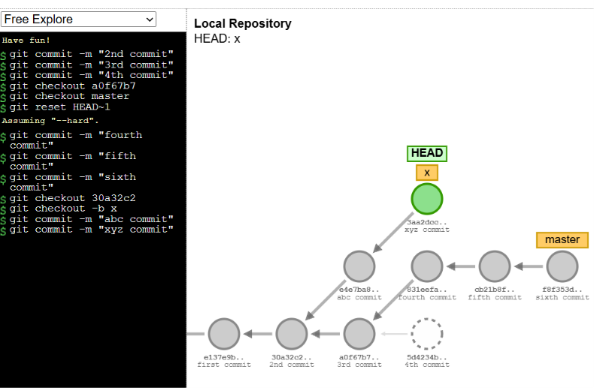
For that we want to create a new branch and switch to that commit number like [ git checkout -b (branch name) (commit number)]
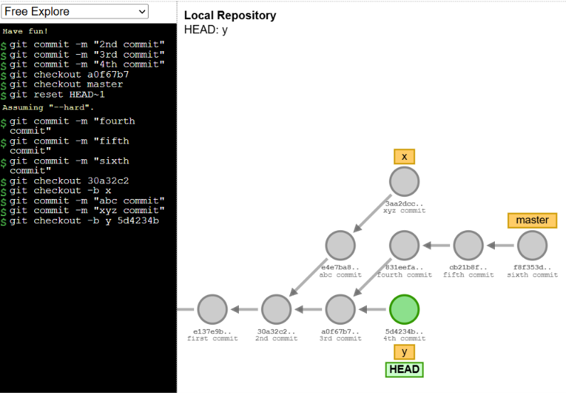
By using git reflog we can saw what are the places the head switches
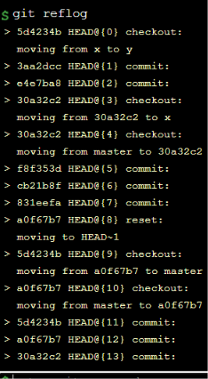
For revcovering branch
