Jenkins
AWS cloud => 15+ serveices
DEVOPS TOOLS=> GIT, Jenkins, Terraform, Docker, Kubernetes , Ansible, Monitoring & logging, Python & BASH, Linux,

AWS minor => lambda , apigateway, dynamodb, eks, ecs
Devops minor => Maven, sonarqube trivy, synk, ARGocd, helm

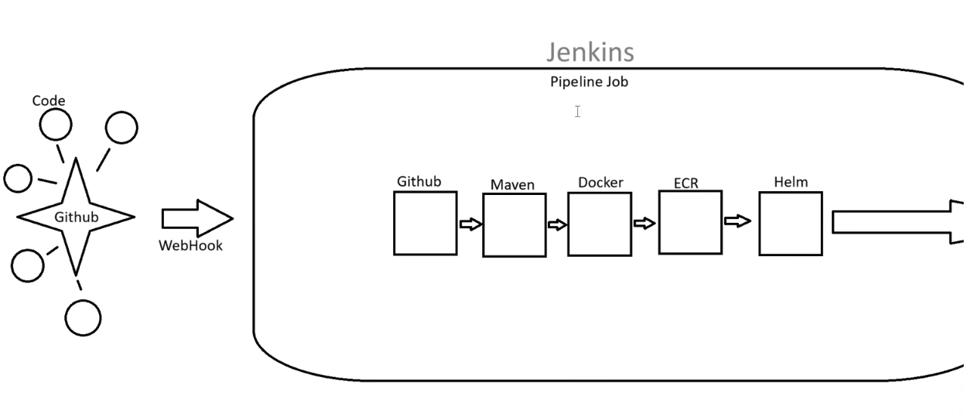
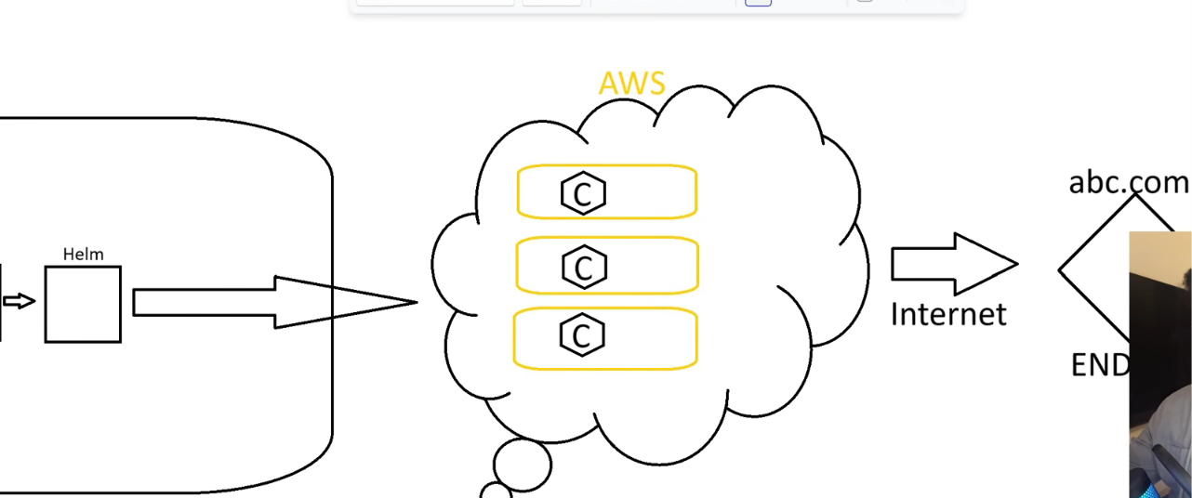
After this we want to create a ec2 instance but this time we want to use ubuntu
And after that we want to install java in that instance , and for login we want to give user name as ubuntu and we want to switch to root user (sudo su – root)

For installing java in that instance (sudo apt update)
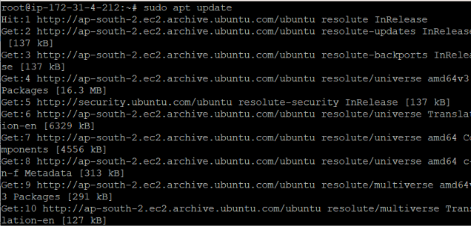
Next we want to give ( sudo apt install fontconfig openjdk-17-jre )
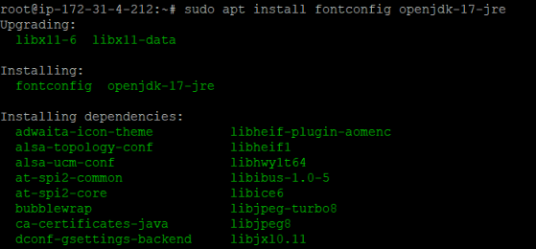
After that we want to check the version for verification of installation
(java --version)
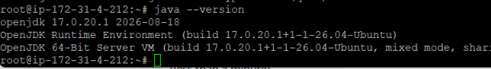
For installing Jenkins
sudo wget -O /etc/apt/keyrings/jenkins-keyring.asc \
https://pkg.jenkins.io/debian-stable/jenkins.io-2026.key
echo "deb [signed-by=/etc/apt/keyrings/jenkins-keyring.asc]" \
https://pkg.jenkins.io/debian-stable binary/ | sudo tee \
/etc/apt/sources.list.d/jenkins.list > /dev/null
sudo apt update
sudo apt install Jenkins
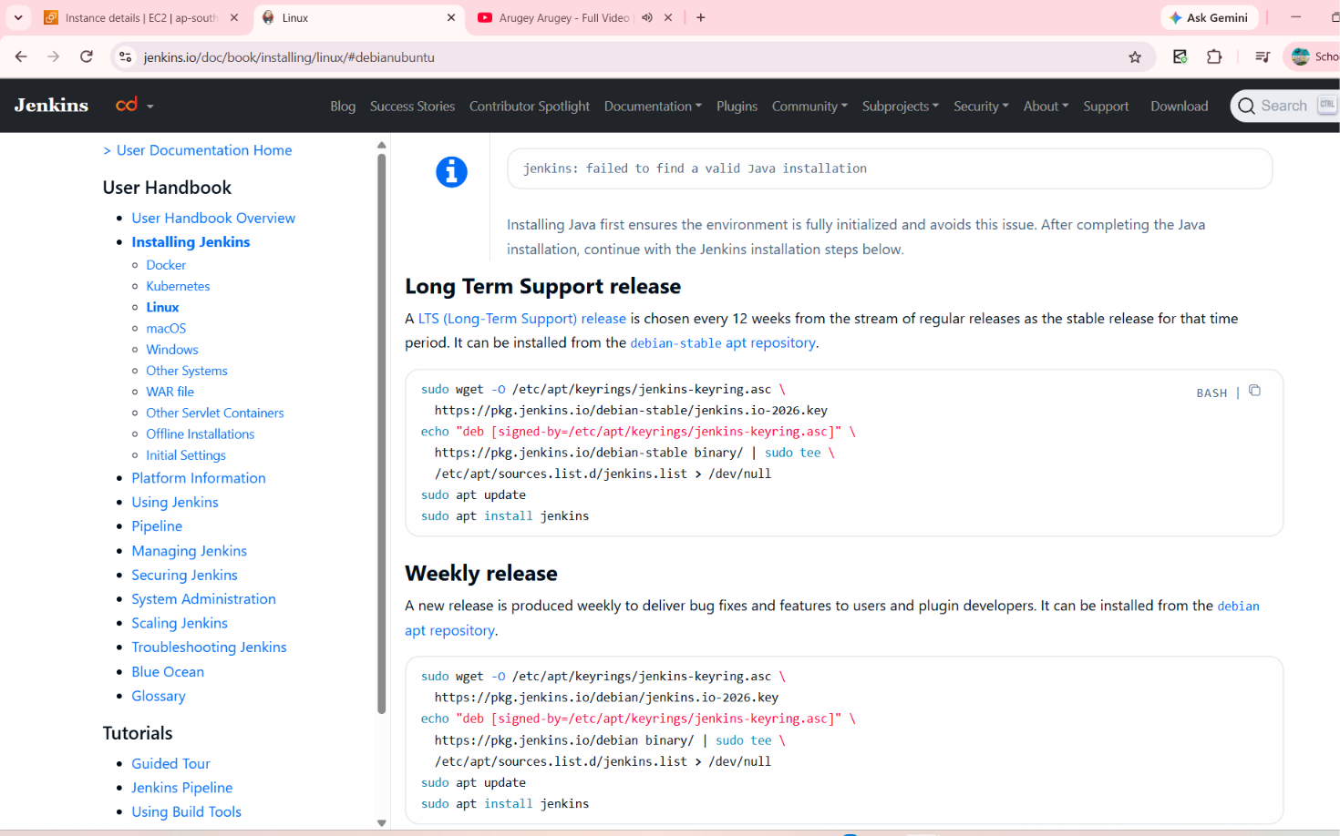

The Jenkins work space port was defaultly in 8080 port:
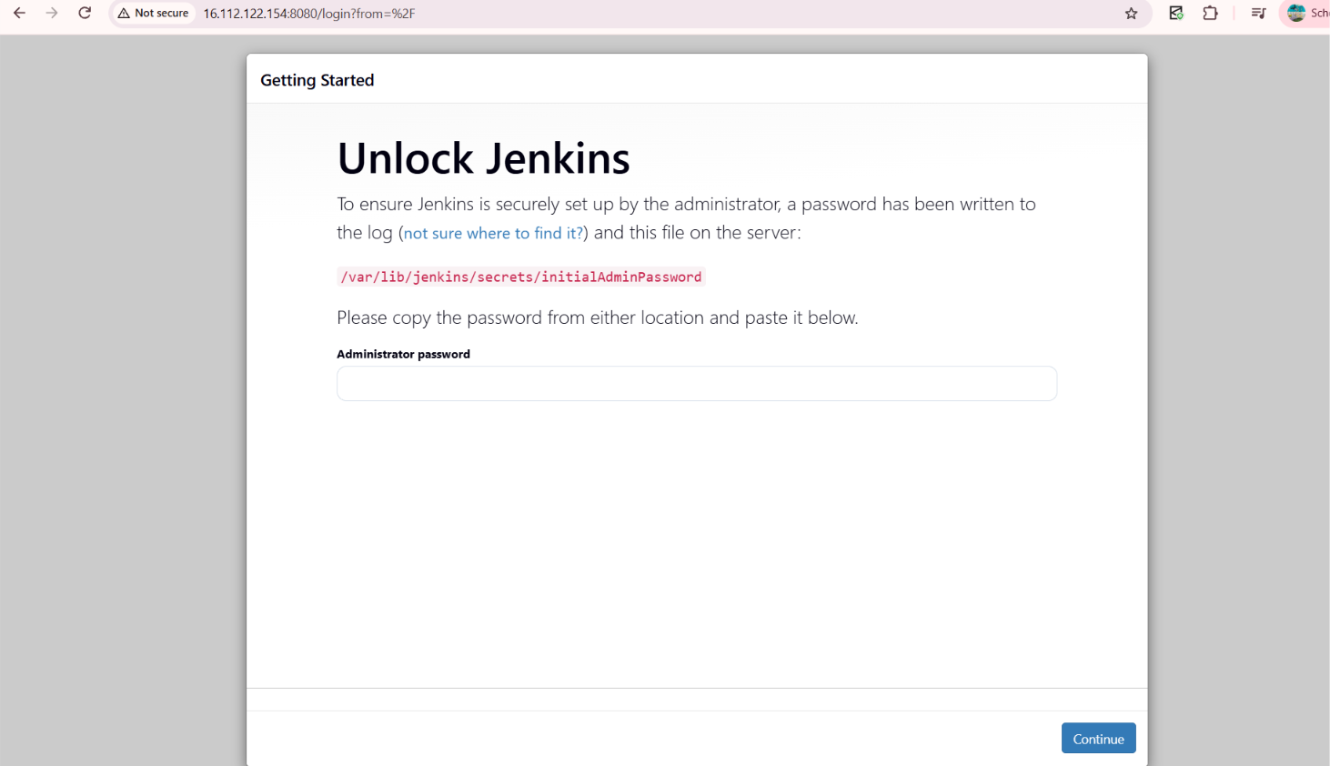
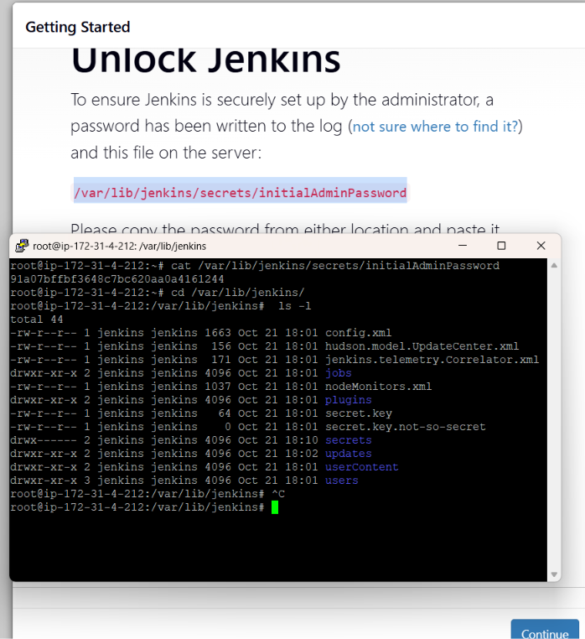 for seeing the password we want to cpoty the file path and paste in putty

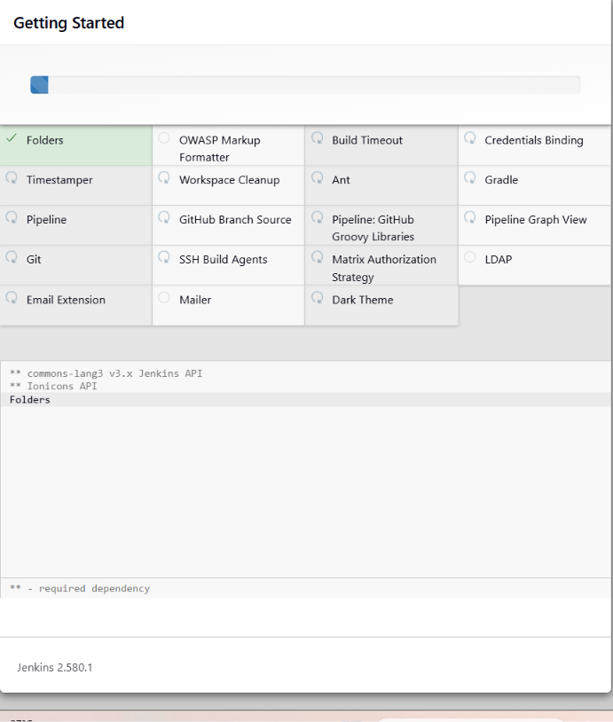

Wether report will show out last 5 runs how many are successful
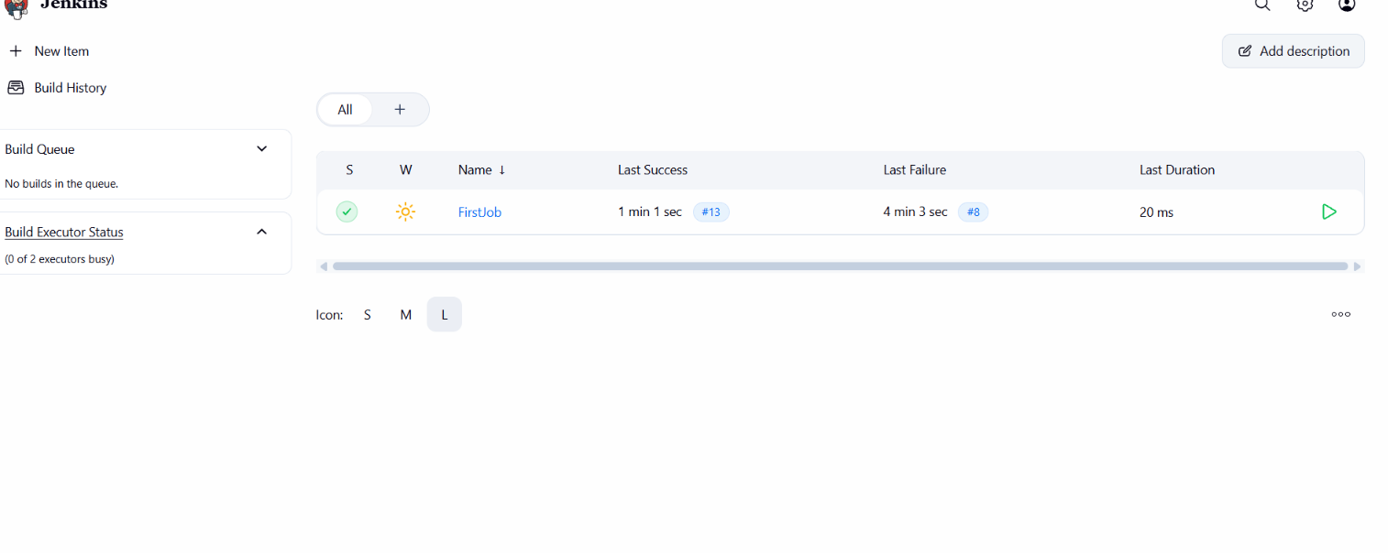
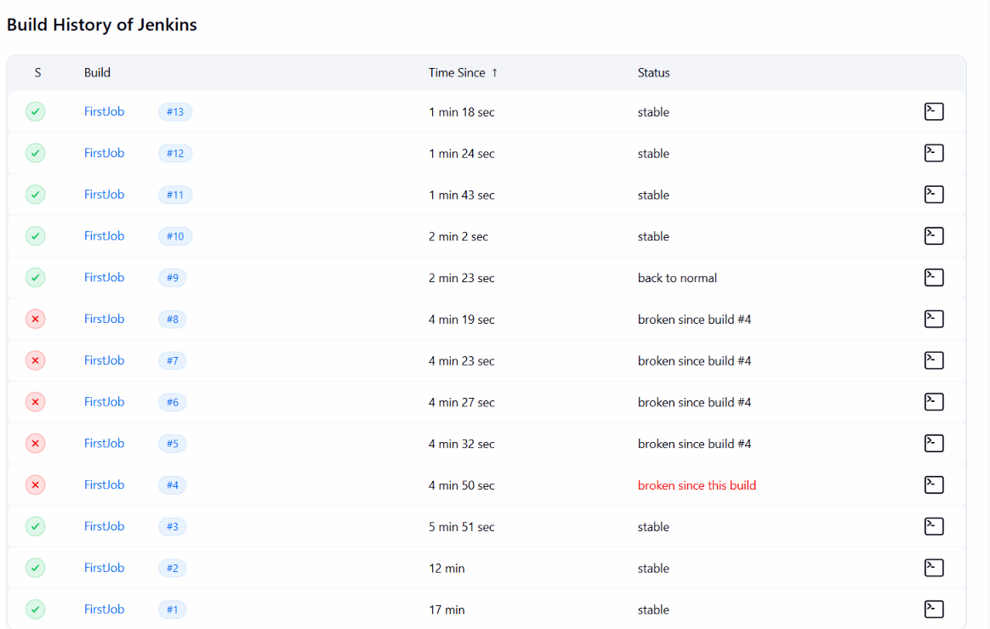

Upstream Downstream
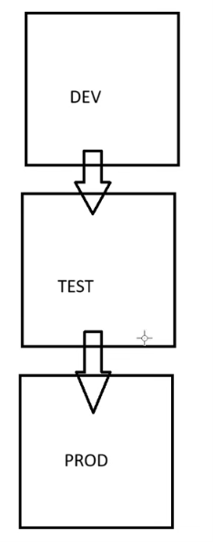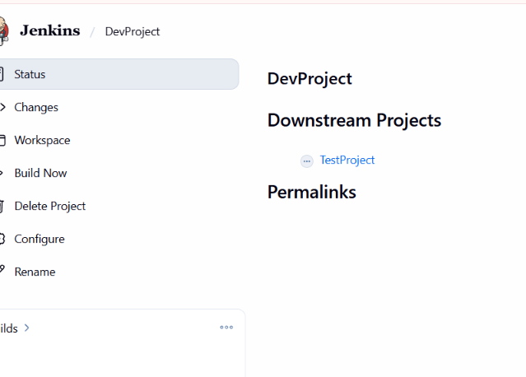
The upstream and downstream projects are the things which will tell what run before and after.
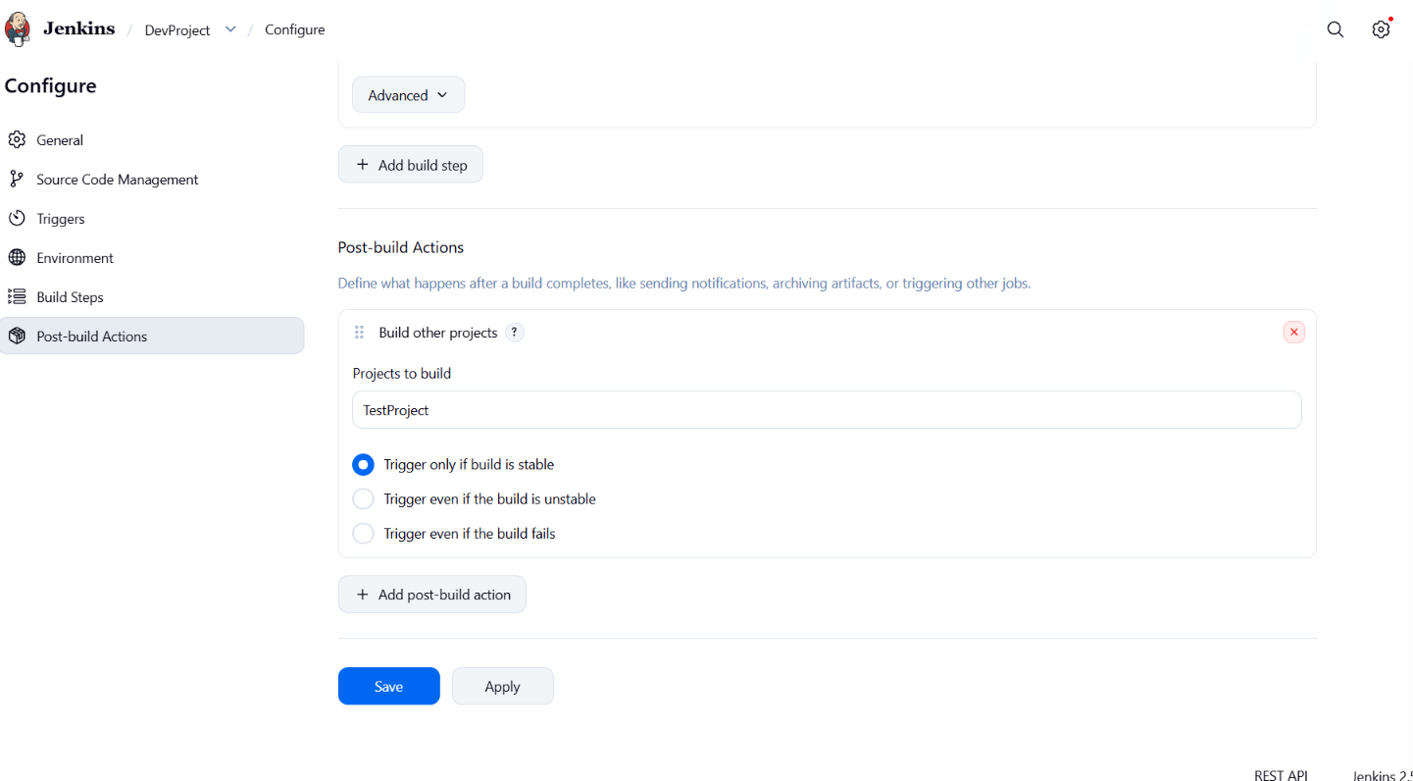
This is the space where we want to connect the tasks form after this to another projects. And this is the one of the type of trigger.
Types of Trigger:
1, Manual Trigger
2, Upstream and Down Stream Trigger
3, Perodic Trigger (for this we will use cronjob (crontab))
4, Remote Trigger
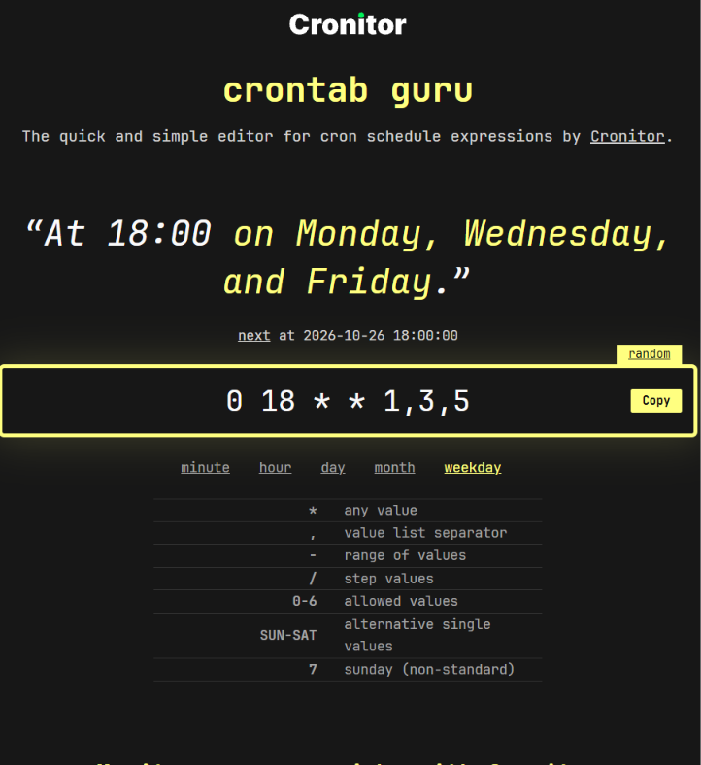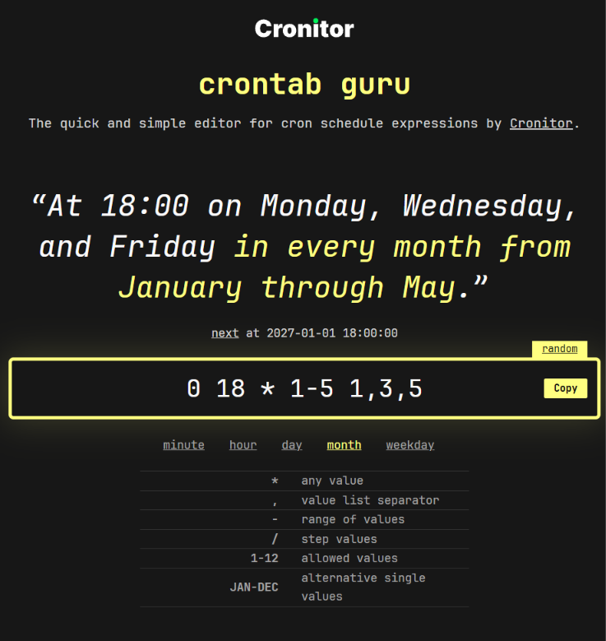
For accessing remotely
JENKINS_URL/job/DevProject/build?token=TOKEN_NAME
http://18.61.15.238:8080/job/DevProject/build?token=12345

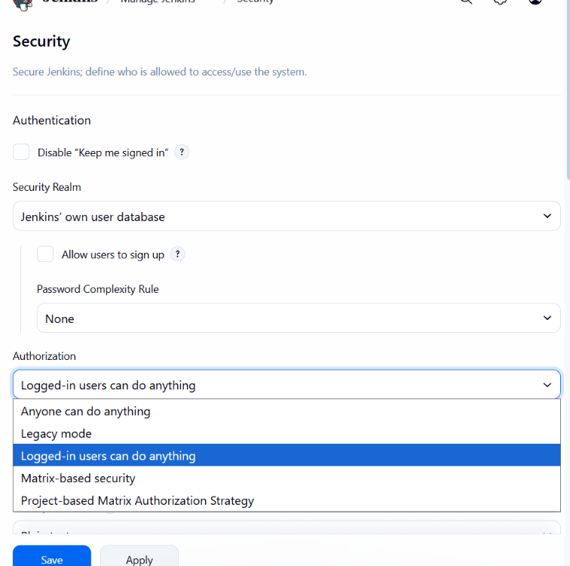

For creating new user
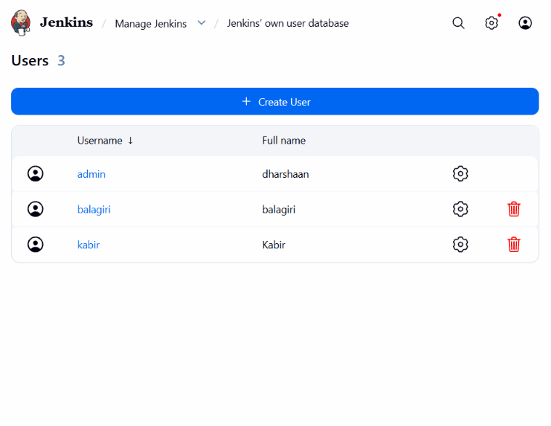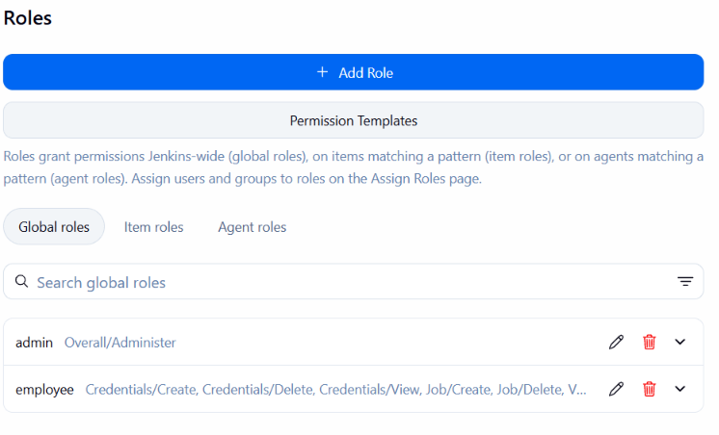
For role management and creating new roles
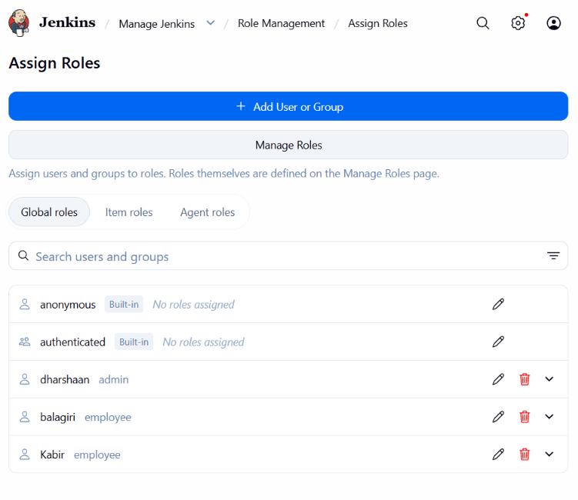 for assigning roles

