SOFTWARE ARCHITECTURE DOCUMENT
Real-Time Chat Application Using Socket Programming
Item | Details
Project | Real-Time Chat Application Using Socket Programming
Course | Software Engineering (UE23CS341A), PES University
Team | Kabir Raju G (Kabir7code)  Keerthana K (KeerthanaK0304)  Joshua (jjosh2005)
Repository | github.com/Kabir7code/Chat-application-Socket-Programming-
Version | 1.0, after Sprint 1 (24 Oct 2026)

1. Introduction

1.1 Purpose
This document describes how the chat application is put together: the architectural style we chose, the main components and what each one is responsible for, how they talk to each other, and how the design meets the non-functional requirements in our SRS. It is written for the team, our instructor, and anyone who needs to change the code later.

1.2 Scope
The document covers the system as it stands at the end of Sprint 1 (19 to 23 Oct 2026). Features planned for Sprint 2 (group chat, the GUI client, the online-users command, timestamps, logging and TLS encryption) are described in Section 10 so it is clear where they will fit, but they are not built yet.

1.3 References
- Software Requirements Specification (FR-001 to FR-010, NFR-001 to NFR-005)
- Use Case Diagram and Use Case Flows (UC-01 to UC-09)
- Test Cases document and Test Plan
- Project backlog: GitHub Project “Chat App - Backlog” (issues #1 to #23)

1.4 Terms used
Term | Meaning
Session | One connected client as the server sees it: its socket, its username once registered, and whether it is still alive.
Frame | One message on the wire: a 4-byte length followed by that many bytes of JSON.
Registration | The first step after connecting, where the client claims a unique username.
Broadcast | Sending a message to every registered user except the sender.

2. Architectural Goals and Constraints
The architecture is driven mainly by the non-functional requirements:
Requirement | What it means for the design
NFR-001 Performance | Messages must reach recipients within 1 second, so the server pushes messages as soon as they arrive. Clients never poll.
NFR-002 Scalability | At least 20 users chatting at once without crashes or long delays. Each client is handled independently and shared state is protected by locks.
NFR-003 Reliability | Messages must arrive complete and only at the intended recipients. This led to explicit message framing and per-socket send locks.
NFR-004 Usability and maintainability | Client, server, protocol and shared state are separate modules so they can be changed and tested on their own.
NFR-005 Security | Only registered sockets may send messages (done). Traffic must be encrypted in transit (planned for Sprint 2).
Constraints we worked within:
- Python 3.10 or newer, standard library only, so the app runs on any team laptop without installing packages.
- Plain TCP sockets, since the course focus is socket programming. No web framework or message broker.
- A team of three and two one-week sprints, which favoured a design that is simple to read and to split into separate pieces of work.

3. Architectural Style
We use a client-server architecture with one thread per connected client. A single server process owns all shared state (who is online, and later the groups). Each user runs their own client, which keeps one TCP connection open to the server for the whole session.

3.1 Why client-server
- Usernames must be unique (FR-001) and everyone needs the same view of who is online (FR-006). Both are easy when one server holds the list, and hard to keep consistent without one.
- Private and group messages must reach only the right people (FR-005, NFR-003). The server can check membership before forwarding, so a client never receives something it should not see.
- Clients stay simple. They only need to know the server's address, not every other user's.

3.2 Alternatives we considered
Option | Why we did not pick it
Peer-to-peer | No single place to enforce unique usernames or group membership, and peers would need to reach each other directly, which breaks on most home and college networks.
Single-threaded event loop (select or asyncio) | Scales to more connections, but it is harder for the whole team to follow and debug. For 20 users, one thread per client is comfortably fast. We can revisit this if the load requirement grows.
UDP instead of TCP | UDP does not guarantee delivery or order, so we would have had to rebuild both ourselves to meet NFR-003.

4. System Overview
Figure 1 shows the main building blocks. A user types into the client, the command parser turns the input into a message, and the protocol layer sends it to the server as a frame. On the server, the listener accepts the connection and starts a handler thread for that client. The handler decodes each frame and passes it to the chat logic, which reads and updates the session registry and forwards the message to the right recipients. On the receiving side, a background thread in each client prints messages as soon as they arrive.
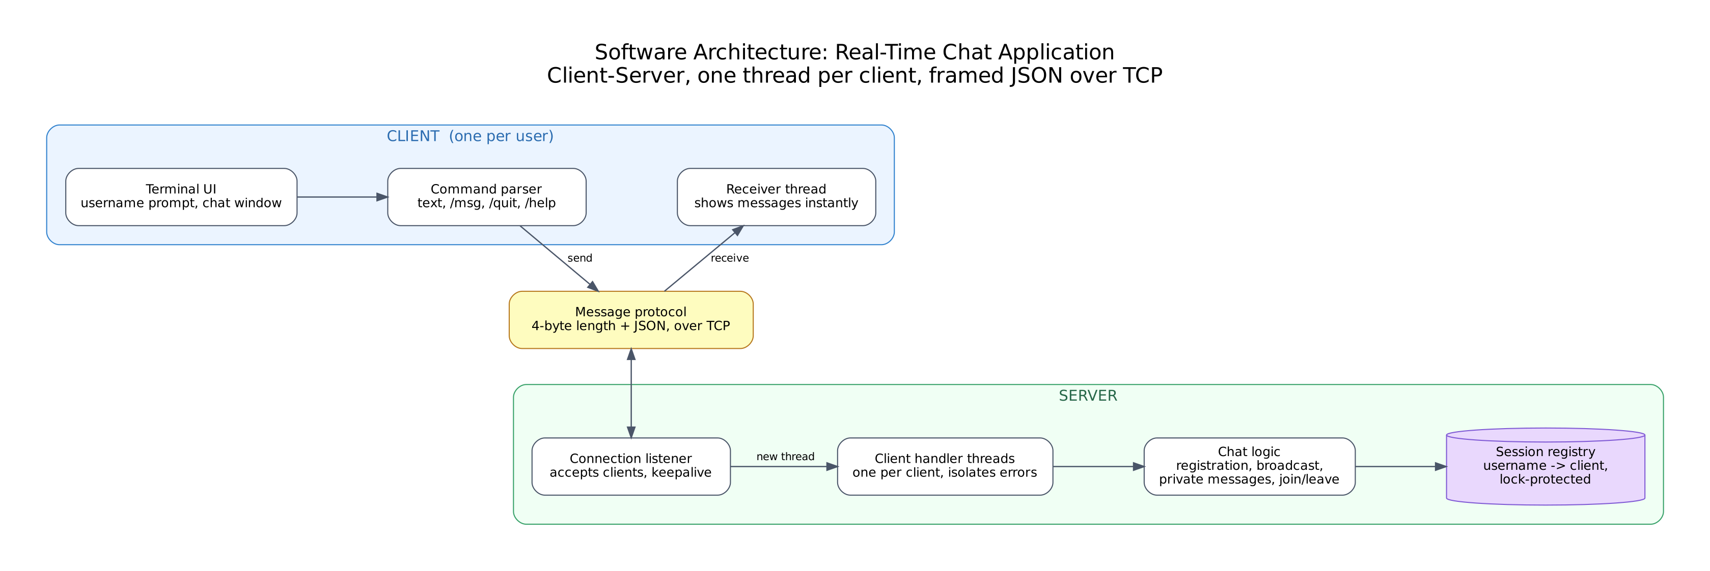
Figure 1: Software architecture (as built in Sprint 1)

5. Component View
Figure 2 is the UML component diagram. The server provides the IChatService interface over TCP, which the client uses. Inside the server, ChatServer uses the session registry through ISessionStore. Both sides share the Protocol and Config components.
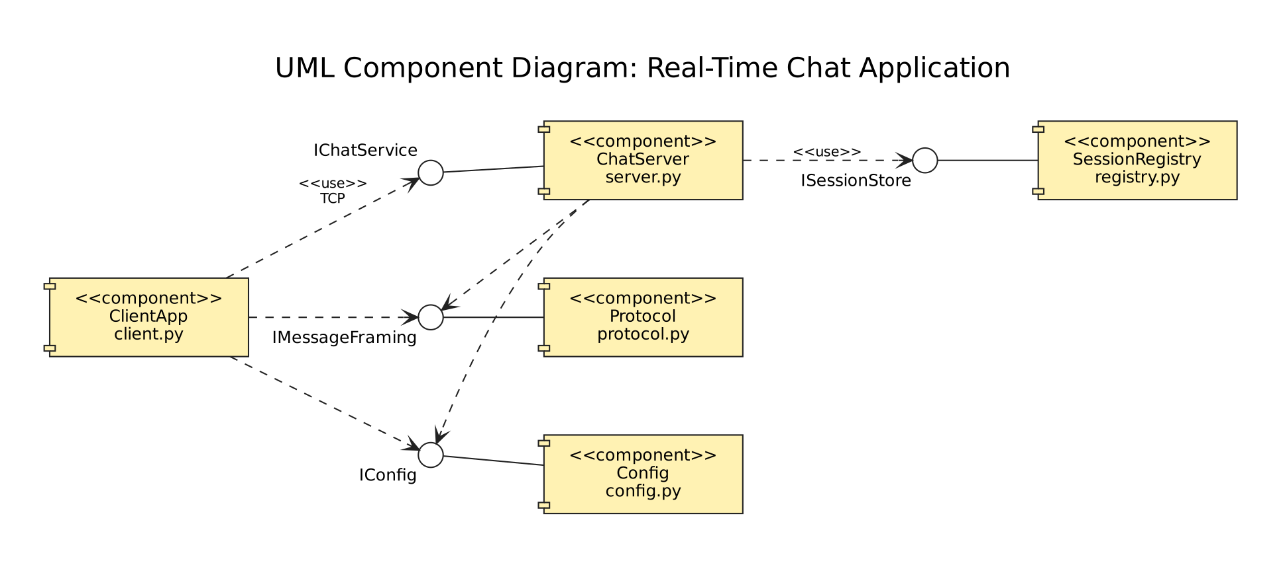
Figure 2: UML component diagram
Component | File | Responsibility | Requirements
ClientApp | chat/client.py | Asks for a username, reads what the user types, turns commands (/msg, /quit, /help) into messages, and prints incoming messages from a background thread. | FR-001, FR-003, FR-005, FR-007
ChatServer | chat/server.py | Accepts connections, runs one handler thread per client, checks registration, routes chat and private messages, sends join/leave notices, and cleans up after disconnects and errors. | FR-001 to FR-003, FR-005 to FR-008, NFR-005
SessionRegistry | chat/registry.py | Holds every connected session and the username-to-session map behind one lock, and gives each session its own send lock. | NFR-002, NFR-003, FR-001
Protocol | chat/protocol.py | Encodes and decodes messages as length-prefixed JSON frames and rejects malformed or oversized ones. | NFR-003, FR-008
Config | chat/config.py | Reads the host and port from command-line flags or environment variables, with defaults. | NFR-004

6. Interfaces

6.1 IChatService (client and server, over TCP)
Every message is a JSON object with a “type” field. The table lists every message type in Sprint 1.
Direction | Type | Fields | Purpose
Client to server | register | username | Claim a username. Must be the first message.
Client to server | chat | text | Send a message to everyone online.
Client to server | private | to, text | Send a message to one user.
Client to server | quit | (none) | Leave the chat.
Server to client | registered | username, users | Registration accepted; includes who is online.
Server to client | chat | from, text, context | A message from another user. context is “general” for now.
Server to client | private | from, to, text | A private message for this user.
Server to client | private_sent | to, text | Confirms a private message was delivered.
Server to client | system | event, username, text | Join and leave notices, for example “bob joined the chat”.
Server to client | error | code, message | Something was wrong with the last request. See 6.2.

6.2 Error codes
Code | When it is sent
INVALID_USERNAME | Username is empty, longer than 20 characters, or contains characters other than letters, digits and underscores.
USERNAME_TAKEN | Someone online already has that name. The text shown is “Username already taken.” (UC-01, flow 3B).
NOT_REGISTERED | A socket tried to send something before registering (NFR-005).
ALREADY_REGISTERED | A registered client tried to register again.
USER_NOT_FOUND | A private message was addressed to someone who is not online. The text is “User not found/offline” (UC-02, flow 4B).
EMPTY_MESSAGE / MESSAGE_TOO_LONG | The text was blank, not a string, or longer than 4000 characters.
MALFORMED | A frame did not contain valid JSON, or its length header was too large. In the second case the client is disconnected, because the stream can no longer be trusted.
UNKNOWN_TYPE / SERVER_ERROR | The message type is not recognised, or handling it raised an unexpected error. The session stays open.

6.3 Framing (IMessageFraming)
TCP delivers a stream of bytes, not separate messages, so one read can return half a message or two messages joined together. Each message is therefore sent as a 4-byte big-endian length followed by the UTF-8 JSON body. The receiver reads exactly 4 bytes, then exactly that many more. Frames larger than 64 KB are refused. This is what keeps long and rapid messages intact (NFR-003).

6.4 Internal interfaces
- ISessionStore (registry.py): connect, register (claims a name atomically and returns False if it is taken), get, disconnect, registered, usernames.
- IConfig (config.py): parse_args returns the host and port. Priority is command-line flag, then CHAT_HOST / CHAT_PORT, then 127.0.0.1:5000.

7. Runtime View

7.1 Threads
- Server: the main thread, one accept thread, and one handler thread per connected client.
- Client: the main thread reads keyboard input and sends; a receiver thread prints incoming messages, so they appear even while the user is typing.

7.2 Concurrency control
Several handler threads read and change the same data, so two locks protect it:
- Registry lock. Every registry operation takes the same lock. Checking a name and claiming it happen in one step, so two clients asking for the same name at the same moment cannot both get it.
- Per-session send lock. Only one thread writes to a given socket at a time. Without this, two broadcasts to the same user could interleave their bytes and corrupt both frames.
Broadcasts loop over a copy of the registered sessions, so users joining or leaving during a broadcast do not break the loop.

7.3 Registration and sending a message
- The client connects and sends register with the chosen name.
- The handler validates the name and asks the registry to claim it. If the name is taken, the client gets USERNAME_TAKEN and can try again.
- On success the client gets registered with the list of online users, and everyone else gets a join notice.
- When the user sends text, the handler checks it and broadcasts it to every other registered user straight away.
- For /msg, the handler looks up the recipient. If they are online, they receive the message and the sender gets private_sent. Otherwise the sender gets USER_NOT_FOUND.

7.4 Disconnects and errors
Every way a handler loop can end (a quit message, the socket closing, a connection reset, or a broken frame) leads to the same clean-up: the session is removed, its username is freed, and the remaining users are told the person left. TCP keepalive is switched on for each client socket, so a client that disappears without closing the connection (for example a laptop going to sleep) is detected after about 25 seconds. An exception while handling one message is caught, reported to that client, and does not end the session or affect anyone else (FR-008).

8. Deployment View
- One machine runs the server: python -m chat.server --host 0.0.0.0 --port 5000.
- Each user runs a client on their own machine on the same network: python -m chat.client --host <server IP>. For a demo, everything can also run on one laptop using 127.0.0.1.
- All state is kept in memory, so restarting the server clears it. Nothing needs to be installed apart from Python.
- GitHub Actions runs flake8 and the pytest suite on Python 3.10 and 3.12 for every push and pull request.

9. Quality Attributes
Requirement | How the architecture handles it | Status
NFR-001 Performance | Push delivery with no polling. In local tests, join and leave notices reached 4 clients in a few milliseconds. | Measured formally in Sprint 2 (#19)
NFR-002 Scalability | Thread per client, lock-protected registry. 10 clients connected at once and 5 senders flooded 250 messages to one receiver without losses in testing. | 20-user load test in Sprint 2 (#20)
NFR-003 Reliability | Length-prefixed framing, per-socket send locks, and routing decided only on the server. | Done. See limitation 11.1.
NFR-004 Usability and maintainability | Separate client, server, protocol, registry and config modules, each with its own tests. Simple terminal commands. | GUI in Sprint 2 (#16)
NFR-005 Security | The server rejects every message from a socket that has not registered. | Encryption in Sprint 2 (#22)

10. Planned for Sprint 2
These additions fit into the existing structure without changing the overall design:
Feature | Where it goes
Group chat and recent history (#15, #18) | A new GroupManager component on the server, used by ChatServer. Group messages use context “group”.
GUI client (#16) | A new Tkinter front end that reuses the same protocol and commands as the terminal client.
/users list (#7) | A new message type handled by ChatServer using the registry's usernames().
Timestamps (#13) | The server adds its time to every delivered message.
Logging (#14) | Python logging in the server for connections, disconnects and errors.
TLS encryption (#22) | Wrap the listener and client sockets with Python's ssl module. Framing and everything above it stay the same.

11. Known Limitations

11.1 Order of simultaneous messages
When two or more users send at exactly the same moment, two other users can occasionally see those messages in a different order. Our tests found this in 4 of 300 runs with fully simultaneous sends, and never with normal back-to-back messages. It happens because each sender's thread broadcasts on its own. Sending all broadcasts through one lock or one queue would fix it, and we plan to do that in Sprint 2.

11.2 Other limitations
- Server state is in memory only, so a server restart logs everyone out.
- One thread per client is fine for our target of 20 users, but would need an event-loop design for hundreds.
- Until TLS is added in Sprint 2, messages travel unencrypted on the local network.
- Usernames are case-sensitive, so “Rahul” and “rahul” are different users.

