CODE COVERAGE REPORT
Real-Time Chat Application Using Socket Programming
Mini Project Part-3, item 2(b)(iii)
Item | Details
Project | Real-Time Chat Application Using Socket Programming
Course | Software Engineering (UE23CS341A), PES University. Mini Project Part-3: Testing
Team | Kabir Raju G (Kabir7code)  Keerthana K (KeerthanaK0304)  Joshua (jjosh2005)
Repository | github.com/Kabir7code/Chat-application-Socket-Programming-
Test run | 11 Nov 2026
Code tested | The complete Sprint 3 code: main on 11 Nov 2026 plus the Sprint 3 pull requests for #53, #54, #59, #60 and #61, which were being merged that day.

1. What was measured
Code (line) coverage is the share of executable lines in the chat package that the automated test suite runs at least once. It shows which parts of the code have no test at all.
- Tool: coverage.py 7.17 through pytest-cov, with branch measurement on (--cov-branch).
- Code measured: every module in chat/ (the tests themselves are not counted).
- Tests: the full automated suite, 338 tests, all passing. Programs started by the tests (the terminal client and the server run from the command line) are measured too (coverage subprocess patch).
- Run: 11 Nov 2026, Python 3.13. Code: The complete Sprint 3 code: main on 11 Nov 2026 plus the Sprint 3 pull requests for #53, #54, #59, #60 and #61, which were being merged that day.
- Target from the Test Plan: at least 80% of lines and 75% of branches.

2. Overall result
Measure | Result
Executable lines | 1235
Lines run by the tests | 1130
Lines never run | 105
Line coverage | 91.5% (target 80%: met)
Branch coverage (see the Branch Coverage Report) | 86.1%
Combined (lines + branches, coverage.py's total) | 90.4%

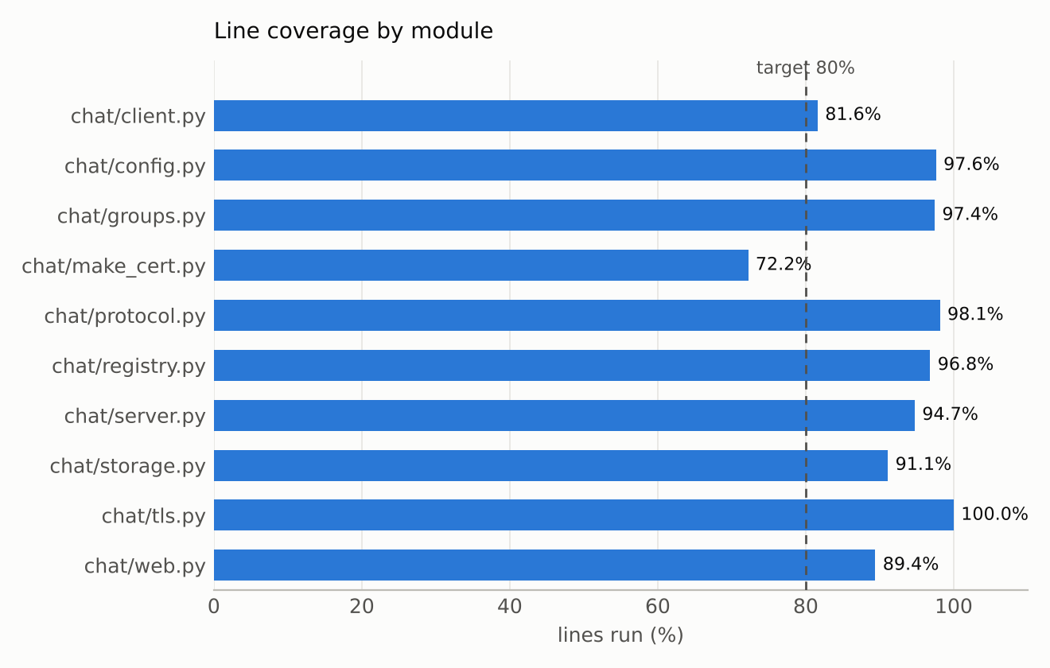

3. Coverage by module
Module | Role | Lines | Run | Missed | Coverage
chat/client.py | terminal client | 136 | 111 | 25 | 81.6%
chat/config.py | settings and command-line options | 42 | 41 | 1 | 97.6%
chat/groups.py | group chats | 117 | 114 | 3 | 97.4%
chat/make_cert.py | certificate tool (run by hand) | 36 | 26 | 10 | 72.2%
chat/protocol.py | message framing | 54 | 53 | 1 | 98.1%
chat/registry.py | connected users | 63 | 61 | 2 | 96.8%
chat/server.py | chat server | 285 | 270 | 15 | 94.7%
chat/storage.py | SQLite message store | 135 | 123 | 12 | 91.1%
chat/tls.py | TLS encryption | 27 | 27 | 0 | 100.0%
chat/web.py | web UI gateway | 340 | 304 | 36 | 89.4%
Total |  | 1235 | 1130 | 105 | 91.5%

4. What is not covered, and why
Module | Lines never run | What they are
chat/client.py | 85, 138-139, 143, 149, 156-161, 168-169, 171-172, 175, 180, 183-184, 188-191, 195-196 | code that only runs in the interactive program: the background thread that prints incoming messages, the certificate and connection error exits of main(), Ctrl+C and 'connection lost' handling, and the end-of-input and retry paths of register(). The scripted test cases run these (UT_01, ST_02, IT_26, ST_17, ST_18), but they are not part of the coverage run.
chat/config.py | 106 | the server's TLS setup from certificate files, used only when the server is started with real certificate files.
chat/groups.py | 50, 108, 122 | three error checks no automated test triggers: loading a saved group with no members, an admin adding someone who is already a member, and leaving a group you are not in.
chat/make_cert.py | 37, 51, 53, 55-60, 64 | the command-line part of the certificate tool (python -m chat.make_cert) and its 'openssl not found' error; the team runs it once by hand.
chat/protocol.py | 79 | the case where the connection closes between a frame's length header and its body.
chat/registry.py | 47-48 | an error from shutdown() on a socket that is already closed.
chat/server.py | 107-114, 116, 131-132, 274, 298-299, 439 | serve_forever() and the command-line start (run by ST_19 as a separate program, outside the coverage run), the accept loop ending when the listener closes, and two error returns in private messaging (text rejected by validation; a failure to queue a message for an offline user).
chat/storage.py | 164-166, 206-208, 225-227, 238-240 | the database-error branches of save_group_state, remember_user, queue_offline and take_offline. The message-saving error branch is covered, and ST_22 checks a failing database end to end.
chat/web.py | 103, 159, 174, 186, 192, 196-198, 213-214, 270-272, 282-283, 358-359, 387-388, 409-410, 413, 438, 445-446, 448-449, 451, 453, 455, 457-460, 462, 466 | main() (starting the gateway from the command line), HTTP error replies for malformed requests (missing Content-Length, a body that is not a JSON object, an unknown URL, a bad command line) and connection errors to the chat server (certificate rejected, server closed or not answering).

Most of what is missed is start-up code run from the command line, the certificate tool, and error branches for situations that are hard to cause on purpose (a database failure in one particular operation, a malformed HTTP request). The scripted test cases cover the start-up paths (ST_02, ST_19, IT_26) and a failing database (ST_22). A few user-facing error checks (leaving a group you are not in, adding an existing member, malformed web requests) have no automated test yet; adding them is the easiest way to raise coverage further.

5. How to reproduce
pip install -r requirements-dev.txt pytest-cov
pytest --cov=chat --cov-branch --cov-report=term-missing --cov-report=html

Attached in Documents/Test_Reports: coverage_html/index.html (open in a browser; every module with its missed lines in red and partly-taken branches in yellow), coverage.xml and coverage.json.

