Autonomous Technology Researcher Agent

Low-Level Design (LLD)

1. Problem Overview

Executive Summary:
The Autonomous Technology Researcher Agent is a Python-based, multi-agent system (LangChain + CrewAI + LLM APIs) that accepts a user’s technology-focused research query, performs autonomous web research across multiple credible sources, synthesizes findings into structured, reviewable summaries, and stores results in a text-based Markdown knowledge repository with machine-readable metadata and indexing. The design emphasizes traceability (citations, provenance), resilience (retries, partial results), and extensibility (pluggable tools, models, and storage backends).

Problem Statement:
Technology research is time-consuming and error-prone due to rapidly changing information, conflicting claims, difficulty verifying credibility and recency, inconsistent documentation structures, and high cost of repeated searches. The system must autonomously gather and synthesize web information while controlling hallucinations and ensuring reproducible output with source attribution.

Functional Requirements:
- Accept natural language queries with optional constraints.
- Perform autonomous web search and content extraction.
- Score and filter sources by credibility and relevance.
- Generate structured reports with citations and references.
- Store reports and metadata in Markdown format.
- Maintain index for searchability.
- Provide CLI interface and optional REST API.
- Persist logs and run metadata for observability.

CLASS DIAGRAM

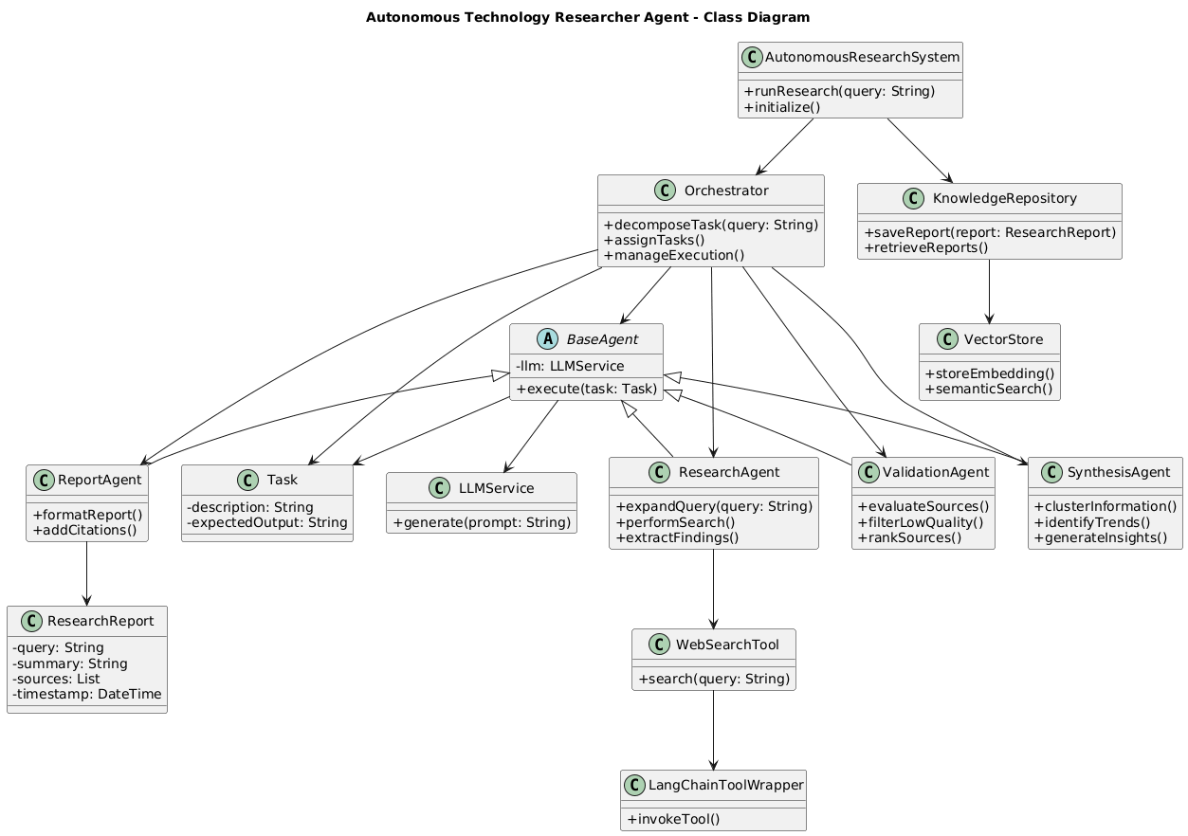

COMPONENT DIAGRAM

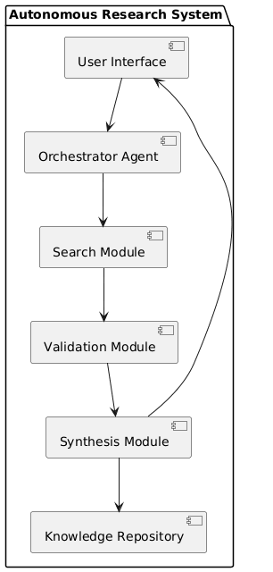

STATE DIAGRAM
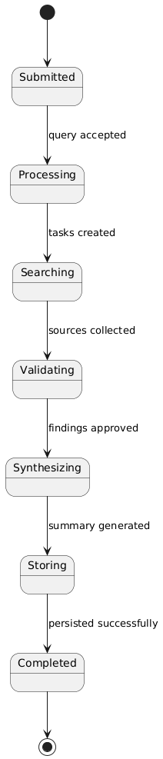

SEQUENCE DIAGRAM

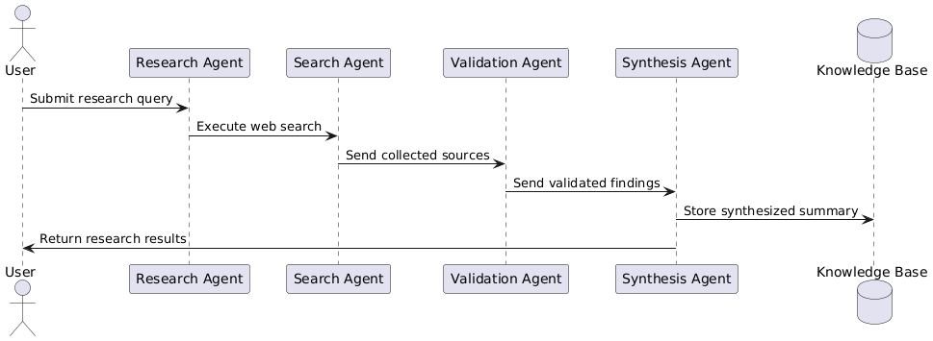

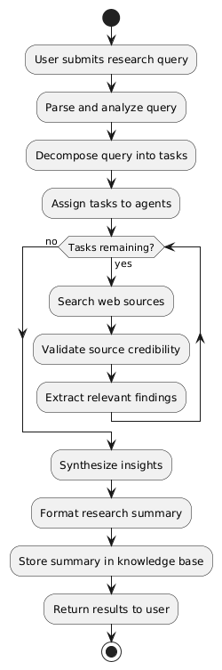
ACTIVITY DIAGRAM

Non-Functional Requirements:
- Traceable claims with source citations.
- Resilient execution with retries and partial results.
- Secure handling of API keys and sanitized content.
- Modular, testable architecture.
- Concurrent execution capability.
- Cost-aware model routing and caching.

Assumptions and Constraints:
- Uses Search API + HTTP fetch (no proprietary connectors).
- LLM outputs require grounding and validation.
- Repository stored on filesystem.
- System focuses on research and documentation only.

2. Technology Stack

Python:
Strong ecosystem for async networking, LLM integration, structured schemas (pydantic), retries (tenacity), extraction (BeautifulSoup), CLI (Typer), and testing (pytest).

LangChain:
Provides abstractions for prompts, tools, document loaders, retrievers, structured outputs, and modular chains.

CrewAI:
Enables multi-agent orchestration with role separation and task dependency control.

LLM API Strategy:
ModelRouter selects models based on task type (fast models for filtering, high-quality models for synthesis) with multi-provider fallback and metadata logging.

Search API Integration:
Abstract SearchClient interface with adapters (e.g., Tavily, Bing). Results normalized into unified schema.

Storage:
Markdown + JSON metadata for auditability, Git compatibility, and low operational overhead.

3. System Architecture

High-Level Flow:
User → Orchestrator → Multi-Agent Crew → Tooling Layer → Knowledge Repository

Components:
- CLI/API Interface
- ResearchOrchestrator
- ResearchAgent
- AnalysisAgent
- DocumentationAgent
- Tooling Layer (Search, Fetch, Extract, Score)
- KnowledgeRepository

Agents communicate through structured artifacts:
SearchPlan → SourceBundle → SynthesisOutline → FinalReport

Deployment Options:
Local process, Docker container, optional cloud with background workers.

4. Core Components

ResearchOrchestrator:
Validates inputs, creates CrewAI crew, enforces budgets/time limits, manages retries, and persists results.

ResearchAgent:
Builds search plan, executes search queries, fetches pages, extracts text, scores credibility and relevance.

AnalysisAgent:
Deduplicates sources, extracts structured claims with evidence quotes, detects contradictions, builds synthesis outline.

DocumentationAgent:
Generates final Markdown report using strict template and citation enforcement.

KnowledgeRepository:
Persists Markdown + metadata, maintains append-only index, supports retrieval and optional vector indexing.

5. Workflow Sequence

1. User submits query.
2. Orchestrator validates and creates run context.
3. ResearchAgent gathers sources in parallel.
4. AnalysisAgent extracts claims and builds outline.
5. DocumentationAgent writes Markdown report.
6. KnowledgeRepository saves report and metadata.
7. Orchestrator returns result paths and summary.

Parallelization:
- Search queries
- URL fetching
- Claim extraction

Failure Handling:
- Retry transient errors
- Continue with partial sources
- Fallback models if needed

6. Data Storage Design

Folder Structure:
knowledge_repo/
index.json
<timestamp>/<run_id>/
report.md
metadata.json
sources/

Metadata includes:
- run_id
- timestamp
- query
- model parameters
- sources with credibility scores
- failures
- quality metrics

Optional:
SQLite indexing and vector DB extension.

7. Error Handling & Resilience

- Retry with exponential backoff for transient errors.
- Timeout controls for HTTP and LLM calls.
- Partial synthesis if below source threshold.
- Citation validation to prevent hallucinations.
- Conservative language for uncertain claims.

8. Security Considerations

- API keys in environment variables.
- Redacted logs.
- Rate limiting per provider.
- Input validation.
- HTML sanitization and size limits.
- Atomic file writes with checksum storage.

9. Scalability Considerations

- Stateless orchestrator workers.
- Shared storage for multi-node deployment.
- Async HTTP with concurrency limits.
- Caching (search results, fetched pages, optional LLM cache).
- Optional background job queue.
- Early filtering and context compression for performance.

10. Design Decisions & Trade-offs

Multi-Agent Architecture:
Improves separation of concerns and controllability but adds orchestration complexity.

Markdown Storage:
Human-readable and Git-friendly but requires indexing for advanced queries.

Alternatives:
Single-agent chain (simpler but less controllable).
Full database storage (more complex ops).
Vector-only storage (less audit-friendly).

Extensibility:
Interface-driven design for SearchClient, LLMClient, Repository, and VectorIndex.
Prompt versioning and potential additional agents (FactCheckAgent, TrendAgent).

Risks & Mitigation:
- Hallucinations → enforced claim evidence mapping.
- Scraping blocks → multiple sources and fallback.
- Provider outages → multi-provider strategy.
- Cost overruns → budget limits and model routing.

Future Enhancements:
- FactCheckAgent
- Vector semantic retrieval
- Scheduled refresh runs
- Evaluation harness
- UI dashboard for audits

