- Solution Architecture Diagram

- Operational Workflow design

- Management Analytics Dashboard

- Security Architecture

- Automation Workflow

- Analytical Insights

- Recommendation

- Limitations

- Assumptions

- Conclusion

1.SOLUTION ARCHITECTURE DIAGRAM

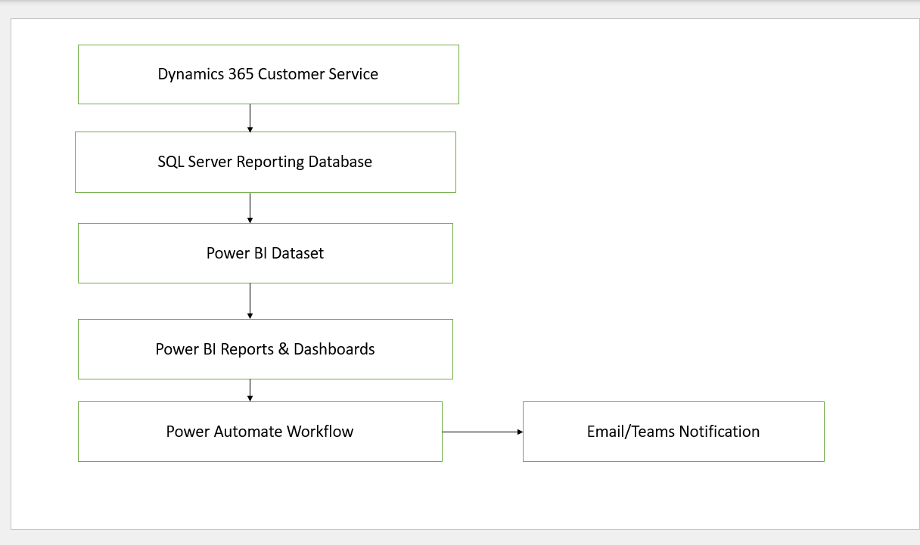

2. DESIGN OPERATIONAL REPORT LAYOUT :
Active Case Monitoring Report
Filters
Date Range | Priority | Status
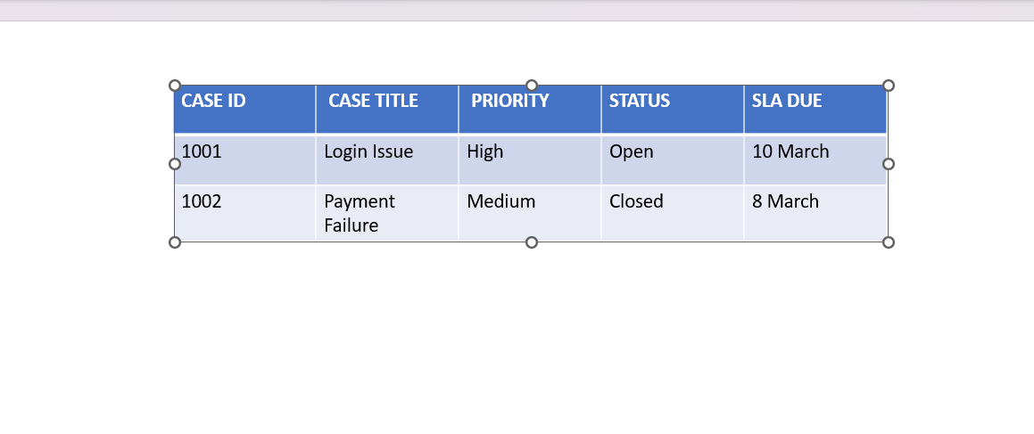
3. MANAGEMENT ANALYTICS DASHBOARD :

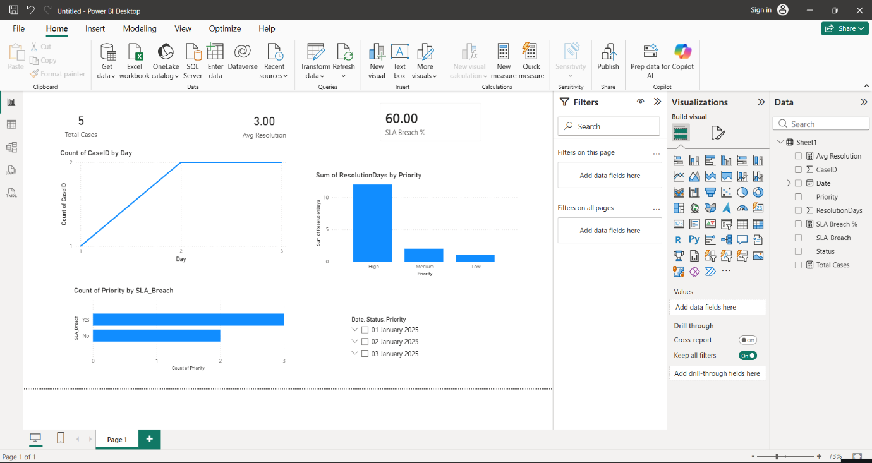

4. SECURITY ARCHITECTURE DIAGRAM :

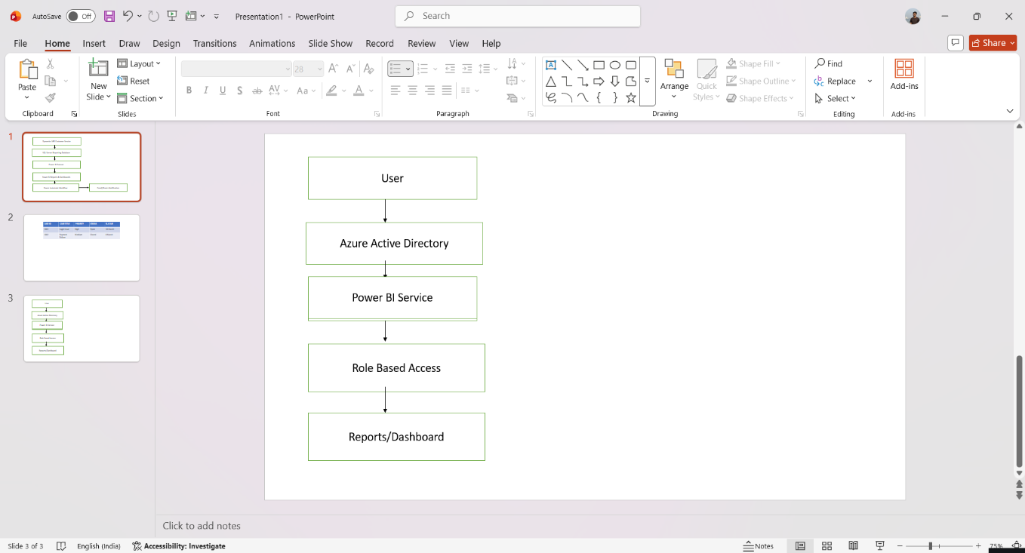

5. AUTOMATION WORK FLOW
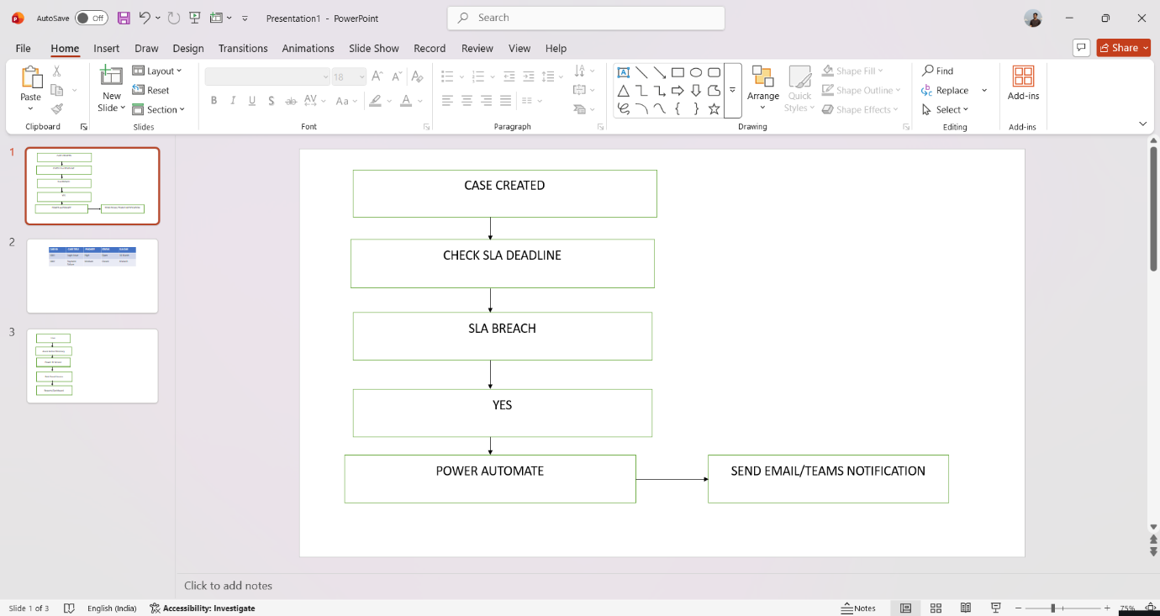

6.ANALYTICAL INSIGHTS
1.High priority cases have higher SLA breaches
2.Case Volume increases during peak period
3.Resolution time varies among agents

7.RECOMENDATIONS
1.implement SLA early-warning alerts
2.Introduce priority -based case routing

