MILESTONE 4 ASSESSMENT

1. Introduction
2. Problem Framing & Objectives
3. Enterprise Reporting Architecture (SSRS)
4. Power BI Analytics & KPI Governance
5. Identity & Security Design
6. Automation & Exception Handling
7. Azure Storage, Secrets & Monitoring
8. Analytical Insights & Recommendations
9. Assumptions and Risks
10. Conclusion

1. Introduction :

Contoso Services Ltd. uses Dynamics 365 to manage customer service across multiple regions. As customer demand grows, the company faces issues like fragmented reports, inconsistent KPIs, and manual processes. The proposed solution is a unified customer intelligence platform that integrates reporting, analytics, automation, and secure cloud architecture. This will improve decision-making, operational efficiency, and governance.

2. Problem Framing & Objectives :

Current Challenges

Challenge | IMPACT
Fragmented reporting | Different departments use different reports
No KPI standard | Performance metrics inconsistent
Manual escalation | SLA breaches handled slowly
Attatchment storage issues | CRM storage cost increases
Security risk | It may expose data

OBJECTIVES:

1.Standardize reporting architecture
2.Create governed KPIs for leadership dashboards.
3.Autoamtate SLA breach escalation workflows
4.Implement secure identity access for internal
and external users.

3. POWER BI DASHBOARD ANALYTICS :

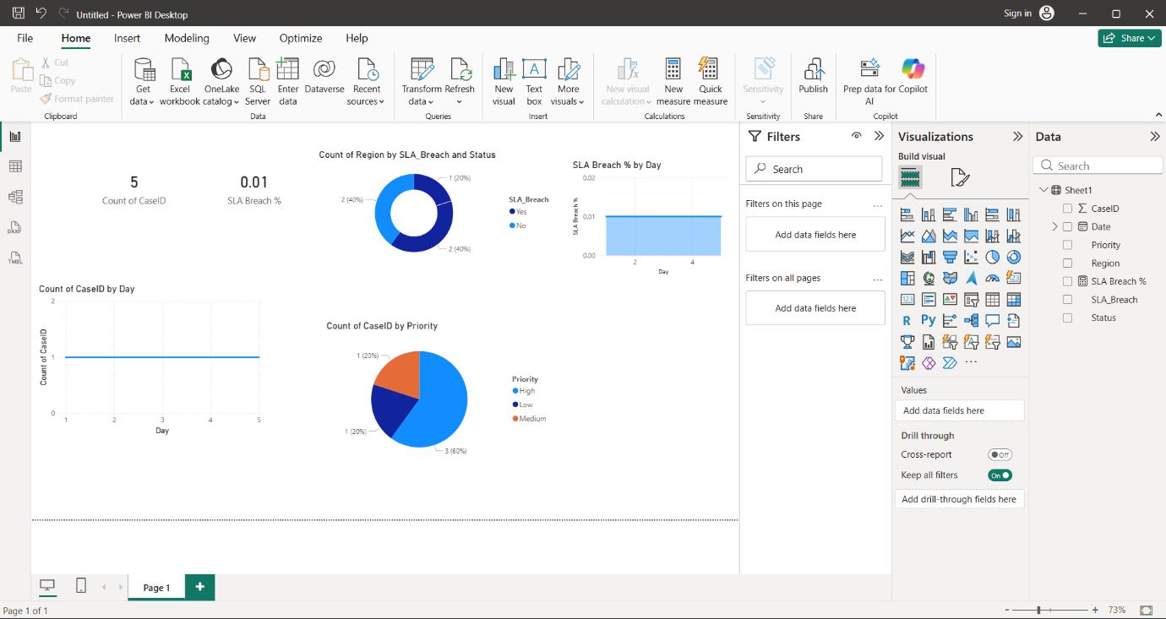

- KPI MEASURE:
1. SLA Breach % =DIVIDE(COUNTROWS(FILTER(Cases,Cases[SLA_Breach]=”Yes”)),
COUNT(Cases[CasesID]))*100
1. This DAX measure calculates the percentage of cases where the SLA was breached in Microsoft Power BI Desktop.
It divides the number of cases with SLA_Breach = "Yes" by the total number of cases, then multiplies the result by 100 to get the percentage.
4 . SSRS Architecture Explanation :

- Operational reporting will be implemented using SQL Server Reporting Services. SSRS is suitable for operational reports that require parameterized filtering, scheduled delivery, and pixel-perfect layouts.

Example parameters:
- Region
- Priority
- SLA Status
- Date Range
Reusable datasets and indexed queries improve report performance.
- SSRS also provides scheduled report execution and delivery, allowing reports to be automatically generated and sent through email subscriptions or stored in shared folders. This ensures that managers and stakeholders receive reports regularly without manual intervention.

5.Identity & Security Design :

- Internal users authenticate using Azure Active Directory, while external partners access systems using Azure AD B2C. Authentication verifies user identity, while authorization determines access permissions.
Security measures include:
- Role-based access control
- Token-based authentication
- Encryption of sensitive data
- API gateway protection for integrations
6.Automation Workflow :

> Service operations automation will use Azure Logic Apps and Azure Functions.
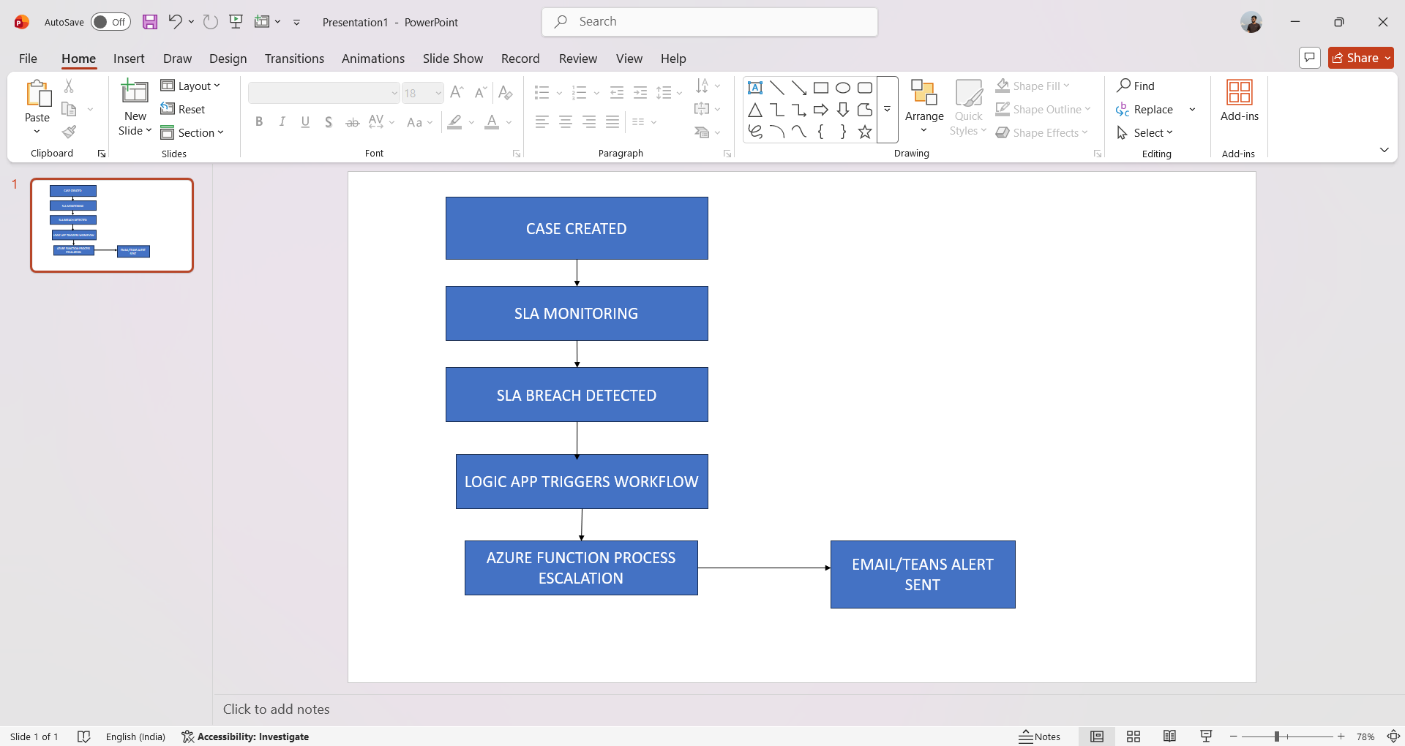
Failure handling includes retry policies, timeout controls, and logging.

7. Azure Storage & Monitoring :

- Attachments will be stored in Azure Blob Storage to reduce CRM storage costs. Sensitive connection strings and API keys are stored securely in Azure Key Vault.

- Application monitoring is implemented using Azure Application Insights, enabling tracking of report execution, automation failures, and service performance metrics.

- Alerts can be triggered when automation failures exceed thresholds.

8. Analytical Insights :

- High-priority cases tend to have more SLA breaches because they are complex and require quick resolution.

- Some regions take longer to resolve cases, possibly due to workload differences or fewer support resources

- Case volume increases during certain peak periods, which can affect response times

- These insights help the organization identify service gaps and improve operational efficiency.

9. Recommendations :

- Set up automated SLA alerts so teams are notified when a case is close to breaching the SLA and can take action quickly

- Improve staffing in busy regions to balance workload and reduce delays in case resolution.

- Standardize KPI definitions across departments so everyone measures performance using the same metrics.

- Store attachments in cloud storage to reduce CRM storage usage and improve system efficiency.

- Regularly monitor service dashboards to quickly identify issues and improve customer service performance.

10. ARCHITECTURE DIAGRAM :

