​ CAPSTONE PROJECT SPRINT-1

Project Title: FinCore Finance & Billing
Analytics Platform

Name : Kabir Ahmed M

Date : March 18, 2026

Batch Name: WIPRO NGA - .Net Full Stack
React FY-26-C3

Instructor Details: Parth Shukla

Table of Contents

- ​Problem Definition and Objectives
- ​Frontend & Backend Architecture
- ​Component Breakdown & API Design
- ​Database Design & Storage Optimization

- Problem Definition and Objectives

- ​ Overview of the problem statement:

- Corporate enterprises frequently experience cash flow bottlenecks due to decentralized, manual invoicing processes.
- Businesses lack a unified system to track pending invoices, manage customer profiles, and visualize outstanding debt in real-time, leading to administrative overhead and delayed revenue collection.

- ​Project goals and objectives:

- The primary objective of the FinCore platform is to deliver a centralized, automated 3-tier web application.

- The goals are to:

- ​Provide a seamless interface for registering corporate clients.
- ​Automate the tracking of standardized billing invoices.
- ​Deliver real-time analytical dashboards tracking Key Performance Indicators (Total Revenue, Pending vs. Overdue ratios, and Customer Debt Load).

- Frontend & Backend Architecture
- Overview of chosen technology stack:

- Frontend: A Single Page Application (SPA) built using HTML5, CSS3 (Bootstrap 5 for responsive design), and TypeScript/JavaScript for asynchronous HTTP fetching and DOM manipulation.

- ​Backend: ASP.NET Core Web API (C#) utilizing a layered architecture (Controllers, Services, Repositories).

- ​Database: Microsoft SQL Server using Dapper (Micro-ORM) for high-performance data access.

- ​Analytics: Power BI for interactive dashboards.

- SPRINT 2 Development with SSRS dataset integration at the SQL level.
SYSTEM DESIGN DIAGRAM:
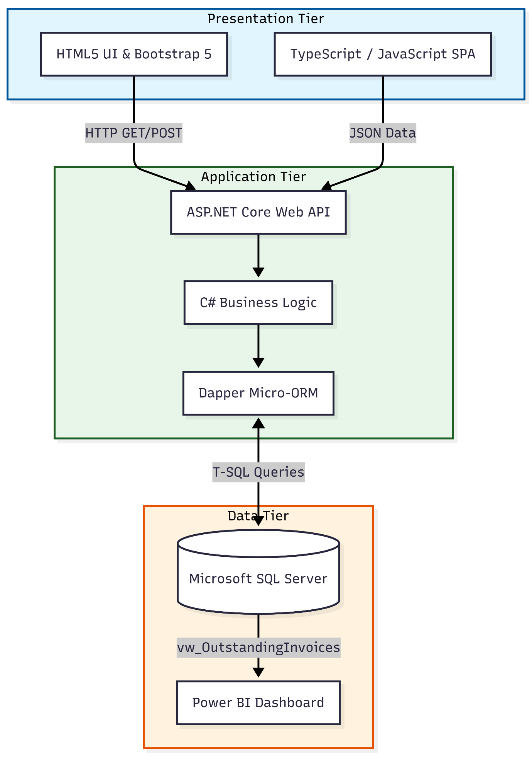
Architecture Diagram
3.Component Breakdown & API Design
Breakdown of major components in frontend:

- UI Components: The UI is modularized into distinct visual sections using Bootstrap, including the Customer Registration Form and the dynamically rendering Recent Transactions Table.

- State Management: Application state (like current form inputs and fetched invoice arrays) is managed locally within the TypeScript execution environment before being sent to the server.

- Routing: Implemented as a Single Page Application (SPA) where the index.html acts as the primary view, dynamically updating the Document Object Model (DOM) without requiring full page reloads.

- ​API design, endpoints:

- The backend exposes RESTful API endpoints utilizing standard HTTP verbs.
- ​Endpoints: Include GET /api/customers (retrieve all), POST /api/customers (register new), and respective endpoints for Invoice and Payment controllers.
- ​Database Design & Storage Optimization

​Entity-Relationship Diagram (ERD):
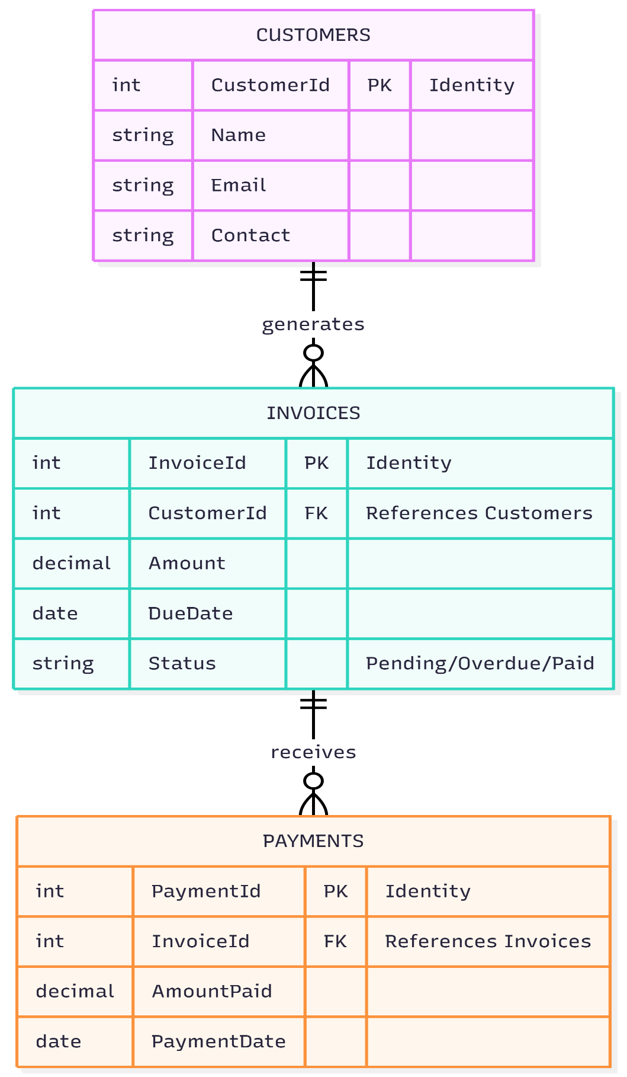
- Optimization techniques for efficient queries:

- ​Schema Normalization: Tables are normalized using Primary and Foreign Keys (e.g., CustomerId linking Invoices to Customers) to prevent data duplication.

- ​SQL Views: Implemented vw_OutstandingInvoices to pre-filter "Paid" statuses at the database level, drastically reducing the payload size before it hits the Power BI dashboard or API layer.

- ​Dapper Micro-ORM: Utilized Dapper instead of heavier frameworks to execute raw, optimized parameterized SQL queries, preventing SQL injection while maintaining maximum execution speed.

