**SECURITY IN COMPUTING**

**JOURNAL**

## TYIT

2021

|  |  |  |  |
| --- | --- | --- | --- |
| **Practical no** | **Title** | **Date** | **Sign** |
| **1** | **Configure Cisco Routers for Syslog, NTP, and SSH Operations** |  |  |
| **2** | **Configuring Extended ACLs** |  |  |
| **3** | **Configure AAA Authentication** |  |  |
| **4** | **Configure IP ACLs to Mitigate Attacks** |  |  |
| **5** | **Configuring IPv6 ACLs** |  |  |
| **6** | **Configuring a Zone-Based Policy Firewall (ZPF)** |  |  |
| **7** | **Configure IOS Intrusion Prevention System (IPS) Using the CLI** |  |  |
| **8** | **Packet Tracer - Layer 2 Security** |  |  |
| **9** | **Layer 2 VLAN Security** |  |  |

# PRACTICAL NO 1:

**Configure Cisco Routers for Syslog, NTP, and SSH Operations**

### OSPF, MD5 Authentication

* OSPF is a routing protocol. Two routers speaking OSPF to each other exchange information about the routes they know about and the cost for them to getthere.
* When many OSPF routers are part of the same network, information about all ofthe routes in a network are learned by all of the OSPF routers within that network— technically called an **area**. (We’ll talk more about area as we goon).
* Each OSPF router passes along information about the routes and costs they’veheard about to all of their adjacent OSPF routers, called**neighbors**.
* OSPF routers rely on **cost** to compute the shortest path through the networkbetween themselves and a remote router or networkdestination.
* The shortest path computation is done using[Djikstra’s algorithm](http://en.wikipedia.org/wiki/Dijkstra%27s_algorithm). This algorithm isn’t uniquetoOSPF.Rather,it’samathematicalalgorithmthathappenstohaveanobvious application tonetworking.

### MD5 Authentication

* MD5 authentication provides higher security than plain textauthentication.
* This method uses the MD5 algorithm to compute a hash value from the contents of the OSPF packet and a password (orkey).
* This hash value is transmitted in the packet, along with a key ID and a non-decreasing sequencenumber.
* The receiver, which knows the same password, calculates its own hashvalue.
* If nothing in the message changes, the hash value of the receiver should match thehash value of the sender which is transmitted with themessage.
* The key ID allows the routers to reference multiplepasswords.
* This makes password migration easier and moresecure.
* For example, to migrate from one password to another, configure a password undera different key ID and remove the firstkey.
* The sequence number prevents replay attacks, in which OSPF packets arecaptured, modified, and retransmitted to arouter.
* As with plain text authentication, MD5 authentication passwords do not have to be the same throughout an area. However, they do need to be the same betweenneighbors.

### Example

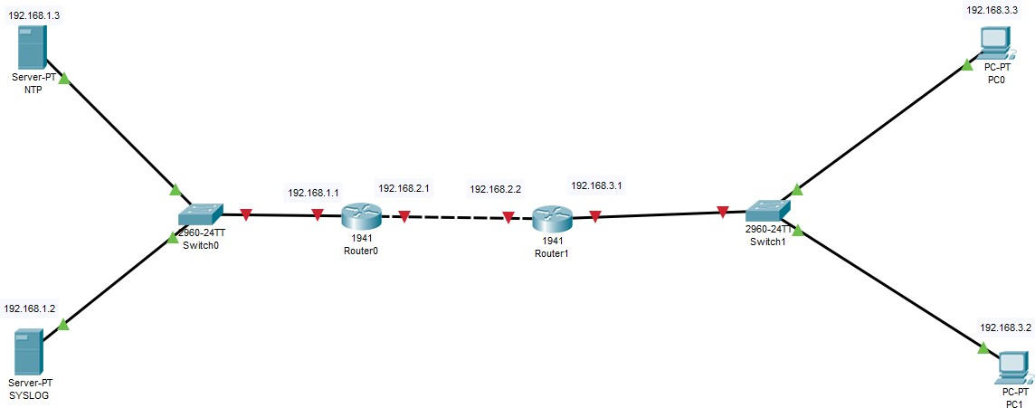**Consider the following topology**

**ConfiguringPC0**

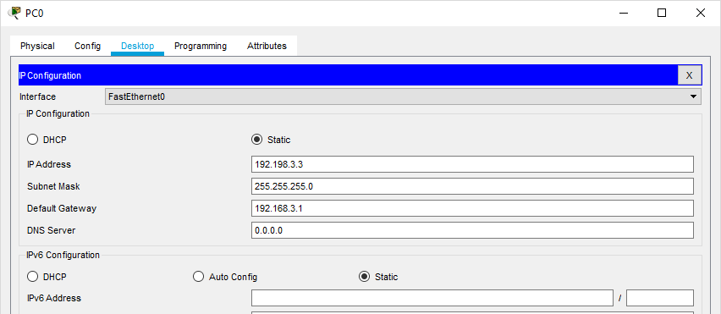

**ConfiguringPC1**

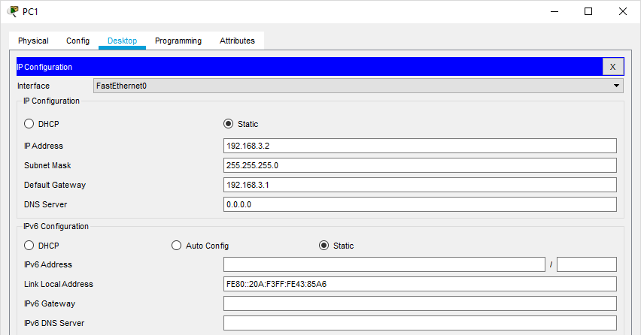

**Configuring NTP Server**

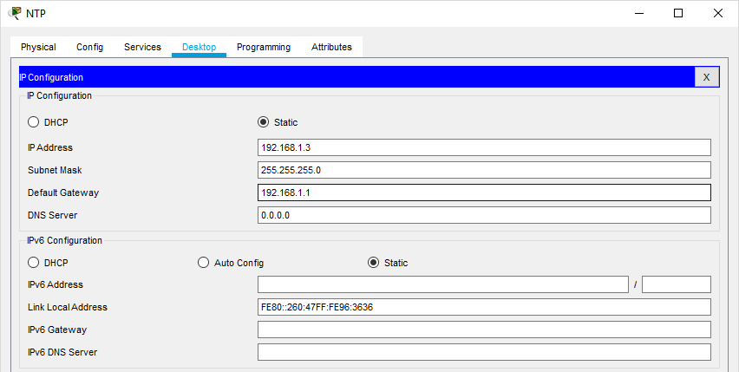

**Configuring SYSLOG Server**

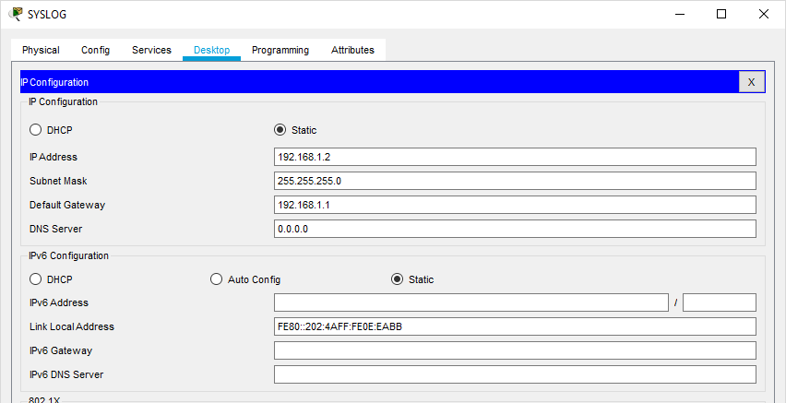

**Configuring Router0**

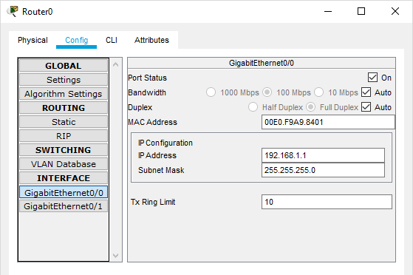

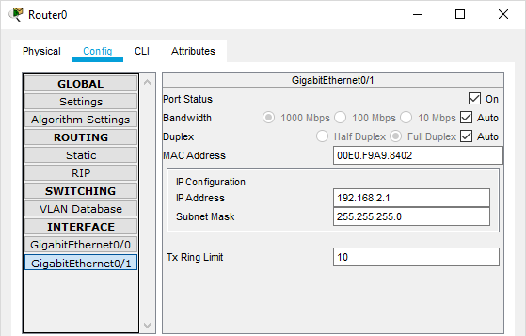

**Configuring Router1**

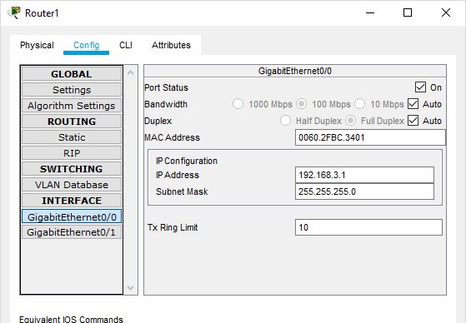

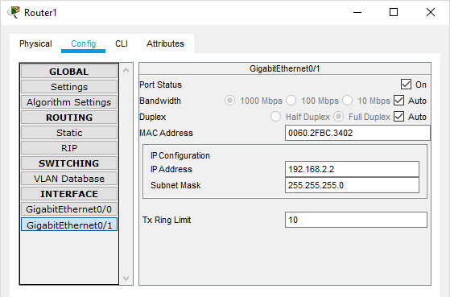

### Part 1: Configure OSPF MD5 Authentication

**ROUTER 0: Type the following command in the CLI mode**

Router>enable Router#configure terminal Router(config)#router ospf 1

Router(config-router)#network 192.168.1.0 0.255.255.255 area 1

Router(config-router)#network 192.168.2.0 0.255.255.255 area 1 Router(config-router)#exit

Router(config)#exit Router#

**ROUTER 1: Type the following command in the CLI mode**

Router>enable Router#configure terminal Router(config)#router ospf 1

Router(config-router)#network 192.168.3.0 0.255.255.255 area 1

Router(config-router)#network 192.168.2.0 0.255.255.255 area 1 Router(config-router)#exit

Router(config)#exit Router#

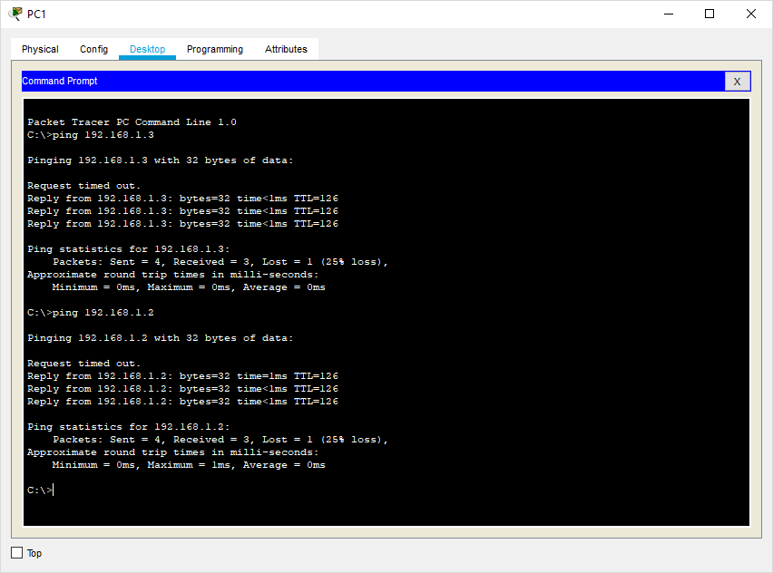**Now we verify the connectivity by using the following**

Hence OSPF has been verified

### MD5 Authentication

**ROUTER 0: Type the following command in the CLI mode**

Router>enable Router#

Router#configure terminal Router(config)#interface GigabitEthernet0/1

Router(config-if)#ip ospf authentication message-digest Router(config-if)#ip ospf message-digest-key 1 md5 smile Router(config-if)#exit

Router(config)#exit

**ROUTER 1: Type the following command in the CLI mode**

Router>enable Router#

Router#configure terminal Router(config)#interface GigabitEthernet0/1

Router(config-if)#ip ospf authentication message-digest Router(config-if)#ip ospf message-digest-key 1 md5 smile Router(config-if)#exit

Router(config)#exit

## Verify the MD5 Authentication using the following command in the CLI mode of Router0

Router#show ip ospf interface gigabitEthernet 0/1

**We get the following output:**

GigabitEthernet0/1 is up, line protocol is up Internet address is 192.168.2.1/24, Area 1

Process ID 1, Router ID 192.168.2.1, Network Type BROADCAST, Cost: 1 Transmit Delay is 1 sec, State BDR, Priority 1

Designated Router (ID) 192.168.3.1, Interface address 192.168.2.2

Backup Designated Router (ID) 192.168.2.1, Interface address 192.168.2.1 Timer intervals configured, Hello 10, Dead 40, Wait 40, Retransmit 5

Hello due in 00:00:06

Index 2/2, flood queue length 0 Next 0x0(0)/0x0(0)

Last flood scan length is 1, maximum is 1

Last flood scan time is 0 msec, maximum is 0 msec Neighbor Count is 1, Adjacent neighbor count is 1 Adjacent with neighbor 192.168.3.1 (Designated Router) Suppress hello for 0 neighbor(s)

**Message digest authentication enabled**

Youngest key id is 1

## MD5 Authentication has been verified

1. **NTP**
   * Network Time Protocol (NTP) is a TCP/IP protocol used tosynchronize computer clocks across datanetworks.
   * NTP was developed in the 1980s by D.L. Mills at the University of Delaware to achieve highly accurate time synchronization and to sustain the effectsof variable latency over packet-switched data networks through a jitterbuffer.

We use the same topology to study the given protocol

**Configure NTP Server and enable the NTP service**

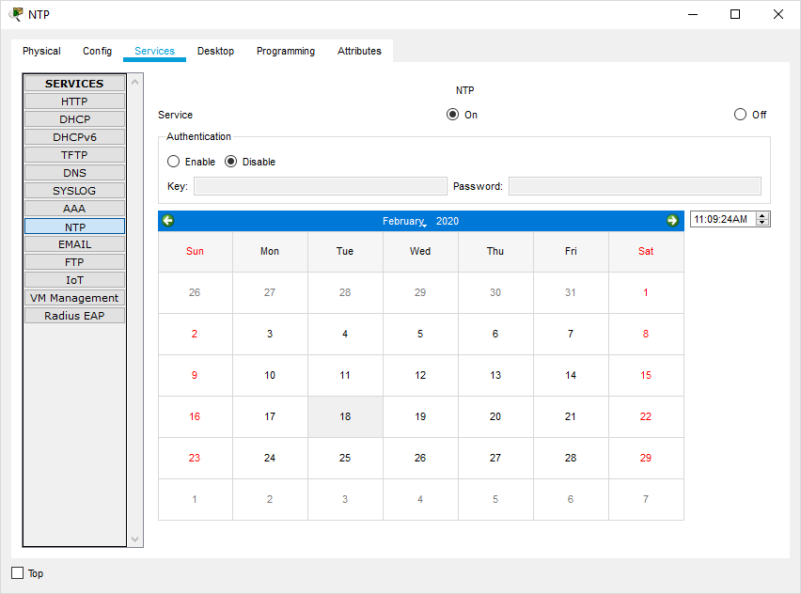

**We must disable the NTP service on other servers else output won’t be obtained**

**Now Go to CLI Mode of Router4 and type the following commands on both theRouters**

Router#config Router#configure t Router#configure terminal

Enter configuration commands, one per line. End with CNTL/Z. Router(config)#ntp server 192.168.1.3

Router(config)#ntp up Router(config)#ntp update-calendar Router(config)#exit

Router#

**To verify the Output we use the following command**

Router#show clock

11:14:58.985 UTC Tue Feb 18 2020

Router#

## SYSLOG server

**Configure SYSLOG Server and enable the service**

* + Syslog is a way for network devices to send event messages to a loggingserver

– usually known as a Syslog server.

* + The Syslog **protocol** is supported by a wide range of devices and can be usedto log different types ofevents.
  + For example, a router might send messages about users logging on toconsole sessions, while a web-server might log access-deniedevents.

## Turn ON the SYSLOG service on the server

**And Turn OFF on all other Servers**

**Now Go to CLI Mode of any Router and type the following commands in all theRouters.**

Router#

Router#configure terminal Router(config)#logging 192.168.1.2 Router(config)#exit

Router#

**Output:**

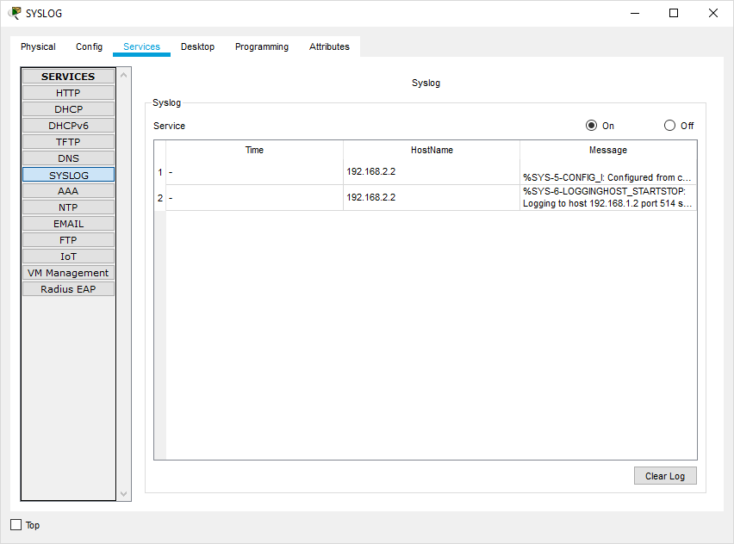

1. **SSH**
   * An **SSH server** is a software program which uses the secure shell protocol to accept connections from remotecomputers.
   * The way **SSH works** is by making use of a client-server model to allow for authentication of two remote systems and encryption of the data that passes betweenthem.
   * It organizes the secure connection by authenticating the client and opening the correct shell environment if the verification issuccessful.

**Now Go to CLI Mode of Router0 and type the following commands.**

Router#configure terminal Router(config)#ip domain-name ismail.com Router(config)#hostname R1

R1(config)#

R1(config)#crypto key generate rsa

The name for the keys will be: R1.ismail.com

Choose the size of the key modulus in the range of 360 to 2048 for your General Purpose Keys. Choosing a key modulus greater than 512 may take a few minutes.

R1(config)#line vty 0 4

R1(config-line)#transport input ssh R1(config-line)#login local R1(config-line)#exit

R1(config)#username ismail privilege 15 password cisco R1(config)#

**Output: Go to cmd of PC1 and type the command**

**ssh –l ismail 192.168.3.1 and type the password cisco**

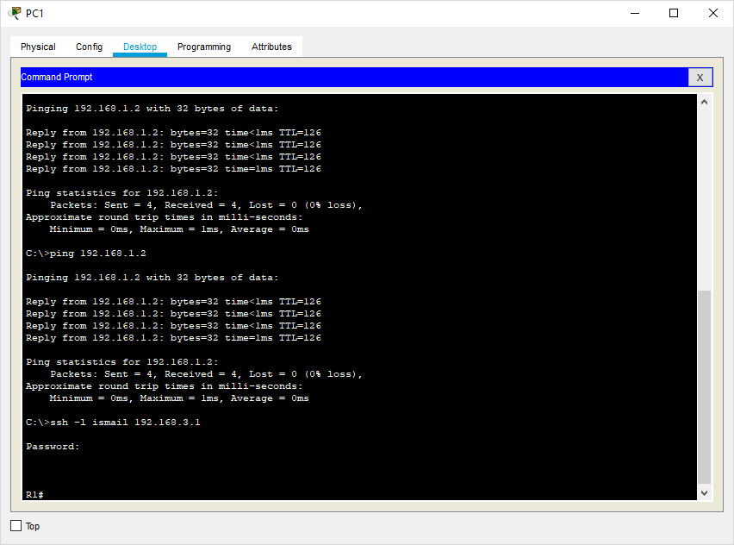

**Hence SSH is also verified**