IAM Project

Java Fundamentals

# By

# Kabirou Adebowale Arinloye

# Lakshay Giridhar

## TABLE OF CONTENTS

1. Subject description
2. Subject analysis
   1. Major features
   2. Application Feasibility
   3. Data description
   4. Expected results
   5. Algorithms study
3. Scope of the application
4. Conception
   * 1. Chosen algorithm
     2. Data structures
     3. Global application flow
     4. Global schema and major features schema
5. Console operations description
6. <One section by operation>
7. Configuration instructions
8. Commented Screenshots
9. Bibliography

## 1. Subject description

The purpose of this project is to introduce computer programming using the java programming language with object-oriented programming principles. Emphasis is placed on programming methods, including creating and manipulating objects, classes, and using object-oriented tools such as the class debugger. The project also gives us ways to implement to best practices used in industry standards.

## 2. Subject analysis

## 2.1 Major features

We can perform CRUD operation (Create, Read, Update and Delete) using database. Here, an authentication is performed before allowing any user to perform action on the software. The user can store his information like Name, Identification Number, Email and Address. On this data he/she can perform CRUD operations.

## 2.2 Application Feasibility

This project is used to demonstrate, our basic knowledge of java. This project cannot be used for commercial purposes until further development. The interface we us here is console based, while a normal user would prefer graphical user interface. This has been designed with all best practices kept in mind, so that further development can be done easily.

## 2.3 Data description

We have used various types of data types like string, integer and objects. Here we have designed our own datatypes called identity and address. Identity contains values like name, uid,email and address. While address contains values like city name, street name, province, country and postal code.

## 2.4 Expected results

The project is used to demonstrate simple CRUD operations. We expect the user to use our application for storing their information and reusing it. We provide basic authentication for the user to keep his or her data secure. The data stored can be manipulated by the user for his/her preferences.

## 2.5 Algorithms study

We do not use any special algorithm here for the project. The various predefined methods used in the project use special within themselves. We use logger to log our errors into the file.

## 2.6 Scope of the application

We are using console-based interface for the user to interaction with user. It is a very basic form of interaction, which is not very user-friendly. We can add graphical user interface for making the interaction easier. The users can add only specific attributes, in future iterations of the project the user can add more attributes to his list.

## 3.Conception

## 3.1 Chosen algorithm

We take the input from the users, pass it onto the POJOs and send it the database using JDBC drivers and store it in table. There in the table, manipulations can be performed on them, data can be retrieved from the table and displayed to the user using JDBC. The data can also be deleted from the table in the database.

## 3.2 Data structures

There are two different types of data structures we have used Identity and Address. Identity has attributes like name, email, uid and address. Address has attributes like city name, street name, country and postal code .

## 3.3 Global application flow

To enter software

Enter username and password>perform CRUD operations

Create

create a list of data>write data into table in database

Read

Read data>retrieve data from table

Update

Update data>input and modify new data into table

Delete

Delete>delete data from the table

## 3.4 Global schema and major features schema

## Class Diagram

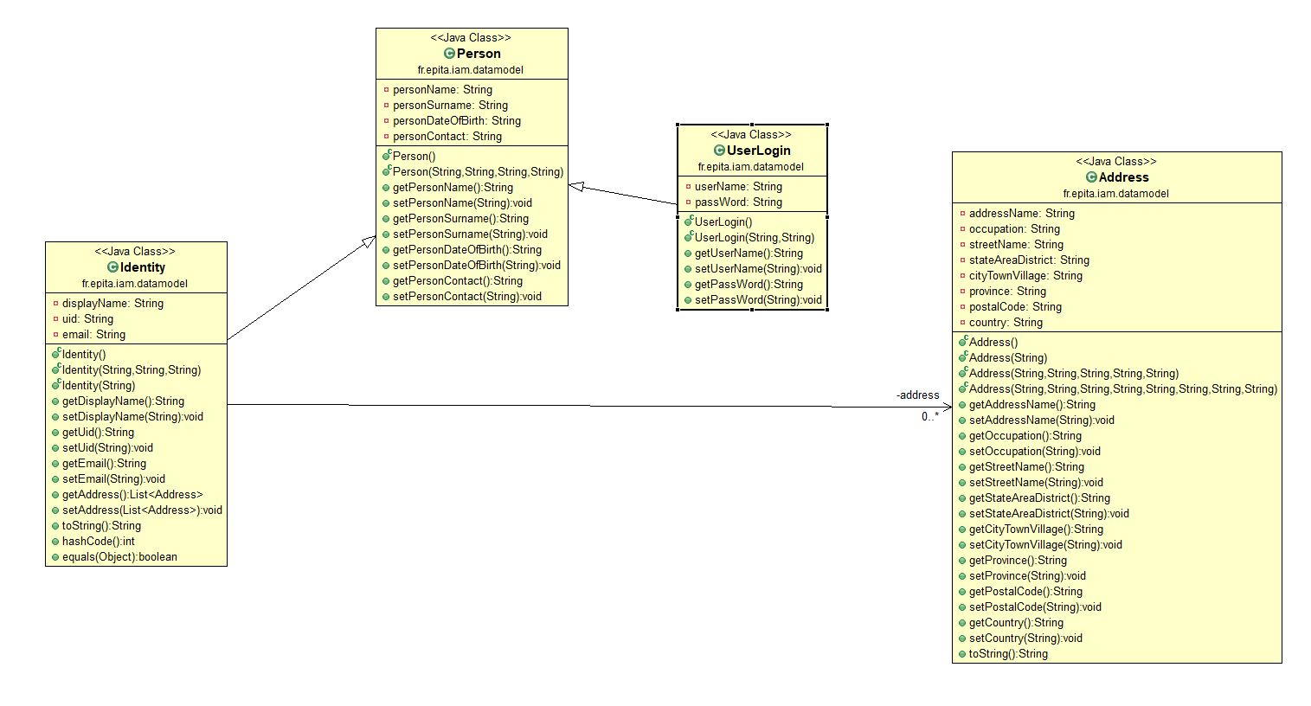

## Flow Chart

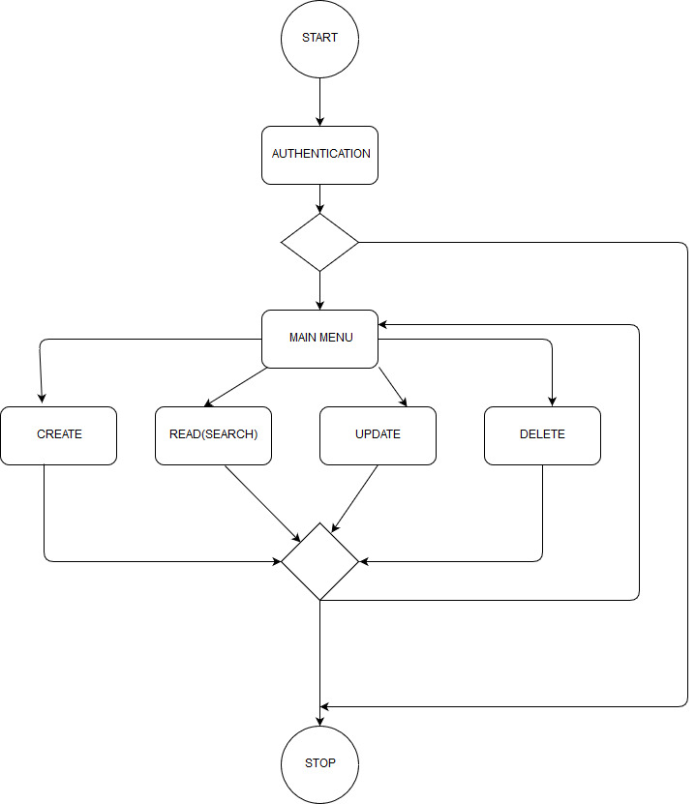

## 4.Console operations description

Enter Username and password

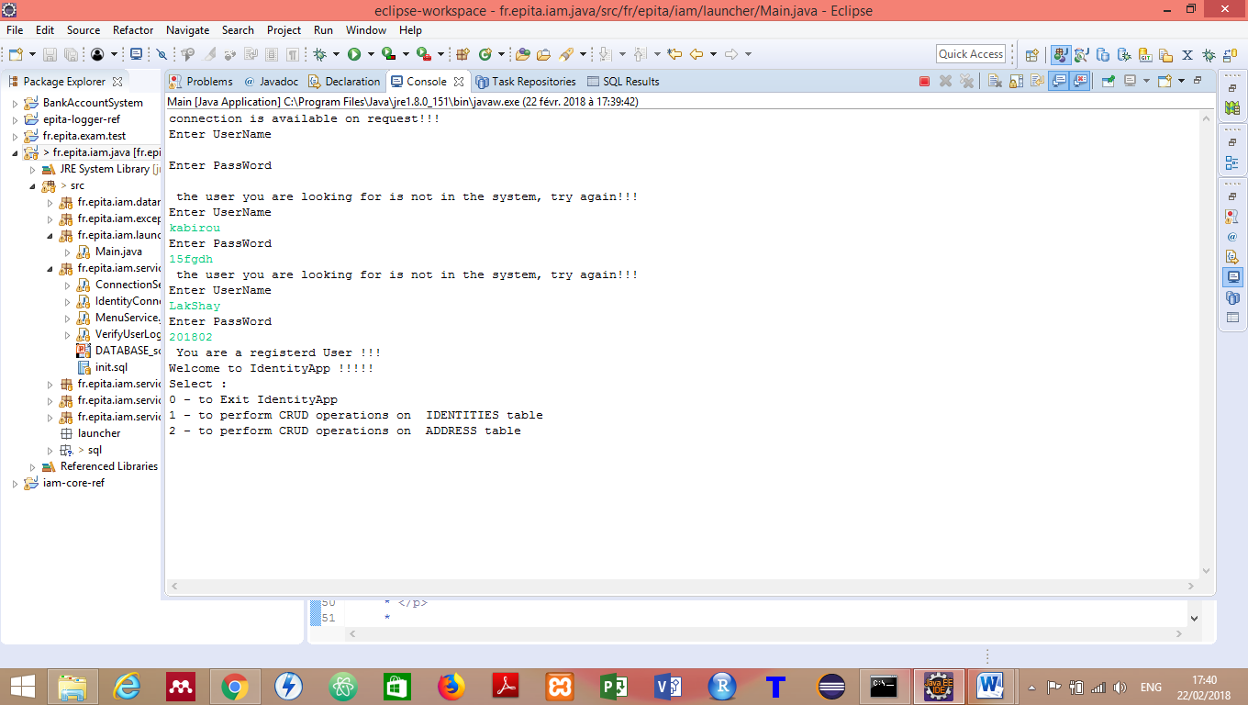

## 5.Configuration instructions

## 6.Commented Screenshots

## 7.Bibliography

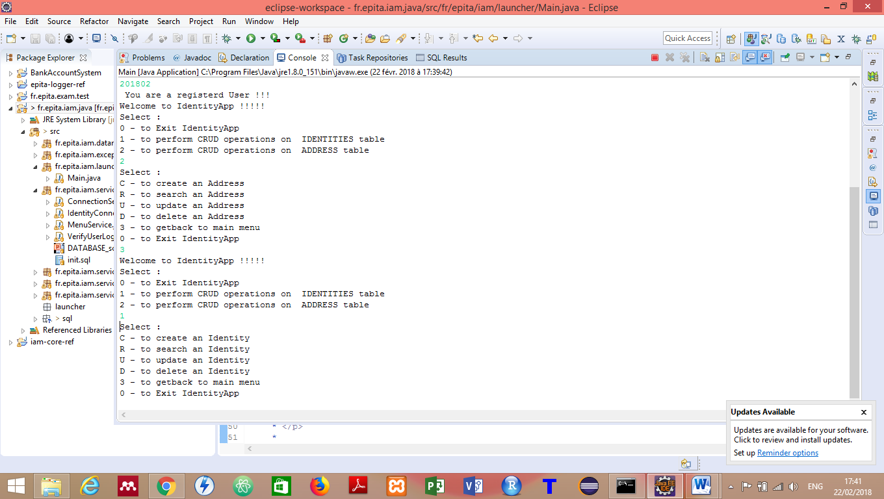Perform CRUD operations

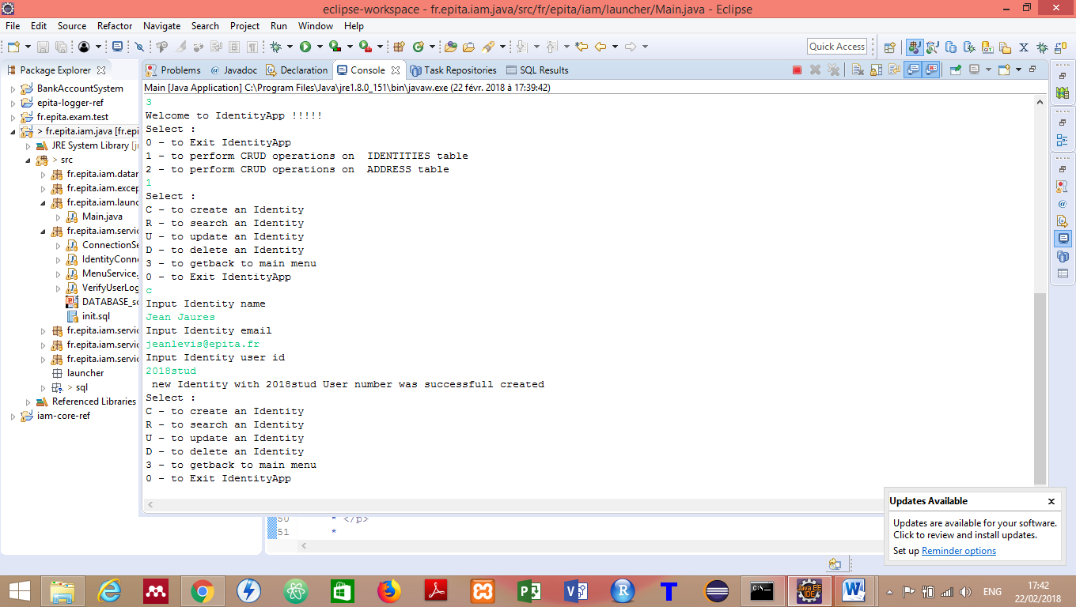

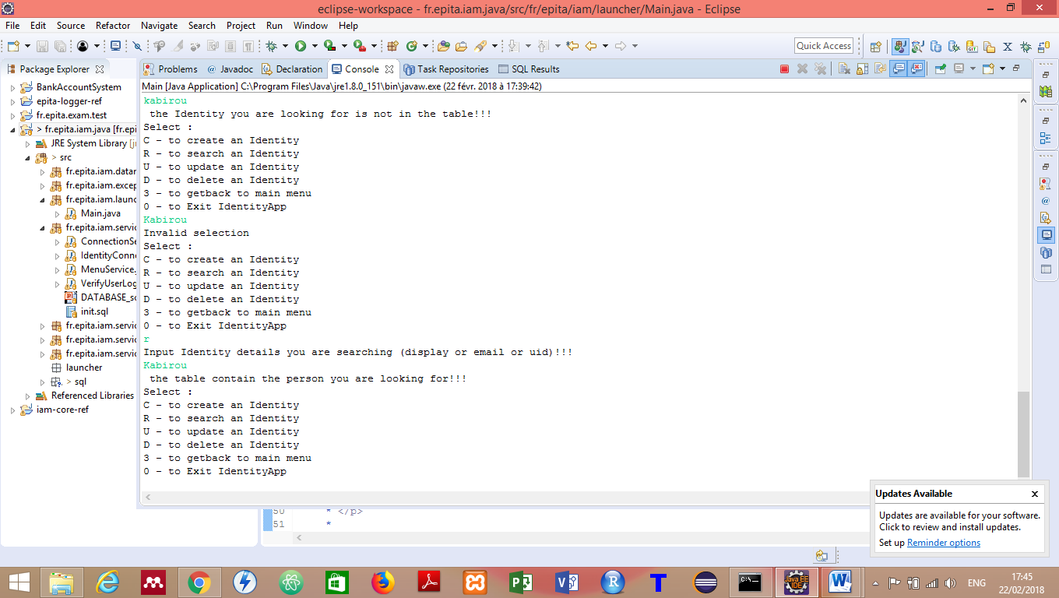

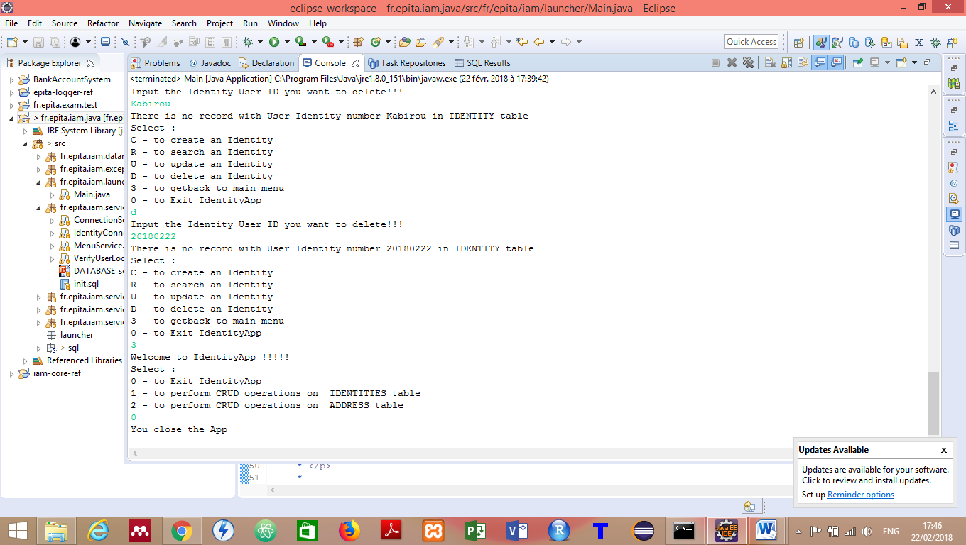

## 5.Configuration instructions

Run all the sql command in init.sql

Create DB with name “IDENTITIES_DB”, username: “root” and password: “root”

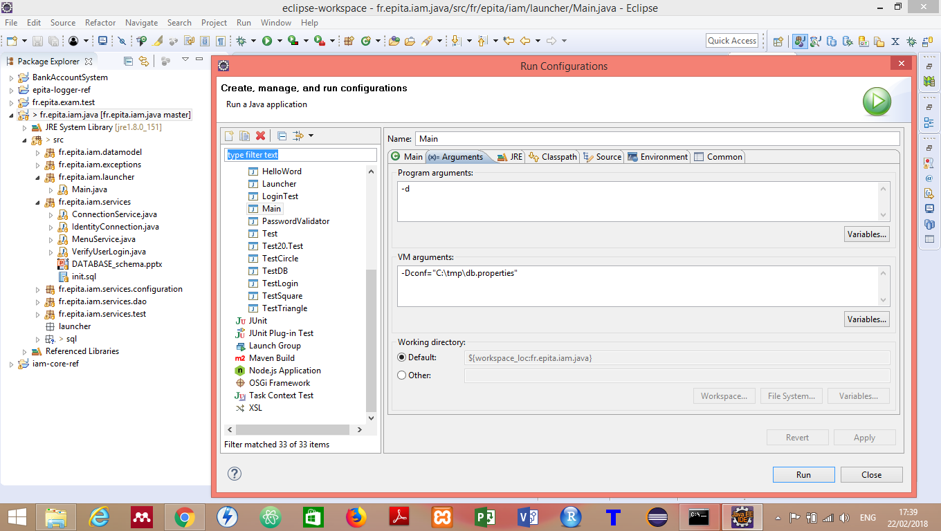

## 6.Commented Screenshots

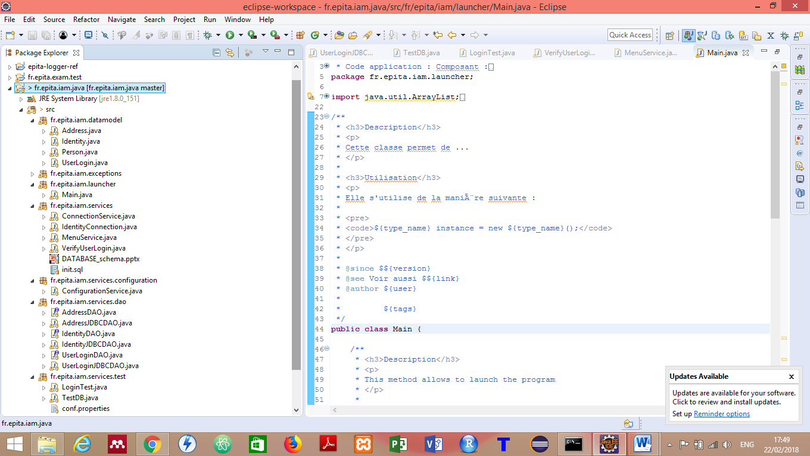

## 7.Bibliography

1. **Java tutorial: - <https://www.tutorialspoint.com/java/index.htm>**
2. **StackOverFlow :-** [**https://stackoverflow.com/questions/tagged/java**](https://stackoverflow.com/questions/tagged/java)
3. **ThomasBroussardJava:-** [**http://thomas-broussard.fr/**](http://thomas-broussard.fr/)