# Student Performance Predictor Report:

# Model Selection for Implementation

After evaluating various machine learning models for the project, we have chosen Linear Regression as the final model for implementation. This decision is based on its superior performance and higher accuracy than other models.

## Reasons for Choosing Linear Regression

1. High Accuracy: Linear Regression demonstrated the highest accuracy among all the models evaluated, making it the most reliable choice for predicting outcomes in this project.

2. Simplicity and Interpretability: The model's straightforward nature makes it easy to interpret the relationships between features and the target variable.

3. Efficiency: Linear Regression requires minimal computational resources, which ensures faster training and prediction times, especially for large datasets.

**Some Points to know about the Linear Regression:**

The linear regression model is a fundamental statistical and machine learning technique used to model the relationship between one or more independent variables (predictors) and a dependent variable (target). Its purpose is to predict the value of the dependent variable based on the values of the independent variables.

Uses of Linear Regression:

1. Prediction:
   * Linear regression is widely used to predict outcomes based on historical data, such as predicting sales, housing prices, or stock prices.
2. Understanding Relationships:
   * It helps in understanding and quantifying the strength and type of relationships (positive/negative) between variables.
3. Trend Analysis:
   * Linear regression can identify and model trends over time, such as predicting population growth or economic trends.
4. Feature Influence:
   * It reveals which features (independent variables) are most influential in predicting the target variable.
5. Optimization:
   * Used in optimization problems where the goal is to minimize the error between predicted and actual values (e.g., cost functions in machine learning).
6. Forecasting:
   * Linear regression helps in forecasting future values based on existing patterns.
7. Benchmarking:
   * Serves as a baseline model to compare with more complex machine learning models.
8. Applications in Various Fields:
   * Finance: Predicting stock prices, risk analysis, etc.
   * Healthcare: Estimating disease progression or hospital resource utilization.
   * Marketing: Measuring the impact of marketing strategies on sales or customer acquisition.
   * Agriculture: Yield prediction based on weather, soil quality, and other factors.

Key Assumptions:

* A linear relationship exists between the dependent and independent variables.
* The residuals (errors) are normally distributed.
* Homoscedasticity (constant variance of errors).
* Independence of observations.

Linear regression is simple, interpretable, and effective, making it a go-to model for many practical applications, especially when the relationship between variables is approximately linear.

**Implementation of The Model:**

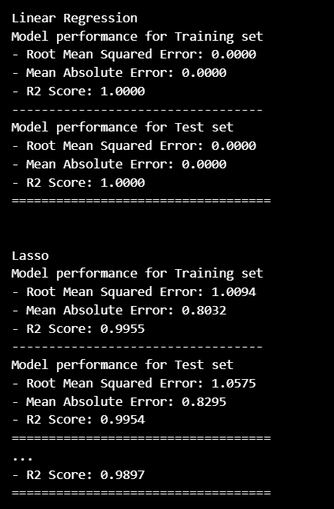

In the above figure, we can see the evaluation matrix for the different models that we have implemented.

The R2 score of the linear regression model is more than the other models. So we can say that the linear regression model is the best fir for our student performance predictor.

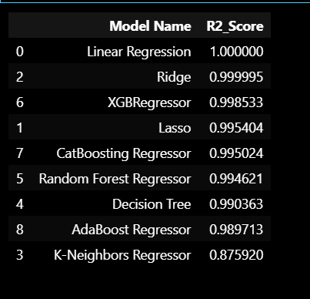

Here we can see that the R2_score for the different models that we have implemented and linear regression is the best fir for our student performance predictor.

The accuracy of our model comes out to be 100%, As the linear regression model is the best fit for our problem statement. The model also gets trained well for our dataset.

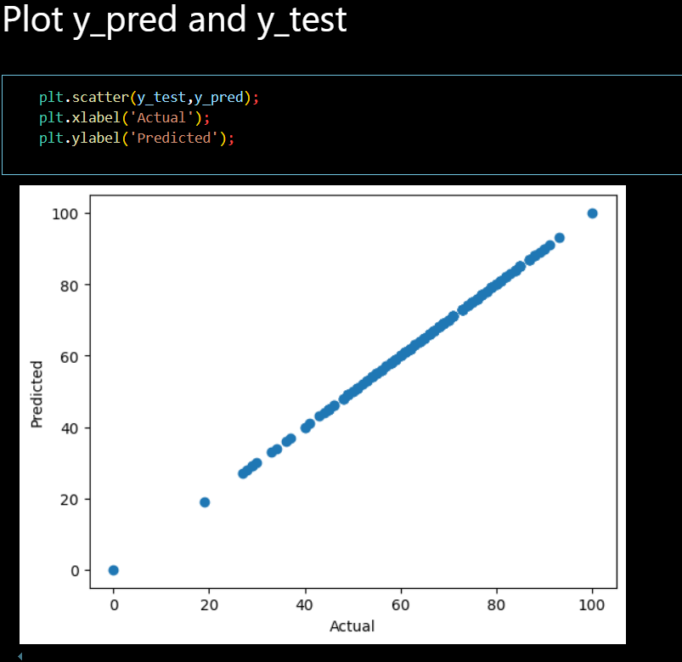

Plot for the y_predict values and y_test values. We can see that the values are linearly plotted.

**Implementation of the code with prediction and front-end:**

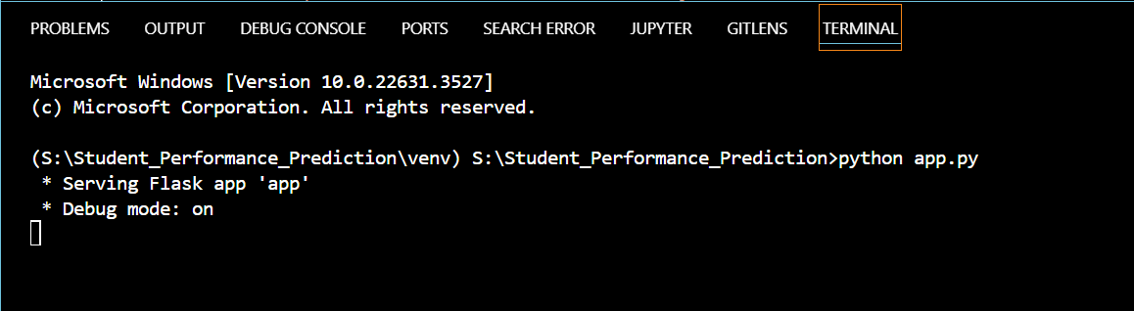

In the above figure, we are opening the server to rout our front page and other pages for the prediction.

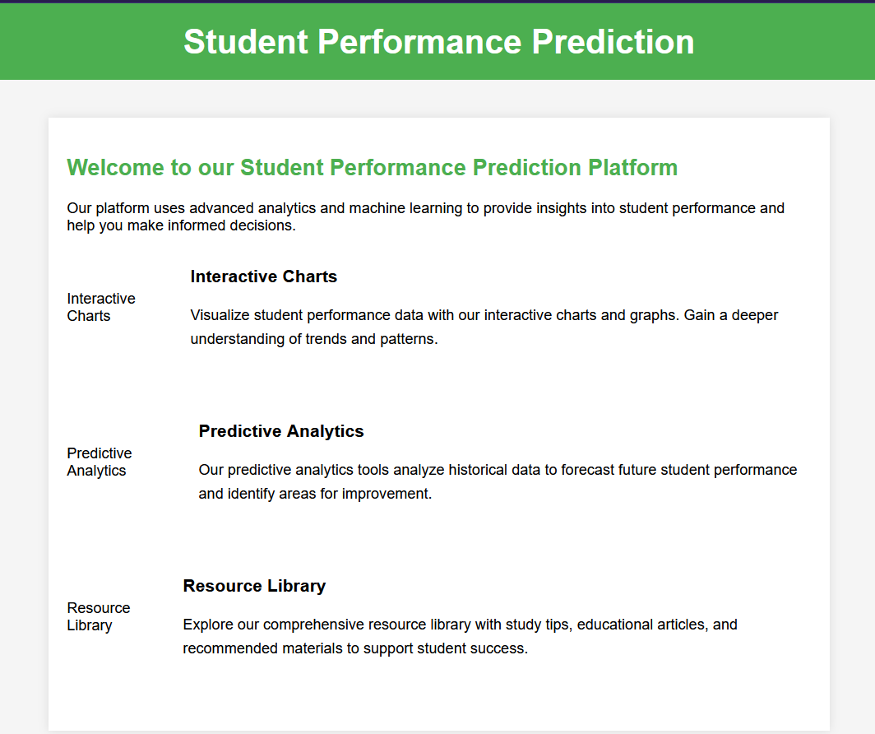

This is the basic front page for our users we can customize this according to our business need.

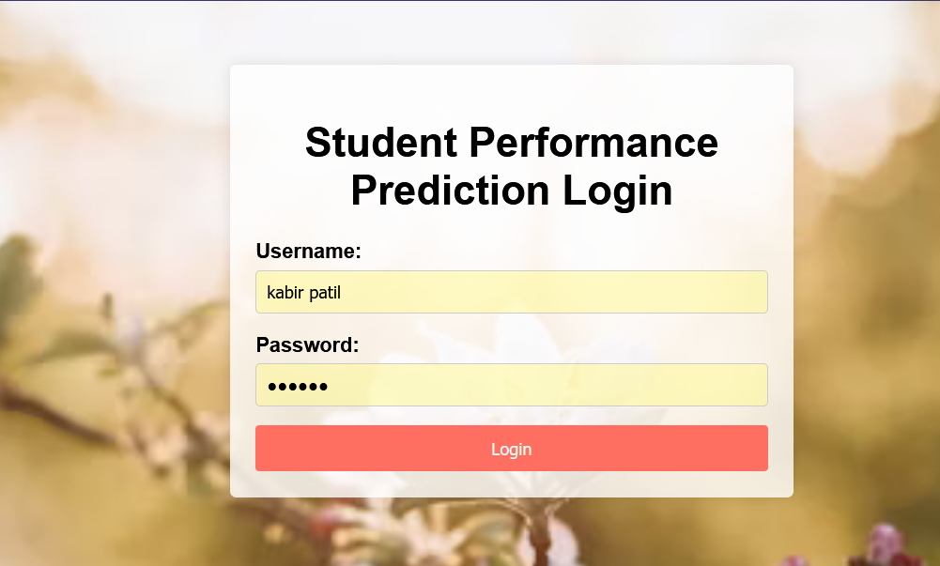

This is our login page where the user can log in herself/himself. To check or get the predicated CGPA for the upcoming exams.

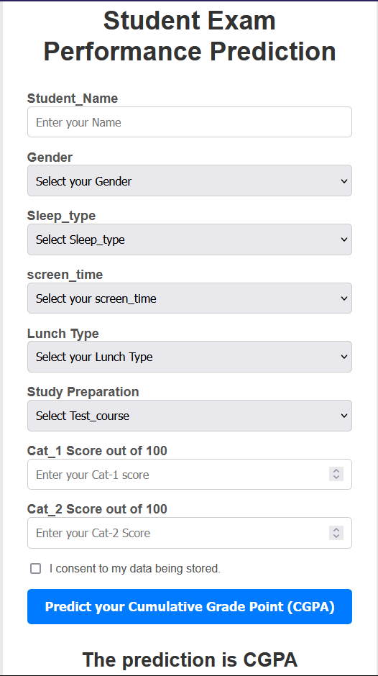

This is our main form where the student can input his/her data and score for the exam which he/she has given and check the predicted CGPA.

## Future Scope of the Student Performance Predictor

## The future scope of the Student Performance Predictor includes implementing a role-based login system to enhance user experience and security. Teachers and students will have distinct roles, allowing teachers to analyze student data and performance, while students can view their academic records. Additionally, the system can be expanded to include advanced data visualization features, enabling users to view marks and CGPA trends over time, thus providing deeper insights into academic performance.

## Conclusion

Given its performance, simplicity, and efficiency, Linear Regression is the optimal choice for our implementation. We are confident that this model will effectively address the objectives of our project and deliver accurate results.