OCEAN-X

User Guide

|  |  |  |
| --- | --- | --- |
| **Supervisor** | Tazeen Anis | |
| **Batch** | 2107E | |
| **Group** | OCEANGATE | |
| **Serial No.** | **ENROLLMENT**  **NUMBER** | **STUDENT NAME** |
| 1. | 1322157 | Abdul Kabir |
| 2. |  | Muhammad Ward |
| 3. |  | Muhammad Areeb Ansari |
| 4. |  | Akasha Lucky |

USER GUIDE

“OCEAN-X” is a website which is based on Crewed Submersibles for charter and Scientific Exploration, If you are into Ocean diving and exploration then this website is for you, more information about website is given below.

1. Top Layout

* At the top of the page user can get the information about “ABOUT” , “WHAT WE DO” Etc( look at the picture for more).



2.HOME PAGE

* This page Contain The information About our Next Generation of 5 Person Submersibles.

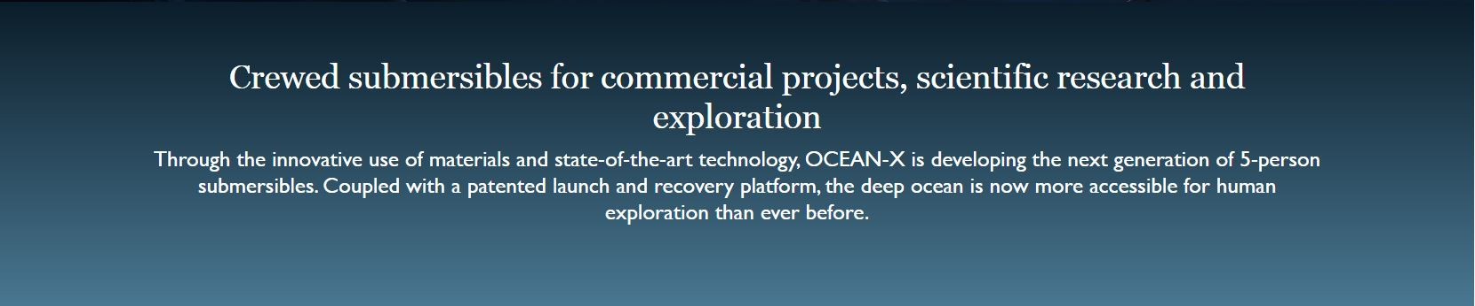

And Right After That

You will see Our services that we provide for

* Scientific Exploration & Adventure.
* Research and Commercial Projects.

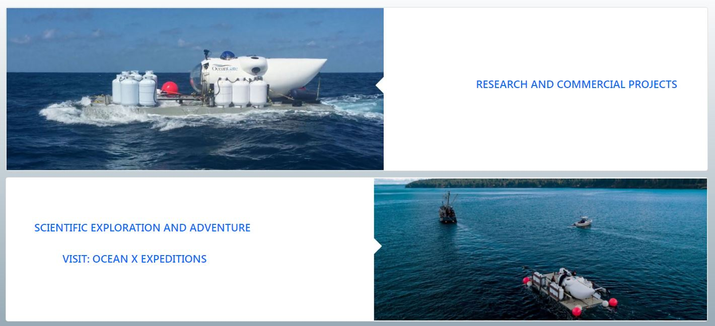

3.At Last

* C:\Users\abc\Desktop\PROJECT 28\Document\Mailing.JPGYou can subscribe to our mailing system just by clicking on
* Below that you will see Map of Site



* And at the bottom you will see our Socials Handles



That is it,

Thanks for your Time.