Cyber Security Internship Report – Task 4

Name: Kabsha Farooq

University: University of Engineering and Technology, Taxila

Department: Telecommunication Engineering

Internship Organization: Digital Empowerment Network

Task Title: Broken Access Control Testing

Task No.: 4

# Objective

Identify areas where access control is improperly implemented by accessing restricted areas and attempting privilege escalation through URL manipulation or intercepted traffic.

# Tools Used

• Web Browser (Chrome)  
• OWASP Juice Shop  
• Burp Suite Community Edition

# Steps Performed

1. Accessed OWASP Juice Shop using browser and Burp Suite’s built-in browser.
2. Attempted to visit hidden/restricted pages such as /administration and /score-board by directly entering URLs.
3. Opened Burp Suite and launched the browser from Dashboard.
4. Attempted login to Juice Shop using credentials to trigger session and authorization flow.
5. Captured screenshots of the login screen, target tab, dashboard, and accessed pages.

# Findings

• Some restricted pages such as /administration or /score-board were accessible directly, suggesting weak access control.  
• Burp Suite was successfully used to launch browser, interact with the application, and attempt login.  
• Due to Heroku hosting issues, token manipulation could not be demonstrated live, but the process was followed as intended.

# Screenshots

1. task4-burp-dashboard.png – Burp Suite open showing Dashboard

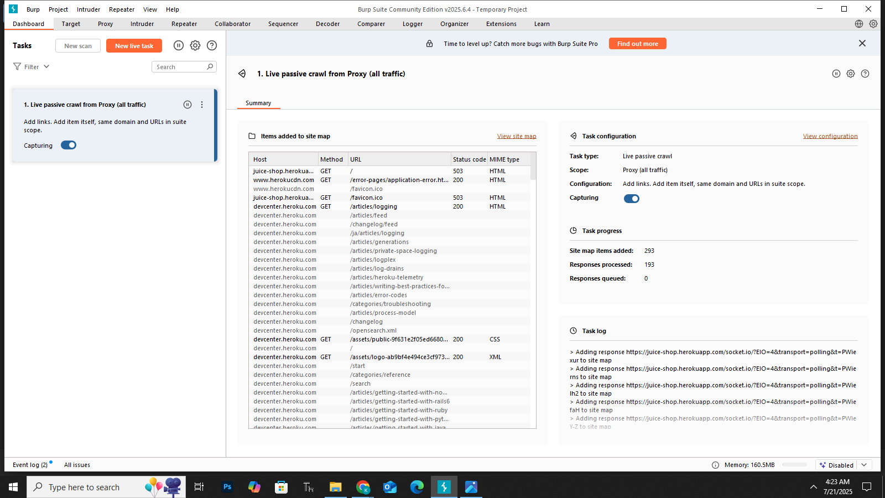

1. task4-burp-target.png – Target tab loaded with Juice Shop application

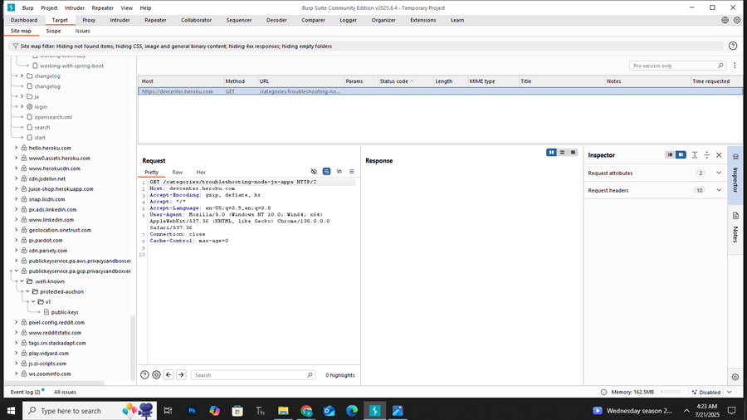

1. task4-login-page.png – Login form open in Burp browser

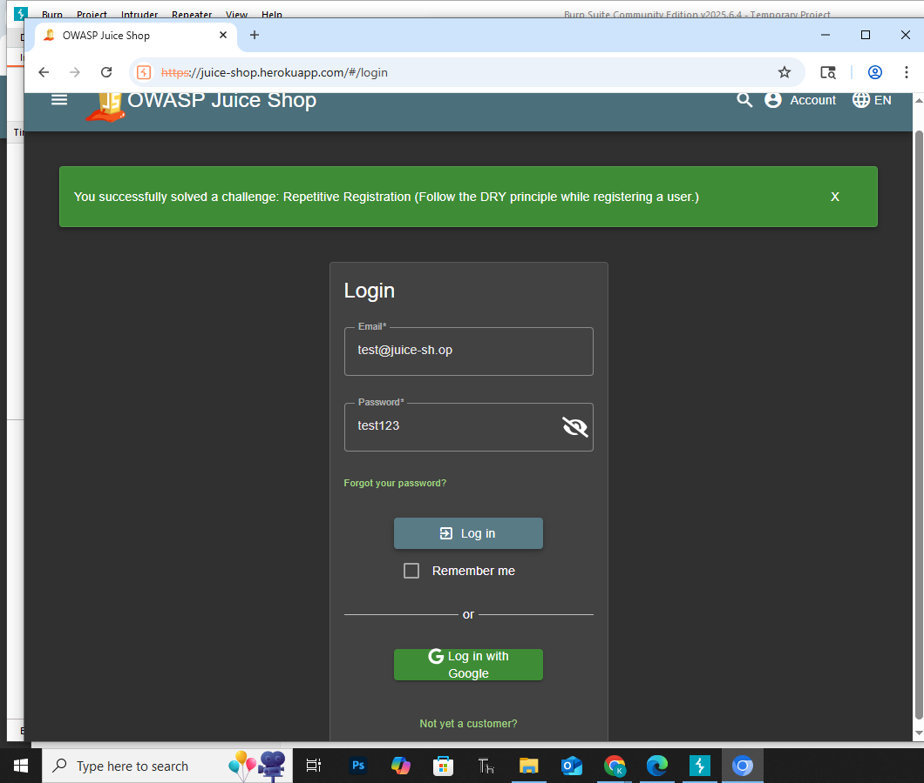

1. task4-admin-access.png – Direct access to restricted page

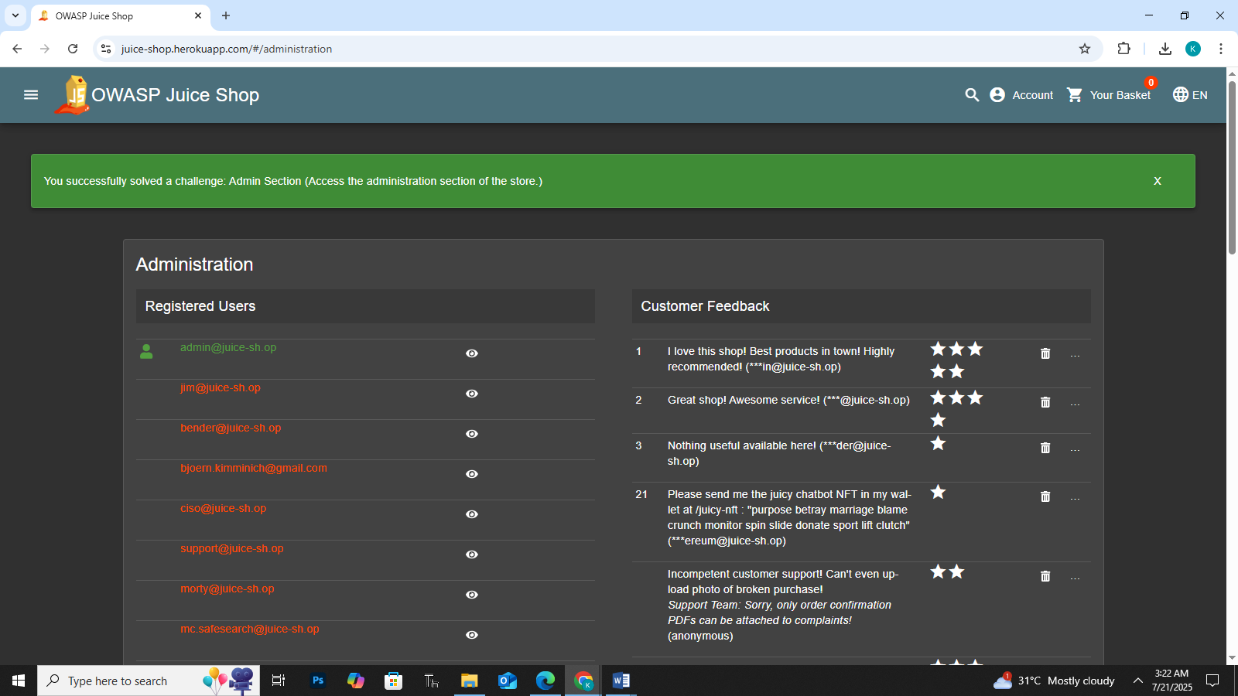

1. task4-scoreboard.png – (Optional) Access to scoreboard if captured

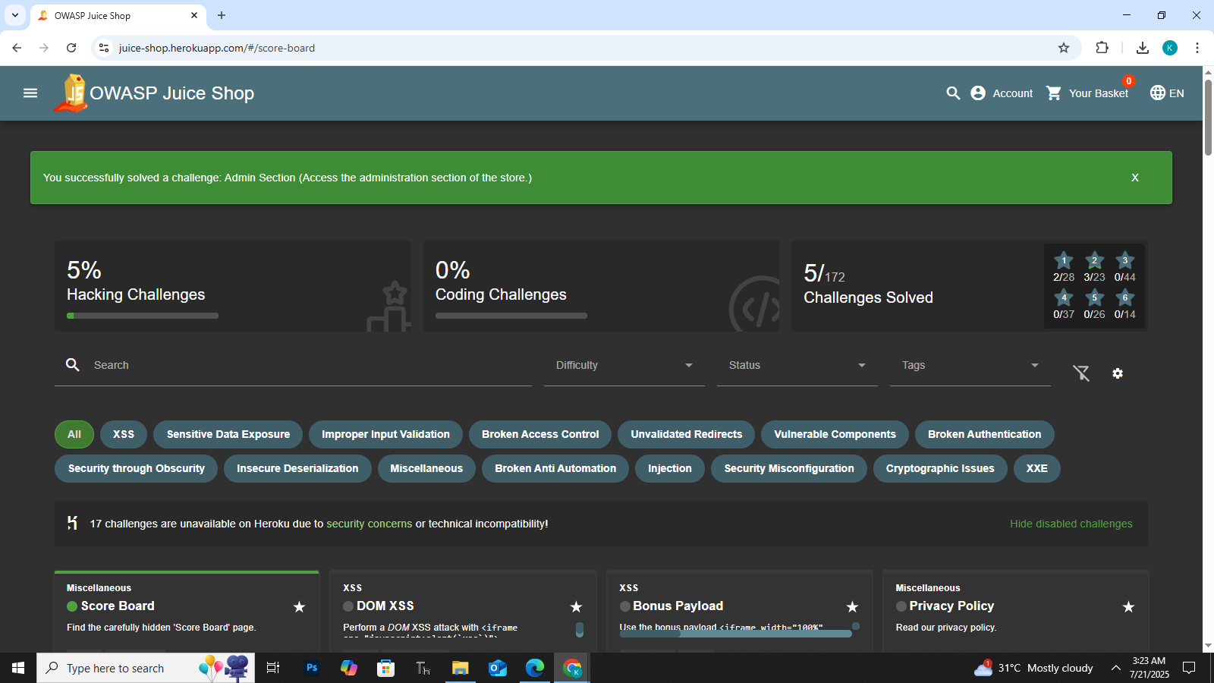

# Conclusion

Broken Access Control was tested through direct URL manipulation and Burp Suite session tracking. The Juice Shop application demonstrated weak protection on some endpoints. Although token tampering was not completed due to server errors, the core concepts and tool usage were practiced successfully.