|  |
| --- |
|  |

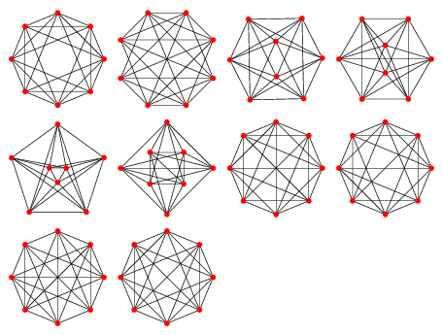

|  |
| --- |
| **The Leukocyte Wars** |
| **Requirements Analysis Document** |
| The Leukocyte Wars is an abstract simulation of a human body with quasi-robotic white blood cells (Leukocytes) that fight off genetic viruses. The goal of the simulation is for either the viruses to kill the host, the host to kill the viruses, or for the two to maintain a symbiotic relationship. The purpose of the simulation is to teach the basic concepts of genetic programming (GP), genetic algorithms (GA), artificial intelligence (AI), computer vision (CV), biomimicry, and robotics programming. |
|  |
|  |
| **Cale McCollough** |
| **5/22/2014** |
|  |

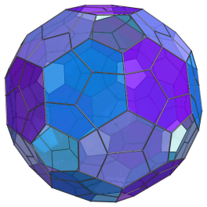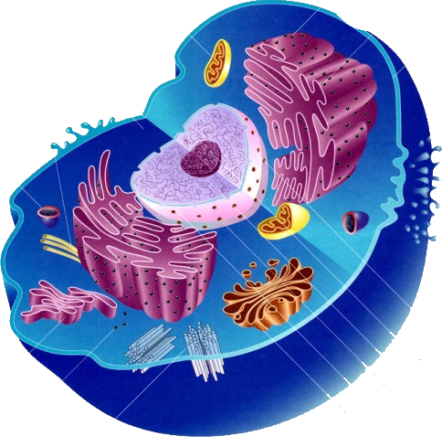

Contents

Overview: 2

Simulation Description 2

Viruses 2

Host 2

White Blood Cells 2

Timescale 2

Simulation Goals 3

Design Requirements 3

Skilled Required 3

Simulation Requirements 3

Genes Requirements 4

Host Requirements 4

Cell Requirements 5

Virus Requirements 5

White Blood Cells Requirements 6

Enzymes Requirements 6

# Overview:

# Simulation Description

## Viruses

they are instead made of geometrical patterns that morph shape and properties through a genetic algorithm. The viruses move around the screen trying to infect “cells” (Cells) and evading “White Blood Cells” using movement patterns that evolve through a genetic program. The viruses wonder around until they find a “cell” they can fit. If the virus “fits inside of the cell”, then the virus takes over that cell and replicates itself out of the cell.

## Host

The host has many “Cells” that are randomly spaced. In order for the virus to fit in a cell, the virus must be of the correct shape and cannot be too big or too small. When a virus comes across a cell and is the correct size, the virus kills the cell, and the host will grow a new one after a specified time. Each time that a virus occupies a cell, the host will evolve to become resistant against that particular strand of virus through its own genetic algorithm that simulates white blood cells (WBC).

The purpose of the simplified simulation is so that uses can graphical see the effects of genetic algorithms at work. Students also get experience setting up rules that govern temporal systems. The rules of the game can then be altered through a GP in order to win the “game”.

## White Blood Cells

The viruses are constantly being attacked by WBC. The way real WBCs fight viruses in the body is by finding proteins around the virus that will eat the virus’s protein structure, and brings the protein to the Virus.

In the simulation, there are simulated “protein strands”, which are basically just translucent polygons similar to the viruses. The way a WBC kills a virus is by locating a “protein strand” near the virus that will fit inside the virus, similar to how a virus takes over a cell. The virus then moves to the protein strand, and moves the strand to the moving virus. The WBCs are in essence simulated robots that use artificial intelligence techniques to track down the viruses.

## Timescale

Each WBC in a human body can consume from between 5-20 viruses before it dies, which is approximately in 13 days, so the same scale is used on the simulation.

# Simulation Goals

The goal of the simulation is for either the viruses to kill the host, the host to kill the viruses, or for the two to maintain a symbiotic relationship.

# Design Requirements

The project’s purpose is to serve as a learning tool for the skills that are required to build the simulation.

## Legend

* AI: Artificial Intelligence
* BIO: Biomimicry
* CV: Computer Vision
* CP: Concurrent Programming
* GA: Genetic Algorithm
* GUI: Graphics User Interface
* HUI: User Interface
* GP: Genetic Program
* RP: Robotics Programming

# Simulation Requirements

|  |  |  |
| --- | --- | --- |
| Design  Requirements | Engineering Requirements | Justification |
| BIO | Simulation must model the way that viruses, cells, and WBCs interact in an animal body in some sort of abstract form. | Because it’s a really cool idea. |
|  |  |  |
|  |  |  |
| GA, GUI, HUI | Simulation requires an Interactive Genetic Algorithm (IGA) |  |
|  | The timescale of the simulation must mimic that of the life cycle of human cells and normal viruses. |  |
|  |  |  |
|  |  |  |

## Genes Requirements

|  |  |  |
| --- | --- | --- |
| Design  Requirements | Engineering Requirements | Justification |
| BIO, GA, GP | All genes must be made of four building blocks: Adenine, Cytosine, Guanine, and Thymine. |  |
| BIO, GA | Cell’s DNA must be able to be infected by virus RNA using a GA. |  |
| BIO, | Genes must describe how to draw the viruses, cells, and WBCs. |  |
| BIO, | A gene consists of a promoter, the codons for an enzyme and a stop codon. |  |
|  | Cell DNA contains between 50,000 to 100,000 genes |  |
|  | Red blood cells are not a part of the simulation. | Red blood cells contain no DNA. |
|  |  |  |

## Host Requirements

|  |  |  |
| --- | --- | --- |
| Design  Requirements | Engineering Requirements | Justification |
| BIO, | Host must have blood. | Models reality. |
| BIO, | Host must have cells. | Models reality. |
| BIO, | Host must have WBCs. | Models reality. |
| BIO, | Host must have enzymes. | Models reality. |
| BIO, | Viruses must be able to move around the host in the blood. | Models reality. |
| BIO, | Host dies if all of the WBCs or Cells are killed. |  |
| BIO, | Host combats Viruses through WBCs. |  |
|  | Enzymes are generated in the liver. |  |
| BIO, | Host has organs. |  |

## Cell Requirements

|  |  |  |
| --- | --- | --- |
| Design  Requirements | Engineering Requirements | Justification |
| BIO | Cell has cell wall, nucleus, and cytoplasm. |  |
| BIO, | Cell and nucleus are constructed by genes. |  |
| BIO, |  |  |
| BIO, | Cells must be able to be infected by Viruses through a method that can be processed by CV. |  |
| BIO, GA | Cells must reproduce and die in real-time throughout the entire simulation. |  |
| BIO, GA | Cells must reproduce with a GA to become immune to viruses. |  |
| BIO, CV | Cell has abstract membrane made of abstract Lipids. |  |
|  | Ribosomes generate proteins. |  |

## Virus Requirements

|  |  |  |
| --- | --- | --- |
| Design  Requirements | Engineering Requirements | Justification |
| BIO, | There are three classes of virus: DNA Virus, RNA Virus, and Reverse Transcribing Viruses. |  |
| BIO, | Virus has some form of abstract RNA |  |
| BIO, | Virus membrane is made if abstract lipids. |  |
| BIO, | Viruses must be able to move around inside of the host. |  |
|  | Virus must have mechanism using computer vision to find spot on the cell where it can infect it using. |  |
|  | Virus must |  |
|  | When virus infects cell, it combines it’s RNA with the Cell’s DNA. |  |
|  | Virus must evolve ability to infect WBCs. |  |
| BIO, | Viruses are between 20-300 nm across. |  |
|  | A Filovirus (RNA Virus: Ebola and Marburg) can grow to be 1400 nm with a diameter of 80 nm |  |
|  | RNA viruses generally have very high mutation rates compared to DNA viruses., |  |

## White Blood Cells Requirements

|  |  |  |
| --- | --- | --- |
| Design  Requirements | Engineering Requirements | Justification |
|  | WBCs must be able to kill viruses by taking enzymes to them. |  |
|  | WBCs must have some method localization. |  |
|  | WBCs must be able take enzymes to viruses to neutralize the virus’s protein structure. |  |
|  |  |  |
|  | WBCs must be able to be infected by Viruses. | Models HIV Virus |
|  | WBC must live between 5-20 days. | Lifespan of a WBC in a human body. |
|  |  |  |

## Enzymes Requirements

|  |  |  |
| --- | --- | --- |
| Design  Requirements | Engineering Requirements | Justification |
|  |  |  |
|  |  |  |
|  |  |  |
|  |  |  |
|  |  |  |
|  |  |  |
|  |  |  |