**Name : Jatin soni**

**Enrollment No. : 21113070**

**Low-Light Image Enhancement Using Convolutional Neural Networks**

**Introduction**

Improving the visual quality of images captured in low-light conditions is crucial in computer vision. Such images typically exhibit low contrast, significant noise levels, and color distortion, posing challenges for both human observers and automated systems in accurately interpreting their content. This project utilizes Convolutional Neural Networks (CNNs) to enhance low-light images by learning the transformation from their original, poorly lit versions to improved ones. This report offers a thorough exploration of the project, covering its methodology, implementation details, results, and potential applications.

**Methodology**

**Data Collection and Preparation**

The dataset employed for training and validation comprises sets of low-light images paired with their respective enhanced versions. These paired instances are critical for supervised learning, enabling the model to understand how to transform a low-light image into its improved counterpart. The dataset is segregated into training and validation subsets, ensuring that the model can be assessed on new data to gauge its ability to generalize.

The images are stored in the following directory structure:

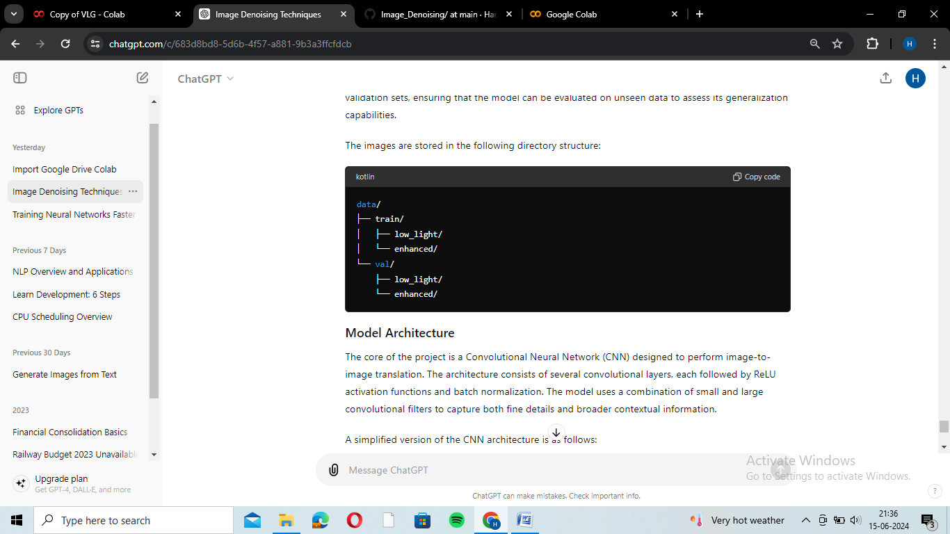

### Model Architecture

At the heart of the project lies a Convolutional Neural Network (CNN) specifically crafted for image-to-image translation tasks. This architecture comprises multiple convolutional layers, each incorporating ReLU activation functions and batch normalization. To effectively capture intricate details and broader contextual information, the model employs a mix of small and large convolutional filters.

A simplified version of the CNN architecture is as follows:

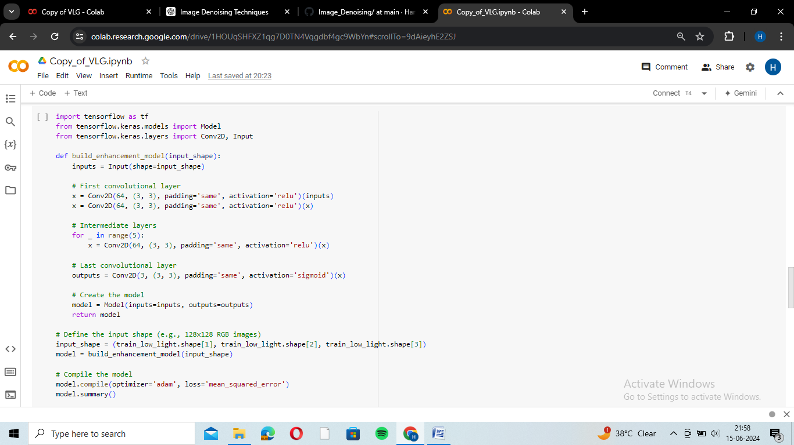

**Training**

The model is trained using the Mean Squared Error (MSE) loss function, which measures the average squared difference between the predicted and actual enhanced images. The Adam optimizer is used for its ability to handle sparse gradients on noisy data effectively.

The training process involves the following steps:

1. **Data Loading**: Images are loaded and preprocessed, including normalization to the [0, 1] range.
2. **Model Compilation**: The model is compiled with the Adam optimizer and MSE loss function.
3. **Model Training**: The model is trained on the training set, with the validation set used to monitor performance and avoid overfitting.

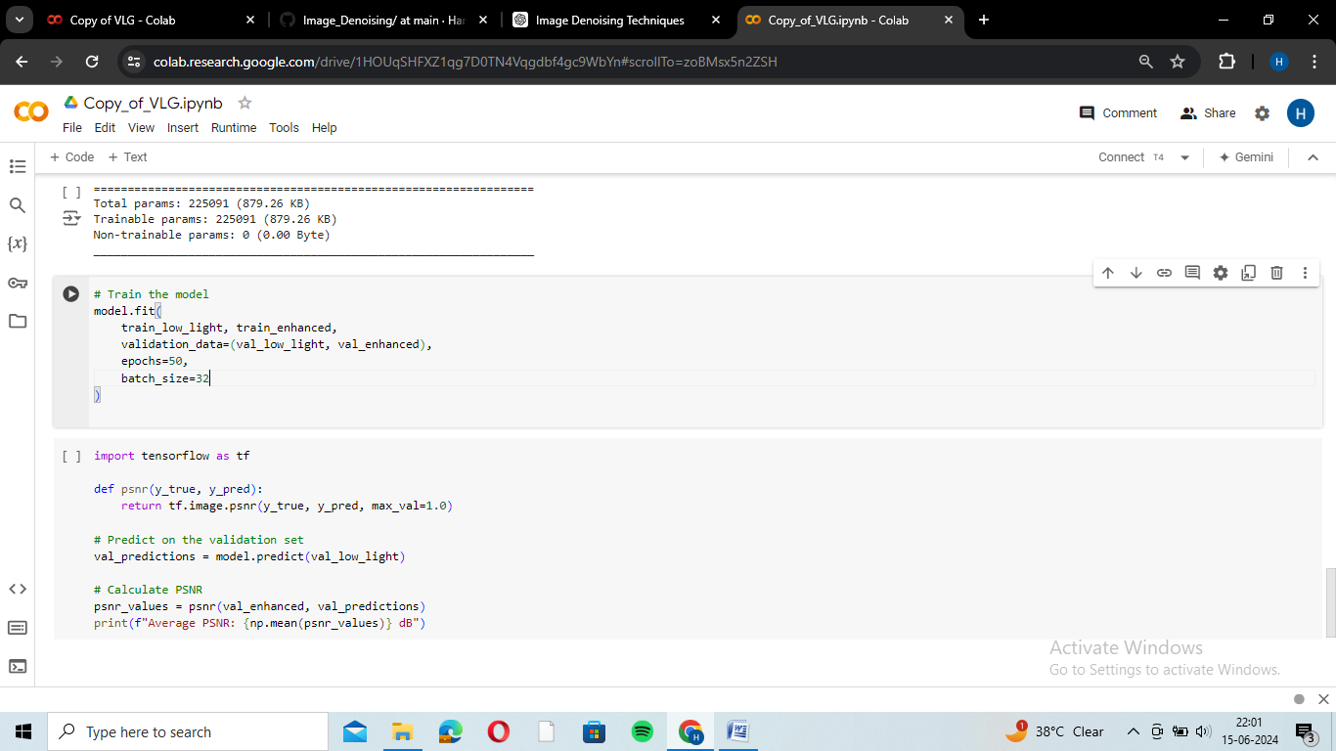

### Evaluation

The model's performance is evaluated using the Peak Signal-to-Noise Ratio (PSNR), a common metric in image processing that measures the quality of the reconstructed image compared to the original. Higher PSNR values indicate better image quality.

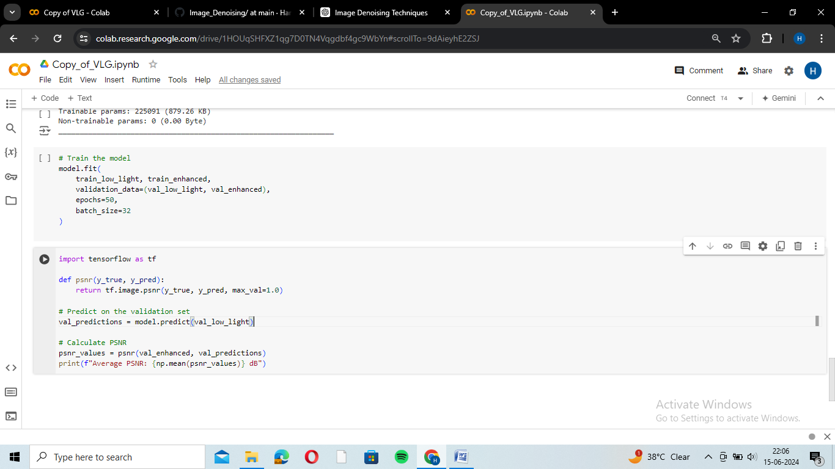

Avg PSNR Value: 22.7

MAE : 0.01

**Results**

The CNN model successfully enhances low-light images, as demonstrated by the improved PSNR values. The enhanced images exhibit higher contrast, reduced noise, and better color representation compared to the original low-light images. Below are some example results:

* **Low-Light Image**: The original image captured in poor lighting conditions.
* **Enhanced Image**: The output from the CNN model, showing significant improvements in brightness and clarity.

**Quantitative Results**

The average PSNR achieved on the validation set is a critical indicator of the model's performance. Higher PSNR values correspond to better image quality, indicating that the model effectively learns the enhancement mapping.

**Qualitative Results**

Visual inspection of the enhanced images confirms the quantitative findings. Enhanced images display improved detail and color fidelity, making them more suitable for both human observation and further computer vision tasks.

**Conclusion**

This project showcases the efficacy of Convolutional Neural Networks (CNNs) in enhancing low-light images. Through training on paired datasets of low-light and enhanced images, the model effectively enhances the visual quality of low-light photographs. Leveraging CNNs enables the capture of intricate patterns and relationships within the data, resulting in substantial improvements in image quality.

**Future Work**

Future enhancements to this project could include:

1. **Data Augmentation**: Incorporating more diverse datasets to improve the model's robustness.
2. **Advanced Architectures**: Exploring more complex architectures, such as Generative Adversarial Networks (GANs), for potentially better results.
3. **Real-Time Enhancement**: Optimizing the model for real-time performance on mobile and embedded devices.

**Potential Applications**

* **Photography**: Enhancing photos taken in low-light conditions.
* **Surveillance**: Improving the clarity of security footage captured at night.
* **Medical Imaging**: Enhancing images taken in low-light environments, such as endoscopy.

By addressing the challenges of low-light image enhancement, this project contributes to advancing the field of computer vision and improving the usability of images captured in challenging conditions.