message = "A3FZ9YBQ" * 100 # 6400 BITOW
num_particles = 30
max_iterations = 30

population_size = 30
num_generations = 30
mutation_rate = 0.3

binary_data = ''.join(random.choice(['0', '1']) for _ in range(131072)) 131072 BITS (POLOWA ZDJECIA 512X512)

ZWIEKSZONO POPULACJE DO 50 oraz epoki do 100

Po optymalizacji 30 epok, 30 populacja, 6400 bitow

Dane do ukrycia byly losowo generowane dla kazdej generacji!!!!
W PSO BRAKOWALO .copy() przy przypisywaniu najlepszej czastki

Ok. 5 sekund poprawy sredniego czasu po przepisaniu ze stringow na array[0,1]

TESTY

populacja : 30
generacje : 30
mutation_rate = 0.3
zdjecie : 256x256 = 65,536 bits
ukryte = 20000 bits
czasy : PSO 10s GENETIC 8s

Po zakomentowaniu czesci od Dekodowania (wykorzystywana do teraz jako sprawdzenie poprawnosci odczytanych danych)

PSO : 4.64 GENETYK : 3.25

TE SAME DANE WIEKSZY OBRAZ 512x512 = 262,144 bits
UKRYTE : 1/3 * 262,144 bits = 87400 bits

PSO : 243.4 GENETIC : 169.5

populacja : 50
generacje : 100
mutation_rate = 0.3
zdjecie : 256x256 = 65,536 bits
ukryte = 20000 bits
CZASY : PSO : 119.5 GENETIC : 91.5

zdjecie : 512x512 = 262,144 bits
ukryte = 87500 bits
CZASY : PSO : 119.5 GENETIC : 91.5

PO ZROWNOLEGLENIU:
* DODANO Pooling
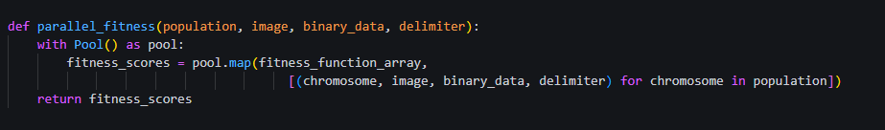
* zmieniono z Threading.Thread na multiprocessing.Process
* przekazano wiele atrybutow jako parametr, w celu zniwelowania ponownych obliczen

Epoki : 30
Populacje : 30
zdjecie : 512x512 = 262,144 bits
ukryte = 87500 bits
Genetic Time: 63.429412841796875 seconds
PSO Time: 63.681725025177 seconds

Epoki : 100
Populacje : 50
Genetic Time: 258.55763602256775 seconds
PSO Time: 259.01299810409546 seconds

Testy porownawcze na 4 procesach dla populacji = 50 oraz epok = 100 wykazaly, ze rownoleglenie nie ma sensu dla malych populacji – czas sekwencyjny byl nizszy niz zrownoleglony:
Starting comparison of algorithms across different image sizes...
Running for matrix size: 120
Starting run for matrix size 120 with 4 processes...
- Starting sequential genetic algorithm...
- Sequential genetic algorithm completed in 0.2876 seconds.
- Starting sequential PSO algorithm...
- Sequential PSO algorithm completed in 0.7161 seconds.
- Starting parallel genetic algorithm with 4 processes...
- Parallel genetic algorithm completed in 35.9950 seconds.
- Starting parallel PSO algorithm with 4 processes...
- Parallel PSO algorithm completed in 36.4752 seconds.
Running for matrix size: 240
Starting run for matrix size 240 with 4 processes...
- Starting sequential genetic algorithm...
- Sequential genetic algorithm completed in 2.1905 seconds.
- Starting sequential PSO algorithm...
- Sequential PSO algorithm completed in 3.8687 seconds.
- Starting parallel genetic algorithm with 4 processes...
- Parallel genetic algorithm completed in 37.8793 seconds.
- Starting parallel PSO algorithm with 4 processes...
- Parallel PSO algorithm completed in 39.1787 seconds.
Running for matrix size: 360
Starting run for matrix size 360 with 4 processes...
- Starting sequential genetic algorithm...
- Sequential genetic algorithm completed in 5.7399 seconds.
- Starting sequential PSO algorithm...
- Sequential PSO algorithm completed in 11.7645 seconds.
- Starting parallel genetic algorithm with 4 processes...
- Parallel genetic algorithm completed in 38.8018 seconds.
- Starting parallel PSO algorithm with 4 processes...
- Parallel PSO algorithm completed in 39.4111 seconds.
Running for matrix size: 480
Starting run for matrix size 480 with 4 processes...
- Starting sequential genetic algorithm...
- Sequential genetic algorithm completed in 9.3823 seconds.
- Starting sequential PSO algorithm...
- Sequential PSO algorithm completed in 18.9872 seconds.
- Starting parallel genetic algorithm with 4 processes...
- Parallel genetic algorithm completed in 40.1139 seconds.
- Starting parallel PSO algorithm with 4 processes...
- Parallel PSO algorithm completed in 40.3677 seconds.
Running for matrix size: 512
Starting run for matrix size 512 with 4 processes...
- Starting sequential genetic algorithm...
- Sequential genetic algorithm completed in 13.5925 seconds.
- Starting sequential PSO algorithm...
- Sequential PSO algorithm completed in 27.5920 seconds.
- Starting parallel genetic algorithm with 4 processes...
- Parallel genetic algorithm completed in 42.3531 seconds.
- Starting parallel PSO algorithm with 4 processes...
- Parallel PSO algorithm completed in 41.6634 seconds.

Starting comparison of algorithms across different image sizes...
Running for matrix size: 120
Starting run for matrix size 120 with 16 processes...
- Starting sequential genetic algorithm...
- Sequential genetic algorithm completed in 0.2754 seconds.
- Starting sequential PSO algorithm...
- Sequential PSO algorithm completed in 0.7055 seconds.
- Starting parallel genetic algorithm with 16 processes...
- Parallel genetic algorithm completed in 49.9150 seconds.
- Starting parallel PSO algorithm with 16 processes...
- Parallel PSO algorithm completed in 52.5241 seconds.
Running for matrix size: 240
Starting run for matrix size 240 with 16 processes...
- Starting sequential genetic algorithm...
- Sequential genetic algorithm completed in 2.1962 seconds.
- Starting sequential PSO algorithm...
- Sequential PSO algorithm completed in 3.8179 seconds.
- Starting parallel genetic algorithm with 16 processes...
- Parallel genetic algorithm completed in 51.5110 seconds.
- Starting parallel PSO algorithm with 16 processes...
- Parallel PSO algorithm completed in 53.5832 seconds.
Running for matrix size: 360
Starting run for matrix size 360 with 16 processes...
- Starting sequential genetic algorithm...
- Sequential genetic algorithm completed in 6.0521 seconds.
- Starting sequential PSO algorithm...
- Sequential PSO algorithm completed in 12.1577 seconds.
- Starting parallel genetic algorithm with 16 processes...
- Parallel genetic algorithm completed in 54.8246 seconds.
- Starting parallel PSO algorithm with 16 processes...
- Parallel PSO algorithm completed in 55.6844 seconds.
Running for matrix size: 480
Starting run for matrix size 480 with 16 processes...
- Starting sequential genetic algorithm...
- Sequential genetic algorithm completed in 9.5145 seconds.
- Starting sequential PSO algorithm...
- Sequential PSO algorithm completed in 19.2747 seconds.
- Starting parallel genetic algorithm with 16 processes...
- Parallel genetic algorithm completed in 55.6263 seconds.
- Starting parallel PSO algorithm with 16 processes...
- Parallel PSO algorithm completed in 57.2177 seconds.
Running for matrix size: 512
Starting run for matrix size 512 with 16 processes...
- Starting sequential genetic algorithm...
- Sequential genetic algorithm completed in 13.7368 seconds.
- Starting sequential PSO algorithm...
- Sequential PSO algorithm completed in 28.0355 seconds.
- Starting parallel genetic algorithm with 16 processes...
- Parallel genetic algorithm completed in 58.0518 seconds.
- Starting parallel PSO algorithm with 16 processes...
- Parallel PSO algorithm completed in 58.7831 seconds.

Zwiekszono populacje do 100
Starting comparison of algorithms across different image sizes...
Running for matrix size: 120
Starting run for matrix size 120 with 2 processes...
- Starting sequential genetic algorithm...
- Sequential genetic algorithm completed in 0.5155 seconds.
- Starting sequential PSO algorithm...
- Sequential PSO algorithm completed in 1.3163 seconds.
- Starting parallel genetic algorithm with 2 processes...
- Parallel genetic algorithm completed in 35.4095 seconds.
- Starting parallel PSO algorithm with 2 processes...
- Parallel PSO algorithm completed in 36.0597 seconds.
Running for matrix size: 240
Starting run for matrix size 240 with 2 processes...
- Starting sequential genetic algorithm...
- Sequential genetic algorithm completed in 4.3160 seconds.
- Starting sequential PSO algorithm...
- Sequential PSO algorithm completed in 7.4325 seconds.
- Starting parallel genetic algorithm with 2 processes...
- Parallel genetic algorithm completed in 38.5903 seconds.
- Starting parallel PSO algorithm with 2 processes...
- Parallel PSO algorithm completed in 39.1616 seconds.
Running for matrix size: 360
Starting run for matrix size 360 with 2 processes...
- Starting sequential genetic algorithm...
- Sequential genetic algorithm completed in 11.5744 seconds.
- Starting sequential PSO algorithm...
- Sequential PSO algorithm completed in 23.2328 seconds.
- Starting parallel genetic algorithm with 2 processes...
- Parallel genetic algorithm completed in 41.0582 seconds.
- Starting parallel PSO algorithm with 2 processes...
- Parallel PSO algorithm completed in 42.1270 seconds.
Running for matrix size: 480
Starting run for matrix size 480 with 2 processes...
- Starting sequential genetic algorithm...
- Sequential genetic algorithm completed in 19.4041 seconds.
- Starting sequential PSO algorithm...
- Sequential PSO algorithm completed in 38.4898 seconds.
- Starting parallel genetic algorithm with 2 processes...
- Parallel genetic algorithm completed in 45.1577 seconds.
- Starting parallel PSO algorithm with 2 processes...
- Parallel PSO algorithm completed in 45.9768 seconds.
Running for matrix size: 512
Starting run for matrix size 512 with 2 processes...
- Starting sequential genetic algorithm...
- Sequential genetic algorithm completed in 27.3253 seconds.
- Starting sequential PSO algorithm...
- Sequential PSO algorithm completed in 54.6740 seconds.
- Starting parallel genetic algorithm with 2 processes...
- Parallel genetic algorithm completed in 50.3200 seconds.
- Starting parallel PSO algorithm with 2 processes...
- Parallel PSO algorithm completed in 50.1486 seconds.

Do 1000:
Starting comparison of algorithms across different image sizes...
Running for matrix size: 120
Starting run for matrix size 120 with 2 processes...
- Starting sequential genetic algorithm...
- Sequential genetic algorithm completed in 5.0681 seconds.
- Starting sequential PSO algorithm...
- Sequential PSO algorithm completed in 12.6751 seconds.
- Starting parallel genetic algorithm with 2 processes...
- Parallel genetic algorithm completed in 38.8783 seconds.
- Starting parallel PSO algorithm with 2 processes...
- Parallel PSO algorithm completed in 48.0434 seconds.
Running for matrix size: 240
Starting run for matrix size 240 with 2 processes...
- Starting sequential genetic algorithm...
- Sequential genetic algorithm completed in 43.1790 seconds.
- Starting sequential PSO algorithm...
- Sequential PSO algorithm completed in 74.6257 seconds.
- Starting parallel genetic algorithm with 2 processes...
- Parallel genetic algorithm completed in 62.1749 seconds.
- Starting parallel PSO algorithm with 2 processes...
- Parallel PSO algorithm completed in 71.1949 seconds.
Running for matrix size: 360
Starting run for matrix size 360 with 2 processes...
- Starting sequential genetic algorithm...
- Sequential genetic algorithm completed in 112.9713 seconds.
- Starting sequential PSO algorithm...
- Sequential PSO algorithm completed in 231.4169 seconds.
- Starting parallel genetic algorithm with 2 processes...
- Parallel genetic algorithm completed in 94.8493 seconds.
- Starting parallel PSO algorithm with 2 processes...
- Parallel PSO algorithm completed in 102.4244 seconds.
Running for matrix size: 480
Starting run for matrix size 480 with 2 processes...
- Starting sequential genetic algorithm...
- Sequential genetic algorithm completed in 189.3037 seconds.
- Starting sequential PSO algorithm...
Dla rozmiaru obrazu 360 pierwsze zyski urownoleglenia.
- Starting sequential PSO algorithm
…Starting run for matrix size 360 with 4 processes... -
Starting sequential genetic algorithm... -
Sequential genetic algorithm completed in 116.3955 seconds. -
Starting sequential PSO algorithm... -
Sequential PSO algorithm completed in 237.6956 seconds. -
Starting parallel genetic algorithm with 4 processes... -
Parallel genetic algorithm completed in 71.9046 seconds. -
Starting parallel PSO algorithm with 4 processes... -
Parallel PSO algorithm completed in 78.4662 seconds.

Po testach zapisu pliku time_seq vs. time_par
Dodano skrypt testowy dla nastepujacych danych w celu obliczenia wydajnosci:
Rozmiary obrazu: [360, 480, 512, 640, 720]
Liczba procesow: [2, 4, 8, 16, 25]
Populacje : 1000
Epoki : 100
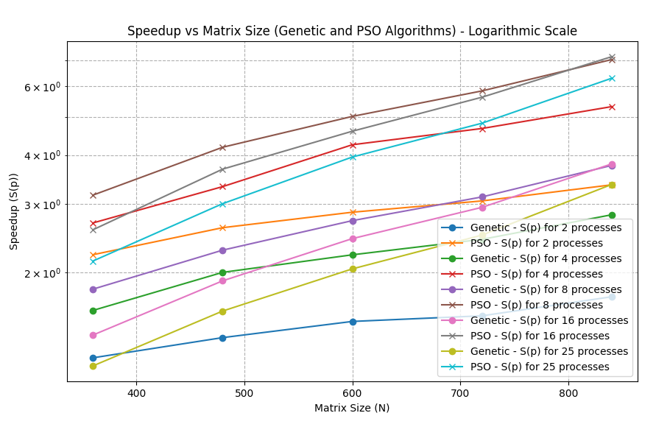

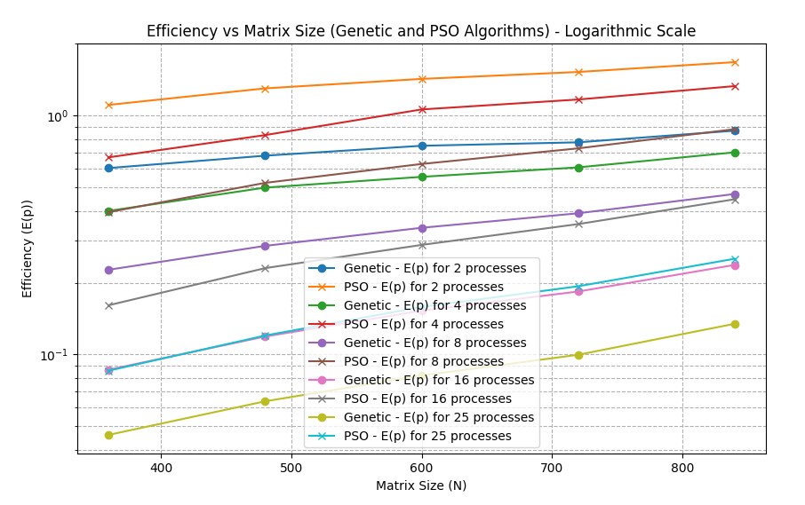
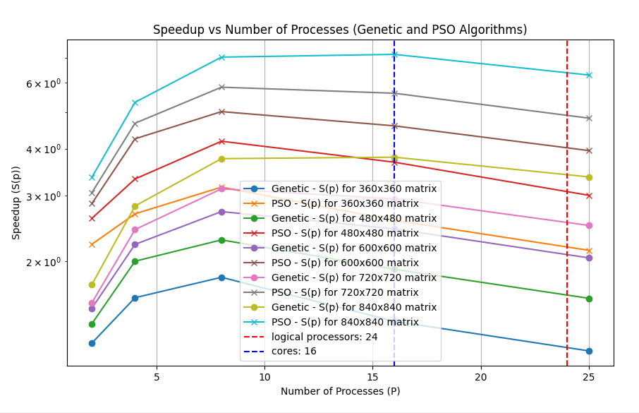
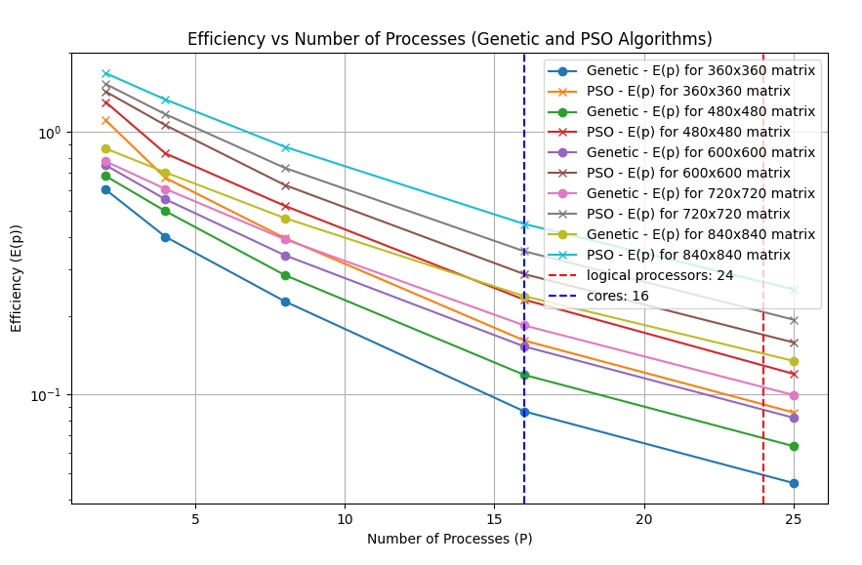

BACKUP CMD:
Starting comparison of algorithms across different image sizes...
Running sequential algorithms for matrix size: 360
Starting sequential run for matrix size 360...
- Starting sequential genetic algorithm...
- Sequential genetic algorithm completed in 114.8637 seconds.
- Starting sequential PSO algorithm...
- Sequential PSO algorithm completed in 231.9453 seconds.
Running sequential algorithms for matrix size: 480
Starting sequential run for matrix size 480...
- Starting sequential genetic algorithm...
- Sequential genetic algorithm completed in 183.8182 seconds.
- Starting sequential PSO algorithm...
- Sequential PSO algorithm completed in 373.4458 seconds.
Running sequential algorithms for matrix size: 600
Starting sequential run for matrix size 600...
- Starting sequential genetic algorithm...
- Sequential genetic algorithm completed in 275.7816 seconds.
- Starting sequential PSO algorithm...
- Sequential PSO algorithm completed in 554.8547 seconds.
Running sequential algorithms for matrix size: 720
Starting sequential run for matrix size 720...
- Starting sequential genetic algorithm...
- Sequential genetic algorithm completed in 387.9285 seconds.
- Starting sequential PSO algorithm...
- Sequential PSO algorithm completed in 789.9013 seconds.
Running sequential algorithms for matrix size: 840
Starting sequential run for matrix size 840...
- Starting sequential genetic algorithm...
- Sequential genetic algorithm completed in 602.4391 seconds.
- Starting sequential PSO algorithm...
- Sequential PSO algorithm completed in 1194.8779 seconds.
Running for matrix size: 360 and num_processes: 2
Starting parallel run for matrix size 360 with 2 processes...
- Starting parallel genetic algorithm with 2 processes...
- Parallel genetic algorithm completed in 95.0529 seconds.
- Starting parallel PSO algorithm with 2 processes...
- Parallel PSO algorithm completed in 104.4107 seconds.
Running for matrix size: 480 and num_processes: 2
Starting parallel run for matrix size 480 with 2 processes...
- Starting parallel genetic algorithm with 2 processes...
- Parallel genetic algorithm completed in 135.0131 seconds.
- Starting parallel PSO algorithm with 2 processes...
- Parallel PSO algorithm completed in 143.3092 seconds.
Running for matrix size: 600 and num_processes: 2
Starting parallel run for matrix size 600 with 2 processes...
- Starting parallel genetic algorithm with 2 processes...
- Parallel genetic algorithm completed in 184.0997 seconds.
- Starting parallel PSO algorithm with 2 processes...
- Parallel PSO algorithm completed in 194.3363 seconds.
Running for matrix size: 720 and num_processes: 2
Starting parallel run for matrix size 720 with 2 processes...
- Starting parallel genetic algorithm with 2 processes...
- Parallel genetic algorithm completed in 250.4942 seconds.
- Starting parallel PSO algorithm with 2 processes...
- Parallel PSO algorithm completed in 258.8205 seconds.
Running for matrix size: 840 and num_processes: 2
Starting parallel run for matrix size 840 with 2 processes...
- Starting parallel genetic algorithm with 2 processes...
- Parallel genetic algorithm completed in 347.6599 seconds.
- Starting parallel PSO algorithm with 2 processes...
- Parallel PSO algorithm completed in 356.0165 seconds.
Results saved to result_2.txt
Running for matrix size: 360 and num_processes: 4
Starting parallel run for matrix size 360 with 4 processes...
- Starting parallel genetic algorithm with 4 processes...
- Parallel genetic algorithm completed in 71.8516 seconds.
- Starting parallel PSO algorithm with 4 processes...
- Parallel PSO algorithm completed in 86.5523 seconds.
Running for matrix size: 480 and num_processes: 4
Starting parallel run for matrix size 480 with 4 processes...
- Starting parallel genetic algorithm with 4 processes...
- Parallel genetic algorithm completed in 91.8388 seconds.
- Starting parallel PSO algorithm with 4 processes...
- Parallel PSO algorithm completed in 112.4498 seconds.
Running for matrix size: 600 and num_processes: 4
Starting parallel run for matrix size 600 with 4 processes...
- Starting parallel genetic algorithm with 4 processes...
- Parallel genetic algorithm completed in 124.2159 seconds.
- Starting parallel PSO algorithm with 4 processes...
- Parallel PSO algorithm completed in 130.4708 seconds.
Running for matrix size: 720 and num_processes: 4
Starting parallel run for matrix size 720 with 4 processes...
- Starting parallel genetic algorithm with 4 processes...
- Parallel genetic algorithm completed in 159.4746 seconds.
- Starting parallel PSO algorithm with 4 processes...
- Parallel PSO algorithm completed in 168.7484 seconds.
Running for matrix size: 840 and num_processes: 4
Starting parallel run for matrix size 840 with 4 processes...
- Starting parallel genetic algorithm with 4 processes...
- Parallel genetic algorithm completed in 214.2276 seconds.
- Starting parallel PSO algorithm with 4 processes...
- Parallel PSO algorithm completed in 224.3370 seconds.
Results saved to result_4.txt
Running for matrix size: 360 and num_processes: 8
Starting parallel run for matrix size 360 with 8 processes...
- Starting parallel genetic algorithm with 8 processes...
- Parallel genetic algorithm completed in 63.3691 seconds.
- Starting parallel PSO algorithm with 8 processes...
- Parallel PSO algorithm completed in 73.4422 seconds.
Running for matrix size: 480 and num_processes: 8
Starting parallel run for matrix size 480 with 8 processes...
- Starting parallel genetic algorithm with 8 processes...
- Parallel genetic algorithm completed in 80.5510 seconds.
- Starting parallel PSO algorithm with 8 processes...
- Parallel PSO algorithm completed in 89.1278 seconds.
Running for matrix size: 600 and num_processes: 8
Starting parallel run for matrix size 600 with 8 processes...
- Starting parallel genetic algorithm with 8 processes...
- Parallel genetic algorithm completed in 101.5211 seconds.
- Starting parallel PSO algorithm with 8 processes...
- Parallel PSO algorithm completed in 110.3614 seconds.
Running for matrix size: 720 and num_processes: 8
Starting parallel run for matrix size 720 with 8 processes...
- Starting parallel genetic algorithm with 8 processes...
- Parallel genetic algorithm completed in 124.1439 seconds.
- Starting parallel PSO algorithm with 8 processes...
- Parallel PSO algorithm completed in 135.1624 seconds.
Running for matrix size: 840 and num_processes: 8
Starting parallel run for matrix size 840 with 8 processes...
- Starting parallel genetic algorithm with 8 processes...
- Parallel genetic algorithm completed in 160.0736 seconds.
- Starting parallel PSO algorithm with 8 processes...
- Parallel PSO algorithm completed in 169.9084 seconds.
Results saved to result_8.txt
Running for matrix size: 360 and num_processes: 16
Starting parallel run for matrix size 360 with 16 processes...
- Starting parallel genetic algorithm with 16 processes...
- Parallel genetic algorithm completed in 83.0929 seconds.
- Starting parallel PSO algorithm with 16 processes...
- Parallel PSO algorithm completed in 90.1175 seconds.
Running for matrix size: 480 and num_processes: 16
Starting parallel run for matrix size 480 with 16 processes...
- Starting parallel genetic algorithm with 16 processes...
- Parallel genetic algorithm completed in 96.5525 seconds.
- Starting parallel PSO algorithm with 16 processes...
- Parallel PSO algorithm completed in 101.4189 seconds.
Running for matrix size: 600 and num_processes: 16
Starting parallel run for matrix size 600 with 16 processes...
- Starting parallel genetic algorithm with 16 processes...
- Parallel genetic algorithm completed in 112.8883 seconds.
- Starting parallel PSO algorithm with 16 processes...
- Parallel PSO algorithm completed in 120.4560 seconds.
Running for matrix size: 720 and num_processes: 16
Starting parallel run for matrix size 720 with 16 processes...
- Starting parallel genetic algorithm with 16 processes...
- Parallel genetic algorithm completed in 132.0229 seconds.
- Starting parallel PSO algorithm with 16 processes...
- Parallel PSO algorithm completed in 140.2886 seconds.
Running for matrix size: 840 and num_processes: 16
Starting parallel run for matrix size 840 with 16 processes...
- Starting parallel genetic algorithm with 16 processes...
- Parallel genetic algorithm completed in 158.6276 seconds.
- Starting parallel PSO algorithm with 16 processes...
- Parallel PSO algorithm completed in 167.0454 seconds.
Results saved to result_16.txt
Running for matrix size: 360 and num_processes: 25
Starting parallel run for matrix size 360 with 25 processes...
- Starting parallel genetic algorithm with 25 processes...
- Parallel genetic algorithm completed in 99.6992 seconds.
- Starting parallel PSO algorithm with 25 processes...
- Parallel PSO algorithm completed in 108.3729 seconds.
Running for matrix size: 480 and num_processes: 25
Starting parallel run for matrix size 480 with 25 processes...
- Starting parallel genetic algorithm with 25 processes...
- Parallel genetic algorithm completed in 115.4085 seconds.
- Starting parallel PSO algorithm with 25 processes...
- Parallel PSO algorithm completed in 124.3585 seconds.
Running for matrix size: 600 and num_processes: 25
Starting parallel run for matrix size 600 with 25 processes...
- Starting parallel genetic algorithm with 25 processes...
- Parallel genetic algorithm completed in 134.9761 seconds.
- Starting parallel PSO algorithm with 25 processes...
- Parallel PSO algorithm completed in 140.2825 seconds.
Running for matrix size: 720 and num_processes: 25
Starting parallel run for matrix size 720 with 25 processes...
- Starting parallel genetic algorithm with 25 processes...
- Parallel genetic algorithm completed in 155.5092 seconds.
- Starting parallel PSO algorithm with 25 processes...
- Parallel PSO algorithm completed in 163.5454 seconds.
Running for matrix size: 840 and num_processes: 25
Starting parallel run for matrix size 840 with 25 processes...
- Starting parallel genetic algorithm with 25 processes...
- Parallel genetic algorithm completed in 179.1087 seconds.
- Starting parallel PSO algorithm with 25 processes...
- Parallel PSO algorithm completed in 189.7299 seconds.
Results saved to result_25.txt

ANALIZA TEORETYCZNA
def create_chromosome_array():
return np.random.choice([0, 1], size=(21,))

O(1)
def hide_bit(value, bit):
result = np.uint8((value & 0xFE) | bit)

return result

O(1)
def get_traversal(start_h, start_w, direction, height, width):
direction_code = direction[0] * 4 + direction[1] * 2 + direction[2]
if direction_code == 0:
return range(start_h, height), range(start_w, width)
elif direction_code == 1: # Right-Down
return range(start_w, width), range(start_h, height)
elif direction_code == 2: # Down-Left
return range(start_h, height), range(width - 1 - start_w, -1, -1)
elif direction_code == 3: # Left-Down
return range(width - 1 - start_w, -1, -1), range(start_h, height)
elif direction_code == 4: # Left-Up
return range(width - 1 - start_w, -1, -1), range(height - 1 - start_h, -1, -1)
elif direction_code == 5: # Up-Left
return range(height - 1 - start_h, -1, -1), range(width - 1 - start_w, -1, -1)
elif direction_code == 6: # Up-Right
return range(height - 1 - start_h, -1, -1), range(start_w, width)
elif direction_code == 7: # Right-Up
return range(start_w, width), range(height - 1 - start_h, -1, -1)

O(1)

def Encode(host, binary_message, binary_chromosome, delimiter):
height, width = host.shape
transformed = host.copy()
start_h = int(''.join(map(str, binary_chromosome[2:10])), 2)
start_w = int(''.join(map(str, binary_chromosome[10:18])), 2)
direction = binary_chromosome[18:21]
rows, cols = get_traversal(start_h, start_w, direction, height, width)
message_idx, delimiter_idx = 0, 0
for h in rows:
for w in cols:
if message_idx < len(binary_message):
transformed[h, w] = hide_bit(
transformed[h, w], binary_message[message_idx])
message_idx += 1
elif delimiter_idx < len(delimiter):
transformed[h, w] = hide_bit(
transformed[h, w], delimiter[delimiter_idx])
delimiter_idx += 1
else:
return transformed
return transformed

O(width * height) = O(N^2(
def calculate_BER(original, received):
if len(original) != len(received):
raise ValueError("Both binary sequences must have the same length.")
bit_errors = np.count_nonzero(original != received)
return bit_errors / original.size
np.count_nonzero – O(N^2)
def fitness_function_array(args):
#print(f"args: {args}")
chromosome, image, binary_data, delimiter = args
secret = Encode(image, binary_data, chromosome, delimiter)
original_binary_data = np.unpackbits(image.astype(np.uint8))
secret_binary_data = np.unpackbits(secret.astype(np.uint8))
psnr = cv2.PSNR(image, secret)
ber = calculate_BER(original_binary_data, secret_binary_data)
#print("COmplete")
return psnr, ber
cv2.PSNR – O(N^2)
np.unpackbits - O(N^2)
OGOLNE : O(N^2)
def parallel_fitness(population, image, binary_data, delimiter, num_processes):
with Pool(processes=num_processes) as pool:
fitness_scores = pool.map(fitness_function_array,
[(chromosome, image, binary_data, delimiter) for chromosome in population])
return fitness_scores

O(wielkosc_populacji * N^2/liczba_procesow)
ROWNOLEGLE
def genetic_with_tracking_array(image, binary_data, delimiter, num_processes):
population_size = 1000
num_generations = 100
mutation_rate = 0.3
num_bits = 21
population = [create_chromosome_array() for _ in range(population_size)]

psnr_values = []
ber_values = []

global_best_position = population[0]
global_best_score = float('-inf')

for generation in range(num_generations):
fitness_scores = parallel_fitness(
population, image, binary_data, delimiter, num_processes)
psnr_scores = [score[0] for score in fitness_scores]
ber_scores = [score[1] for score in fitness_scores]

max_psnr_index = np.argmax(psnr_scores)
max_psnr_value = psnr_scores[max_psnr_index]
best_chromosome = population[max_psnr_index]

if max_psnr_value > global_best_score:
global_best_score = max_psnr_value
global_best_position = best_chromosome

psnr_values.append(global_best_score)

ber_values.append(ber_scores[max_psnr_index])

selected_parents = random.choices(
population, weights=psnr_scores, k=population_size)

offspring = []
for i in range(0, population_size, 2):
parent1 = selected_parents[i]
parent2 = selected_parents[i + 1]
crossover_point = np.random.randint(1, num_bits - 1)
offspring1 = np.concatenate(
[parent1[:crossover_point], parent2[crossover_point:]])
offspring2 = np.concatenate(
[parent2[:crossover_point], parent1[crossover_point:]])
offspring.extend([offspring1, offspring2])

for i in range(population_size):
for j in range(num_bits):
if np.random.random() < mutation_rate:
offspring[i][j] = 1 - offspring[i][j]

offspring[-1] = global_best_position
population = offspring

return psnr_values, ber_values

O(populacja * generacje * N^2/liczba procesow)
def pso_with_tracking_array(image, binary_data, delimiter, num_processes):
num_particles = 1000
num_dimensions = 21
max_iterations = 100
c1, c2 = 2.0, 2.0 # Cognitive and social coefficients
w_max, w_min = 0.9, 0.4 # Inertia weight range

particles = [create_chromosome_array() for _ in range(num_particles)]
velocities = np.random.uniform(-1, 1, (num_particles, num_dimensions))

personal_best_positions = particles.copy()
personal_best_scores = [float('-inf')] * num_particles

global_best_position = particles[0]
global_best_score = float('-inf')

psnr_values = []
ber_values = []

for iteration in range(max_iterations):
fitness_scores = parallel_fitness(
particles, image, binary_data, delimiter, num_processes)
psnr_scores = [score[0] for score in fitness_scores]
ber_scores = [score[1] for score in fitness_scores]

for i, score in enumerate(psnr_scores):
if score > personal_best_scores[i]:
personal_best_scores[i] = score
personal_best_positions[i] = particles[i].copy()
if score > global_best_score:
global_best_score = score
global_best_position = particles[i].copy()

psnr_values.append(global_best_score)
ber_values.append(ber_scores[np.argmax(psnr_scores)])

w = w_max - (w_max - w_min) * (iteration / max_iterations)

for i in range(num_particles):
for j in range(num_dimensions):
r1, r2 = random.random(), random.random()
cognitive = c1 * r1 * (personal_best_positions[i][j] - particles[i][j])
social = c2 * r2 * (global_best_position[j] - particles[i][j])
velocities[i][j] = w * velocities[i][j] + cognitive + social

velocities[i][j] = np.clip(velocities[i][j], -4, 4)

probability = 1 / (1 + np.exp(-velocities[i][j]))
if random.random() < probability:
particles[i][j] = 1 - particles[i][j]

return psnr_values, ber_values

O(populacja * generacje * N^2/liczba procesow)
SEKEWNCYJNE
def genetic_with_tracking_array_seq(image, binary_data, delimiter):
global best_solution
population_size = 1000
num_generations = 100
mutation_rate = 0.3
num_bits = 21
population = [create_chromosome_array() for _ in range(population_size)]
psnr_values = []
ber_values = []

best_individual = population[0]

for generation in range(num_generations):
fitness_scores = [fitness_function_array(
(chromosome, image, binary_data, delimiter))[0] for chromosome in population]
psnr_values.append(max(fitness_scores))
best_individual = population[np.argmax(fitness_scores)]
ber_values.append(fitness_function_array(
(best_individual, image, binary_data, delimiter))[1])

selected_parents = random.choices(
population, weights=fitness_scores, k=population_size)

offspring = []
for i in range(0, population_size, 2):
parent1 = selected_parents[i]
parent2 = selected_parents[i + 1]
crossover_point = np.random.randint(1, num_bits - 1)
offspring1 = np.concatenate(
[parent1[:crossover_point], parent2[crossover_point:]])
offspring2 = np.concatenate(
[parent2[:crossover_point], parent1[crossover_point:]])
offspring.extend([offspring1, offspring2])

for i in range(population_size):
for j in range(num_bits):
if np.random.random() < mutation_rate:
offspring[i][j] = 1 - offspring[i][j]

best_fitness_index = np.argmax(fitness_scores)
best_chromosome = population[best_fitness_index]

offspring[-1] = best_chromosome
population = offspring

best_solution = max(population, key=lambda x: fitness_function_array(
(x, image, binary_data, delimiter))[0])
return psnr_values, ber_values

O(N^2 * populacja * generacje)
def pso_with_tracking_array_seq(image, binary_data, delimiter):
num_particles = 1000
num_dimensions = 21
max_iterations = 100
c1, c2 = 2.0, 2.0
global_best_position = None

particles = [create_chromosome_array() for _ in range(num_particles)]
velocities = [[random.uniform(-1, 1) for _ in range(num_dimensions)]
for _ in range(num_particles)]
best_positions = particles[:]
best_fitness = [fitness_function_array((p, image, binary_data, delimiter))[0]
for p in particles]

psnr_values = []
ber_values = []

fitness_scores = [fitness_function_array((p, image, binary_data, delimiter))[0]
for p in particles]
global_best_position = particles[np.argmax(fitness_scores)]

for iteration in range(max_iterations):
for i in range(num_particles):
fitness = fitness_function_array(
(particles[i], image, binary_data, delimiter))[0]

if fitness > best_fitness[i]:
best_fitness[i] = fitness
best_positions[i] = particles[i].copy()

if global_best_position is None or fitness > fitness_function_array(
(global_best_position, image, binary_data, delimiter))[0]:
global_best_position = particles[i].copy()

psnr_values.append(fitness_function_array(
(global_best_position, image, binary_data, delimiter))[0])
ber_values.append(fitness_function_array(
(global_best_position, image, binary_data, delimiter))[1])

w = 0.9 - (0.5 * iteration / max_iterations)

for i in range(num_particles):
for j in range(num_dimensions):
r1, r2 = random.random(), random.random()

cognitive = c1 * r1 * \
(int(best_positions[i][j]) - int(particles[i][j]))
social = c2 * r2 * \
(int(global_best_position[j]) - int(particles[i][j]))

velocities[i][j] = w * velocities[i][j] + cognitive + social

velocities[i][j] = np.clip(velocities[i][j], -4, 4)

# Sigmoid-based update
probability = 1 / (1 + np.exp(-velocities[i][j]))
if np.random.random() < probability:
particles[i][j] = 1 - particles[i][j] # Flip the bit

return psnr_values, ber_values

O(N^2 * populacja * generacje)

def run_sequential_for_size(image, delimiter, matrix_size):
print(f"Starting sequential run for matrix size {matrix_size}...")

binary_data = np.random.randint(
0, 2, math.ceil(matrix_size * 3/5), dtype=np.uint8)
cropped_image = cv2.resize(
image, (matrix_size, matrix_size), interpolation=cv2.INTER_LINEAR)

print(f" - Starting sequential genetic algorithm...")
start_time = time.time()
psnr_gen_seq, ber_gen_seq = genetic_with_tracking_array_seq(
cropped_image, binary_data, delimiter)
end_time = time.time()
sequential_time_gen = end_time - start_time
print(
f" - Sequential genetic algorithm completed in {sequential_time_gen:.4f} seconds.")

print(f" - Starting sequential PSO algorithm...")
start_time = time.time()
psnr_gen_seq, ber_gen_seq = pso_with_tracking_array_seq(
cropped_image, binary_data, delimiter)
end_time = time.time()
sequential_time_pso = end_time - start_time
print(
f" - Sequential PSO algorithm completed in {sequential_time_pso:.4f} seconds.")

return sequential_time_gen, sequential_time_pso
O(binary_message * matrix_size^2 + 2(generacje*populacje)
def run_parallel_for_size(image, delimiter, matrix_size, num_processes, sequential_times):
print(f"Starting parallel run for matrix size {matrix_size} with {num_processes} processes...")

binary_data = np.random.randint(
0, 2, math.ceil(matrix_size * 3/5), dtype=np.uint8)
cropped_image = cv2.resize(
image, (matrix_size, matrix_size), interpolation=cv2.INTER_LINEAR)

print(f" - Starting parallel genetic algorithm with {num_processes} processes...")
start_time = time.time()
psnr_gen_par, ber_gen_par = genetic_with_tracking_array(
cropped_image, binary_data, delimiter, num_processes)
end_time = time.time()
parallel_time_gen = end_time - start_time
print(
f" - Parallel genetic algorithm completed in {parallel_time_gen:.4f} seconds.")

print(f" - Starting parallel PSO algorithm with {num_processes} processes...")
start_time = time.time()
psnr_gen_par, ber_gen_par = pso_with_tracking_array(
cropped_image, binary_data, delimiter, num_processes)
end_time = time.time()
parallel_time_pso = end_time - start_time
print(
f" - Parallel PSO algorithm completed in {parallel_time_pso:.4f} seconds.")

return matrix_size, num_processes, sequential_times[0], parallel_time_gen, sequential_times[1], parallel_time_pso
O(binary_message * matrix_size^2 + (2(generacje*populacje)/liczba procesow)
def compare_algorithms(image, delimiter, matrix_sizes, num_processes):
print(f"Starting comparison of algorithms across different image sizes...")
sequential_results = {}
for matrix_size in matrix_sizes:
print(f"Running sequential algorithms for matrix size: {matrix_size}")
sequential_times = run_sequential_for_size(
image, delimiter, matrix_size)
sequential_results[matrix_size] = sequential_times

for num_proc in num_processes:
csv_filename = f"result_{num_proc}.txt"
with open(csv_filename, mode='w', newline='') as file:
writer = csv.writer(file)
writer.writerow(['MatrixSize', 'NumProcesses', 'SequentialTime_gen', 'ParallelTime_gen', 'SequentialTime_pso', 'ParallelTime_pso']) # Header

for matrix_size in matrix_sizes:
print(f"Running for matrix size: {matrix_size} and num_processes: {num_proc}")
sequential_time_gen, sequential_time_pso = sequential_results[matrix_size]
result = run_parallel_for_size(
image, delimiter, matrix_size, num_proc, (sequential_time_gen, sequential_time_pso))
writer.writerow(result)

print(f"Results saved to {csv_filename}")

O((liczba_macierzy * liczba procesow * (O_ run_parallel_for_size)) + liczba_macierzy * (O_ run_sequential_for_size)

PROFILER:
ncalls tottime percall cumtime percall filename:lineno(function)
1 0.001 0.001 7802.050 7802.050 ProjektPrzejsciowy.py:473(compare_algorithms)
317322/317308 2.303 0.000 6455.609 0.020 connection.py:246(recv)
389000 9.317 0.000 6094.872 0.016 connection.py:202(send)
419000/418722 3.172 0.000 6082.487 0.015 connection.py:284(_send_bytes)
30 0.009 0.000 6007.590 200.253 ProjektPrzejsciowy.py:444(run_parallel_for_size)
6000 0.014 0.000 5530.466 0.922 ProjektPrzejsciowy.py:108(parallel_fitness)
6000 0.054 0.000 5530.452 0.922 pool.py:738(__exit__)
6000 0.084 0.000 5530.363 0.922 pool.py:654(terminate)
85001 0.158 0.000 5361.570 0.063 util.py:208(__call__)
6000 0.311 0.000 5358.774 0.893 pool.py:680(_terminate_pool)
18000/6000 2.486 0.000 5257.711 0.876 threading.py:1018(_bootstrap)
18000/6000 0.322 0.000 5257.157 0.876 threading.py:1058(_bootstrap_inner)
18000/6000 0.120 0.000 5079.967 0.847 threading.py:1001(run)
6000 0.043 0.000 4918.949 0.820 pool.py:671(_help_stuff_finish)
227707 2.054 0.000 4792.837 0.021 pool.py:500(_wait_for_updates)
6000 0.125 0.000 4754.428 0.792 pool.py:573(_handle_results)
6000 18.385 0.003 4398.900 0.733 {method 'acquire' of '_multiprocessing.SemLock' objects}
328423/317564 2.896 0.000 4198.662 0.013 connection.py:310(_recv_bytes)
6000 0.091 0.000 4112.540 0.685 pool.py:527(_handle_tasks)
6000 0.267 0.000 4053.556 0.676 pool.py:362(map)

