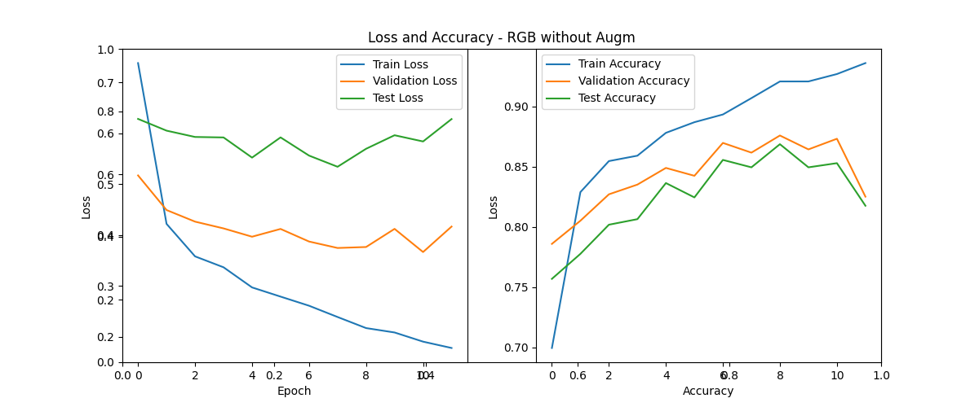

Stopped after 12 epochs

Best model:  
Epoch 9: Train Loss: 0.2174, Val Loss: 0.3766, Test Loss: 0.5693610178544986

Train Accuracy: 0.9207, Val Accuracy: 0.8758, Test Accuracy: 0.8686

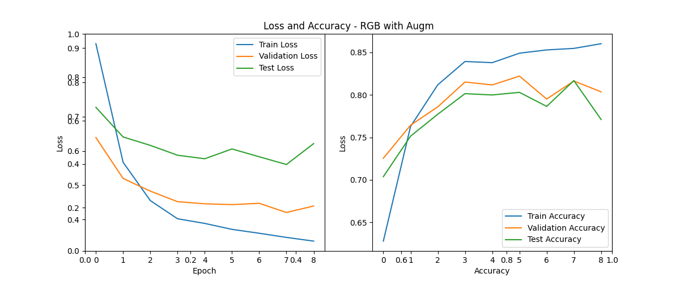

Stopped after 9 epochs

Best model - Epoch 6:

Train Loss: 0.3711, Val Loss: 0.4434, Test Loss: 0.6057766931610202

Train Accuracy: 0.8489, Val Accuracy: 0.8220, Test Accuracy: 0.8029

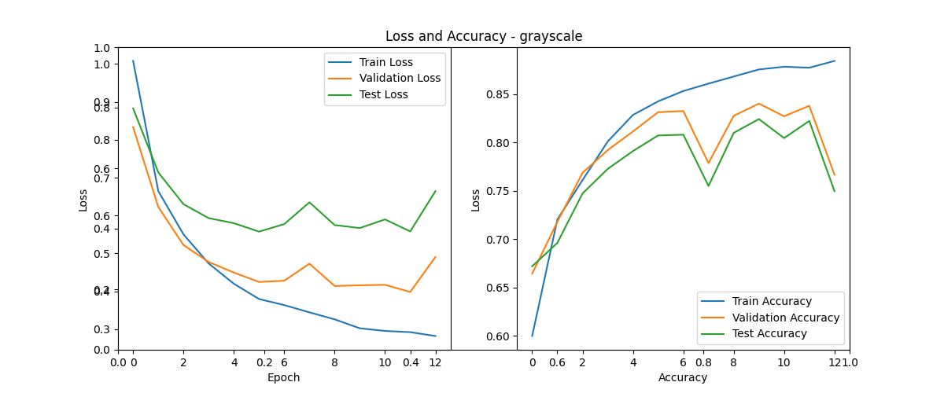

Stopped after 13 epochs

Best model: Epoch 10:

Train Loss: 0.3025, Val Loss: 0.4160, Test Loss: 0.5670718764324533

Train Accuracy: 0.8753, Val Accuracy: 0.8401, Test Accuracy: 0.8240

Results are just 3-4% worse than with color, so it looks like color doesn’t play a significant role for this model.