Team Based Project Release #3

1. Github link: <https://github.com/Kachi19/Software-Engineering-I-Project/blob/master/NewShoppingRelase3Update.java>
2. Design Patterns
3. The first design pattern we implemented is a Singleton Pattern.

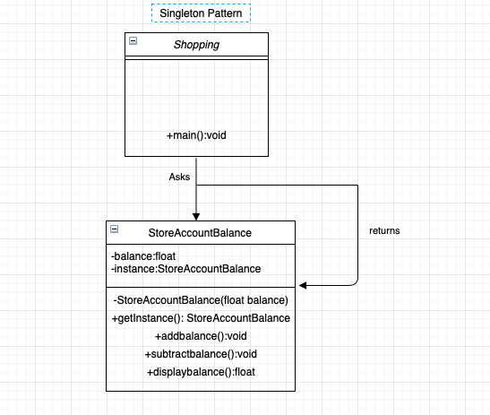

Instead of having a wallet variable that would hold the account balance of the user, we decided to create a StoreAccountBalance class. By doing this, we aid in data hiding, abstraction, and security in our program. We believe this update will improve the overall design and functionality of the program. The definition for this design is defined just before the main() function, and then the methods of the design are seen throughout the code in different locations.

1. The second design we implemented is also a Singleton Pattern.

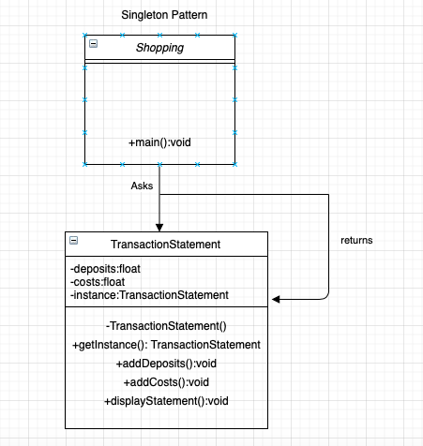

This design shows the details of the transactions users of the program made. This design has all the benefits of the aforementioned StoreAccountBalance class while also giving the user more information about what they did while using the program. The definition for this design is implemented just before the main function, and most of the methods are implemented in the middle of the program. The results of the TransactionStatement function are displayed at the end of the program when the user chooses to exit the program.

1. Execution
2. StoreAccountBalance

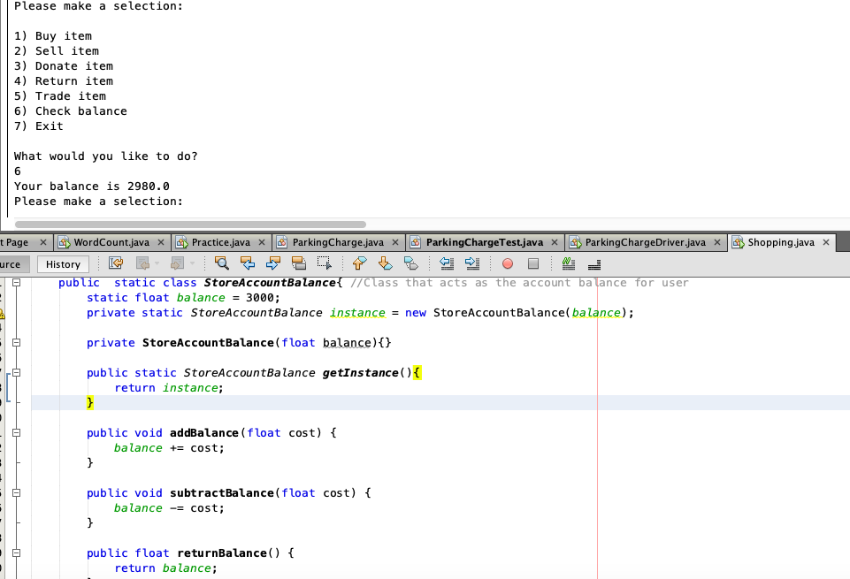

1. TransactionStatement

