**NAME:** Kacho Muneeb

**PRN:** 22070122092

**BATCH:** 2022-26

**CLASS:** CS-B1

**DATE OF SUBMISSION:** 29/08/2023

**TITLE OF ASSIGNMENT:** IMPLEMENT (i) LINEAR AND (ii) BINARY SEARCHING TECHNIQUES AND FIND THE TIME COMPLEXITY

**THEORY:** DISCUSS THE BEST CASE, WORST CASE TIME COMPLEXITIES OF LINEAR AND BINARY SEARCH

**PROGRAM:**

1. LINEAR SEARCH:

Time complexity:

1. Best case: O(1)
2. Worst case: O(n)

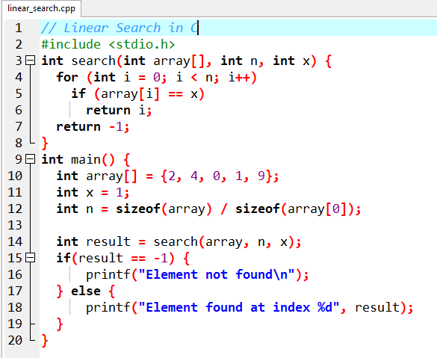

**OUTPUT:**

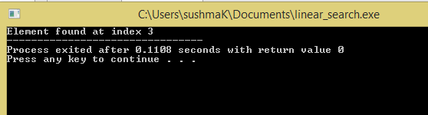

1. **BINARY SEARCH: ITERATIVE METHOD**

Time complexity:

1. Best case: O(1)
2. Average case: O(log n)
3. Worst case: O(log n)

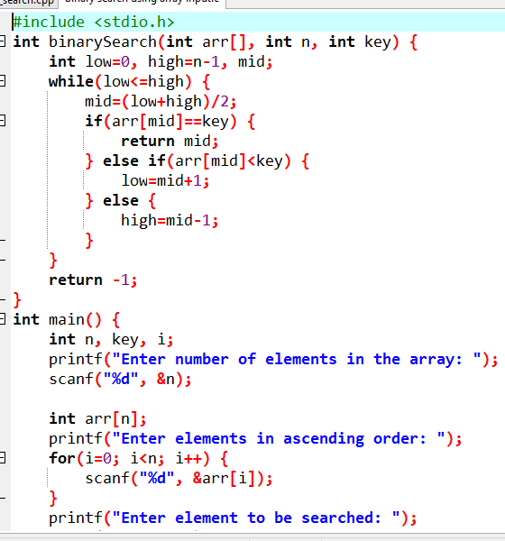

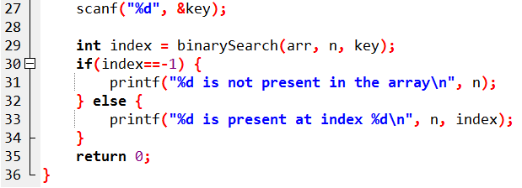

**OUTPUT:**

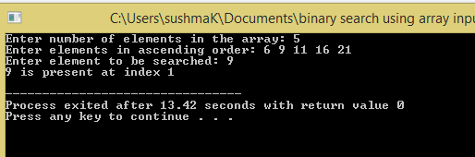

**RECURSIVE METHOD:**

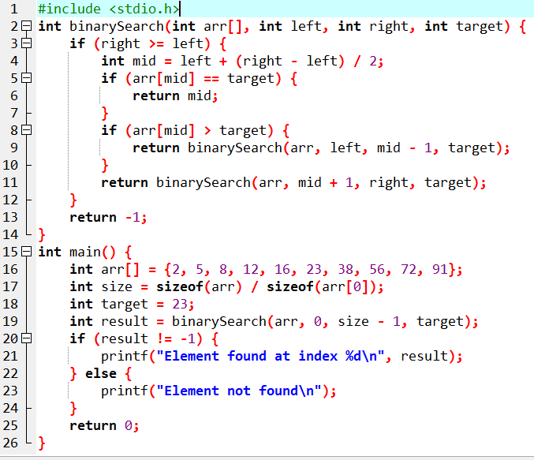

**OUTPUT:**

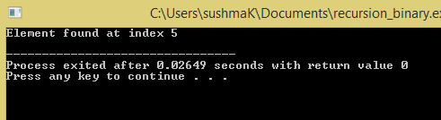

**CONCLUSION:** Thus we have studies different searching algorithms and their time complexities.