MILK10k: from one photo to the whole dataset
This note looks at the full MILK10k table: 10,480 photos of 5,240 lesions. Every lesion has two photos, one ordinary close-up and one dermoscopic. The label we want to predict is diagnosis_1: Benign, Malignant, or Indeterminate. The split is uneven: Malignant 69%, Benign 28%, Indeterminate 2%.

1. Which table fields move with the diagnosis?
Two columns are ids (isic_id, lesion_id) and one is the label (diagnosis_1). The other columns are described below. None of them is free text. A few are numbers or yes/no flags; most are categories. Missing means the cell is empty.
Column | Type | Missing | What it is
isic_id | identifier | 0.0% | Id of one photo
attribution | constant | 0.0% | Same text on every row
copyright_license | constant | 0.0% | Same value on every row
age_approx | numeric | 0.4% | Age in years
anatom_site_general | categorical | 37.3% | Body site
anatom_site_special | categorical | 98.0% | Extra site detail
concomitant_biopsy | boolean | 0.0% | Was a biopsy done
diagnosis_1 | target | 0.0% | Target label
diagnosis_2 | categorical | 0.0% | Finer diagnosis name
diagnosis_3 | categorical | 1.5% | Still finer diagnosis name
diagnosis_4 | categorical | 85.5% | Most specific name
diagnosis_confirm_type | categorical | 0.0% | How the label was decided
image_manipulation | categorical | 0.0% | Edited, or left as captured
image_type | categorical | 0.0% | Close-up or dermoscopy
lesion_id | identifier | 0.0% | Lesion id, two photos each
melanocytic | categorical | 77.2% | Filled in only when true
sex | categorical | 0.0% | Female or male

For categories, the chart shows the mix of labels inside each body site (including a bar for blank site). For age, a box plot compares the three labels. Age is a number and the label is a group, so the link is measured with ANOVA. Eta-squared is 0.15 (p < 0.001): that is the share of age variation that lines up with the label. Category fields use a chi-square test, reported as Cramer's V (0 means no link, 1 means a perfect link). With more than 10,000 rows, a tiny difference can still get a very small p-value, so the effect size matters more than the p-value alone.
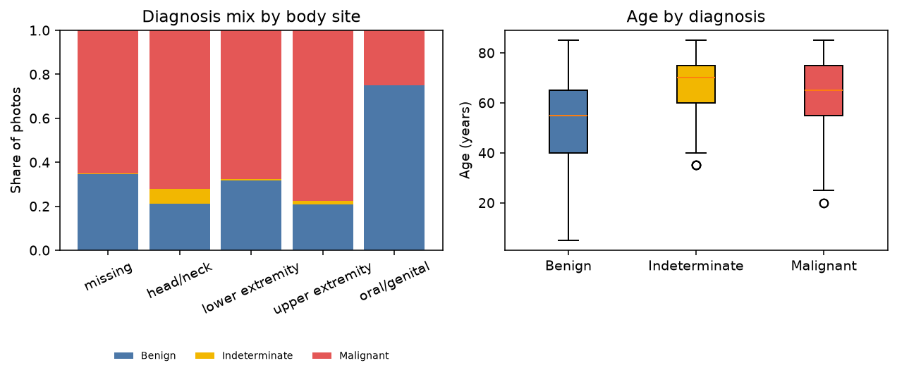
Left: label mix within each body site. Right: age by label. Mean age is about 52 (Benign), 68 (Indeterminate), and 65 (Malignant).
Body site has a moderate link (Cramer's V 0.16). Indeterminate photos are mostly from the head or neck, and many benign photos have no site filled in. The oral/genital bar is only 16 photos, so ignore its exact mix. Sex is a weak link (V 0.09): men are a bit more common in the malignant group, but the two sexes appear in every class. Image type has V = 0. Every class is exactly half close-up and half dermoscopy, because every lesion was photographed both ways.
Field | Test | Effect | p | Use as a model input?
diagnosis_2 | chi-square | 1.000 (Cramer's V) | < 0.001 | No. It is the label
diagnosis_3 | chi-square | 0.998 (Cramer's V) | < 0.001 | No. It is the label
melanocytic | chi-square | 0.414 (Cramer's V) | < 0.001 | No. Blank is informative
diagnosis_4 | chi-square | 0.403 (Cramer's V) | < 0.001 | No. It is the label
concomitant_biopsy | chi-square | 0.311 (Cramer's V) | < 0.001 | No. Biopsy decision
diagnosis_confirm_type | chi-square | 0.311 (Cramer's V) | < 0.001 | No. Same as biopsy
anatom_site_general | chi-square | 0.157 (Cramer's V) | < 0.001 | Yes
age_approx | ANOVA | 0.152 (eta-squared) | < 0.001 | Yes
image_manipulation | chi-square | 0.139 (Cramer's V) | < 0.001 | Careful. Edit flag
sex | chi-square | 0.093 (Cramer's V) | < 0.001 | Weak
anatom_site_special | chi-square | 0.065 (Cramer's V) | < 0.001 | No. Almost empty
image_type | chi-square | 0.000 (Cramer's V) | 1.000 | No

Fields that actually describe the patient or the photo, and that show a real link: age first, then body site. Sex is only a weak extra. Least useful: study name and license (one value for the whole table), image type (no difference at all), and the special site column (empty on about 98% of rows).
Some strong links should not be used as features. diagnosis_2 lines up perfectly with the label (Cramer's V = 1). diagnosis_3 and diagnosis_4 are the same diagnosis written in more detail. A model that sees them is being handed the answer. concomitant_biopsy and diagnosis_confirm_type are the same fact twice. They match on every row. Nearly every malignant case was biopsied, while many benign cases were not. That column stores a doctor's decision, not something measured from the pixels. It would look helpful in this table and then fail on a new photo that has not been biopsied. melanocytic is stored only when the value is true, so a blank cell already hints at the kind of lesion. lesion_id is an id. The two photos of one lesion must stay in the same train or test split. If one photo is used to train and the other to test, the test is not a new lesion.

2. Do the classes look different in color?
Histograms below use 25 photos from each class, so the large malignant group does not drown out the small indeterminate group. Each line is the average shape of the photos in that class. The table is the average color of those same photos (0 is black, 255 is white).
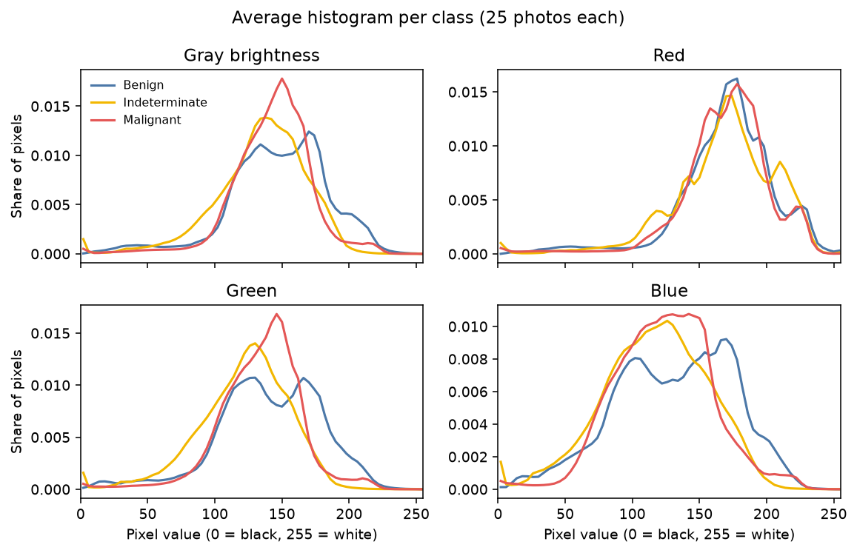
Average gray and red/green/blue histograms. The three classes cover the same range.
Class | Mean red | Mean green | Mean blue | Mean gray
Benign | 170 | 140 | 131 | 148
Indeterminate | 168 | 121 | 116 | 135
Malignant | 169 | 134 | 123 | 143

Average gray is 148 for Benign, 135 for Indeterminate, and 143 for Malignant. The gap between the highest and lowest class average is about 13 points. Inside one photo, gray typically spreads by about 25 points, which is larger than that gap. Green moves a little more than red (about 140 vs 121), but the curves still overlap. A cutoff on brightness or average color would mix the classes. A small shift can also come from the camera, the room light, gel on the lens, or skin tone, not from the diagnosis. Color alone is a weak signal. A useful model needs the shape and texture of the lesion, not only how light or red the photo is.

3. Processing, loading, and plots
preprocess_image does three things and reports what it did: it resizes to 224×224, keeps RGB or converts to gray, and divides by 255 so values sit in 0 to 1. Dividing by 255 uses the real range of an 8-bit photo. Stretching each photo to its own min and max would wipe out the brightness differences measured above. preprocess_batch calls that function on a list of files or on metadata rows. If one file is missing or unreadable, it is skipped and the reason is kept; the rest of the batch still returns. ImageBatchLoader is what later training code should loop over. You build it with the metadata table, the images folder, and a batch size. Each step of the loop gives (images, labels). images has shape (batch, 224, 224, 3) and values from 0 to 1. labels are the diagnosis_1 text. Only rows with a file on disk are included, and only one batch is read at a time. The plot helpers take either a table, a list of images, or a batch from the loader, so the same functions can check the raw data and the loader output.
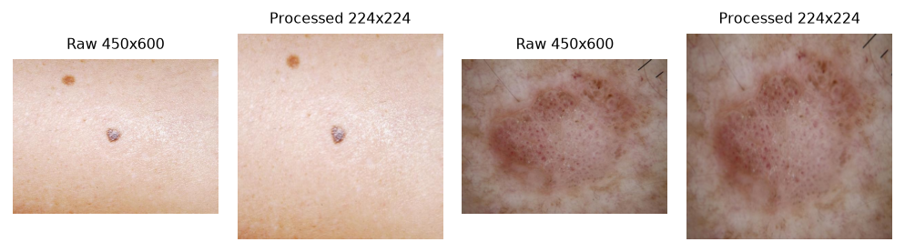
Two raw photos next to the same photos after resize and scaling to 0-1.
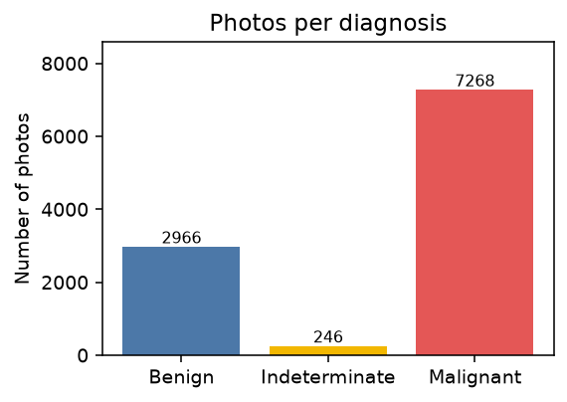
Class counts on the photos that are on disk. The set is imbalanced.
Because Malignant is most of the data, a model can look accurate by almost always saying Malignant. Later training should watch recall on each class, not accuracy alone, and should give more weight to the rare classes or balance the training set. The test set should stay in its natural mix. A processed batch from the loader has pixel values from 0.00 to 0.82, which matches the 0-1 scaling. show_labeled_grid puts the diagnosis on each photo, so a batch can be checked by eye.

