KA/HR/DP/HR/095/26/1010 12/February/2026

Ms. Kirti Oberoi

APPOINTMENT LETTER

Dear Ms. Kirti Oberoi

This is with reference to your application and the subsequent discussions you had with us. We are pleased to appointment you the position of HR Executive effective 16th February 2026, on the terms and conditions mutually agreed upon during the interview process.

As discussed, your Monthly Amount would be Rupees 27,000/- (Rupees Twenty-Seven Thousand only).

Leave/Holidays
- You are entitled to no casual leave of day.
- You are entitled to working days of no paid sick leave.
- The Company will inform you in advance about the list of each declared holiday.

The department concerned shall be known as and all individuals joining this department shall be bound by the applicable retainer terms and conditions. You shall be on a probationary period of six (6) months, upon completion of which, subject to your performance being found satisfactory, you may, at the sole discretion of the Company, be confirmed as an employee or a permanent employee.

You will be required to enter into a Confidentiality Agreement with the Company and provide accurate information to be filled in your joining form, sending along with your appointment letter.

All applicable terms and conditions are detailed in the joining kit. Submission of the duly filled joining kit along with the signed appointment letter shall be mandatory, and only upon receipt of both shall the appointment be deemed to have been accepted.

Please sign a duplicate copy of this letter and fill the joining form as a token of your acceptance and send the same email id hr@kactto.com (HR Manager) back to us. The letter and joining kit will be valid for 2 days only from the day it is issued.

We Welcome you and look forward for your arrival in EASY ONLINE MARKETING.

Thanking You Sincerely
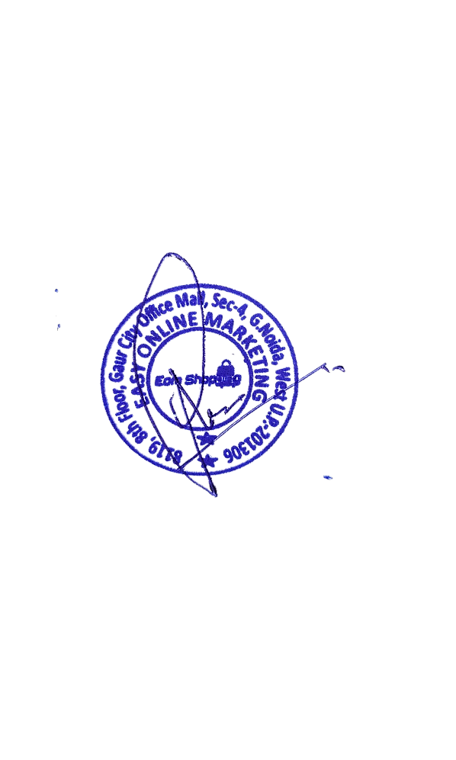
For EASY ONLINE MARKETING I accept the terms and conditions

Kirti Oberoi
Authorized Signatory Signature of Applicant

