# Inventory and Sales Tracking System for a Retail Store

Main Menu

1.Manage Products:

1.1. Add Product

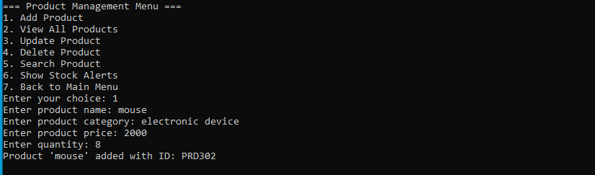

1.2 View All Products

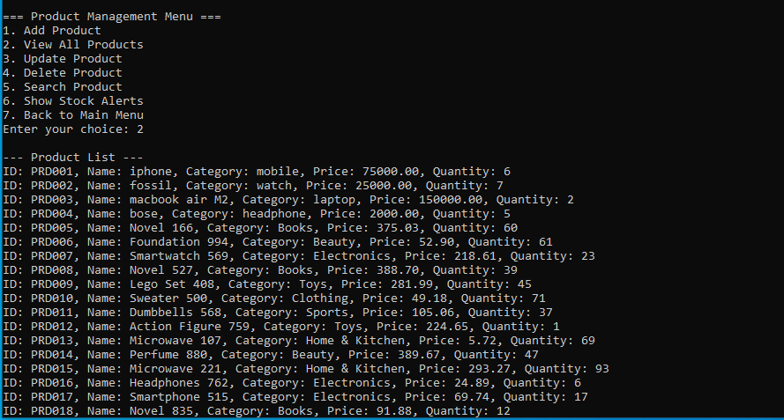

1.3 Update Product

1.4 Delete Product

1.5.1 Search Product by Name

1.5.2 Search Products by Category

1.6.1 Show Stock Alert(below 5)

1.6.2Show Stock Alert(equal to 5)

1.6.3 Show Stock Alert(above 5)

1.7 From Product To Main Menu

2. Manage Customers:

2.1 Add Customer

2.2 View All Customers

2.3 Update Customer

2.4 Delete Customer

2.5 From Customers to Main Menu

3. Sales Menu:

3.1 Record a Sale

3.2 View All Sales

3.3 Show daily Sales summary

3.4 Show Monthly Sale Summary

3.5 From Sales to Main Menu

4. Generate Bills:

4.1 Open Generate Bill

4.2 Generate Bill by Customer ID

4.3 From Billing To Main Menu

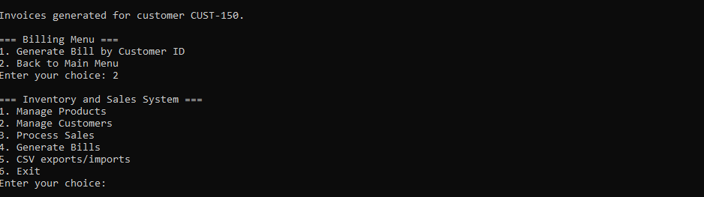

5.CSV exports/imports:

5.1 Export Product CSV Files

5.2 Export Customer CSV Files

5.3 Export Sales CSV

5.4 Exit from CSV Files

