EcoSociety AI :Artificial Intelligence Based Sustainability Platform for Residential Societies

Atharva Kadam | Vedant Bhoyar | Rituraj Gupta

Prof. Tanvee Ramteke | Prof. Shweta Lilhare | Dr. Babaso Shinde | Prof. Pooja Rasane

Introduction
Construction and Residential Industries is one of the primary contributors to climate change, consuming as much as 30-40% of energy resources worldwide and approximately one-third of the world's total CO2 emissions. The enormous effect on the environment has resulted in an urgent need for sustainable housing practices that will help preserve natural resources and minimize carbon footprints. In addition to this, artificial intelligence has introduced a breakthrough in the domains of architecture, engineering, and construction, enabling professionals to study, automate, and optimize all life-cycle processes in the built environment. Nevertheless, despite the technological breakthroughs in this sphere, housing societies are still lacking adequate instruments for implementing eco-friendly technology.
In order to fill this void, the AI Smart Sustainability Platform for Housing Societies becomes a scalable digital platform that aims at assisting societies in adopting sustainable practices without having to go through the hassle of finding green technologies. The main aim of the platform is solving the problems associated with gathering information and logistics when trying to integrate various green technologies. Thanks to machine learning techniques used by the platform, housing societies will be able to get an estimate of their present sustainability state and receive AI recommendations according to their demographic and architectural restrictions. Moreover, the platform will allow users to compare various eco-friendly services like charging stations for electric vehicles, solar panels installation and waste disposal companies while making predictions about the future performance.

Literature Review
Table 1: Literature review
Sr No | Paper Title & Authors | Details of Publication | Findings
1. | AI-driven smart home optimization for sustainable energy and water management: a systematic review  Ogbuanya, C. E., Eneh, J. N., & Udanor, C. N. | Frontiers in Control Engineering  May 2026  DOI: 10.3389/fcteg.2026.1793880 | The research evaluates AI-based methodologies like machine learning, deep learning, and reinforcement learning to enhance energy efficiency, cost optimization, and real-time decision-making. However, it notes that the majority of current systems optimize only a single resource, highlighting a major gap in comprehensive energy-water optimization.
2. | Smart Infrastructure for Sustainable Energy Consumption: Leveraging AI and Big Data  Sargiotis, D. | National Technical University of Athens  2024 | The paper outlines a smart grid infrastructure leveraging AI-driven decision-making and big data to minimize energy waste, accurately forecast demand surges, and improve load balancing. Using Masdar City as a baseline model, it demonstrates that these integrated systems can reduce urban building energy consumption by up to 40%.
3. | Machine Learning Applications for Smart Building Energy Utilization: A Survey  Huotari, M., Malhi, A., & Främling, K. | Archives of Computational Methods in Engineering  2024  Springer | The survey maps out machine learning applications across electric grids, HVAC control, and energy management systems. It identifies key operational hurdles, observing that models face significant limitations in generalization and transferability when moved from data-rich environments to data-scarce buildings.
4. | Artificial Intelligence in Sustainable Housing  Sharifi Poor Bgheshmi, M. S., & Aeini, B. | International Journal of Advanced Multidisciplinary Research and Studies  August 2024  ISSN: 2583-049X | The systematic review outlines how AI-powered surrogate models, neural networks, and ensemble methods achieve high predictive accuracies exceeding 0.9 for building thermal loads and HVAC use. It notes that real-world deployment is currently restricted by a scarcity of high-quality training datasets and resistance due to legacy systems.
5. | Towards a just AI-assisted energy transitions for vulnerable communities  Delina, L. L., & Tung, Y. S. M. | Energy Research & Social Science  September 2024  Elsevier | The research focuses on the socio-economic dimension of technological shifts, noting that algorithmic cost-effectiveness modeling often ignores social equity. It warns that over-reliance on unrepresentative datasets can result in an unequal distribution of financial burdens, amplifying vulnerabilities for marginalized groups.

Drawbacks of existing system
  - Fragmented and Isolated Solutions: Most existing AI-based energy systems and studies operate independently of one another or are limited to individual smart homes and broad urban grid management, lacking an integrated solution specifically tailored for residential housing societies.
  - Theoretical Rather Than Practical Implementation: A significant portion of existing AI-based green energy projects remains purely theoretical or functions primarily in high-resource, controlled environments rather than community-level residential areas.
  - Lack of Multi-Resource Optimization: Current smart home technologies primarily focus on optimizing only a single resource (such as energy), leaving a major research and implementation gap in multi-resource optimization (such as simultaneously managing energy, water, and waste).
  - Absence of Centralized Knowledge and Analytical Tools: Housing society management committees currently lack the technical expertise, tools, and data required to manually analyze complex eco-friendly activities like carbon auditing, rainwater harvesting, or solar feasibility.
  - Infrastructural Barriers and Lack of Standardization: The practical deployment of smart green infrastructures suffers from high initial costs and a lack of standard, universally applicable regulations across community housing structures.

Proposed Methodology
The software development process will be done on the basis of the Agile methodology that will be classified according to front-end, back-end, and AI tiers. For front-end development, React.js, HTML5, and CSS3 will be employed to develop the dynamic interface. Back-end server-side development and API management will be performed using Java and Spring Boot. For the purpose of implementing the machine learning models and predictive analytics, Python and TensorFlow will be used. The SQL database will be used to implement, maintain, and query the data present in the unstructured data of the platform.

- System Architecture
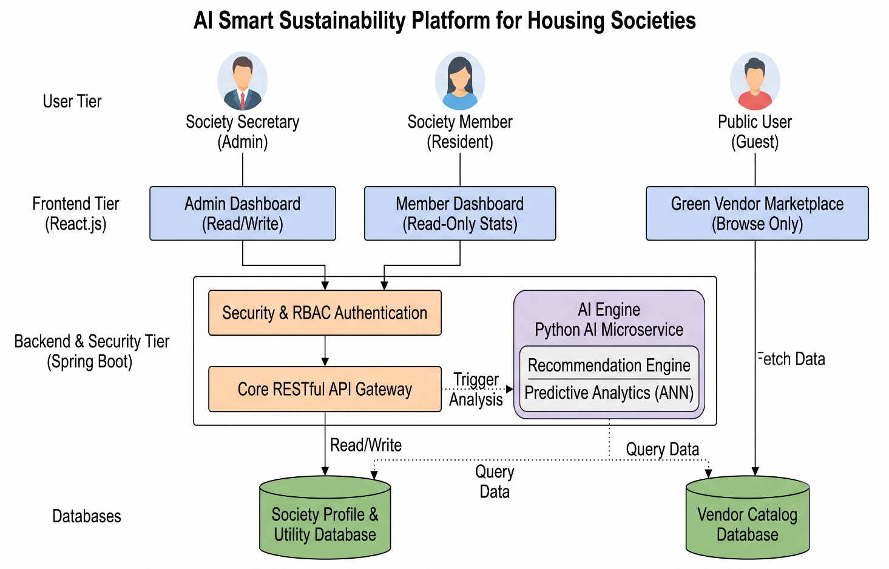

Fig no. 4.1: AI Smart Sustainability Platform Architecture

- Algorithm
The user accesses the web-based Smart Sustainability Platform's landing page, which provides an introductory overview and guided tour of the system's features for first-time visitors. Upon initiating the login or sign-up process, the core API gateway verifies the user's identity and role (Society Admin, Member, or Public Guest) using Role-Based Access Control (RBAC). Existing authenticated users are routed directly to their respective dashboards, while new society administrators are directed to a step-by-step onboarding workflow to create an account.

Step 1: User Registration and Profile Setup. Collect housing society demographics, available space, and budget details. All data is stored in the database and a society profile is created.

Step 2: Utility Data Logging. Society administrators have to input existing energy bills, water utility bills, and resource consumption data regularly.

Step 3: Choices for the user to select either Sustainability Recommendations or the Vendor Marketplace.

Step 4: If the user goes for Sustainability Recommendations, then the system's AI analyzes the society profile and spatial constraints to generate personalized green technology recommendations (e.g., solar installation, rainwater harvesting).

Step 5: If the user goes for the Vendor Marketplace, then the system displays available eco-friendly service providers based on the society's specific requirements. The user compares vendors for services like EV charging or waste disposal.

Step 6: After processing all data, the predictive analytics engine shows the forecasted cost savings, ROI, and carbon footprint reduction to the user, and the user can select and hire a vendor.

Step 7: End.

- Objectives
- To analyse the fragmented green technology market and make an integrated digital platform that solves informational and logistical challenges for residential housing societies.
- To develop a dynamic assessment system to evaluate and optimize multi-resource utility consumption, including energy, water, and waste management.
- To provide an AI-driven recommendation engine that suggests highly viable green solutions (such as solar installation and EV chargers) according to the society's specific budget, geographic location, and architectural constraints.
- To implement a transparent vendor marketplace feature so that society administrators can conveniently search for, compare, and hire eco-friendly service providers.
- To use predictive modeling to estimate cost savings, ROI, and carbon footprints, giving users the confidence to transition to sustainable living.

- Module Information
Module 1: Data collection and forming database :
Make our own dataset by gathering primary utility and spatial data along with secondary API data, and implementing steps for data cleaning, imputation, and Min-Max scaling.
Module 2: Implementation of AI recommendation and prediction system :
Implement machine learning models for predictive analytics and content-based filtering using Python, TensorFlow, and Scikit-learn.
Module 3: Designing Frontend of website :
Frontend of the website will be created using React.js, HTML5, and CSS3 to build a dynamic, responsive Society Dashboard and Vendor Portal.
Module 4: Implementation of core business logic and APIs :
Core business logic and user authentication will be implemented in the backend using Java and Spring Boot to create secure RESTful APIs.
Module 5: Integration of frontend, backend and AI tiers :
Frontend, Backend, and AI microservices will be combined using RESTful APIs and will be ready for rigorous unit and integration testing.
Expected Outcome:
- A fully operational, responsive web platform featuring a Society Dashboard and a Vendor Portal tailored for housing society officials and eco-friendly service providers.
- An implemented AI recommendation system that accurately processes structural, geographical, and budget constraints to suggest optimal sustainability improvements using content-based filtering.
- A predictive engine powered by an Artificial Intelligence that forecasts return on investment (ROI), financial savings, and carbon footprint reductions based on historical utility bills.
- A centralized database storing verified green vendor profiles, pricing details, and technical efficiency parameters to democratize and streamline green procurement.
- A scalable urban utility optimization model that directly reduces community-level greenhouse gas emissions and utility costs while relieving pressure on the central grid.
Conclusion
In the current paper, we have developed an innovative platform which will combine personalized recommendations on sustainability and a central marketplace for vendors of green technologies. The platform uses cutting-edge algorithms such as content-based filtering and Artificial Neural Networks to create a solution aimed at improving resource management and faster adoption of eco-friendly approaches in the residential communities. The use of a microservices approach and cloud computing in the development of the platform allows handling high-speed data and increased user traffic without any reduction in efficiency. Other innovations include the possibility of predicting the return on investment (ROI) and the reduction of carbon footprints, thus making the proposed solution highly competitive in the market and addressing the information gaps in currently fragmented systems. In addition to that, the current research has not only resulted in democratically oriented green procurement but also laid down the groundwork for future developments in local urban planning and utility optimization.

