# What is DevOps?

The DevOps is the combination of two words, one is **Software Development** and other is **Operations**. It is a culture to promote the development and operation process collectively.

DevOps helps you to reduce the disconnection between software developers, quality assurance (QA) engineers, and system administrators.

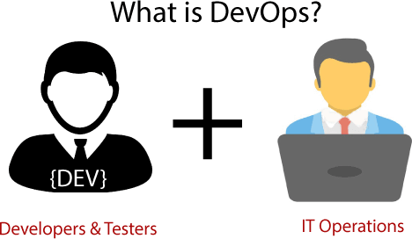

# Tools Of DevOps?

The DevOps will help you to learn DevOps basics and provide depth knowledge of various DevOps tools such as **Git, Docker, Jenkins,** and **Kubernetes**.

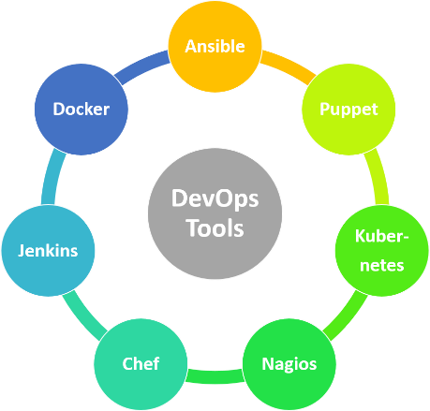

# Why DevOps?

DevOps is important because it's a software development and operations approach that enables faster development of new products and easier maintenance of existing deployments.

Without the use of DevOps, the team members are spending a large amount of time on designing, testing, and deploying instead of building the project.

# Features of DevOps

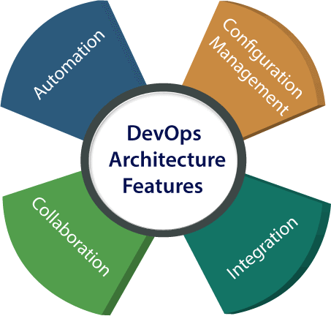

## 1) Automation

Automation can reduce time consumption, especially during the testing and deployment phase. The productivity increases, and releases are made quicker by automation.

## 2.Collaboration

The Development and Operations team collaborates as a DevOps team, which improves the cultural model as the teams become more productive with their productivity, which strengthens accountability and ownership.

## Integration

Applications need to be integrated with other components in the environment. The integration phase is where the existing code is combined with new functionality and then tested. Continuous integration and testing enable continuous development.

## Configuration management

It ensures the application to interact with only those resources that are concerned with the environment in which it runs. The configuration files are not created where the external configuration to the application is separated from the source code.

# Architecture of DevOps

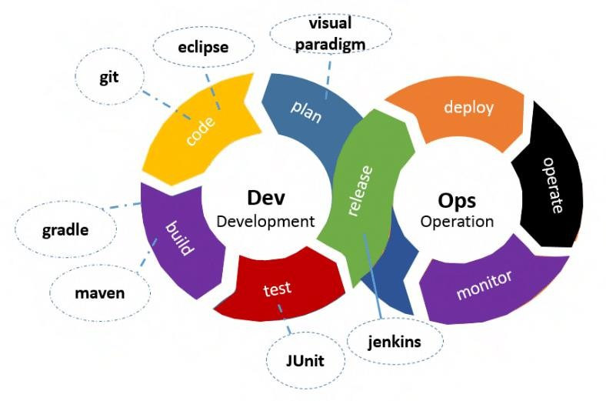

## Build

Without DevOps, the cost of the consumption of the resources was evaluated based on the pre-defined individual usage with fixed hardware allocation. And with DevOps, the usage of cloud, sharing of resources comes into the picture, and the build is dependent upon the user's need, which is a mechanism to control the usage of resources or capacity.

## Code

Many good practices such as Git enables the code to be used, which ensures writing the code for business, helps to track changes, getting notified about the reason behind the difference in the actual and the expected output, and if necessary, reverting to the original code developed.

## Test

The application will be ready for production after testing. In the case of manual testing, it consumes more time in testing and moving the code to the output. The testing can be automated, which decreases the time for testing so that the time to deploy the code to production can be reduced as automating the running of the scripts will remove many manual steps.

## Plan

DevOps use Agile methodology to plan the development. With the operations and development team in sync, it helps in organizing the work to plan accordingly to increase productivity.

## Monitor

Continuous monitoring is used to identify any risk of failure. Also, it helps in tracking the system accurately so that the health of the application can be checked.

## Deploy

Many systems can support the scheduler for automated deployment. The cloud management platform enables users to capture accurate insights and view the optimization scenario, analytics on trends by the deployment of dashboards.

## Operate

DevOps changes the way traditional approach of developing and testing separately. The teams operate in a collaborative way where both the teams actively participate throughout the service lifecycle. The operation team interacts with developers, and they come up with a monitoring plan which serves the IT and business requirements.

## 7) Operate

DevOps changes the way traditional approach of developing and testing separately. The teams operate in a collaborative way where both the teams actively participate throughout the service lifecycle. The operation team interacts with developers, and they come up with a monitoring plan which serves the IT and business requirements.