* **What is Git?**

Git is a version control system used for tracking changes in computer files. It is generally used for source code management in software development.

* Git is used to tracking changes in the source code
* The distributed version control tool is used for source code management
* It allows multiple developers to work together
* It supports non-linear development through its thousands of parallel branches.
* **Feature of Git?**
* Tracks history
* Free and open source
* Supports non-linear development
* Creates backups
* Scalable
* Supports collaboration
* Branching is easier
* Distributed development

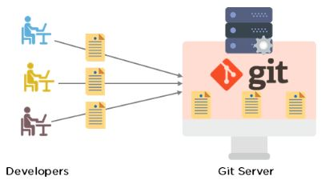

* **Command in Git.**
* Create Repositories  
  git init
* Make Changes  
  add  
  commit  
  status
* Parallel Development  
  branch  
  merge  
  rebase
* Sync Repositories  
  push  
  pull  
  add origin

**Why git?**

# Git is a DevOps tool used for source code management. It is a free and open-source version control system used to handle small to very large projects efficiently. Git is used **to tracking changes in the source code, enabling multiple developers to work together on non-linear development.** Why Should You Use

**Installation Steps of Git:**

**1.Git Downloads**

**Created new repository as SocialNetwoking in GitHub and committed project using below commands:**

1.Cd “location of our project” 🡪 project location

2.Git push origin 🡪 its used to upload local repository content to remote repository

3.Ls 🡪 its lists the current directory contents

4.Git init 🡪 it creates a new git repository (initializing repository)

5.Git remote add origin repo link 🡪 Create a new, empty Git repository on your remote server.

6.Git add . 🡪 The git add command adds a change in the working directory to the staging area

7.Git commit -m “first commit” 🡪Commits are the core building block units of a Git project timeline

8.Git push origin master 🡪Whenever we need to push the changes to a remote repository, we use git push along with the remote repository “origin” and “master”

branches

