**Kubernetes**

* **What is Kubernetes?**

Kubernetes is an open-source software that allows you to deploy and manage containerized applications at scale.

Kubernetes manages the clusters of Amazon Elastic Compute (EC2).

Kubernetes (also known as k8s or “kube”).

* **What is Kubernetes is used for?**

Kubernetes **automates operational tasks of container management** and includes built-in commands for deploying applications, rolling out changes to your applications, scaling your applications up and down to fit changing needs, monitoring your applications, and more—making it easier to manage applications.

## **Features of Kubernetes**

## **Features of Kubernetes –**

1. **Automated Scheduling**– Kubernetes provides advanced scheduler to launch container on cluster nodes. It performs resource optimization.
2. **Self-Healing Capabilities**– It provides rescheduling, replacing and restarting the containers which are died.
3. **Automated Rollouts and Rollbacks**– It supports rollouts and rollbacks for the desired state of the containerized application.
4. **Horizontal Scaling and Load Balancing**– Kubernetes can scale up and scale down the application as per the requirements.

* **kubernetes architecture :**

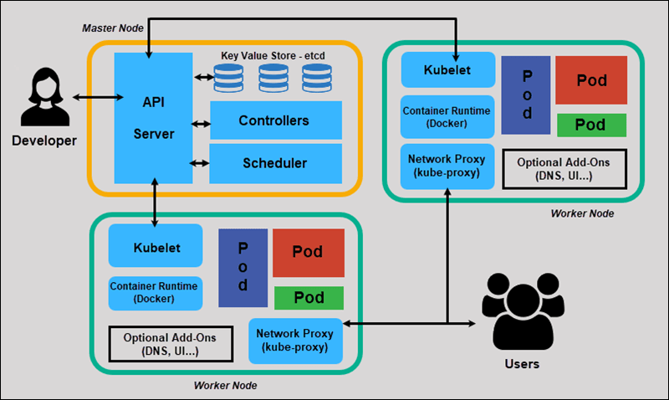 The architecture of Kubernetes actually follows the client-server architecture. It consists of the following two main components:

1. Master Node (Control Plane)
2. Slave/worker node

### **Master Node or Kubernetes Control Plane :**

The master node in a Kubernetes architecture is used to manage the states of a cluster. It is actually an entry point for all types of administrative tasks. In the Kubernetes cluster, more than one master node is present for checking the fault tolerance.

Following are the four different components which exist in the Master node or Kubernetes Control plane:

1. API Server
2. Scheduler
3. Controller Manager
4. ETCD

**API Server :**

The Kubernetes API server receives the REST commands which are sent by the user. After receiving, it validates the REST requests, process, and then executes them. After the execution of REST commands, the resulting state of a cluster is saved in '**etcd**' as a distributed key-value store.

**Scheduler :**

The scheduler in a master node schedules the tasks to the worker nodes. And, for every worker node, it is used to store the resource usage information.  
In other words, it is a process that is responsible for assigning pods to the available worker nodes.

**Controller Manager :**

The Controller manager is also known as a controller. It is a daemon that executes in the non-terminating control loops. The controllers in a master node perform a task and manage the state of the cluster. In the Kubernetes, the controller manager executes the various types of controllers for handling the nodes, endpoints, etc.

**ETCD :**

It is an open-source, simple, distributed key-value storage which is used to store the cluster data. It is a part of a master node which is written in a GO programming language.

Now, we have learned about the functioning and components of a master node; let's see what is the function of a slave/worker node and what are its components.

### **Worker/Slave node :**

The Worker node in a Kubernetes is also known as minions. A worker node is a physical machine that executes the applications using pods. It contains all the essential services which allow a user to assign the resources to the scheduled containers.

Following are the different components which are presents in the Worker or slave node:

**Kubelet :**

This component is an agent service that executes on each worker node in a cluster. It ensures that the pods and their containers are running smoothly. Every **kubelet** in each worker node communicates with the master node. It also starts, stops, and maintains the containers which are organized into pods directly by the master node.

**Kube-proxy :**

It is a proxy service of Kubernetes, which is executed simply on each worker node in the cluster. The main aim of this component is request forwarding. Each node interacts with the Kubernetes services through **Kube-proxy**.

**Pods :**

A **pod** is a combination of one or more containers which logically execute together on nodes. One worker node can easily execute multiple pods.

**Installation Steps :**

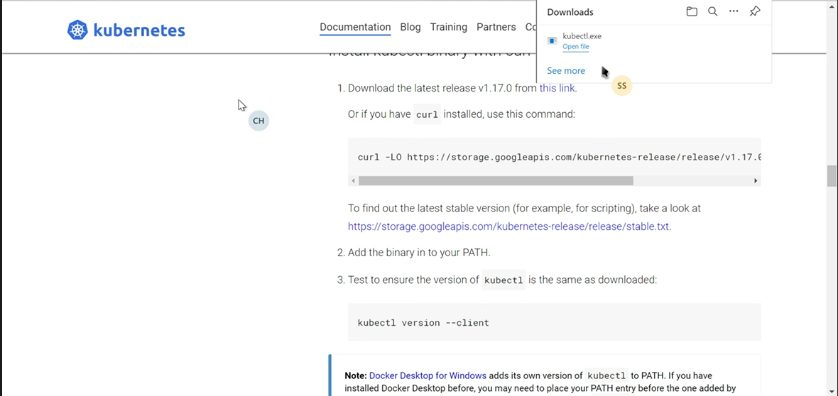

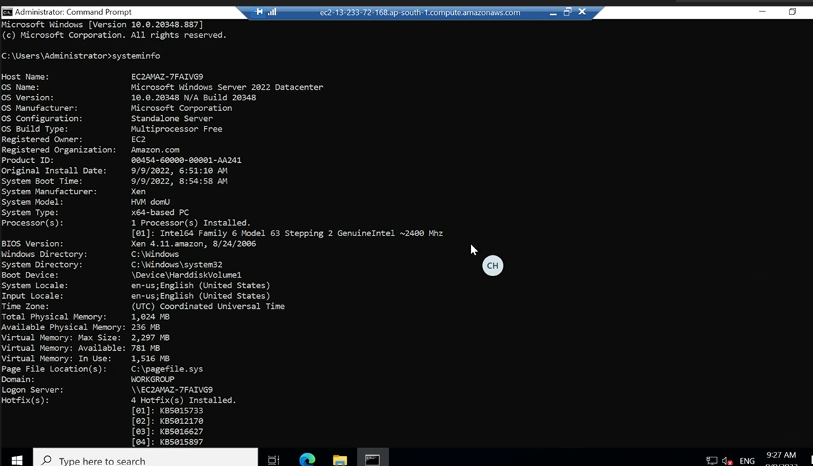

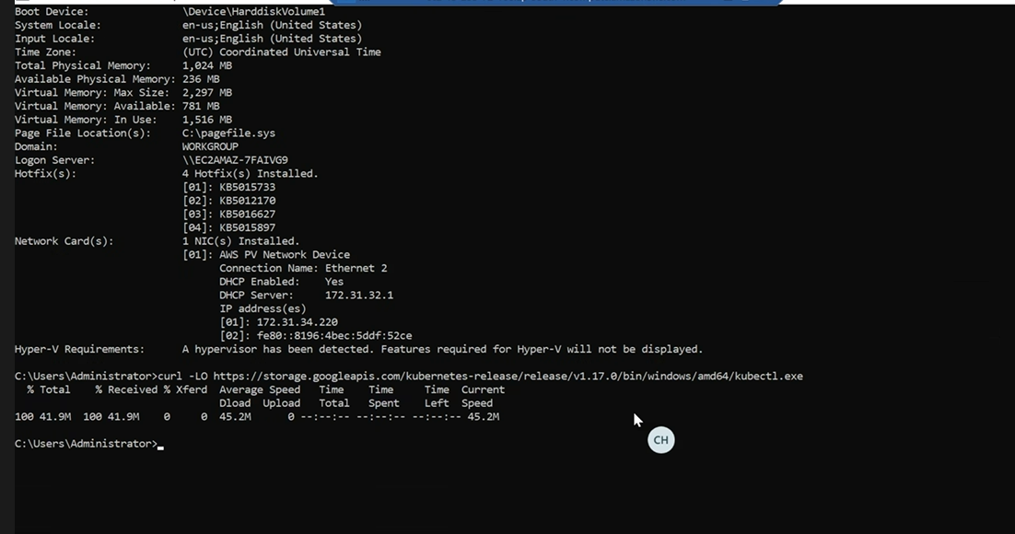

**Checking version**

