* **What is Maven?**

Maven is a popular open-source build tool developed by the Apache Group to build, publish, and deploy several projects at once for better [project management](https://www.simplilearn.com/project-management-skills-article). The tool provides allows developers to build and document the lifecycle framework.

Maven is written in [Java](https://www.simplilearn.com/tutorials/java-tutorial) and is used to build projects written in [C#](https://www.simplilearn.com/c-sharp-programming-for-beginners-article), Scala, [Ruby,](https://www.simplilearn.com/tutorials/java-tutorial/what-is-ruby-on-rails) etc. Based on the Project Object Model (POM), this tool has made the lives of [Java developers](https://www.simplilearn.com/introducing-simplilearns-full-stack-java-developer-masters-program-article) easier while developing reports, checks build and testing automation setups.

* **Why Maven?**

Maven is chiefly used for Java-based projects, **helping to download dependencies**, which refers to the libraries or JAR files. The tool helps get the right JAR files for each project as there may be different versions of separate packages

* **Feature of Maven**

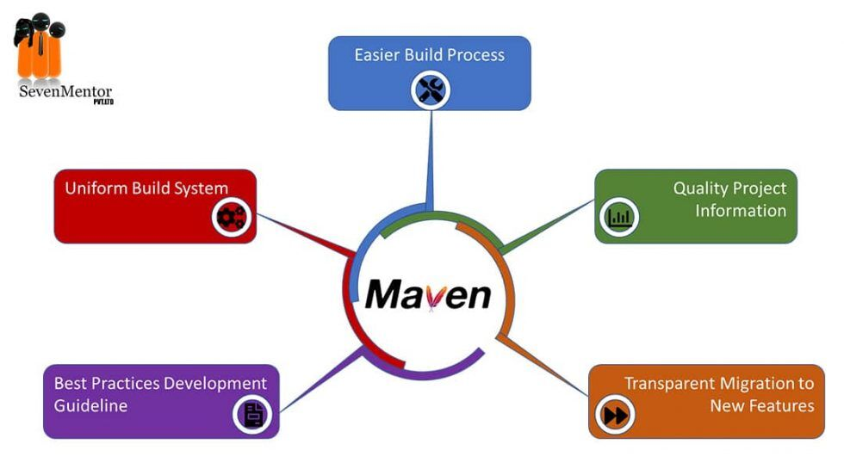

**Maven installation Steps:**

**Go to the files sections and download the maven by the given link for binary zip archive file**

**After downloading zip file and extract**

**Setting up java and maven in Jenkins**

**open environment variable to set the path and verify the java home path**

**Checking java version in cmd (java -version)**

**Checking maven version in cmd (mvn -version)**

