* **What is Git?**

Git is a version control system used for tracking changes in computer files. It is generally used for source code management in software development.

* Git is used to tracking changes in the source code
* The distributed version control tool is used for source code management
* It allows multiple developers to work together
* It supports non-linear development through its thousands of parallel branches.
* **Feature of Git?**
* Tracks history
* Free and open source
* Supports non-linear development
* Creates backups
* Scalable
* Supports collaboration
* Branching is easier
* Distributed development
* 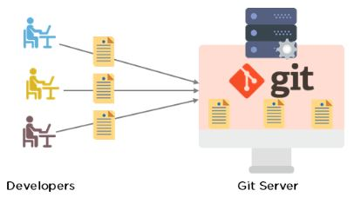
* **Command in Git.**
* Create Repositories  
  git init
* Make Changes  
  add  
  commit  
  status
* Parallel Development  
  branch  
  merge  
  rebase
* Sync Repositories  
  push  
  pull  
  add origin

**Why Should we use git?**

# Why Should You Use

GIT

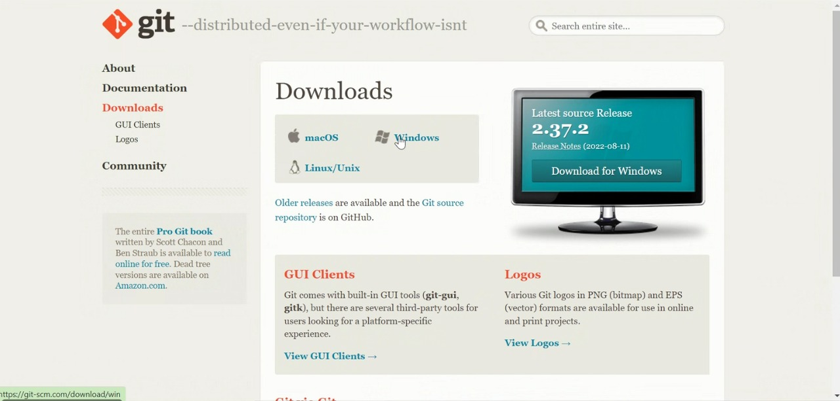

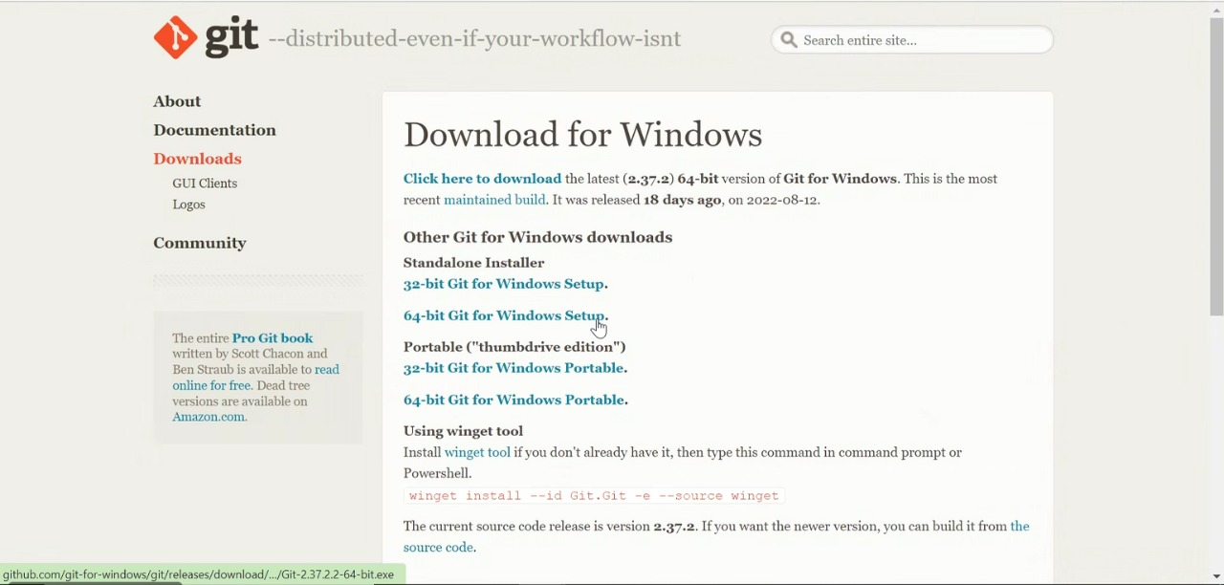

Created new repository as E-book in GitHub and committed project using below commands

