**Component 1: Checklist**

**Student Name/ID**: **Kadamber** **Verma/77202825**

**Development Choice:**

* **PHPStorm / XAMPP**: ❌
* **PHPStorm / Vagrant**: ❌
* **Eclipse Che**: ❌
* **Other** – **VSCODE / XAMPP ✅**

**Add Screenshots to show successful setup – project window should show supplied case study**

* **Successful XAMPP installation**

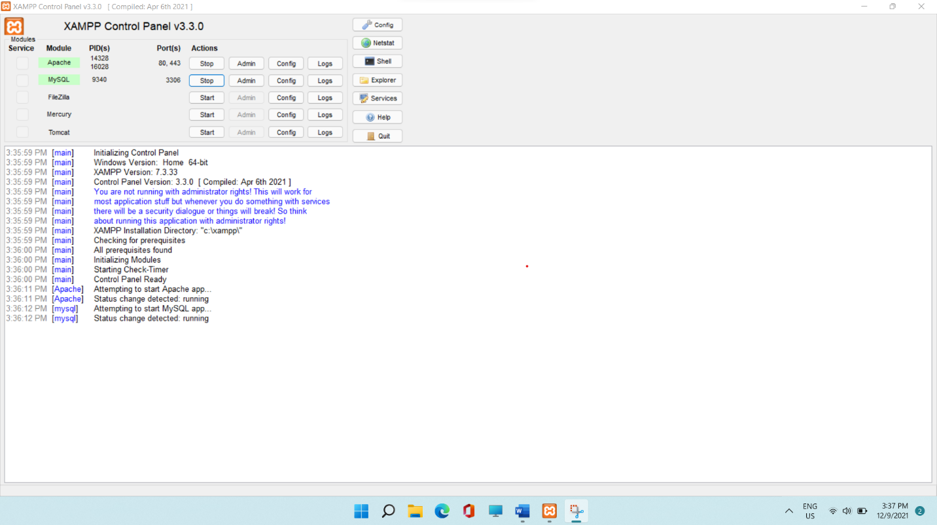

* **Successful environment variable setup for accessing PHP from anywhere using terminal**

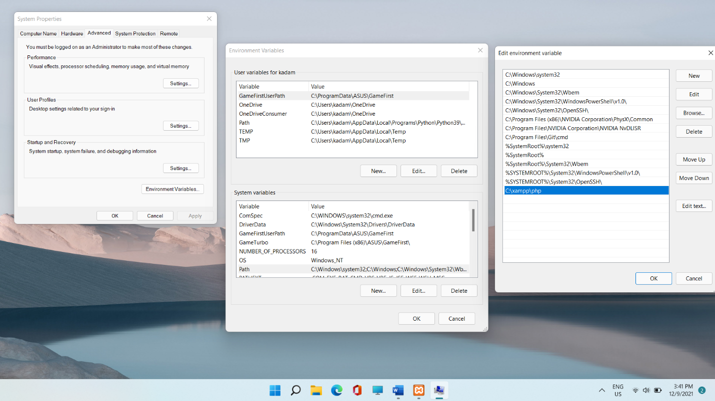

* **Successful Composer Setup with path set in environment variable**

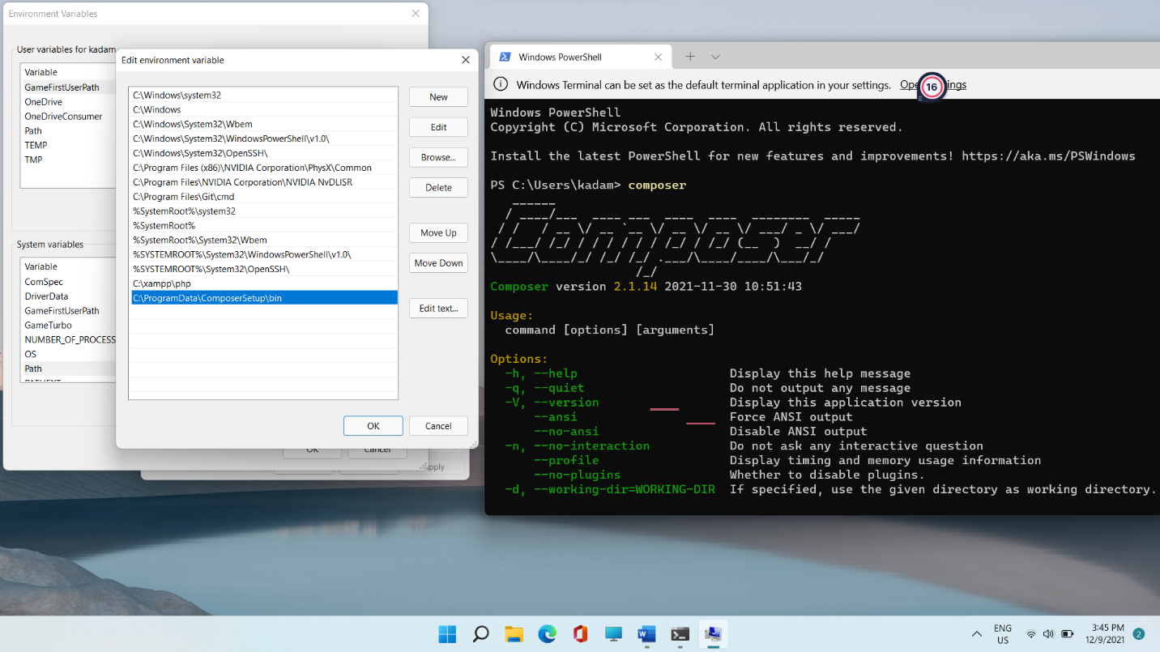

* **Laravel Installer after successfully installing Composer**

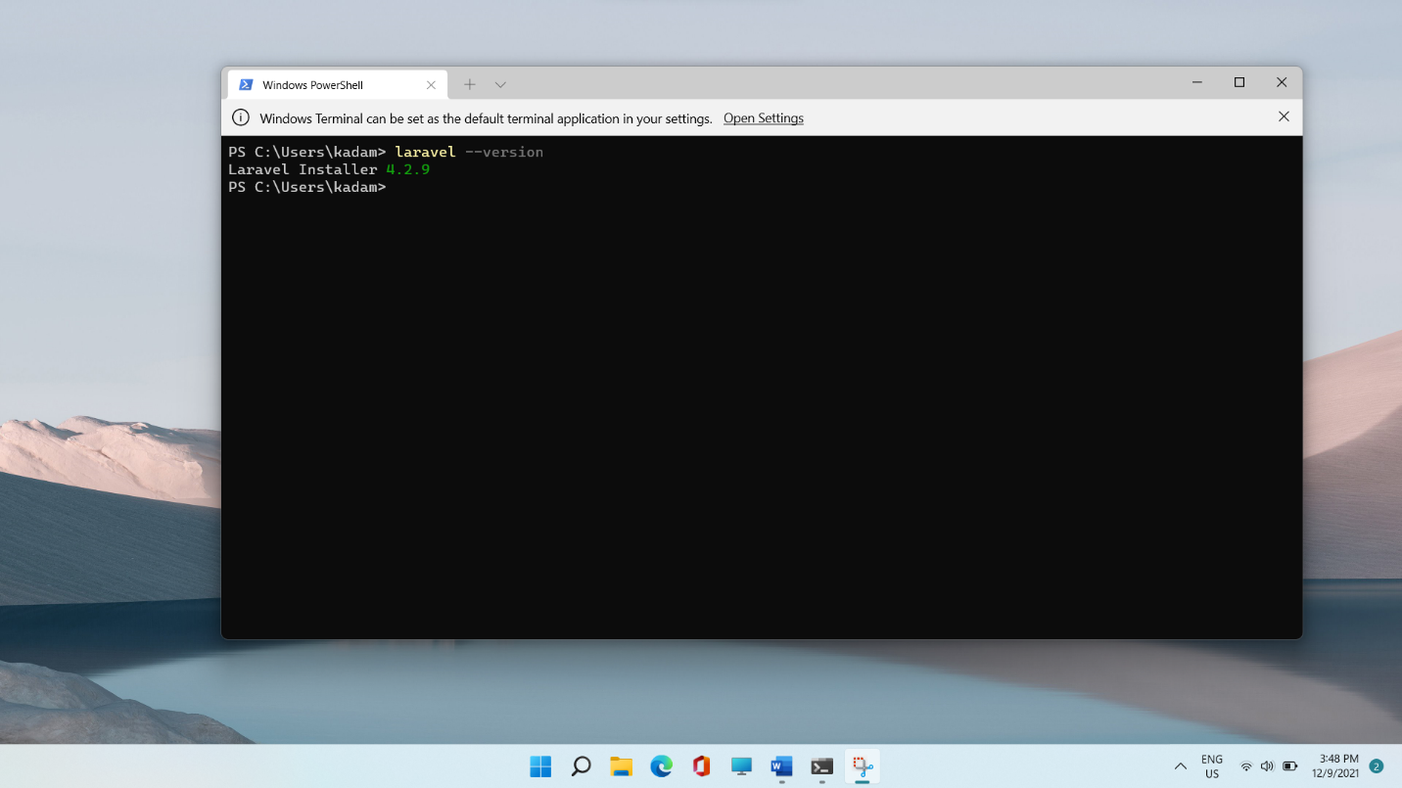

* **Case Study Solution to add functionality for adding Game Product –**

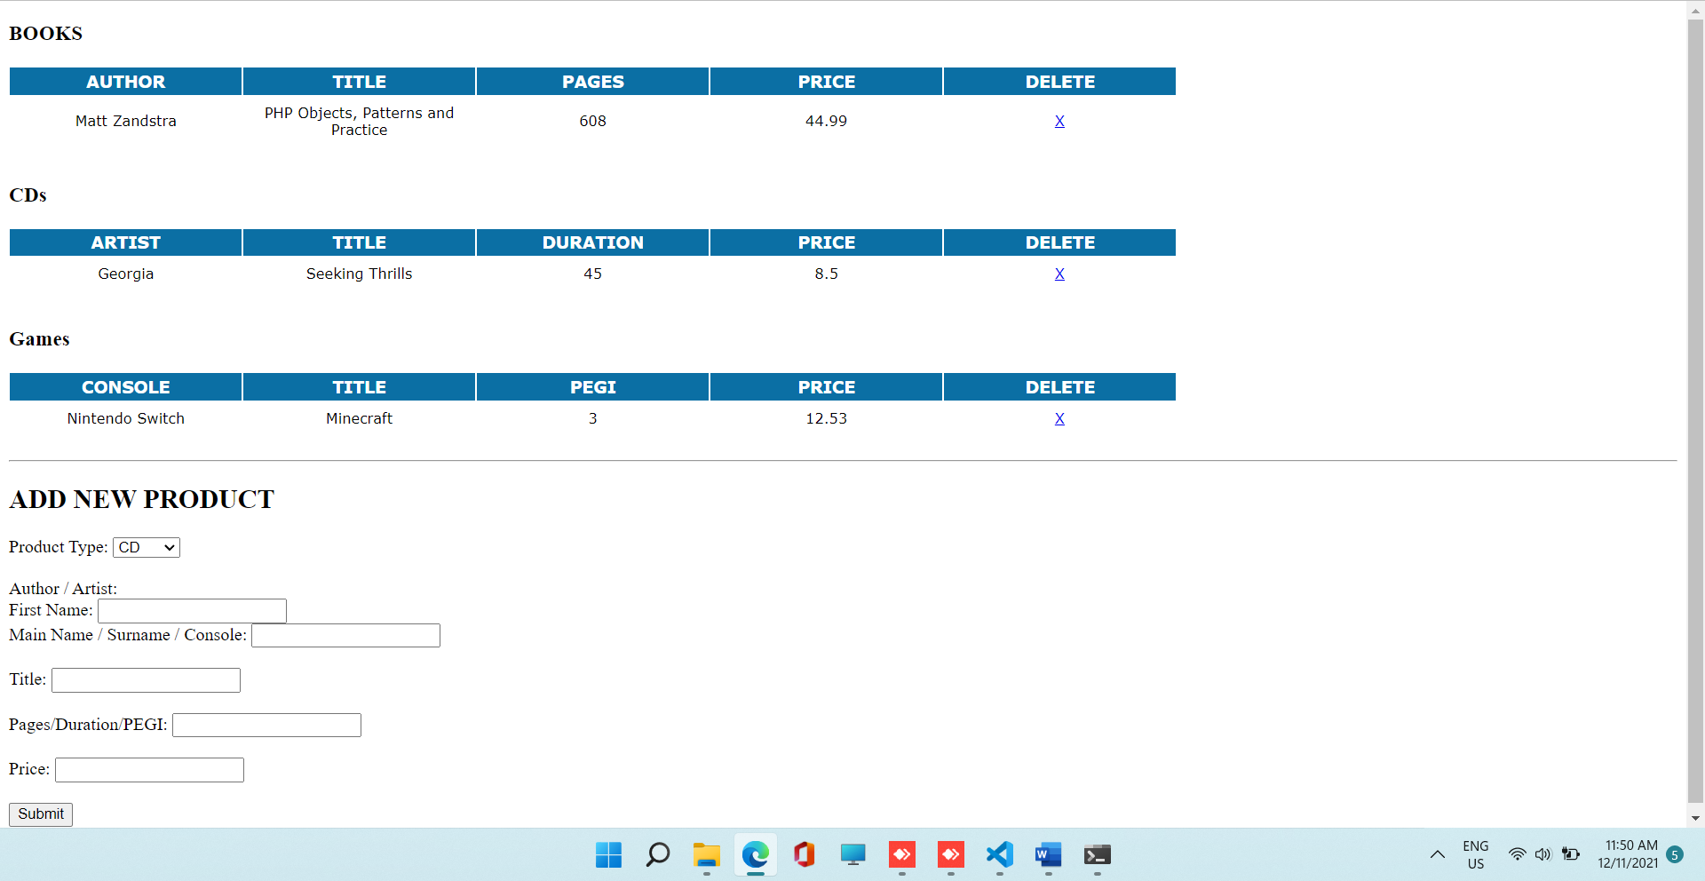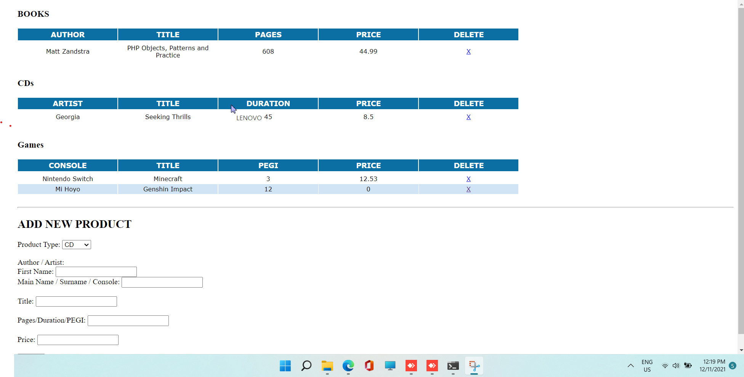

**PHP Version being used**: **7.3.33**

**XDebug installed**: ✔

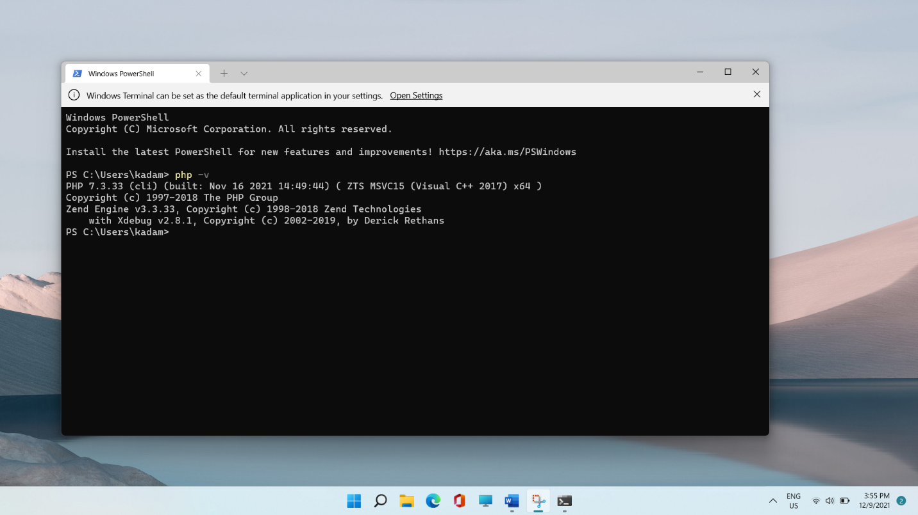

**Git account created and used**: [**KadamberVerma/awe-component-1 (github.com)**](https://github.com/KadamberVerma/awe-component-1)

**Remaining marks are awarded for completion of the short PHP exercise**