INFOVERSE

Project Overview
INFOVERSE is a production-oriented full-stack platform designed to support placement training operations across students, trainers, TPO teams, coordinators, administrators, and alumni. It centralizes training delivery, assessments, coding contests, attendance, notifications, and placement visibility into a single role-driven web application.
The platform currently supports these primary user groups:
- Student – Manage profile, upload resume, track attendance, access assignments/ quizzes/ contests/ references, and view placement-related updates.
- Trainer – Manage assigned batches, conduct assessments, monitor attendance sessions, and engage students through academic content modules.
- TPO – Manage batches, assign trainers/coordinators, oversee approvals, monitor attendance analytics, and export placement reports.
- Coordinator – Handle attendance operations, profile/dashboard workflows, and student activity support functions.
- Admin / Super Admin – Perform secure administration, user management, batch governance, placement imports, and landing-content management.
- Past Student (Alumni) – Access self-service profile/placement portal functions.

2. System Architecture
INFOVERSE follows a layered architecture that separates UI, API/business logic, and data services for maintainability and scalable deployment.
Layer | Technology | Runtime / Hosting Mode
Frontend (Presentation) | React + Vite + Tailwind CSS | Static build (Vercel-compatible)
Backend (Business Logic) | Node.js + Express.js | Vercel serverless (@vercel/node) + local Node runtime
Database (Data Layer) | MongoDB Atlas (Mongoose) | Cloud-hosted MongoDB
Media Storage | Cloudinary + Multer Storage | Cloudinary CDN
Email Service | Nodemailer + Gmail SMTP | SMTP via environment configuration
Code Execution Engine | Local compilers + external judge fallback (Wandbox / Judge0) | Local VM/host or serverless-compatible external API
Communication uses HTTPS REST APIs between frontend and backend. The backend is serverless-aware (connection caching and reconnect middleware) and exposes health/debug endpoints for runtime diagnostics.

2.1 Architecture Diagrams

Diagram A: High-Level System Architecture

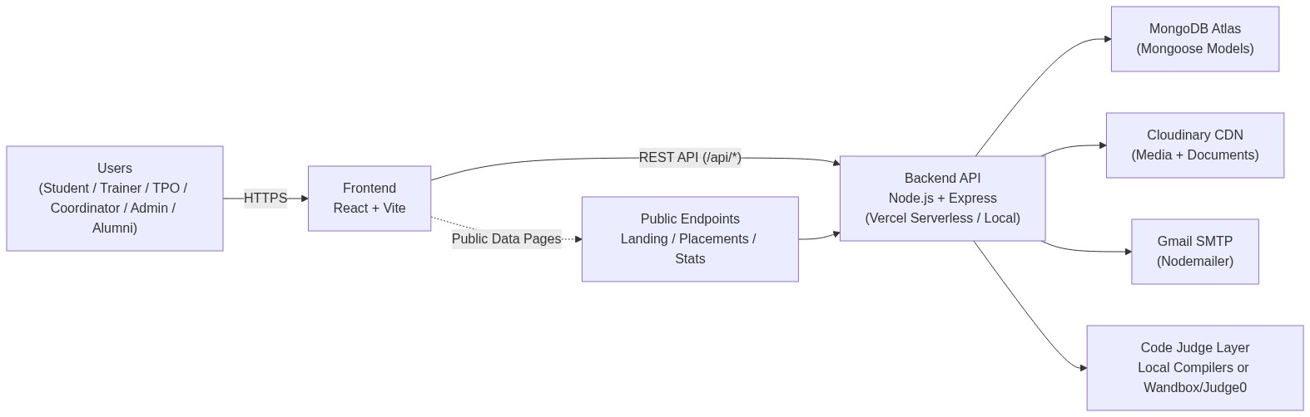

Diagram B: Backend Module Interaction

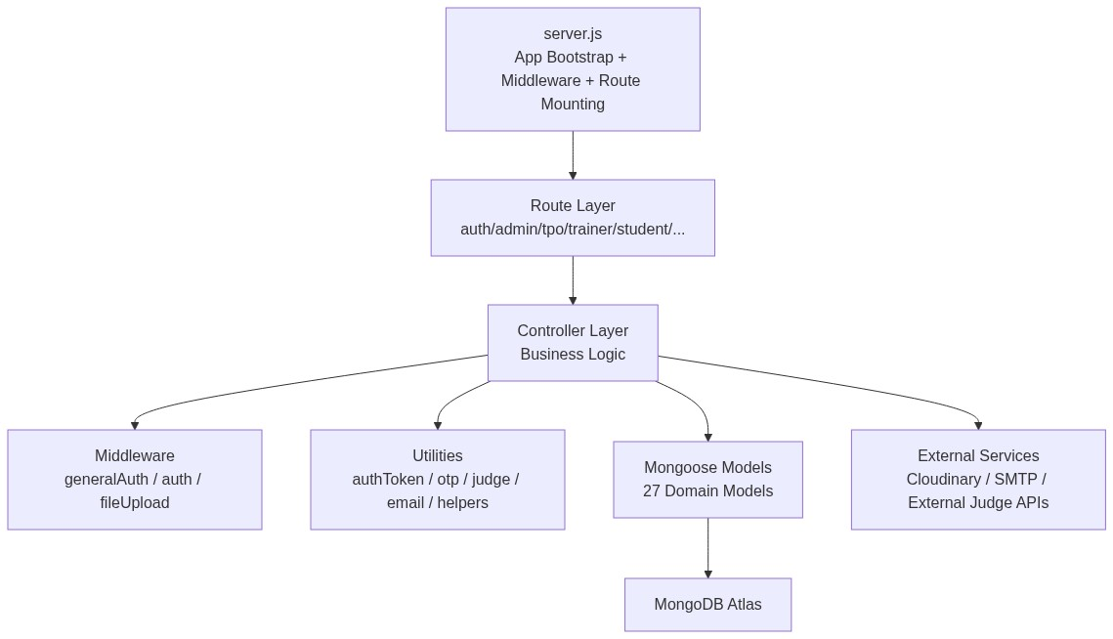

Diagram C: Request Flow (Auth + Protected API)

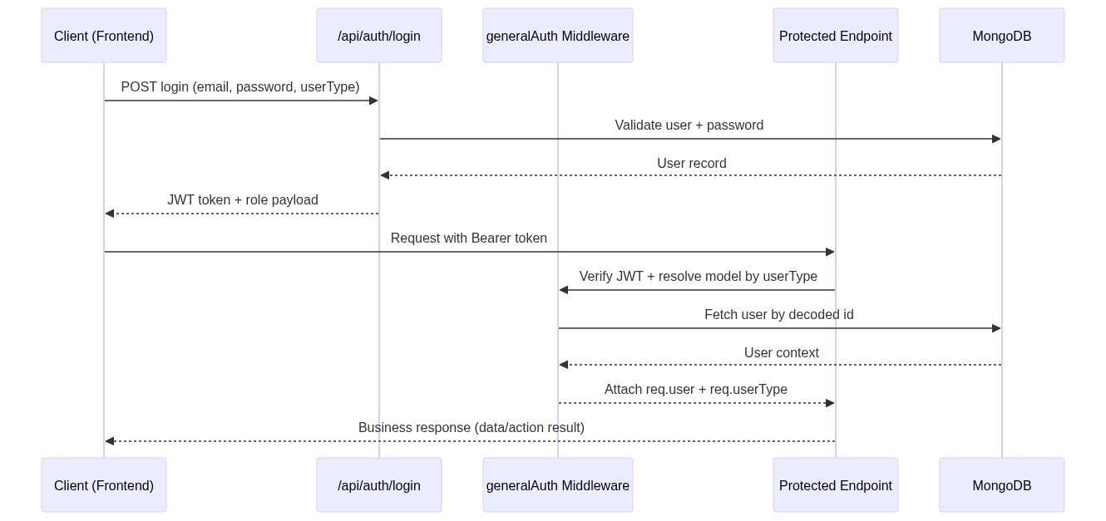

3. Technology Stack

Frontend
- React (frontend package: v18.x)
- Vite build/dev tooling
- React Router DOM for routing
- Axios with auth-aware interceptors
- Tailwind CSS for styling
- Additional visualization/util packages: Recharts, FileSaver, xlsx, Framer Motion, React Icons/Lucide

Backend
- Node.js + Express (Express 5.x)
- Mongoose for MongoDB persistence
- JWT-based auth token flow
- bcrypt/bcryptjs for password hashing and verification
- Nodemailer for OTP and account emails
- Multer + Cloudinary for media/document uploads
- ExcelJS / xlsx for import-export pipelines

Infrastructure/Platform Notes
- CORS configured for multi-origin frontend deployment.
- Vercel-specific runtime support (serverless DB reconnection, /tmp usage for execution files).
- Environment-driven behavior for production/local execution.

4. Core Features

4.1 Authentication & Access Control
- Multi-role authentication pipeline for student, trainer, tpo, and coordinator via generalized auth APIs.
- Separate super-admin login with OTP verification flow (login -> OTP -> token issuance).
- Forgot/reset password flows implemented for admin and role-auth endpoints.
- JWT Bearer token validation middleware for protected route access.
- Account lock/failed-login handling appears in role models and auth controllers.

4.2 Role-Based Dashboards & Operations
- Dedicated API modules and frontend pages for Admin, TPO, Trainer, Student, and Coordinator.
- Admin controls include account provisioning (admin/trainer/tpo), status toggles, batch operations, and governance endpoints.
- TPO workflows include student lifecycle operations, trainer assignment, schedule exports, approvals, attendance reports, and placed-student exports.

4.3 Training & Academic Workflow
- Assignment management with batch targeting (regular/noncrt/placement/both), submissions, and grading.
- Quiz management with timed windows, batch restrictions, submissions, and performance metadata.
- Syllabus and reference/resource modules for learning distribution.
- Student activity tracking endpoints for multiple roles.

4.4 Coding Contest & Online Judge Workflow
- Contest creation/management with question banks, test cases, leaderboard, and participant/submission tracking.
- Code run/submit endpoints backed by judge utilities.
- Execution supports languages including Python, JavaScript, C, C++, and Java.
- Runtime strategy: local compiler execution in development, external judge APIs in serverless/production scenarios.

4.5 Attendance, Notifications & Event/Landing Workflows
- Attendance APIs across coordinator/trainer/student/tpo perspectives (daily, monthly, date-range, aggregate exports).
- Notification model supports role-targeted recipients, categories, read-state tracking, and persistence.
- Placement calendar/events modules and public landing/placements endpoints.
- Public-facing APIs expose landing content, placement statistics, and downloadable placement sheets.

4.6 File Upload & Content Pipelines
- Profile image upload to Cloudinary.
- Resume upload pipeline (PDF/DOC/DOCX with validations).
- Landing page media upload for hero/content assets.
- Excel upload and parsing flows for CRT batch creation and placement data import.

5. Database Design
The backend currently uses 27 Mongoose models, including:
- Admin, TPO, Trainer, Student, Coordinator, Alumni, User
- Batch, PlacementTrainingBatch, Attendance, Timetable
- Assignment, Submission, Quiz, Contest, CodingQuestion, syllabus, Reference
- Notification, Feedback, Complaint, Contact, Calendar
- Company, ImportHistory, LandingContent, OTP

Key Relationship Patterns
- Students are linked to both academic (Batch) and placement training (PlacementTrainingBatch) contexts.
- Placement batches link students, TPO ownership, coordinators, and assigned trainers with schedules.
- Assignments/quizzes connect trainers to target batches and track student submissions/results.
- Notifications support polymorphic sender/recipient references across multiple role models.

Database Runtime Behavior
- Standard runtime and serverless-specific MongoDB connection modules are both implemented.
- Serverless connection logic includes cached connection reuse, retry attempts, and pool/timeouts suited for function environments.

6. Deployment & Operations Status
The repository is configured for Vercel-compatible deployment:
- Root/frontend vercel.json handles frontend static build and SPA routing.
- Backend vercel.json deploys Express API as a serverless Node function.
- Backend includes VERCEL-aware behavior (DB reconnect checks, temp path strategy for code execution).
Operationally, the project also supports local full-stack development with concurrent frontend/backend scripts in the monorepo.

7. Key Achievements (Current Codebase)
- Role-driven platform architecture spanning admin, operations, academic, and student workflows.
- OTP-enabled super-admin authentication and JWT-secured protected APIs.
- End-to-end placement training lifecycle (batching, trainer assignment, approvals, attendance, exports).
- Integrated assessment ecosystem (assignments, quizzes, coding contests, submissions, leaderboards).
- Cloudinary-backed media/document handling with validated upload flows.
- Public information delivery (landing content, placements, statistics, downloads).
- Serverless-aware backend engineering for Vercel runtime compatibility.

8. Future Enhancements
Potential roadmap items based on current architecture:
- Real-time notifications (WebSocket/Socket.IO) on top of existing persisted notifications.
- Richer proctoring and anti-cheat signals for coding assessments.
- Stronger audit dashboards and security hardening (rate-limit/helmet enforcement coverage across all entry points).
- CI/CD quality gates (lint/test/build + deployment checks) for faster, safer releases.

Team Lead
Pavani Kadari
kadaripavani1@gmail.com

