**DAY-05**

**Assignment-05**

**10th September, 2024**

1. Understanding the Box Model

● Explain the CSS Box Model. How does the content, padding, border, and margin

properties affect the layout of an element?

● Give an example of a div element with the following properties: a width of 200px,

padding of 20px, a border of 5px, and a margin of 10px. Calculate the total width of

the element on the page.

2. Practical Application

● Create a div element that visually separates itself from other elements by using the

box model properties. The element should have:

○ A padding of 15px

○ A solid border of 2px with color #3498db

○ A margin of 20px

○ A width of 300px Submit the HTML and CSS code for this.

3. Box-Shadow Manipulation

● Create a box-shadow effect that gives the illusion of depth. Use at least two values

for horizontal offset, vertical offset, blur radius, and spread. Provide an explanation of

how each value in box-shadow affects the appearance of the shadow.

4. Debugging CSS Box Model Issues

● You have an element that is overflowing outside of its container, even though the

width is set to 100%. Explain why this might be happening and how to fix it using

the box-sizing property.

5. Advanced Customization (Challenging)

● Create a card component with a shadow that increases when the user hovers over it.

The card should have:

○ A padding of 20px

○ A border of 1px solid gray

○ A subtle shadow that becomes more prominent on hover Submit the code

for the hover effect using box-shadow.

1 ANS:-

CSS BOX MODEL

The box model consists of 4 properties

1. Content: The actual content of the element
2. Padding: This is the space between content and the border
3. Border: Visible border around the element
4. Margin: Space between element and another element

Ex:

div {

width: 200px;

padding: 20px;

border: 5px solid black;

margin: 10px;

}

Total width calculation:

🡪 Content width: 200px

🡪 Padding: 20px (left) + 20px (right) = 40px

🡪 Border: 5px (left) + 5px (right) = 10px

🡪 Margin: 10px (left) + 10px (right) = 20px

🡪 Total width: 200px + 40px + 10px + 20px = 270px

2 ANS:

<div class="pa">

  Practical Application

</div>

<style>

  .pa{

padding: 15px;

    border: solid 2px #3498db;

    margin: 20px;

    width: 300px;

    }

</style>

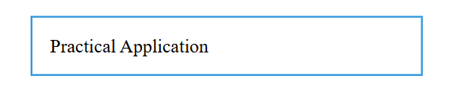

3 ANS:

    box-shadow: 10px 10px 20px 5px rgba(0, 0, 0, 0.2), -10px -10px 20px 5px rgba(0, 0, 0, 0.2);

1. Horizontal offset (10px, -10px): Moves shadow left and right.
2. Vertical offset (10px, -10px): Moves shadow up and down.
3. Blur radius (20px): Blurs shadow.
4. Spread (5px): Increases shadow size.
5. Color (rgba(0, 0, 0, 0.2)): Sets shadow color and opacity.

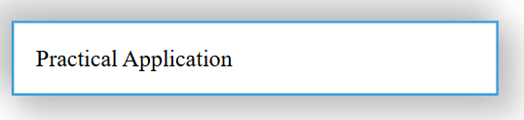

4 ANS:- Debugging CSS Box Model Issues

Issue: Element overflowing container despite 100% width.

Cause: Padding, border, or margin adding to element's width.

Fix: box-sizing: border-box;

This property includes padding and border in the element's width calculation.

5 ANS:

<p>ADVANCED CUSTOMIZATION</p>

<div class="card">

  <h2>Mern Stack</h2>

  <p>This is the 5th class of the shedule Mern Stack</p>

</div>

