**DAY -1:** Orientation Class

**DAY -2:** Introduction to AI

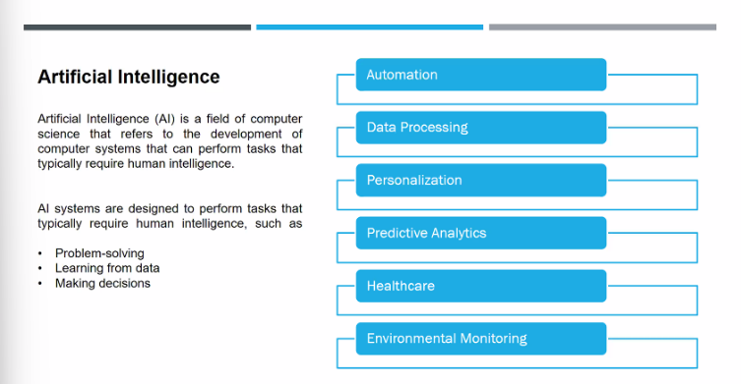

HISTORY OF AI

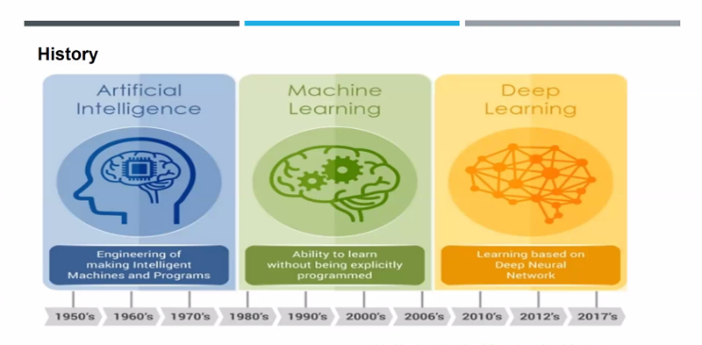

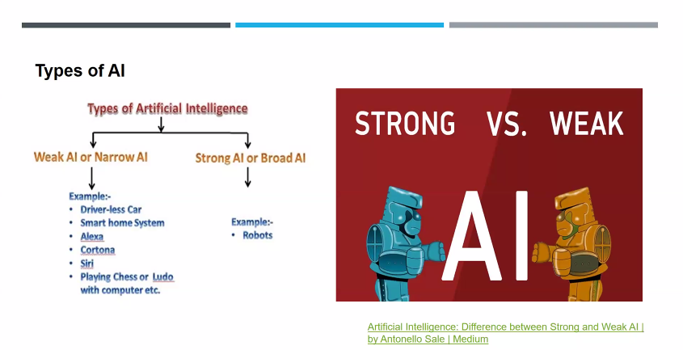

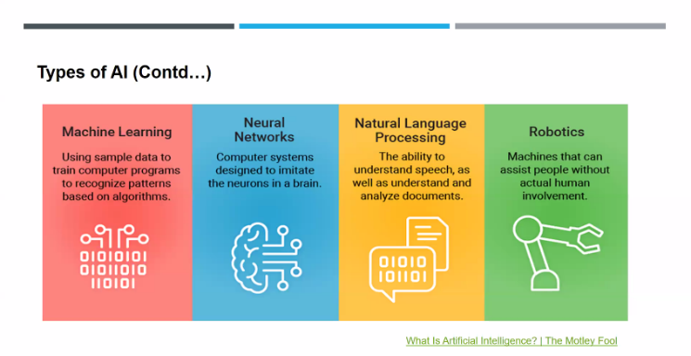

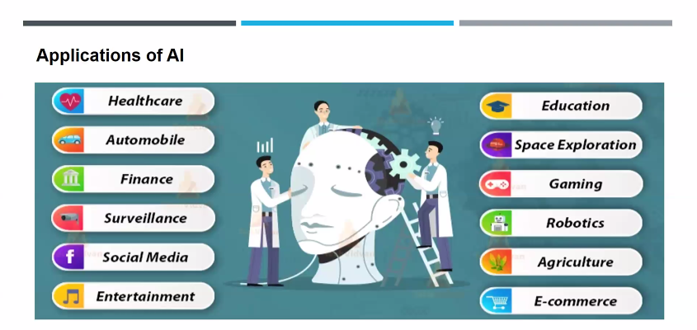

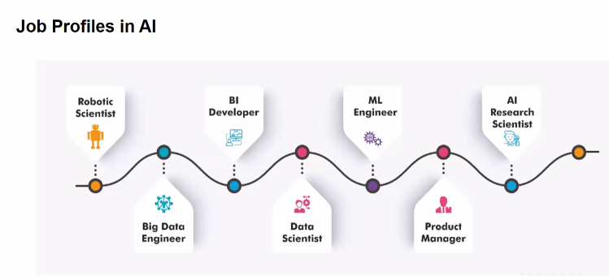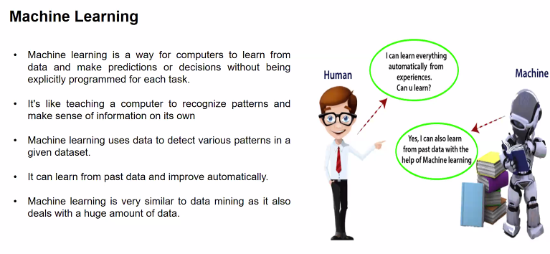

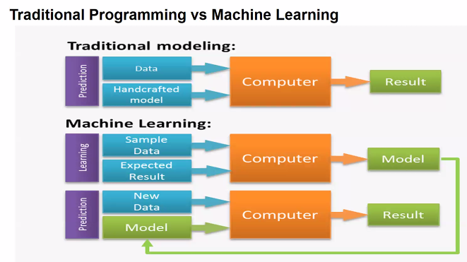

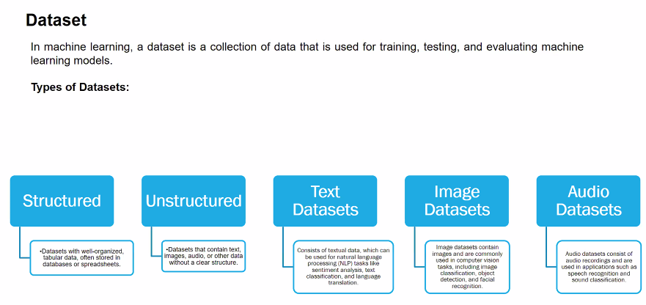

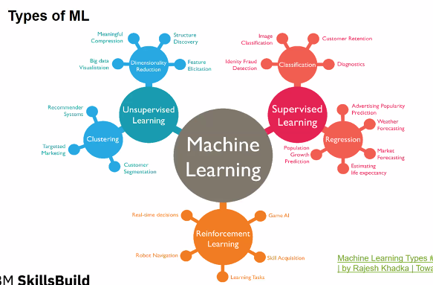

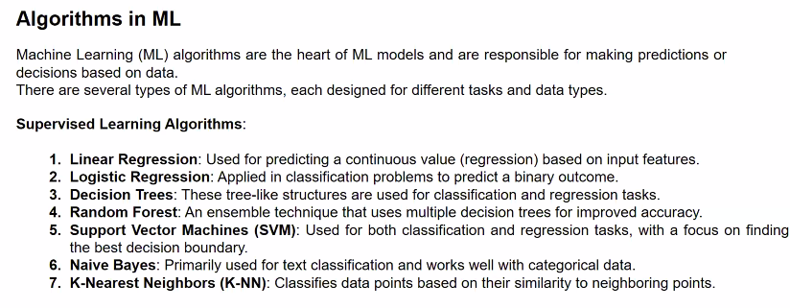

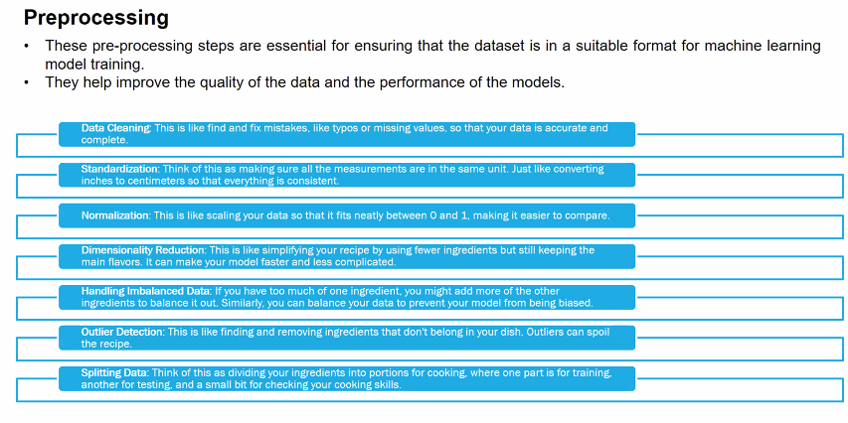

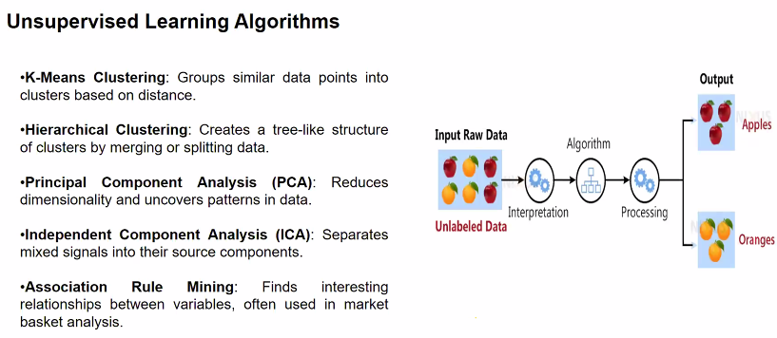

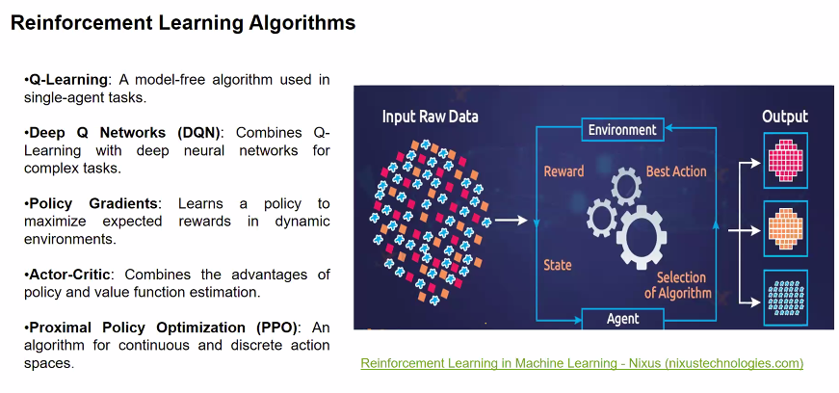

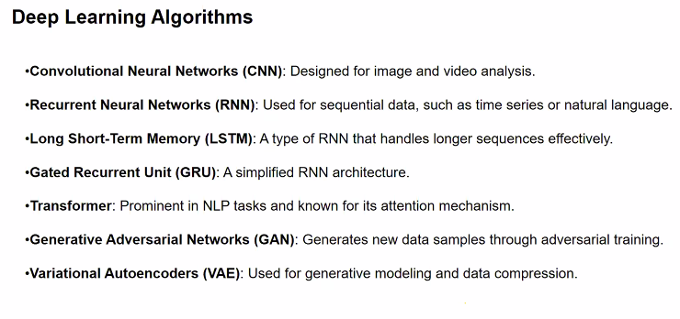

**DAY -3: Introduction to Sentiment Analysis**

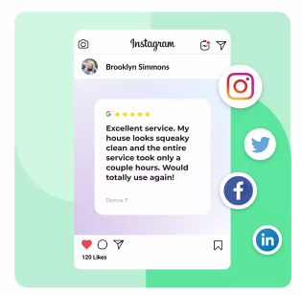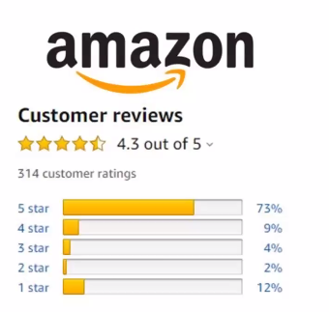

**SENTIMENT ANALYSIS ☹:- (Reviews)**

* Marketing strategy that applied for products.
* Simply ratings are be called as Sentiment Analysis.
* Collecting opinion from the user / customer
* By following the customer reviews the product will be upgraded.

**What is sentiment Analysis:-**

Process used text analysis to determine the emotional tone behind the series of words

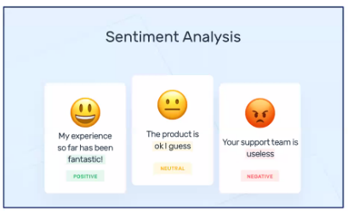

* It is used to understand the attitudes, opinions and emotion expressed within an online mention
* The analysis is comonly performed in textual data to help business understand custoomer feedback, social media interations, and market research.

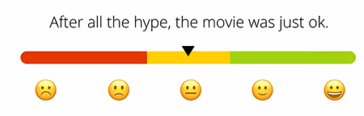

**Why sentiment analysis important?**

* Customer Feedback
* Brand Monitoring
* Market research
* Social media analysis
* By the customer Feedback it will improve the service or quality of the product..!
* To track the customer feeling about the products to monitor their companies Brand..!
* To identify trends and patterns in the market Ex:-**IPL.**
* By noticing the someone review on particualar video comment , we can use that video to see.
* Also used in college joining by the reviews.

**How does Sentiment Analysis works??**

* Text collection (from various resources and different languages)
* Text preprocessing (cleaning the text data for removing the stop words..ie., AND, THIS, THE)
* Tokenization (Breakdown text into similar pieces)

Eg: Edunet is Non-Profit Organization

It will divide into single single words

* Feature Extraction (Identify importat words)

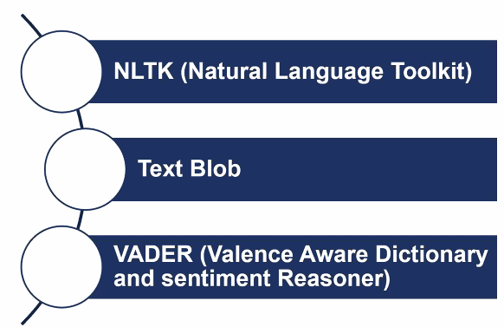Eg: This is a good/bad mobile

Here good/bad describe about the mobile.

* Classification

**Basic Tools and Libraries for sentiment analysis**.

* NLTK (Natural Language Toolkit)
* Text Blob
* VADER (Valence Aware Dictionary and Sentiment Reasoner)

**Real Time Examples of Sentiment Analysis:**

* Customer Feedback
* Social Media Monitoring
* Market Research
* Financial Markets. (stock market/shares)
* Healthcare (To improve healthcare services.., like door-to-door services, tablets..)

**Industries using Sentiment Analysis:**

* Retail and E-commerce
* Hospitality and Tourism
* Finance
* Healthcare
* Entertainment 🡪 Simply movie ratings , spotify
* Public relations
* Technology 🡪 apps ratings

**Advantages of Sentiment Analysis**

* Real-Time Insights 🡪 Provide immediate feedback and apply on the particular product. Eg:- Great Indian Sales, amazon, flipkart
* Cost-Effective (No need to do marketing and campaigns)
* Trend Identification (Ages people – products they buy, and which brand is more in the field)
* Scalability 🡪 We can take 1000’s of pesons feedback at a time
* Improved Customer service 🡪 If negative , improve the products from the negative pick

**Disadvantage of Sentiment Analysis**

* Accuracy Issues
* Context Dependency
* Language Limitations
* Ambiguity 🡪 Not bad
* Data Quality

**Conclusion**

* Sentiment Analysis is a valuable tool for summarize the text into Analysis about the products.

**Summary**

* To identify and catogaraize emotions expressed in text
* To descibe the piece of text is positive, negative or neutral.
* To analyze customer feedback, social media interations and market trends.

**Example Handson Experience**

Drive Link of Google Colaboratory:-

[**Click Here**](https://colab.research.google.com/drive/1HdCjE37heV0hzVMS0H4CyPEabG9ort1Y#scrollTo=jkdRsiKO_Gl6)

**DAY -4: Introduction to Sentiment Analysis**

* import pandas as pd
* data=pd.read_csv("Reviews.csv")
* print(data)
* data
* data.head()
* data.tail()
* data.head(10)
* data.tail(10)
* data.info()
* data.isnull().sum()
* data.duplicated()
* import seaborn as sns
* import matplotlib.pyplot as plt
* from wordcloud import WordCloud
* combined_text=" ".join(data['Review']) #Combine all review text into one string
* wordcloud=WordCloud(width=800,height=400,background_color='white').generate(combined_text)
* plt.figure(figsize=(10,6))
* plt.imshow(wordcloud,interpolation='bilinear')
* plt.axis('off')
* plt.title('Word Cloud of Reviews')
* plt.show()
* from collections import Counter
* targeted_words=['good','great','amazing','bad','not bad']
* all_words=" ".join(data['Review']).lower().split() #flattened reviews into a single list of words
* word_counts=Counter(all_words)
* target_word_count={word:word_counts[word] for word in targeted_words}

#plotting

* plt.figure(figsize=(8,6))
* plt.bar(target_word_count.keys(),target_word_count.values(),color=['blue','green','orange','red','black'])
* plt.xlabel('Words')
* plt.ylabel('Frequency')
* plt.title('Frequency of specific words in reviews')
* plt.show()

**DAY -5: STEPS IN SENTIMENT ANALYSIS**

* Importing Dataset
* Data Preprocessing 🡪 Cleaning the data
  + Text Preprocessing 🡪 Converting Dataset into lowercase
  + Tokenization 🡪 Divide the sentence into smaller pieces; when a new datapoint add it will automatically recognizes and adds to all the +ve and -ve features
  + Stop words 🡪 Removing the stop words (And, the,…)
  + Stemming method 🡪 Cutting off the end of a word to get its basic form.(Running = Run; Happiness = Happi)
  + Lemmatization 🡪 Finding the original form of a word, using a dictionary. (Running =Run; Happiness =Happiness)
  + Removing the numbers
  + Normalization 🡪 To remove the special characters (@,#,$,%,….)
  + Removing the emojis (😊,☹,..)
  + Removing hyperlinks

**DAY -6: STEPS IN SENTIMENT ANALYSIS**