MATH X314 - Data Visualisation
Assessment 4B: Project Portfolio
The Rise of Aggressive Batting in the IPL
How scoring patterns, batting behaviour, and team adaptation shaped modern T20 cricket
Submitted by
Pranav Kadari
A1987287

Introduction
The Indian Premier League has changed the way modern T20 cricket is played. Since its introduction in 2008, IPL batting has become faster, more aggressive, and more dependent on sustained scoring pressure. This project uses IPL match-level and ball-by-ball data from Kaggle to explore how scoring patterns have evolved, how batting performance reflects this change, and how team success connects to adaptation in a high-scoring environment.
The central idea of this data story is that IPL cricket has become increasingly high-scoring, and long-term success depends on how well players and teams adapt to aggressive batting demands. The story is built around five visualisations that move from league-level scoring trends to player-level batting behaviour and finally to team-level success.

1. The IPL has become a higher-scoring competition
The first sign of change appears at the match level. If IPL batting has become more aggressive, then average innings scores should show a clear movement over time. The line chart below tracks average first innings score by season, giving a broad view of how scoring expectations have shifted across IPL history.
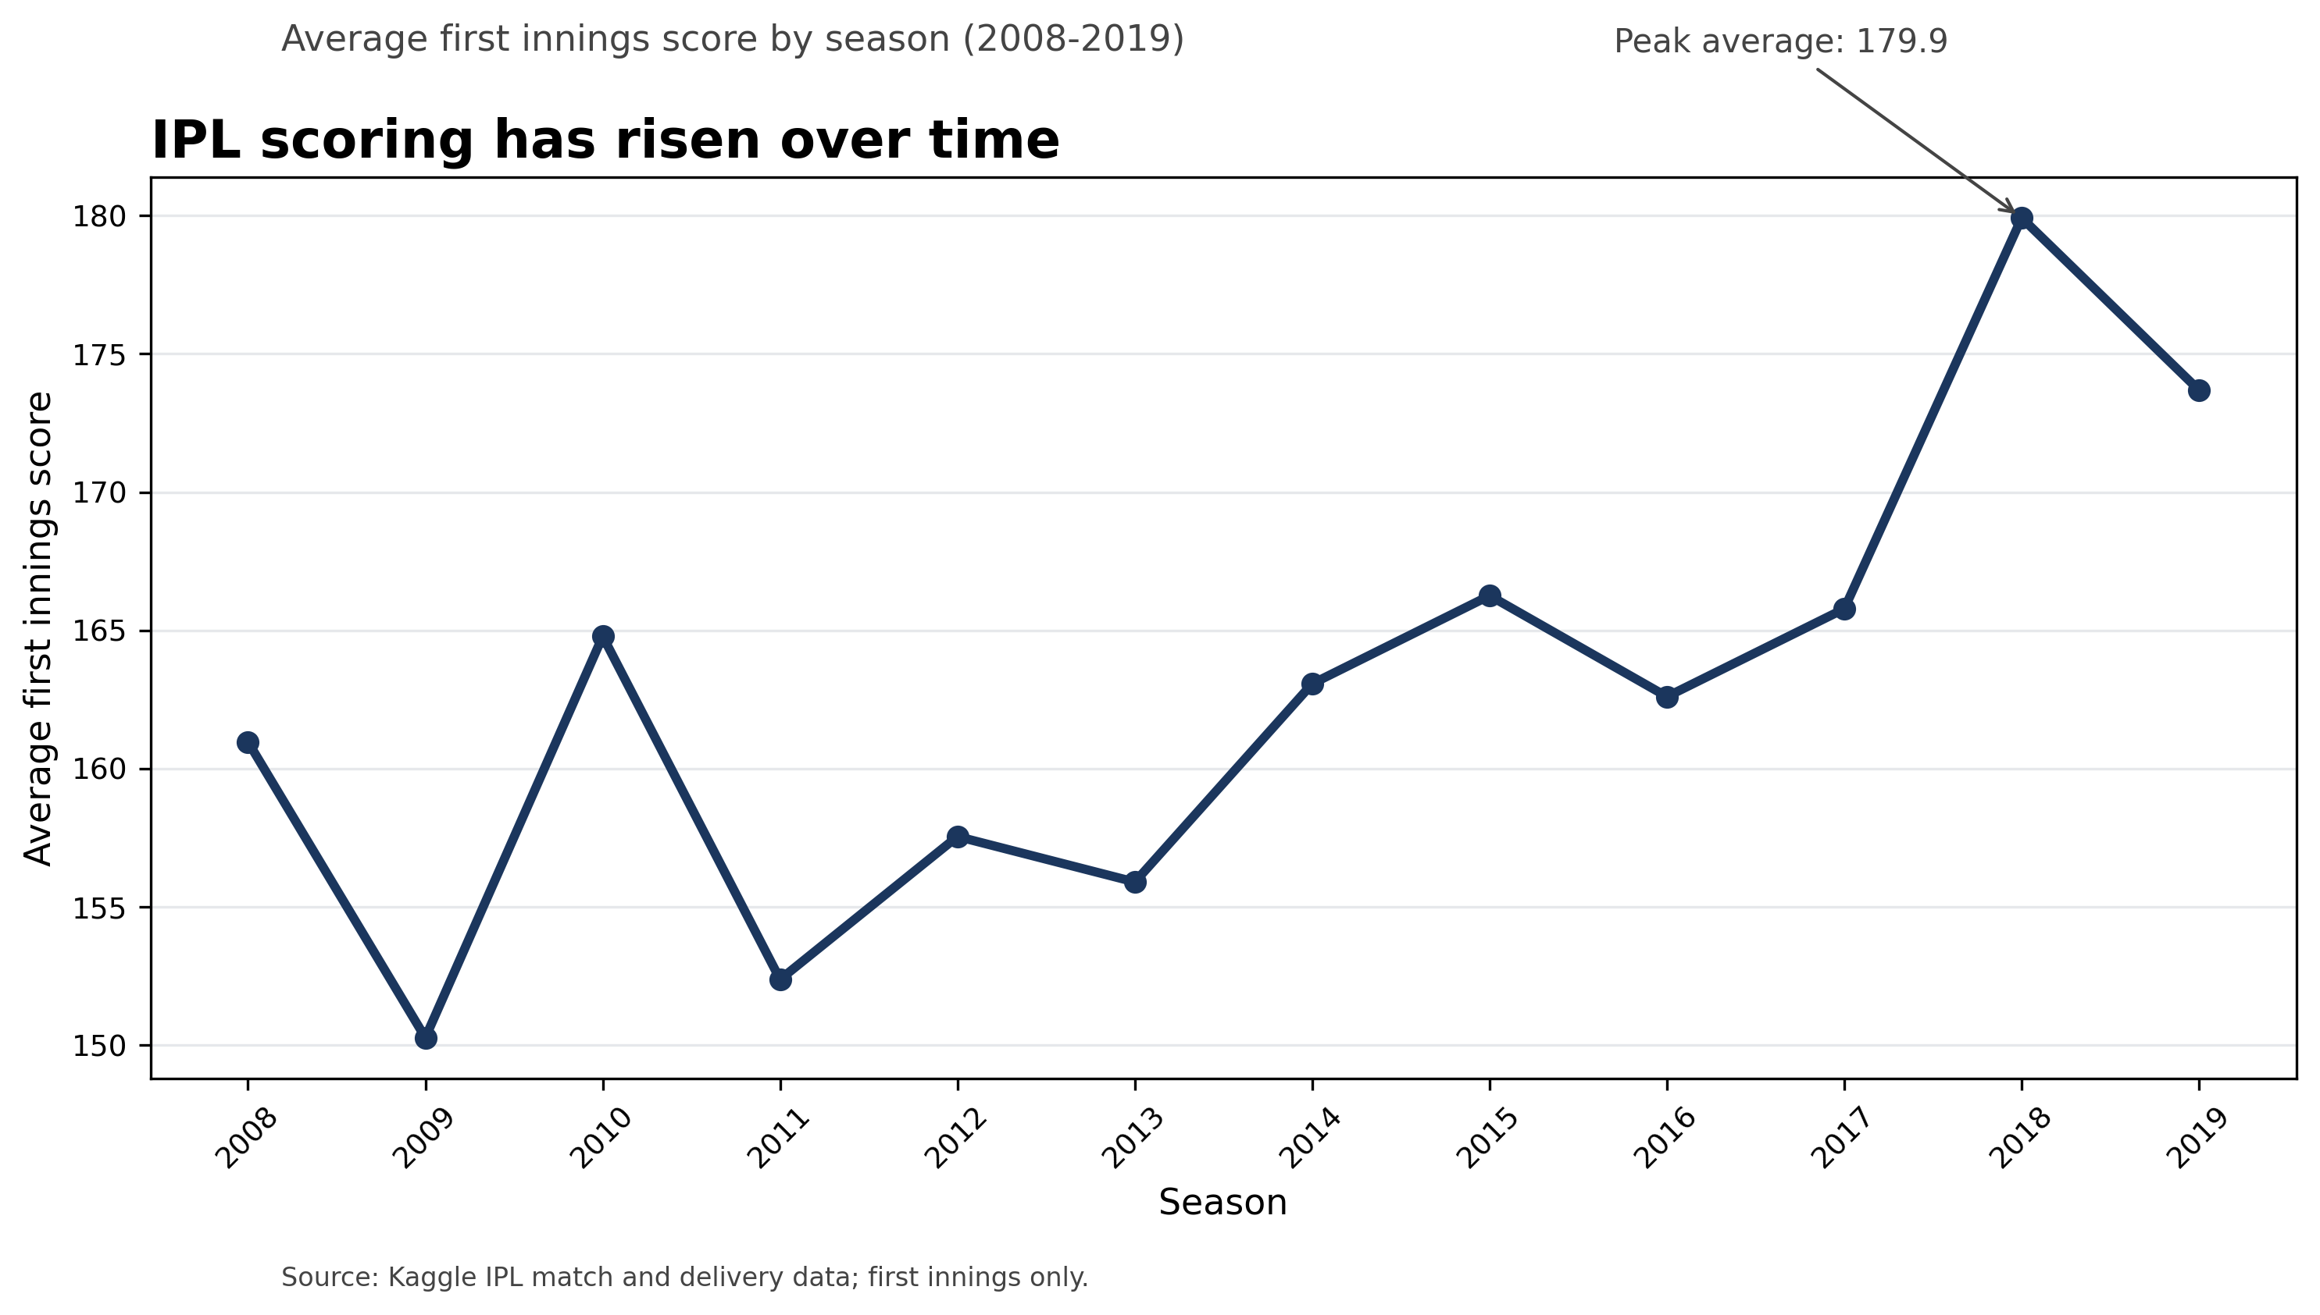
Figure 1. Average first innings scores by season show the broader movement towards higher-scoring IPL cricket.
The trend shows that average first innings scores have generally increased across IPL seasons. While individual years fluctuate, the overall pattern suggests that teams are increasingly expected to produce higher totals. This supports the idea that IPL cricket has moved towards a more attacking scoring environment.
However, a single average can hide important variation. To understand whether high scores are becoming normal rather than occasional, the next visualisation looks at full score distributions by season.

2. High scores are becoming more common
Average scores show the broad trend, but they do not reveal how much variation exists within each season. A boxplot provides a deeper view by showing median scores, spread, and unusually high or low innings totals.
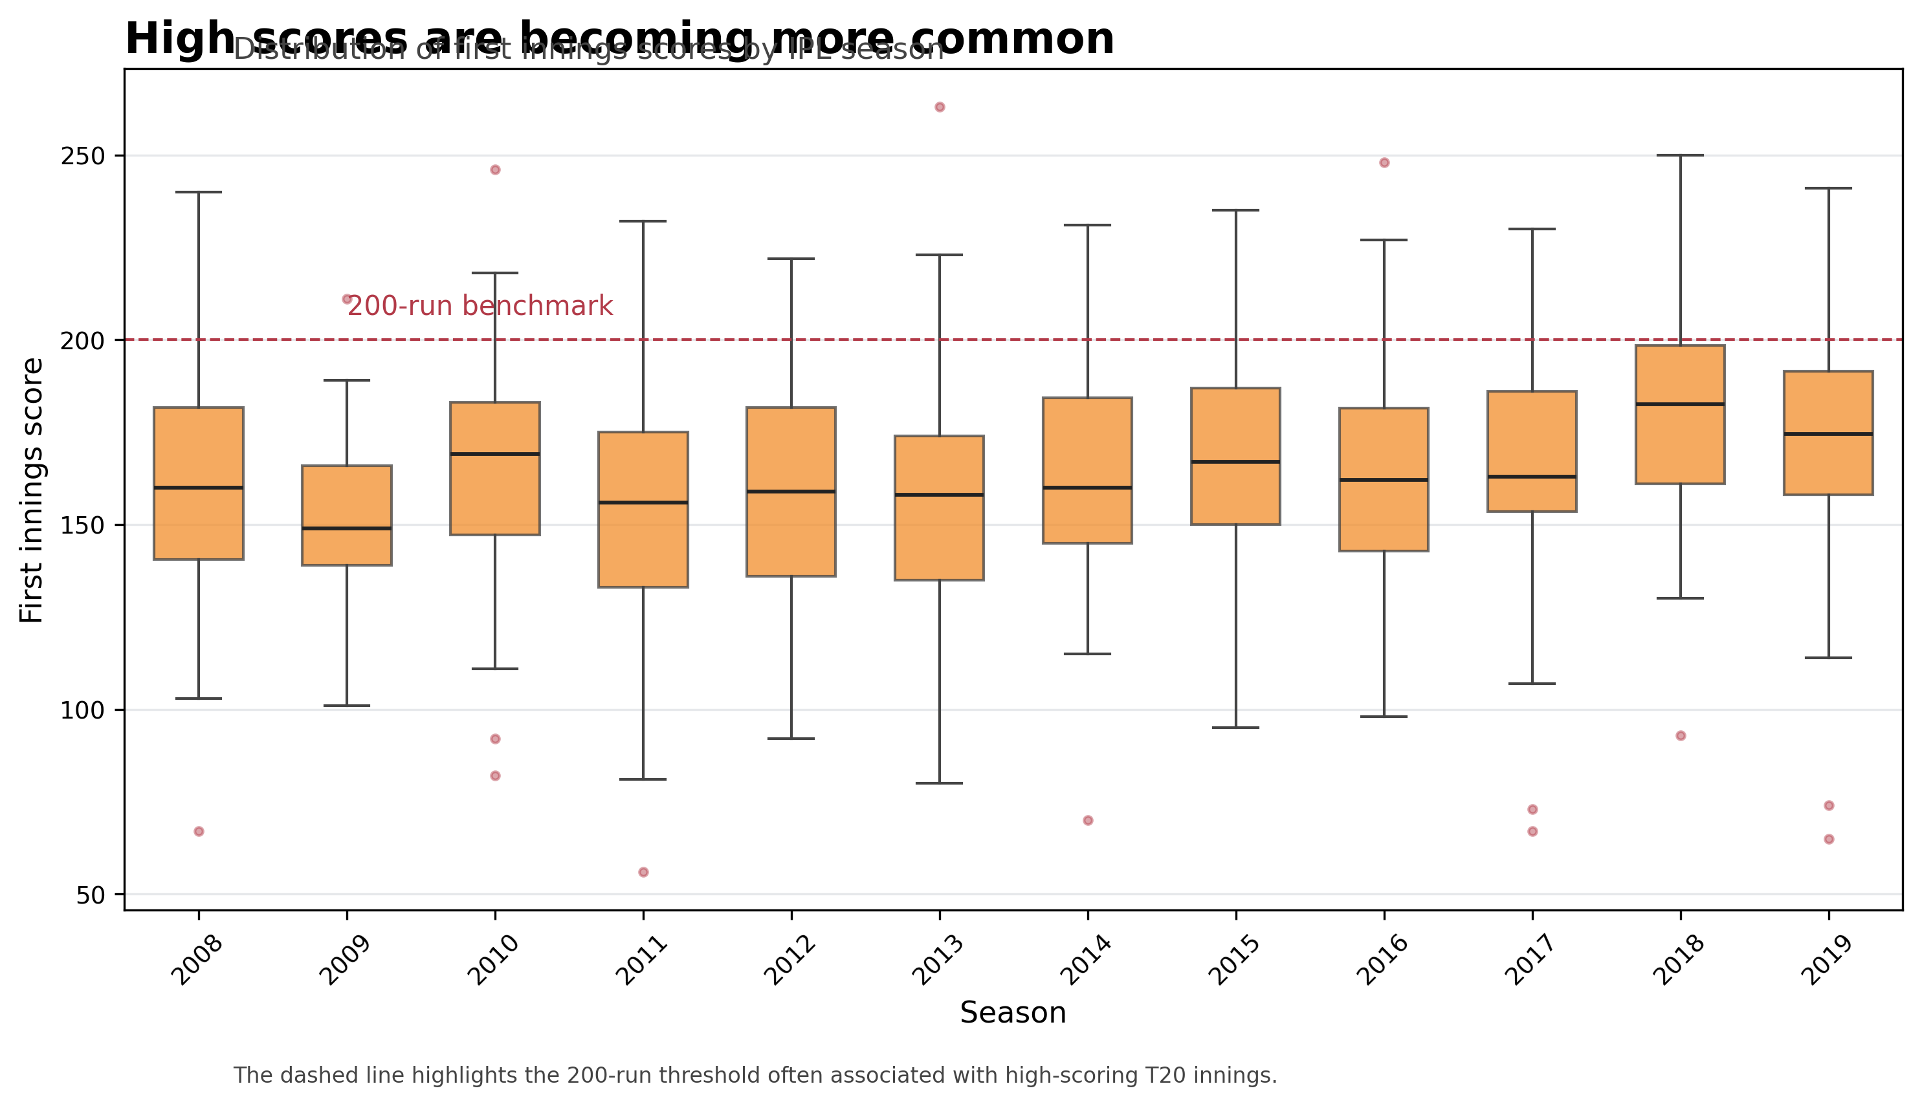
Figure 2. Score distributions show medians, spread, and high-scoring outliers across IPL seasons.
The distribution of first innings scores shows that recent IPL seasons contain more high-scoring outliers and generally higher central values. The 200-run benchmark appears increasingly relevant in later seasons, suggesting that high totals have become more common rather than rare exceptions. The widening spread also indicates that teams are taking more risks, producing both very high totals and occasional failures.
These changing scoring expectations raise a player-level question: what kind of batting creates these totals?

3. Successful batting balances speed and volume
In T20 cricket, scoring quickly is important, but successful innings also require batters to stay long enough to build meaningful contributions. The scatterplot below examines the relationship between runs scored and strike rate for IPL batting innings.
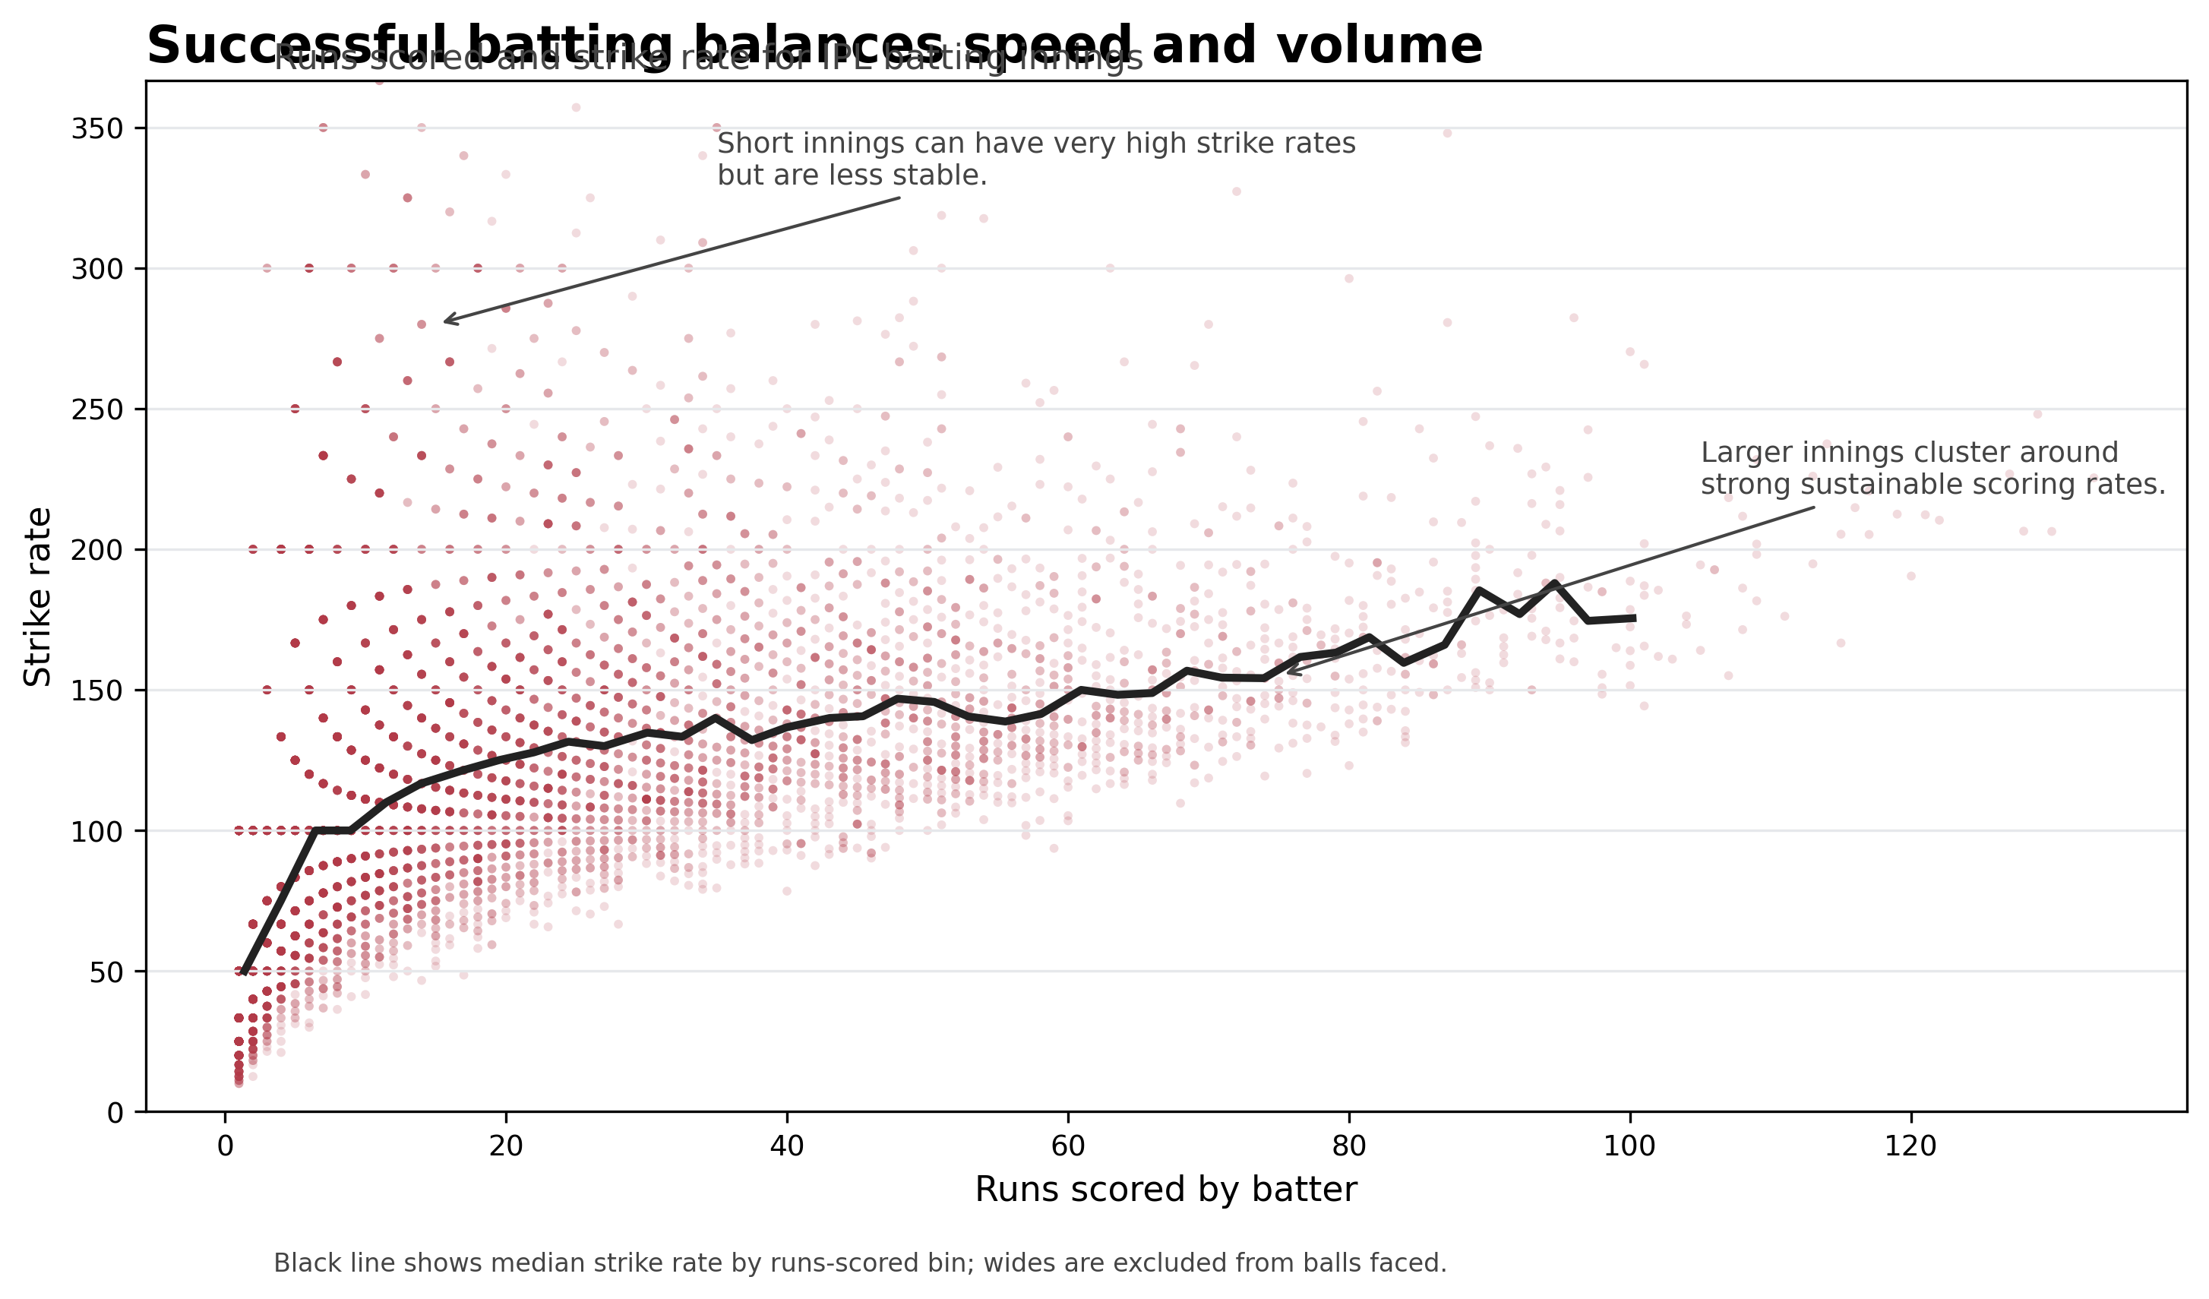
Figure 3. Runs scored and strike rate together reveal how aggressive batting becomes sustainable.
The scatterplot shows that runs scored and strike rate are positively related, but the relationship is not simple. Short innings can produce extreme strike rates, but larger scores tend to cluster around strong and sustainable scoring rates. This suggests that successful IPL batting is not only about hitting quickly; it is about maintaining aggression over a longer innings.
If modern IPL batting requires this balance, then team success may depend on how effectively franchises build squads and strategies around aggressive but consistent scoring.

4. Some teams win more consistently than others
Win rate provides a simple way to compare long-term team performance across IPL history. Although a team’s success is influenced by many factors, win rate helps show which franchises have been most consistent in the competitive T20 environment.
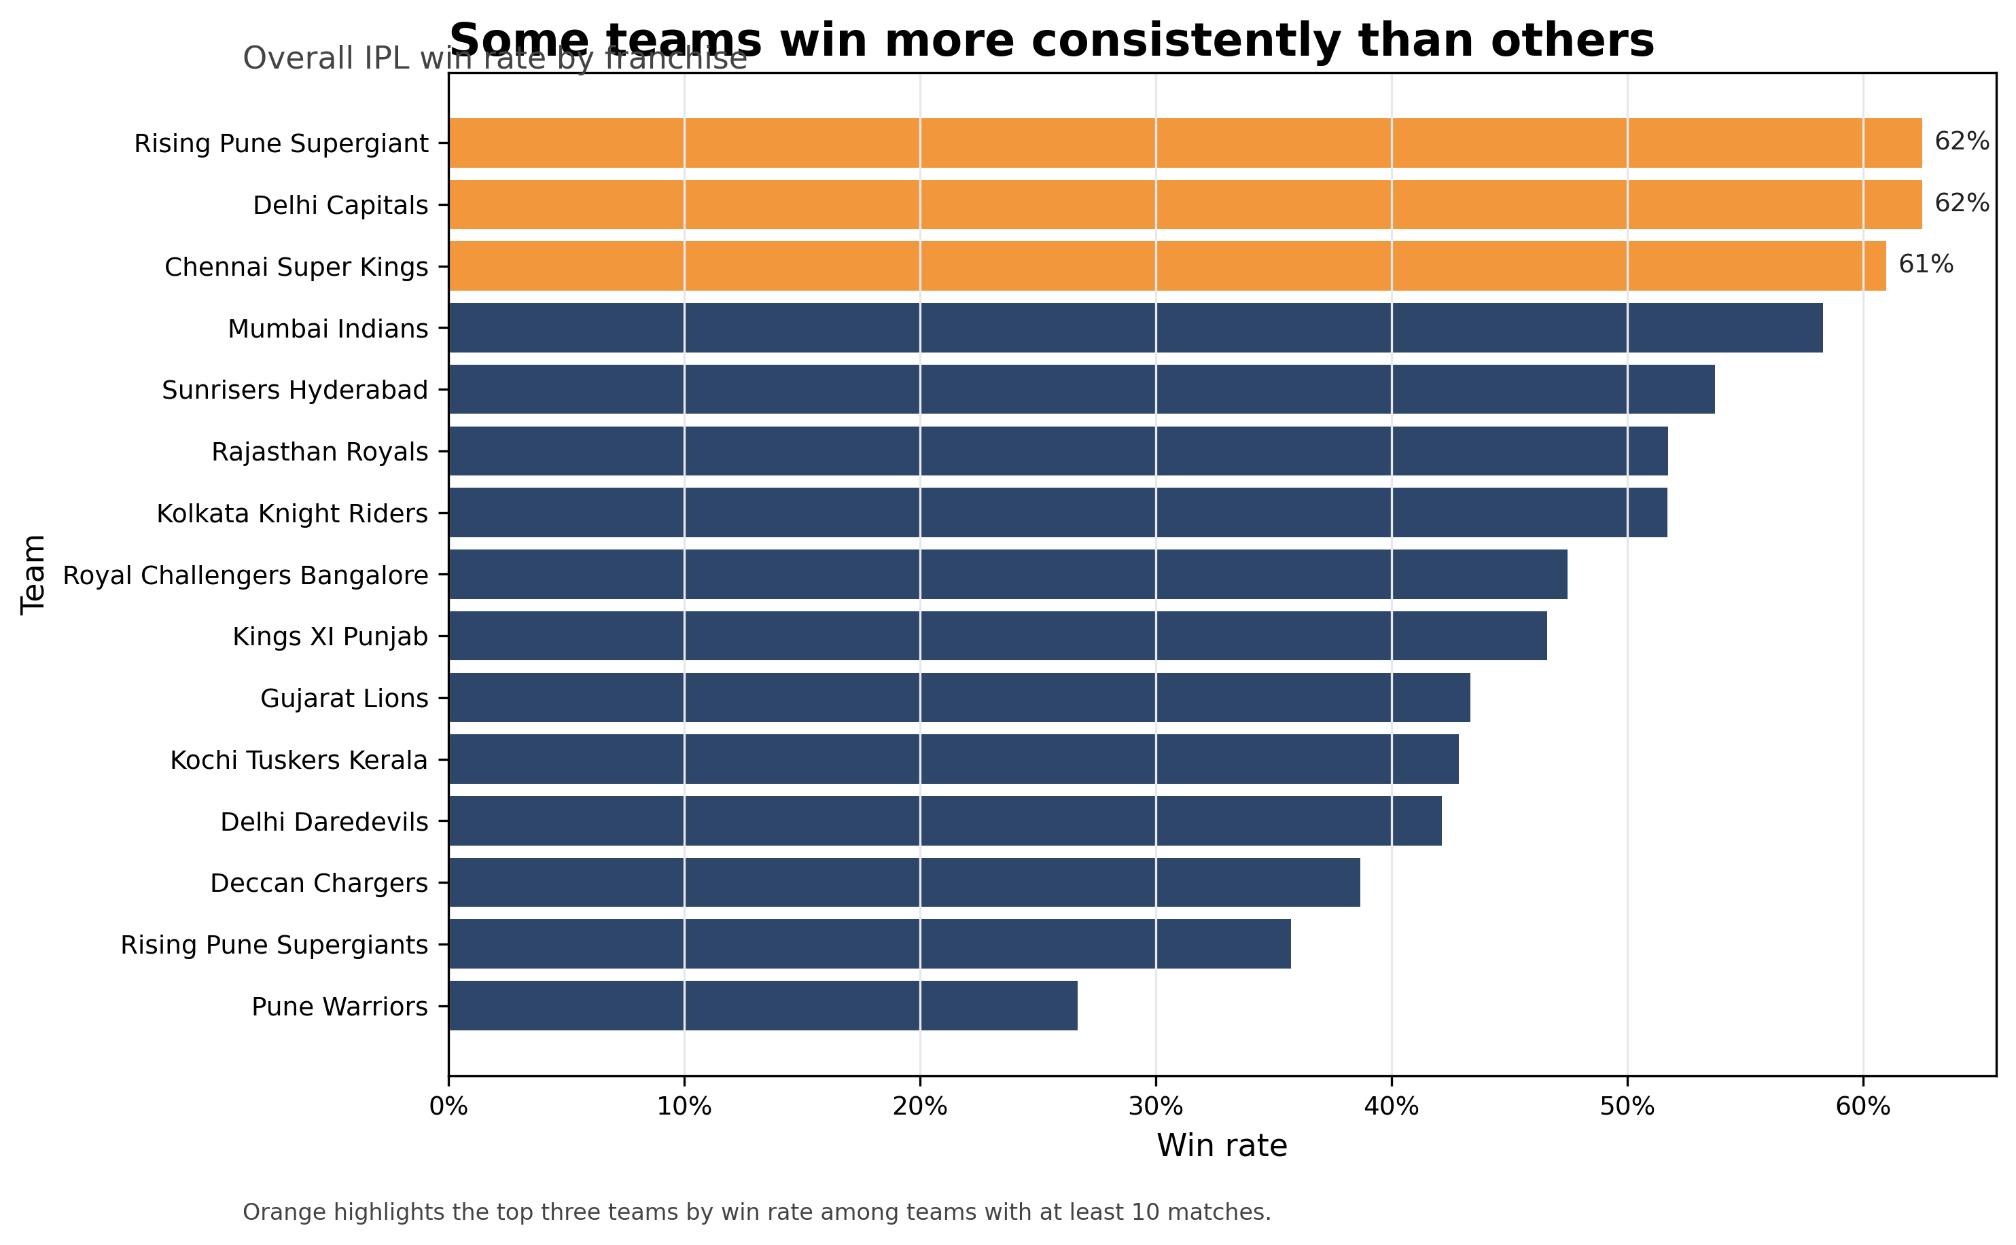
Figure 4. Team win rates show long-term differences in franchise success.
The win-rate comparison shows clear differences between franchises. Some teams achieve stronger win rates, while others struggle to sustain success. Although win rate is not caused by batting alone, the comparison suggests that consistent performance in the IPL depends on adaptation, squad balance, and tactical stability.
The next question is whether team scoring patterns also reveal uneven adaptation to the league’s higher-scoring environment.

5. Team scoring patterns reveal adaptation over time
The heatmap connects scoring trends more directly with teams by comparing average first innings scores across franchises and seasons. This adds a higher-order view of the data because it combines team, season, and scoring intensity in one visualisation.
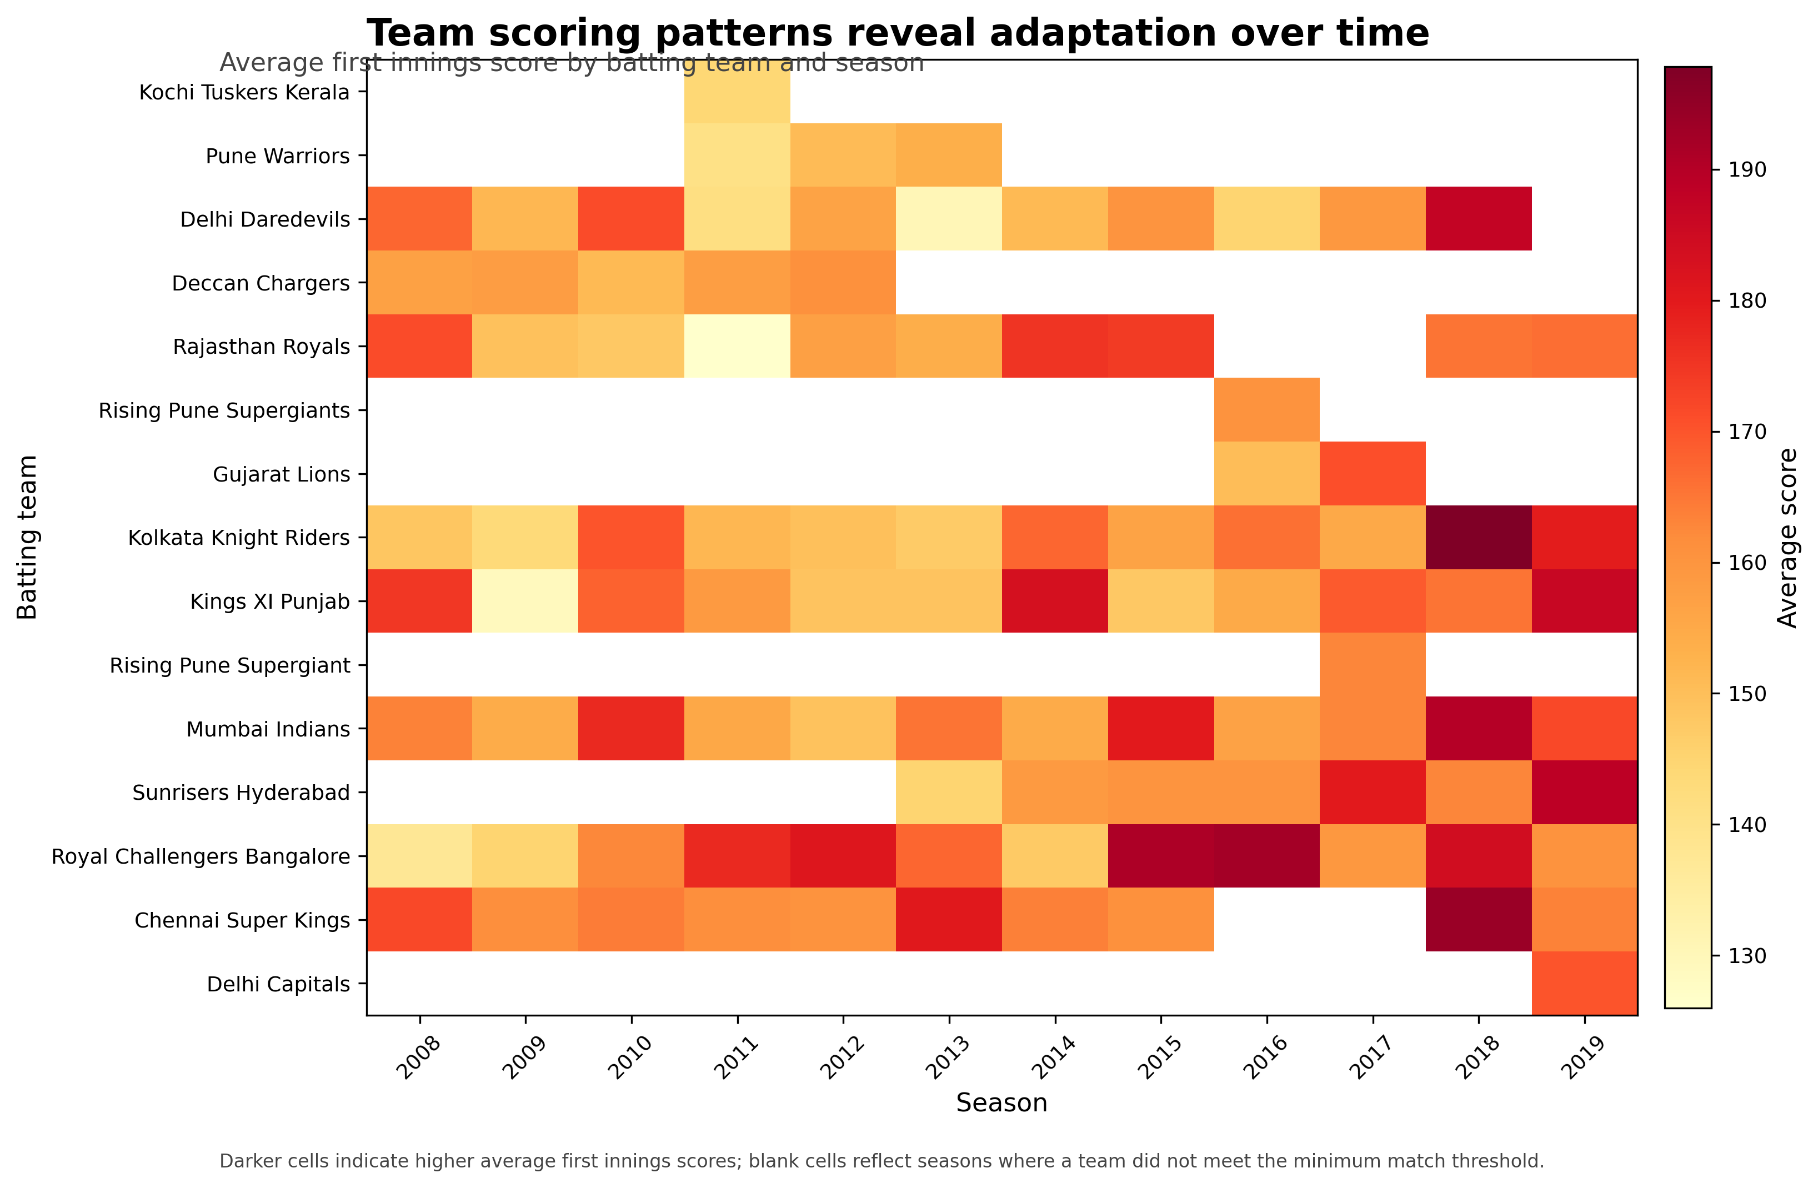
Figure 5. Team-season scoring intensity highlights uneven adaptation to high-scoring IPL cricket.
The heatmap shows that high-scoring cricket is not evenly distributed across all teams and seasons. Some franchises and time periods are associated with consistently higher first innings scores, while others show more inconsistent scoring patterns. This supports the broader story that adaptation to high-scoring cricket is uneven across the league.

Interactive exploration
A separate interactive HTML explorer is included with this portfolio. It allows viewers to choose individual teams and inspect scoring trends with hover tooltips. This interactive component extends the static story by allowing deeper user-led exploration of team performance and scoring patterns.

Conclusion
Across the IPL’s history, the evidence points to a clear shift towards higher-scoring and more aggressive cricket. Average first innings scores have risen, high totals have become more common, and successful batting increasingly requires a balance between strike rate and sustained run production.
At team level, the strongest franchises appear to combine aggressive scoring potential with consistency and tactical adaptability. The IPL therefore reflects a broader transformation in modern T20 cricket: success is no longer only about individual talent, but about building teams and strategies that can survive and thrive in a faster, higher-scoring environment.

References
Kaggle. (n.d.). IPL Complete Dataset (2008-2020). Kaggle. https://www.kaggle.com/datasets/patrickb1912/ipl-complete-dataset-20082020
Sievert, C. (2020). Interactive web-based data visualization with R, plotly, and shiny. Chapman and Hall/CRC.
Wickham, H. (2016). ggplot2: Elegant graphics for data analysis. Springer.

