Banking Project Phase 2 Document
Design Document

(Shane, Omar, Janno, Manisha, Kaden)
Table of Contents

- Project Overview (pg. 3)
- UML Class Diagram (Pg. 4)
- UML Use Case Diagram (PG. 5)
- UML Sequence Diagram (Pg. 6 - 8)
- FUTURE FEATURES TO IMPLEMENT (PG. 9)

- Project Overview
For our banking system, we designed a multithreaded client-server architecture utilizing the client server pattern so multiple users can connect and perform transactions at the same time without the system slowing down or freezing. We divided users into two groups: Customers and Employees, each with their own client application. Customers will use a digital ATM interface to deposit, withdraw, transfer funds between own accounts, and freeze their accounts. Employees (tellers) will use a separate workstation application that allows them to perform those same actions for customers, along with additional administrative tasks such as looking up accounts, creating new customer profiles, closing accounts, and unfreezing accounts.
To keep everything consistent, we created a shared package so both the client and server use the same data structures for users and accounts.
We also use inheritance to handle different account types like Checking, Savings, and Credit, since each type has its own rules for things like interest and withdrawal limits. Communication between the client and server is handled by sending serialized Java objects, specifically using a Message class that packages a command type along with any necessary data. This approach keeps communication structured and avoids the need to parse raw text. On the server side, each new connection is handled by a separate ClientHandler thread, allowing the system to stay responsive even with multiple users. This allows multiple clients to interact with the system concurrently without blocking each other. All data is processed on the server and stored in a text file database so that account information and transaction history are preserved even if the system restarts.

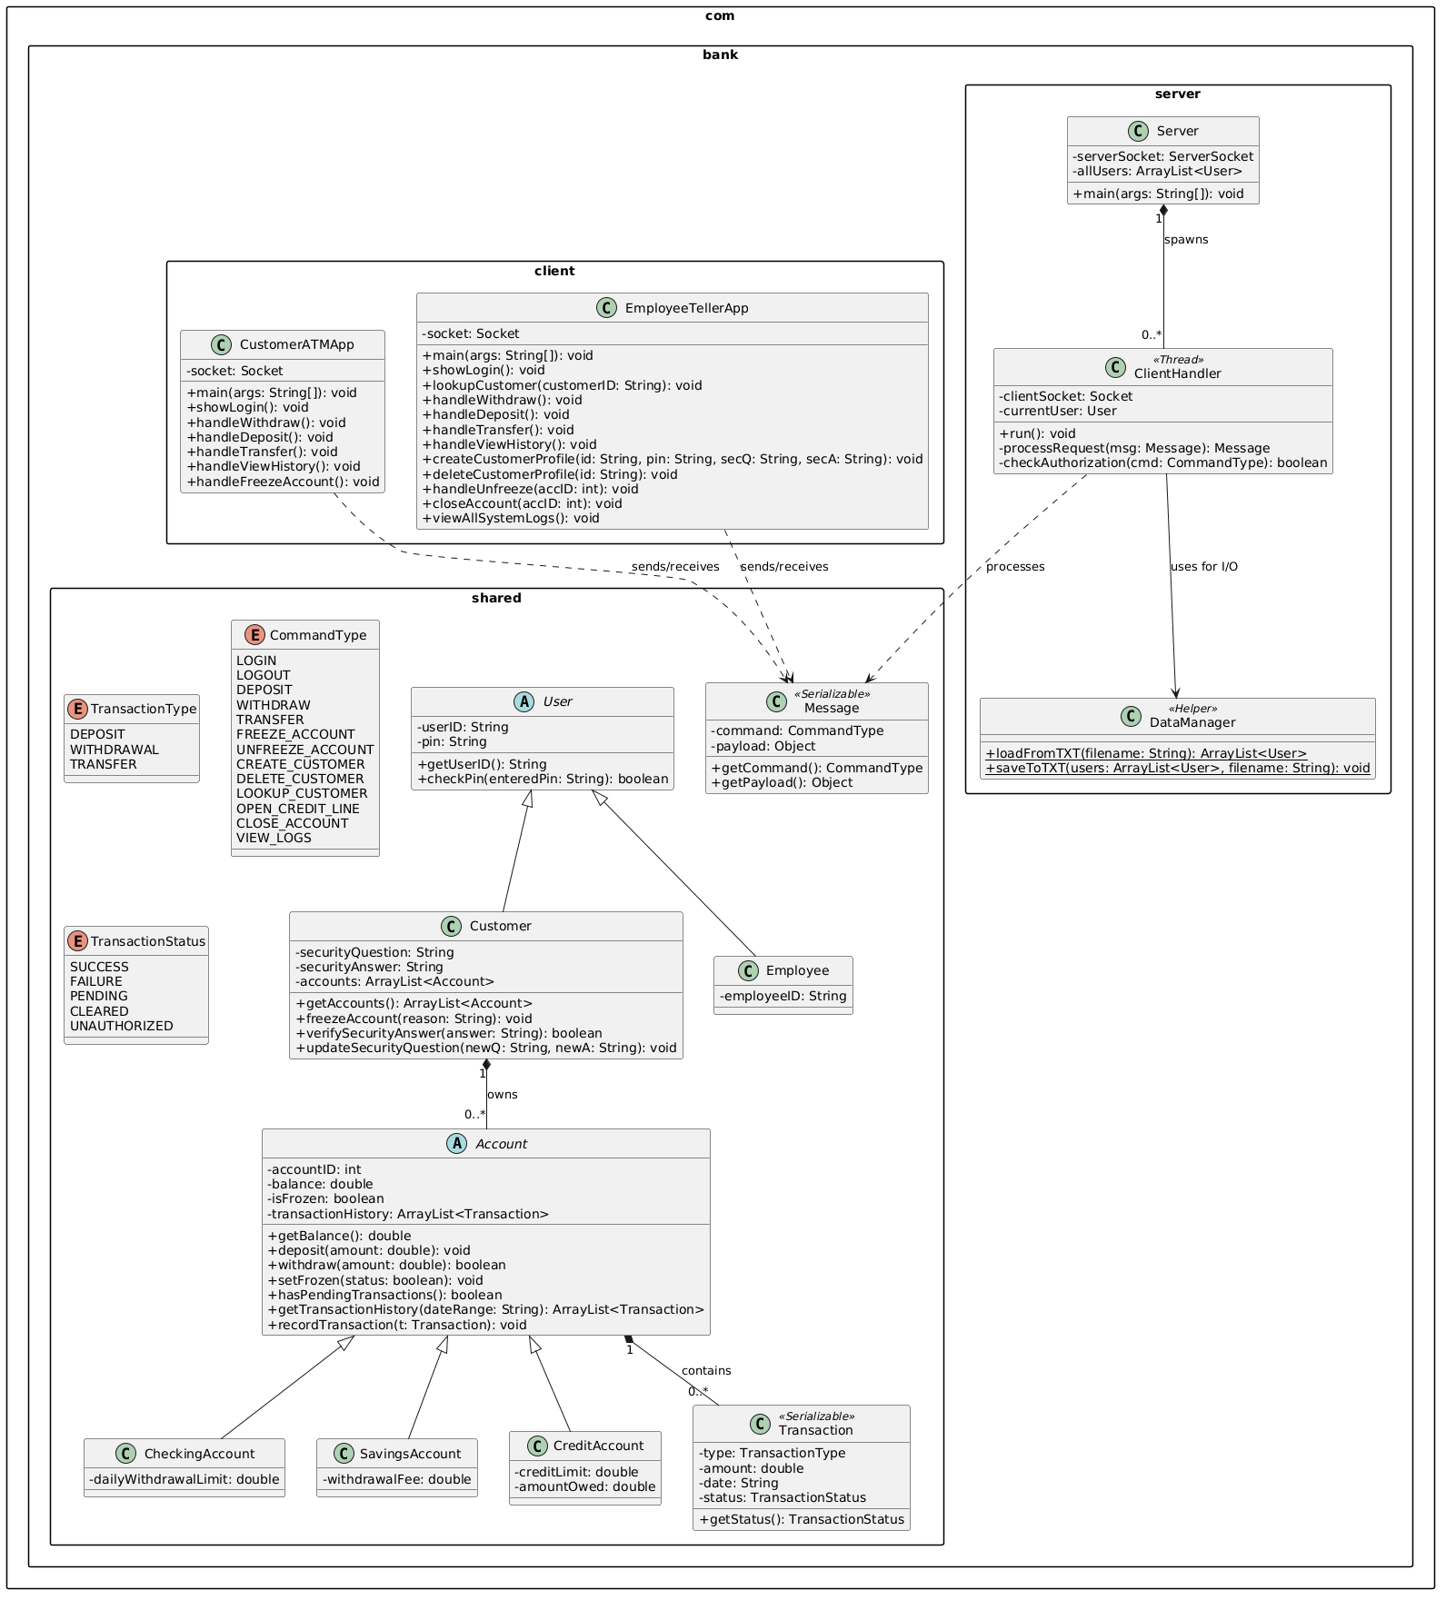
- UML Class Diagram
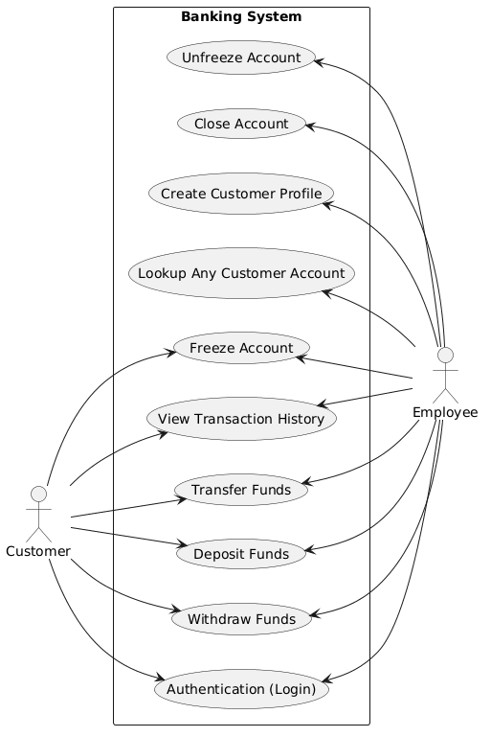
- UML Use Case Diagram
D. UML Sequence DiagramS
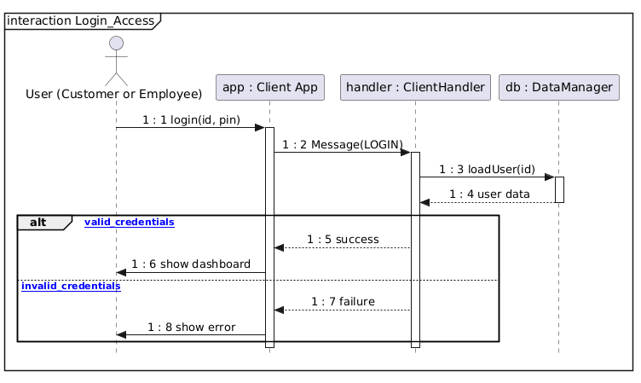
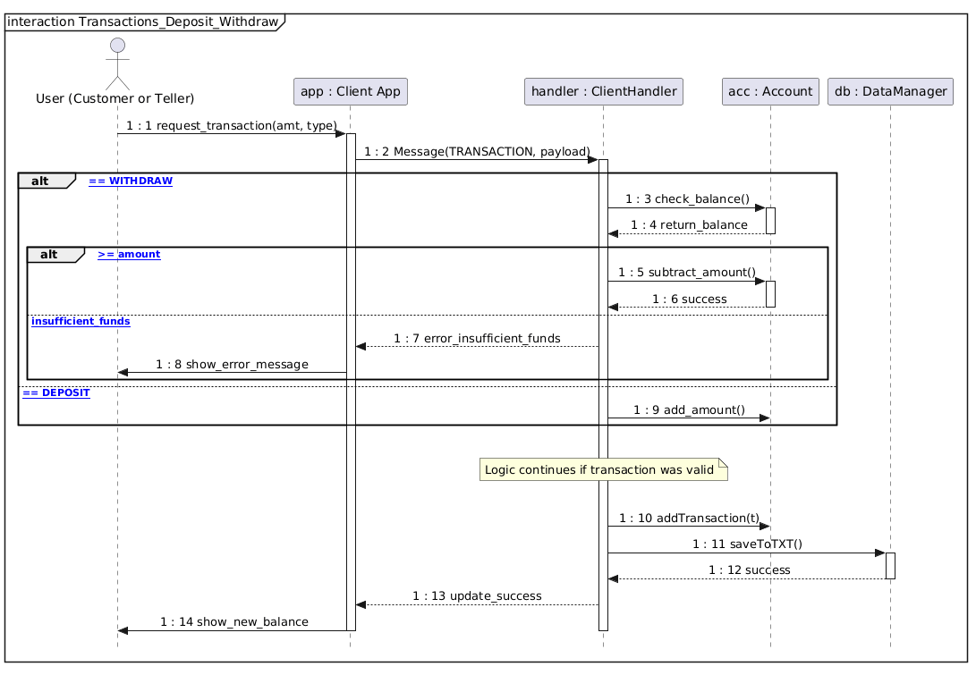

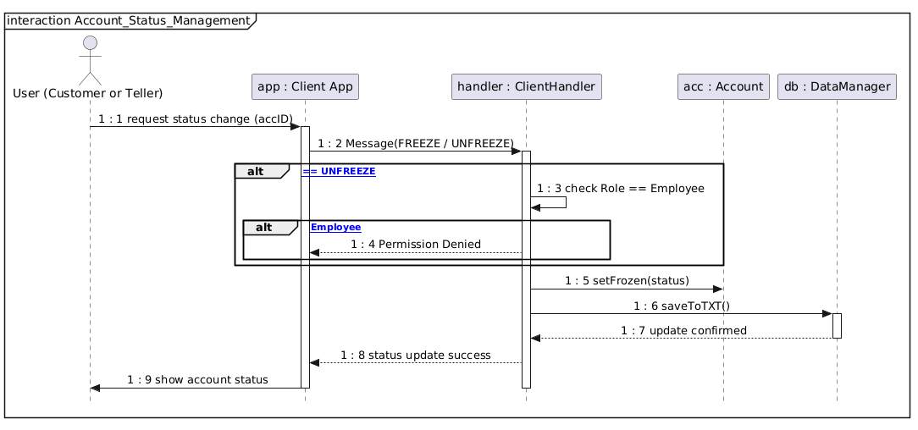
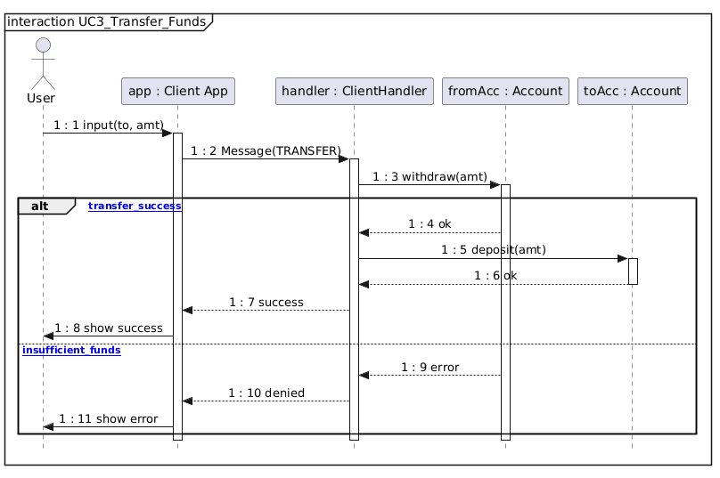

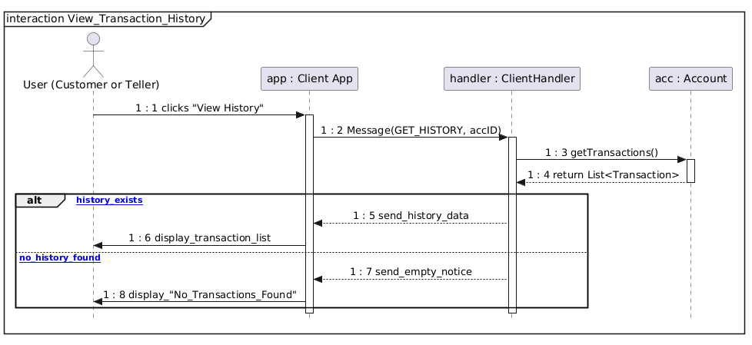

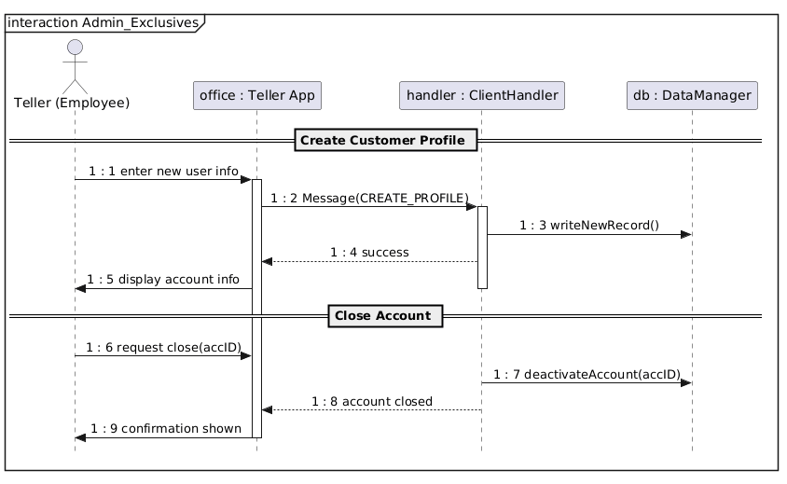

E. FUTURE FEATURES TO IMPLEMENT
There were a few features in the design CONSIDERED FOR THE FUTURE that we have to finish implementing fully:
- Transaction History/LOGS
- CUSTOMERS TRANSFERING FUNDS TO OTHER CUSTOMERS.

