main main document

Micro-City Traffic Routing Simulation Using Dijkstra's and Floyd-Warshall Algorithms
Algorithm Design Project Documentation
Submitted by:
Del Rosario, Kervin
Dorosan, Jessica Danielle
Guiang, Mariah Kate
Sabayo, Arnulfo

Course: Algorithms and Complexity
Instructor: Sir Joel C. De Goma
Date of Submission: July 3, 2026

TABLE OF CONTENTS
1. INTRODUCTION 2
1.1. Background of the Problem 2
1.2. Problem Statement 2
1.3. Objectives 2
2. REVIEW OF RELATED CONCEPTS 3
3. METHODOLOGY / ALGORITHM DESIGN 3
3.1. Overview of Solution 3
3.2. Design Technique 3
3.3. Algorithm Explanation 3
3.4. Pseudocode Format 4
3.5. Flowchart / Diagram 6
4. IMPLEMENTATION 8
4.1. Programming Language 8
4.2. Tools Used 8
4.3. Code Format 8
5. TESTING AND RESULTS 9
5.1. Test Cases Table 9
5.2. Complexity Analysis 9
5.3. Results Discussion 9
6. ANALYSIS AND DISCUSSION 9
7. CONCLUSION 9
8. RECOMMENDATIONS 9
9. REFERENCES 9
10. APPENDICES 10
11. CONTRIBUTION TABLE 10

INTRODUCTION

Background of the Problem
Urban congestion and inefficient delivery routing are major logistical challenges in central business districts like Makati. As commercial traffic increases, identifying the fastest route between key intersections becomes critical to reducing travel time and operational overhead. Algorithmic pathfinding provides a mathematical foundation for solving these routing inefficiencies by representing city streets as weighted graphs.

Problem Statement
The core problem is minimizing delivery and travel time within a small road network. This requires computing the optimal sequence of intersections to traverse between a specific start and destination node to yield the lowest cumulative travel time.
Constraints
- Input Size: The simulated map is restricted to a small-scale micro-city grid containing 6 to 9 nodes (intersections).
- Connectivity: The graph must be fully connected with at least two alternate routes between some pairs of nodes so the shortest path is not trivially obvious.
- Values: Roads (edges) are assigned specific travel-time weights in minutes.

Objectives
General Objective
To evaluate and compare the implementation and execution efficiency of Dijkstra's and Floyd-Warshall algorithms in solving the shortest path problem within a micro-city road network.

Specific Objectives
- Create a 7-intersection test map of the Makati CBD with realistic travel times in minutes.
- Write Python code for both Dijkstra's and Floyd-Warshall algorithms to calculate the shortest routes on the map.
- Record how fast each algorithm runs (in milliseconds) and explain why their actual speeds might differ from their theoretical limits.

REVIEW OF RELATED CONCEPTS
- Discuss related algorithms or techniques
- Cite references properly using APA format
- Use in-text citations

METHODOLOGY / ALGORITHM DESIGN

Overview of Solution
High-level explanation

Design Technique
(Bold the chosen technique)
- Brute force
- Decrease-and-conquer
- Divide-and-conquer
- Dynamic Programming
- Greedy
- Backtracking
Provide justification (1-2 paragraphs)

Algorithm Explanation
- Present step-by-step explanation
- Use numbered format:
- Initialize variables
- Process Inputs
- Apply logic
- Return result

Pseudocode Format
Djikstra’s Algorithm:

function Dijkstra(Graph, StartNode, DestinationNode):
// 1. Initialization
Create a map 'distances', set all to Infinity
distances[StartNode] = 0
Create a map 'previous_nodes' to reconstruct the path
Create a PriorityQueue and insert (0, StartNode)

// 2. Exploration
While PriorityQueue is not empty:
CurrentDistance, CurrentNode = PriorityQueue.pop()

// Early exit if destination is reached
if CurrentNode == DestinationNode:
break

// 3. Relax edges
For each Neighbor, Weight in Graph[CurrentNode]:
NewDistance = CurrentDistance + Weight

if NewDistance < distances[Neighbor]:
distances[Neighbor] = NewDistance
previous_nodes[Neighbor] = CurrentNode
PriorityQueue.push((NewDistance, Neighbor))

return distances, previous_nodes

Floyd-Warshall Algorithm

function FloydWarshall(Graph):
// 1. Initialization
Let V be the list of all nodes
Create a 2D array 'dist' filled with Infinity
Create a 2D array 'next_node' filled with Null

// Set base cases
For each node v in V:
dist[v][v] = 0

For each node u in Graph:
For each neighbor v, weight w of u:
dist[u][v] = w
next_node[u][v] = v

// 2. Dynamic Programming Triple Loop
For each intermediate node k in V:
For each source node i in V:
For each destination node j in V:
// If path through k is faster, update
if dist[i][j] > dist[i][k] + dist[k][j]:
dist[i][j] = dist[i][k] + dist[k][j]
next_node[i][j] = next_node[i][k]

return dist, next_node

Flowchart / Diagram
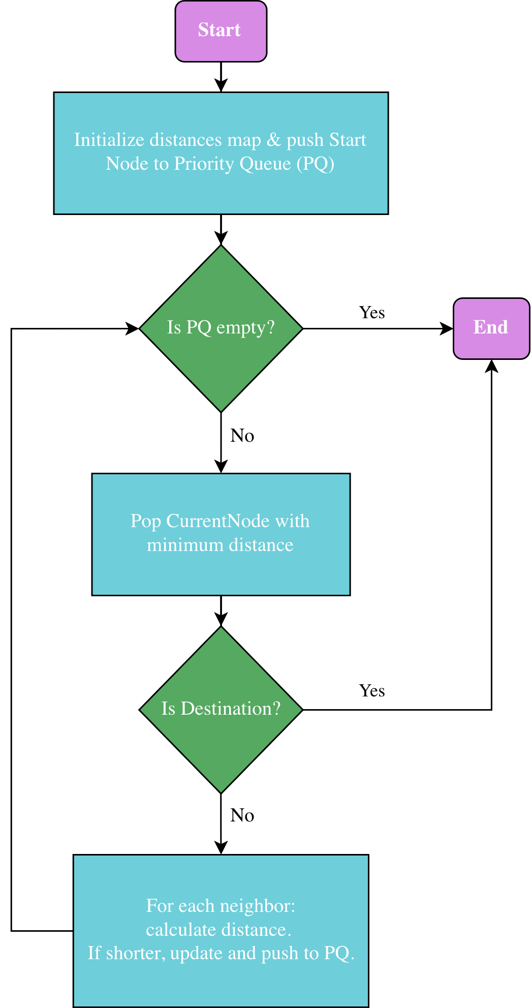

Figure 1. Djikstra’s Algorithm Flowchart

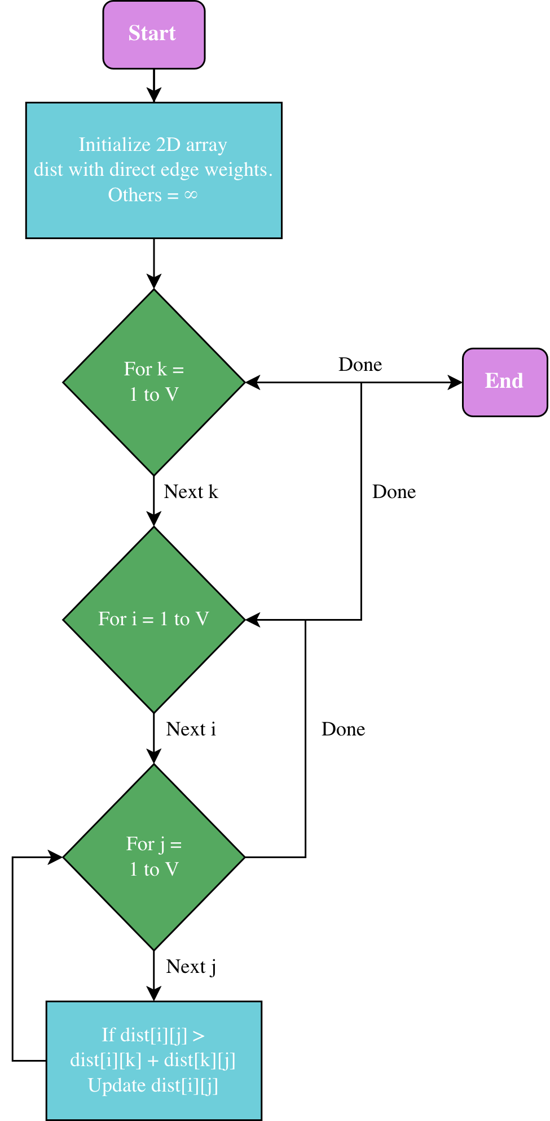
Figure 2. Floyd-Warshall Algorithm Flowchart

IMPLEMENTATION

Programming Language
Python 3.x

Tools Used
Editor: Visual Studio Code (VS CODE)
Libraries: Heapq, time, math

No external packages or pip installs required.

Code Format
Dijkstra

while priority_queue:
current_distance, current_node = heapq.heappop(priority_queue)

if current_node == destination:
break

if current_node in visited:
continue
visited.add(current_node)

for neighbor, travel_time in graph[current_node].items():
new_distance = current_distance + travel_time
if new_distance < distances[neighbor]:
distances[neighbor] = new_distance
previous_nodes[neighbor] = current_node
heapq.heappush(priority_queue, (new_distance, neighbor))

Floyd-Warshall
for k in nodes:
for i in nodes:
for j in nodes:
if dist[i][k] == math.inf or dist[k][j] == math.inf:
continue
path_through_k = dist[i][k] + dist[k][j]
if path_through_k < dist[i][j]:
dist[i][j] = path_through_k
next_node[i][j] = next_node[i][k]

TESTING AND RESULTS

Test Cases Table

Test Case | Input | Dijkstra Output | Floyd-Warshall Output | Match
TC1 | EDSA_Ayala→ Makati_Kalayaan | 14 min | 14 min | Pass
TC2 | EDSA_Buendia → Ayala_Makati | 9 min | 9 min | Pass
TC3 | Ayala_Paseo → Buendia_Makati | 7 min | 7 min | Pass
TC4 | EDSA_Ayala → Buendia_Makati | 11 min | 11 min | Pass
EC1 | Ayala_Paseo → Ayala_Paseo | 0 min | 9 min | Pass
EC2 | EDSA_Ayala → Isolated_Node | No path | No path | Pass
EC3 | Isolated_Node→ Buendia_Makati | No path | No path | Pass

Complexity Analysis

 | Dijkstra | Floyd-Warshall
Time | O((V+E) log V) | O(V³)
Space | O(V+E) | O(V²)

Results Discussion
All routes were verified by hand-calculating every possible road combination between each start/destination pair and comparing the smallest total against the program's output. All 7 test cases matched, including Route 1 (EDSA_Ayala → Makati_Kalayaan), where two different paths both total 14 minutes. This confirms that the algorithm correctly recognizes ties rather than missing a cheaper option. Both isolated-node edge cases returned "No path found" without crashing, whether the isolated node was the source or destination.

ANALYSIS AND DISCUSSION

Strengths
- Dijkstra: cheaper per single query; early-exit stops as soon as the destination is settled; correctness guaranteed since all edge weights are positive
- Floyd-Warshall: computes every possible route in one pass; any future query after that is instant (O(1) lookup); simpler triple-loop logic, easy to verify
Limitations
- Dijkstra: must be fully re-run from scratch for a new starting intersection; not designed for negative weights
- Floyd-Warshall: O(V³) cost grows quickly with map size; uses more memory (two V×V tables) than Dijkstra needs
Comparison
At this map's scale (8 nodes), runtime differences are negligible, both run in under 0.1 ms. Measured: Dijkstra ~0.005–0.04 ms per query, Floyd-Warshall ~0.08–0.10 ms as a one-time cost. The real distinction is the query pattern: Dijkstra wins for a single one-off delivery route. Floyd-Warshall wins if the system must answer many repeated routing queries against the same fixed map, since its expensive O(V³) pass only needs to run once.

CONCLUSION

This project set out to compare a greedy algorithm against a dynamic programming algorithm for solving a real-world routing problem. Using Dijkstra's algorithm and Floyd-Warshall on the same Makati CBD intersection map, both approaches were tested against four standard routes and three edge cases, including a starting point equal to the destination and an isolated intersection with no roads. Every result matched between the two algorithms, which confirmed that both implementations were correct.

The project also showed that picking the "better" algorithm depends on how the system will actually be used. Dijkstra finished faster on a single route because it stops searching the moment it reaches the destination. Floyd-Warshall took a bit longer on its one-time run because it solves every possible route at once, but after that single run, any future query could be answered instantly with no extra computation needed.

Key insights:

Dijkstra and Floyd-Warshall reached identical answers across all test cases, which validated both implementations against each other

A greedy algorithm can outperform a DP algorithm in raw speed for a single query, even though DP solves a harder, more general version of the problem

At a small scale of 7 to 8 intersections, the runtime gap between the two algorithms was barely noticeable in practice, even though their theoretical complexities differ significantly

The right algorithm depends on the use case. A one-time delivery lookup favors Dijkstra, while a system that needs to answer many routing queries on the same map favors Floyd-Warshall

RECOMMENDATIONS

Future improvements
- Test the algorithms on a much larger map with 50 or more intersections to see the O(V³) cost of Floyd-Warshall actually show up in measured runtime
- Add one-way streets by making the graph directed instead of treating every road as two-way
- Build in time-of-day traffic multipliers on edge weights to simulate rush hour conditions
Possible extensions
- Implement A* search with a distance-based heuristic and compare it against Dijkstra for further speed gains
- Add a simple visual map of the city with the chosen route highlighted, instead of only printing results to the console
- Extend the program to handle multiple delivery stops in one trip, which would turn this into a basic version of the traveling salesman problem

REFERENCES
(ACM format only)

APPENDICES
- Full source code
- Additional test results
- Screenshots (if necessary)

CONTRIBUTION TABLE

Member Name | Contribution
Del Rosario, Kervin
Dorosan, Jessica Danielle
Guiang, Mariah Kate
Sabayo, Arnulfo

old main doc

Step-by-step path to finish
1. Problem Definition
- Problem: minimizing delivery/travel time in a small road network
- Inputs:
  - A fully connected graph representing a micro-city road network.
  - Nodes: 7 major intersections within the Makati Central Business District.
  - Edges: Bi-directional roads connecting networks.
  - Weights: Estimated travel time in minutes based on typical traffic conditions.
  - A designated starting node and a destination end node.
- Output:
  - The optimal sequence of intersections to traverse (Shortest path).
  - The total travel time for the resulting path.
  - The execution runtime of the applied algorithm in milliseconds.
2. Design your sample map
The following graph visualizes the 7 intersections.
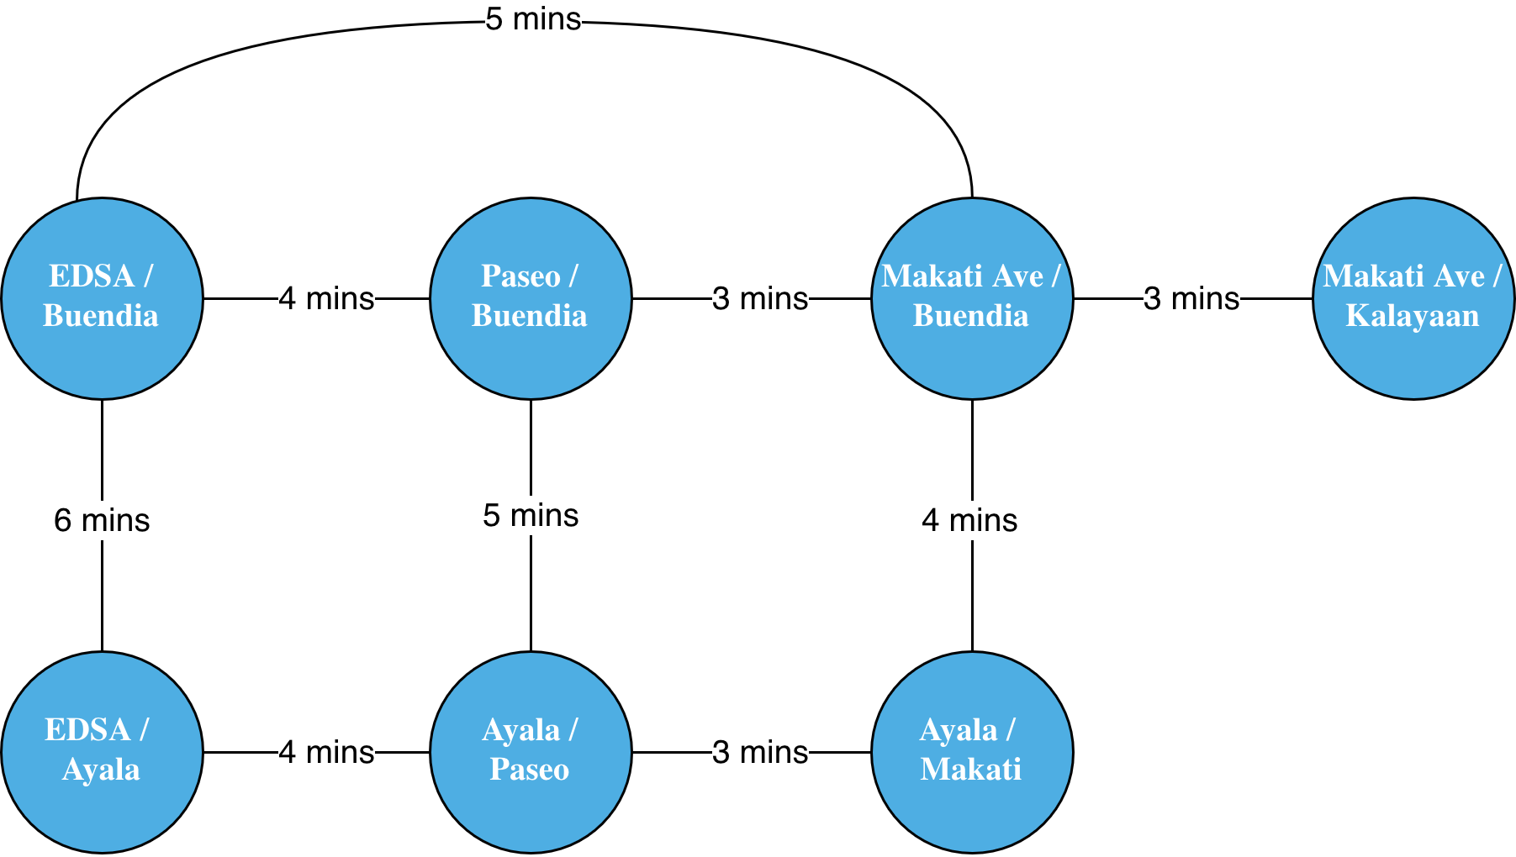

3. Algorithm design (pseudocode for both)
- Dijkstra: greedy, builds shortest path from one source to all nodes
- Floyd-Warshall: DP, computes shortest paths between all pairs of nodes
- Note for your report: these solve slightly different versions of the problem (single-source vs all-pairs) — that's actually a useful point to discuss in your analysis section, not a flaw in the proposal.
4. Implementation
- Pick a language you're comfortable with (Python is easiest for this).
- Represent the graph as an adjacency matrix or list.
- Implement Dijkstra (priority queue) and Floyd-Warshall (triple nested loop).
- Use a timer (e.g., Python's time.perf_counter()) around each algorithm call to report execution time in ms.
5. Analysis
- Time complexity: Dijkstra O(E log V) with a heap vs Floyd-Warshall O(V³)
- Space: Dijkstra O(V+E) vs Floyd-Warshall O(V²)
- Since your graph is small (<10 nodes), discuss why Floyd-Warshall's worse asymptotic complexity may not show up much in practice at this scale — that's a good real insight for your report.
6. Testing
- Run several start/destination pairs
- Include an edge case: disconnected node (if any), single-edge path, identical start/destination
7. Deliverables
- Report: problem, design, complexity tables, results
- Code: well-commented Dijkstra + Floyd-Warshall implementation
- Recorded presentation: walk through your map, run the program live, show both algorithms agreeing on the shortest path, and discuss the runtime/complexity comparison

proposal
PROJECT PROPOSAL:
Our group proposes a Micro-City Traffic Routing Simulation to address the real-world problem of urban congestion and delivery route optimization. The objective is to calculate the most efficient path through a local neighborhood grid to minimize overall travel time. To satisfy the project requirements, we will implement and compare a greedy algorithm, such as Dijkstra's algorithm, against a dynamic programming approach, like the Floyd-Warshall algorithm, specifically focusing on evaluating their time and space complexities.

The input for this project will be a connected graph representing a small local map consisting of fewer than 10 intersections. The nodes will represent the intersections, while the edges will represent the connecting roads. Each edge will be assigned a numerical weight to denote the estimated travel time in minutes.

The outcome of the proposal will be a program that outputs the optimal sequence of intersections required to travel from a starting node to a destination node. It will also provide the total calculated travel time for that route and display the execution time of the algorithms in milliseconds to practically demonstrate the differences in their theoretical time complexities.

delegation

Micro-City Traffic Routing Simulation — Team Delegation Guide
4 members, broken into 4 roles. Each role has concrete steps, in order, so anyone can pick up their part and know exactly what to do next.

MEMBER 1 — Problem Definition & Map Designer
Owns: the foundation everyone else builds on. Do this FIRST, others are blocked until the map exists.
- Write the Problem Definition section of the report:
  - Restate the real-world problem (urban congestion / delivery routing)
  - Define inputs: graph of intersections (nodes), roads (edges), travel time weights (minutes), a start node, a destination node
  - Define outputs: shortest path sequence, total travel time, algorithm runtime (ms)
- Design the actual sample neighborhood map:
  - Pick 6–9 intersections, name them (A, B, C... or real-sounding street names if you want it more "real-world")
  - Draw it on paper/Figma/draw.io first — make sure it's connected (every node reachable) and has at least 2 alternate routes between some pairs of nodes (so "shortest path" isn't trivially obvious)
  - Assign travel-time weights to every road (edge)
- Convert the map into the graph dictionary format in the code (replace the placeholder example with your real map)
- Write the pseudocode / flowchart for BOTH algorithms for the report (Member 2 & 3 can help verify these match their actual code later)
- Hand off: send the finalized graph dictionary to Members 2 & 3
Deliverable: Problem Definition write-up, finalized map (diagram + code dictionary), pseudocode/flowcharts

MEMBER 2 — Dijkstra Implementation Lead
Owns: the greedy algorithm. Can start once Member 1 hands off the map.
- Take the dijkstra() function from the base script
- Read through it line by line until you can explain to the others:
  - Why a priority queue (heap) is used
  - Why it's called "greedy" (always expands the closest unvisited node)
  - Why it can stop early once the destination is reached
- Re-comment/annotate the function in your own words (for originality — don't just leave AI-generated comments verbatim)
- Run it against Member 1's real map for at least 3 different start/destination pairs, record the path + total time for each
- Test 1 edge case: start == end (should return path of just that node, time 0)
- If your professor wants directed roads (one-way streets) instead of two-way, this is the function to modify — flag it to the team early if so
- Hand off: confirmed working Dijkstra results to Member 4 for the complexity comparison
Deliverable: Working, commented Dijkstra function + test results

MEMBER 3 — Floyd-Warshall Implementation Lead
Owns: the dynamic programming algorithm. Can start once Member 1 hands off the map.
- Take the floyd_warshall() + reconstruct_fw_path() functions
- Read through until you can explain:
  - Why it's DP (builds up shortest paths via intermediate nodes k, reusing previously computed subresults)
  - Why it computes ALL pairs, not just one route
  - How the next table is used to rebuild the actual path
- Re-comment/annotate in your own words
- Run it against the SAME start/destination pairs Member 2 used, confirm results match Dijkstra's (they should — sanity check correctness)
- Test 2 edge cases:
  - Start == end
  - A disconnected node (add an isolated intersection with no roads, confirm the program handles it gracefully instead of crashing — e.g. returns "no path found")
- Hand off: confirmed working Floyd-Warshall results to Member 4
Deliverable: Working, commented Floyd-Warshall function + test results, including edge cases

MEMBER 4 — Analysis, Visualization & Presentation Lead
Owns: tying everything together. Some tasks can start early (timing code structure), most depend on Members 2 & 3 finishing.
- Early (parallel with others): set up the timing harness — the time.perf_counter() wrapper around each algorithm call (already in the base script, just verify/extend it)
- Once Members 2 & 3 hand off results: build a comparison table — | Route | Dijkstra path | Dijkstra time(ms) | FW path | FW time(ms) |
- Write the Analysis section of the report:
  - Theoretical: Dijkstra O((V+E) log V) vs Floyd-Warshall O(V^3)
  - Theoretical space: O(V+E) vs O(V^2)
  - Practical: explain why at <10 nodes the measured times may look similar or even favor FW sometimes (overhead noise), but Dijkstra scales much better as the graph grows — this is the "interesting insight" your professor wants
- (Optional but recommended for creativity points) Add a simple static diagram of the map with the shortest path highlighted, for use in the report and recording
- Compile the final written report — pull in Member 1's problem definition + pseudocode, Member 2 & 3's code explanations, your own analysis
- Organize the recorded presentation:
  - Suggested order: Member 1 introduces problem + map -> Member 2 explains/demos Dijkstra -> Member 3 explains/demos Floyd-Warshall -> Member 4 presents the comparison table and wraps up
  - Keep it tight — most rubrics for this kind of project expect under 10 minutes total
- Final pass: check the submission against ACM citation format and the professor's formatting instructions before submitting
Deliverable: Comparison table, Analysis section, final report compilation, recorded presentation

Suggested Order of Operations (sequence, not a strict calendar)
- Member 1 finishes map + problem definition -> unblocks everyone
- Members 2 & 3 work in parallel on their algorithms
- Member 4 starts timing harness in parallel, then waits for 2 & 3
- Members 2 & 3 hand off results -> Member 4 builds analysis + table
- Everyone reviews the full report once compiled
- Record presentation last, after everything is verified to actually run

graph dictionary
# Makati CBD Micro-City Traffic Routing Graph
# Nodes: 7 major intersections
# Weights: Average travel times in minutes

makati_map = {
'EDSA_Ayala': {
'Ayala_Paseo': 4,
'EDSA_Buendia': 6
},
'Ayala_Paseo': {
'EDSA_Ayala': 4,
'Ayala_Makati': 3,
'Buendia_Paseo': 5
},
'Ayala_Makati': {
'Ayala_Paseo': 3,
'Buendia_Makati': 4
},
'Buendia_Makati': {
'Ayala_Makati': 4,
'Buendia_Paseo': 3,
'EDSA_Buendia': 5,
'Makati_Kalayaan': 3
},
'Buendia_Paseo': {
'Ayala_Paseo': 5,
'Buendia_Makati': 3,
'EDSA_Buendia': 4
},
'EDSA_Buendia': {
'EDSA_Ayala': 6,
'Buendia_Paseo': 4,
'Buendia_Makati': 5
},
'Makati_Kalayaan': {
'Buendia_Makati': 3
}
}

pseudocode/flowchart
Djikstra’s Algorithm
Flowchart:


Pseudocode:

function Dijkstra(Graph, StartNode, DestinationNode):
// 1. Initialization
Create a map 'distances', set all to Infinity
distances[StartNode] = 0
Create a map 'previous_nodes' to reconstruct the path
Create a PriorityQueue and insert (0, StartNode)

// 2. Exploration
While PriorityQueue is not empty:
CurrentDistance, CurrentNode = PriorityQueue.pop()

// Early exit if destination is reached
if CurrentNode == DestinationNode:
break

// 3. Relax edges
For each Neighbor, Weight in Graph[CurrentNode]:
NewDistance = CurrentDistance + Weight

if NewDistance < distances[Neighbor]:
distances[Neighbor] = NewDistance
previous_nodes[Neighbor] = CurrentNode
PriorityQueue.push((NewDistance, Neighbor))

return distances, previous_nodes

Floyd-Warshall Algorithm
Flowchart:

Pseudocode:
function FloydWarshall(Graph):
// 1. Initialization
Let V be the list of all nodes
Create a 2D array 'dist' filled with Infinity
Create a 2D array 'next_node' filled with Null

// Set base cases
For each node v in V:
dist[v][v] = 0

For each node u in Graph:
For each neighbor v, weight w of u:
dist[u][v] = w
next_node[u][v] = v

// 2. Dynamic Programming Triple Loop
For each intermediate node k in V:
For each source node i in V:
For each destination node j in V:
// If path through k is faster, update
if dist[i][j] > dist[i][k] + dist[k][j]:
dist[i][j] = dist[i][k] + dist[k][j]
next_node[i][j] = next_node[i][k]

return dist, next_node

Documentation Template

Criteria | Excellent (Full Points) | Good | Needs Improvement | Points
Introduction (10 | Clear background, well-defined problem, complete objectives | Minor missing details | Unclear or incomplete | 10
Review | Relevant, properly cited, well explained | Some missing links/citations | Weak or irrelevant | 10
Method | Correct technique, strong justification, clear pseudocode, complete steps | Minor errors or unclear parts | Incorrect or missing elements | 25
Implementation ( | Fully working code, well-structured, readable | Minor syntax/logic issues | Incomplete or non-working | 15
Testing & Results (15 pts) | Complete test cases, correct outputs, analysis present | Limited cases or explanation | Missing or incorrect | 15
Analysis & Discussion (10 pts | Insightful strengths, limitations, comparison | Basic discussion only | Weak or missing | 10
Conclusion & Recommendations (5 pts) | Clear, concise, meaningful | General summary | Weak conclusion | 5
Formatting & Documentation (5 pts | Follows format strictly, clean and professional | Minor formatting issues | Poor formatting | 5
Team | Balanced, clearly documented roles | Slight imbalance | No contribution details | 5

📘 ALGORITHM DESIGN PROJECT DOCUMENTATION TEMPLATE (WITH FORMATTING)

✅ GENERAL FORMAT REQUIREMENTS
- Paper Size: A4
- Margins: 1 inch (Top, Bottom, Left, Right)
- Font Style: Times New Roman
- Font Size:
  - Title: 16 pt, Bold, Centered
  - Headings: 14 pt, Bold
  - Subheadings: 12 pt, Bold
  - Body Text: 12 pt
- Line Spacing: 1.5
- Alignment: Justified
- Page Number: Bottom Center
- Paragraph Indent: 0.5 inch (first line)
- Spacing After Paragraph: 6 pt

📄 COVER PAGE FORMAT
(All centered)
PROJECT TITLE
(Bold, 16 pt)
Algorithm Design Project Documentation
Submitted by:
- Name 1
- Name 2
- Name 3 (Max: 5 members only)
Course: Algorithms and Complexity
Instructor: Sir Joel C. De Goma
Date of Submission: __________

📑 TABLE OF CONTENTS
- Use automatic Table of Contents (References → Table of Contents in Word)

1. INTRODUCTION

1.1 Background of the Problem
(Justified, 12 pt)
Explain the context and importance of the problem.

1.2 Problem Statement
- Clearly define the problem
- Include constraints and assumptions

1.3 Objectives
General Objective:
- One sentence summary
Specific Objectives:
- Objective 1
- Objective 2
- Objective 3

2. REVIEW OF RELATED CONCEPTS
- Discuss related algorithms or techniques
- Cite references properly (APA format)
- Use in-text citations

3. METHODOLOGY / ALGORITHM DESIGN

3.1 Overview of Solution
- High-level explanation

3.2 Design Technique
(Bold the chosen technique)
- Brute Force
- Decrease-and-Conquer
- Divide-and-Conquer
- Dynamic Programming
- Greedy
- Backtracking
Provide justification (1–2 paragraphs)

3.3 Algorithm Explanation
- Present step-by-step explanation
- Use numbered format:
- Initialize variables
- Process input
- Apply logic
- Return result

3.4 PSEUDOCODE FORMAT
(Use monospace font e.g., Consolas, 11 pt)
Plain Text
Algorithm AlgorithmName(Input)
Step 1: Initialize variables
Step 2: Perform computation
Step 3: Return output
End Algorithm
Show more lines

3.5 FLOWCHART / DIAGRAM
- Insert figure (centered)
- Add caption below:
Figure 1. Algorithm Flowchart

4. IMPLEMENTATION

4.1 Programming Language
- Example: Python / Java

4.2 Tools Used
- IDE, libraries, frameworks

4.3 CODE FORMAT
(Use monospace font: Consolas, 10–11 pt)
Python
def example():
return "Hello World"
``
Show more lines
- Avoid screenshots; use formatted code blocks

5. TESTING AND RESULTS

5.1 Test Cases Table
(Table format required)
Test Case | Input | Expected Output | Actual Output | Result
TC1 | 5 | 120 | 120 | Pass

5.2 Complexity Analysis
- Time Complexity: O(n), O(log n), etc.
- Space Complexity

5.3 Results Discussion
- Observations
- Accuracy of algorithm

6. ANALYSIS AND DISCUSSION
- Strengths (bullet format)
- Limitations
- Comparison with other methods

7. CONCLUSION
- Summary (1–2 paragraphs)
- Key insights

8. RECOMMENDATIONS
- Future improvements
- Possible extensions

9. REFERENCES
(ACMFormat Only)
Example:
atricia S. Abril and Robert Plant. 2007. The patent holder's dilemma: Buy, sell, or troll? Commun. ACM 50, 1 (Jan. 2007), 36-44. https://doi.org/10.1145/1188913.1188915

10. APPENDICES
- Full source code
- Additional test results
- Screenshots (if necessary)

✅ BONUS: CONTRIBUTION TABLE (REQUIRED)
Member Name | Contribution
Juan Dela Cruz | Coding
Maria Santos | Documentation

📘 ALGORITHM DESIGN PROJECT DOCUMENTATION (WITH SAMPLE CONTENT)

📄 COVER PAGE (Example)
FINDING THE MAXIMUM ELEMENT USING DIVIDE-AND-CONQUER
Algorithm Design Project Documentation
Submitted by:
- Juan Dela Cruz
- Maria Santos
- Pedro Reyes
Course: Algorithms and Complexity
Instructor: Sir Joel C. De Goma
Date of Submission: June 30, 2026

📑 1. INTRODUCTION

1.1 Background of the Problem
Efficient data processing is essential in computer science. One common task is finding the maximum value in a dataset. While a simple linear approach exists, more advanced strategies such as divide-and-conquer can improve efficiency and scalability for large datasets.

1.2 Problem Statement
Given an array of integers, determine the maximum value using an efficient algorithmic approach.
Constraints:
- Input size: n ≥ 1
- Values are integers
- Must analyze time complexity

1.3 Objectives
General Objective:
To design and implement an efficient algorithm to find the maximum value in an array.
Specific Objectives:
- Apply divide-and-conquer strategy
- Compare performance with brute force
- Analyze algorithm efficiency

📚 2. REVIEW OF RELATED CONCEPTS
The brute force approach checks every element sequentially, resulting in O(n) complexity. Divide-and-conquer splits the problem into smaller subproblems, solves them recursively, and combines the result.
According to Cormen et al. (2009), divide-and-conquer reduces problem complexity by breaking tasks into manageable parts.

⚙️ 3. METHODOLOGY / ALGORITHM DESIGN

3.1 Overview of Solution
The array is divided into two halves recursively until a single element remains. The maximum values from each half are compared to determine the overall maximum.

3.2 Design Technique
✅ Divide-and-Conquer
Justification:
This technique reduces repeated comparisons by structuring the problem recursively, making it scalable for large datasets.

3.3 Algorithm Explanation
- Divide the array into two halves
- Recursively find maximum in the left half
- Recursively find maximum in the right half
- Compare both results
- Return the larger value

3.4 Pseudocode
Plain Text
Algorithm FindMax(arr, left, right)
If left == right
Return arr[left]

mid = (left + right) / 2

max1 = FindMax(arr, left, mid)
max2 = FindMax(arr, mid + 1, right)

If max1 > max2
Return max1
Else
Return max2
End Algorithm
Show more lines

3.5 Flowchart
(Insert diagram in Word)
Figure 1. Recursive division of array for maximum search

💻 4. IMPLEMENTATION

4.1 Programming Language
Python

4.2 Tools Used
- Visual Studio Code
- Python 3.x

4.3 Code Example
Python
def find_max(arr, left, right):
if left == right:
return arr[left]

mid = (left + right) // 2

max1 = find_max(arr, left, mid)
max2 = find_max(arr, mid + 1, right)

return max(max1, max2)

arr = [3, 7, 2, 9, 5]
print("Maximum:", find_max(arr, 0, len(arr)-1))
Show more lines

🧪 5. TESTING AND RESULTS

5.1 Test Cases
Test Case | Input | Expected Output | Actual Output | Result
TC1 | [3,7,2,9,5] | 9 | 9 | Pass
TC2 | [1] | 1 | 1 | Pass
TC3 | [-5,-1,-9] | -1 | -1 | Pass

5.2 Complexity Analysis
- Time Complexity: O(n)
- Space Complexity: O(log n) (recursion stack)

5.3 Results Discussion
The algorithm correctly identified the maximum value for all test cases. Recursive calls introduce overhead but maintain efficiency.

📊 6. ANALYSIS AND DISCUSSION
Strengths:
- Efficient for large datasets
- Structured and scalable
Limitations:
- Recursion overhead
- Slightly more complex than brute force
Comparison:
- Brute Force: O(n), simple
- Divide-and-Conquer: O(n), more structured

✅ 7. CONCLUSION
The divide-and-conquer approach effectively solved the maximum element problem. Although it has similar time complexity to brute force, it demonstrates an important algorithm design strategy useful for more complex problems.

🔮 8. RECOMMENDATIONS
- Apply this method to other problems like sorting (merge sort)
- Optimize recursion using iterative methods
- Explore parallel computing

📖 9. REFERENCES
Patricia S. Abril and Robert Plant. 2007. The patent holder's dilemma: Buy, sell, or troll? Commun. ACM 50, 1 (Jan. 2007), 36-44. https://doi.org/10.1145/1188913.1188915

📎 10. APPENDICES
- Full program code
- Additional test cases
- Screenshots of execution

👥 CONTRIBUTION TABLE
Member Name | Contribution
Juan Dela Cruz | Coding
Maria Santos | Documentation
Pedro Reyes | Testing

Video Template

🎥 ALGORITHMS AND DESIGN PROJECT
Video Presentation Guidelines
📌 Objective
The video presentation aims to evaluate students' ability to:
- Explain algorithm design clearly and logically
- Demonstrate analytical and problem-solving skills
- Present solutions using appropriate techniques (e.g., brute force, divide-and-conquer, decrease-and-conquer)
- Communicate technical concepts effectively

📋 GENERAL REQUIREMENTS
1. ⏱️ Duration
- Minimum: 8 minutes
- Maximum: 12 minutes
(Strictly enforced – Excess or lack of time affects the score)
2. 👥 Group Participation
- All members must be visible and actively present in the video
- Each member should explain a specific part of the project
3. 🎙️ Video Format
- Must include:
  - Clear audio (no background noise)
  - Clear visuals (slides, diagrams, or code)
  - Face camera OR voice + presentation (preferred: both)
4. 📂 Submission Format
- File format: MP4 or equivalent
- Upload via MS Teams
- File name format:
- Section_GroupNo_ProjectTitle.mp4

📊 REQUIRED CONTENT (Structured Flow)
1. Introduction (1–2 minutes)
- Problem statement
- Real-world relevance
- Objectives of the project
2. Problem Analysis
- Input and output description
- Constraints and assumptions
- Complexity considerations
3. Algorithm Design
- Strategy used:
  - Brute Force / Divide-and-Conquer / Decrease-and-Conquer / others
- Step-by-step explanation (flowchart or pseudocode required)
4. Implementation Overview
- Key code snippets
- Explanation of major functions
(Do NOT read code line-by-line—explain logic)
5. Testing and Results
- Sample inputs and outputs
- Performance observations
6. Complexity Analysis
- Time Complexity (Big-O)
- Space Complexity
7. Conclusion
- Key insights
- Improvements or future work

⚠️ PRESENTATION DOs and DON'Ts
✅ DO:
- Use diagrams, flowcharts, or visuals
- Speak clearly and confidently
- Divide parts among members logically
- Practice timing
❌ DON’T:
- Read directly from slides
- Copy explanations without understanding
- Overload slides with text
- Submit raw recording without editing

🧮 RUBRIC FOR VIDEO PRESENTATION (100 POINTS)
Criteria | Description | Points
Content Completeness | All required sections are present and well-organized | 20
Algorithm Understanding | Demonstrates deep understanding of algorithm design and logic | 20
Clarity of Explanation | Concepts are explained clearly and logically | 15
Technical Accuracy | Correct use of algorithm concepts, analysis, and implementation | 15
Visual Presentation | Effective use of slides, diagrams, and flowcharts | 10
Delivery & Communication | Confidence, clarity of speech, engagement | 10
Team Participation | Equal contribution of all members | 5
Time Management | Within required duration | 5
TOTAL |  | 100

🎯 PERFORMANCE LEVEL GUIDE
Score Range | Description
90–100 | Excellent – Clear, well-structured, technically strong
80–89 | Good – Minor issues but overall solid understanding
70–79 | Satisfactory – Basic explanation, lacks depth
60–69 | Needs Improvement – Weak explanation and organization
Below 60 | Poor – Incomplete or unclear presentation

🎥 Algorithm Project Video Presentation Reminder
• 8–12 minutes only ⏱️
• All members must present 👥
• Explain logic, not just code 💡
• Use visuals (flowchart, pseudocode) 📊
• Upload in MS Teams (MP4 format) 📂

