**PROJECT REPORT**

**PROPERTY MANAGEMENT APPLICATION USING**

**SALESFORCE**

**1 INTRODUCTION**

* 1. Overview
* A Property management application built on the salesforce platform can be a powerful tool for managing real estate assets.
* Salesforce property management enables the realty managers to keep track of crucial data about financial & household properties incorporating associated cash flow, primary tenants, and occupancy rates.
  1. Purpose
* Leverage real-time reports and dashboards.

Streamline lead, opportunity, and contact management.

* Simplify document management and data sharing.
* Enhance communication and collaboration tools.

**2 Problem Definition & Design Thinking**

2.1 Empathy Map

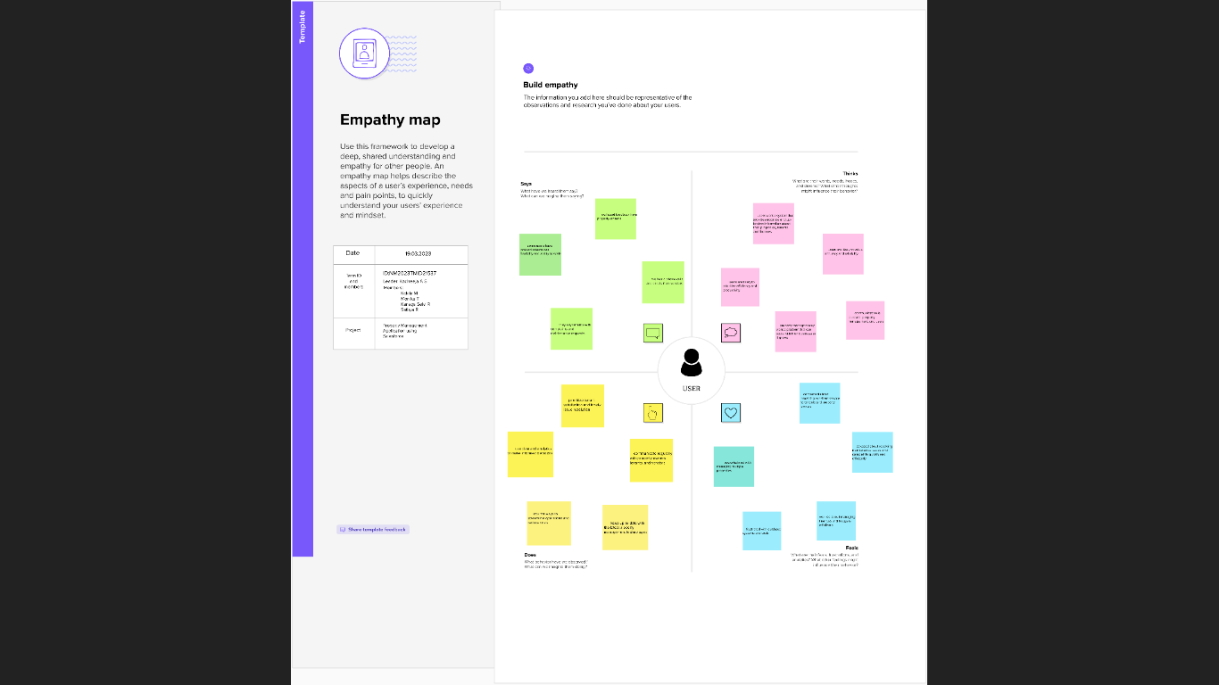

2.2 Ideation & Brainstorming Map

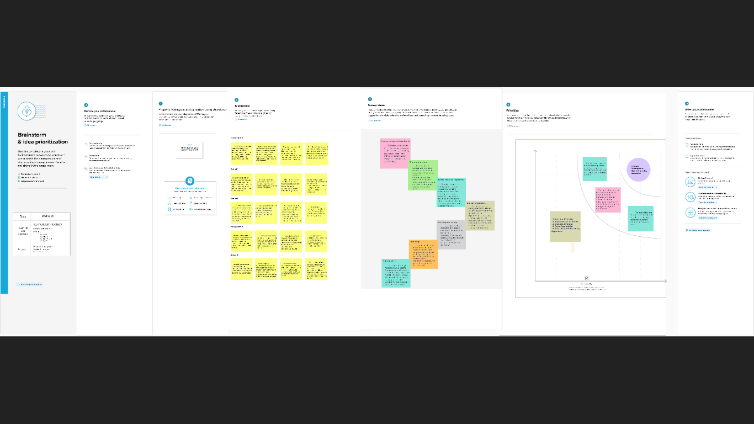

**3 RESULT**

3.1 Data Model:

|  |  |
| --- | --- |
| **Object name** | **Fields in the object** |
| Lead | |  |  | | --- | --- | | Field label | Data type | | Lead | Auto number | | State | Picklist | | City | Picklist | | Email | Email | | Phone | Phone | |

|  |  |  |  |  |  |  |  |  |  |  |  |  |  |  |  |
| --- | --- | --- | --- | --- | --- | --- | --- | --- | --- | --- | --- | --- | --- | --- | --- |
| Buy | |  |  | | --- | --- | | Field label | Data type | | Buy | Currency | | Property type | Picklist | | Discount | Percentage | | State | Picklist | | City | Picklist | | Annual Amount To Be Paid | Currency | |
| Rent | |  |  | | --- | --- | | Field label | Data type | | Rent | Auto number | | Rental city | Text | | BHK type | Picklist | |
| Loan | |  |  | | --- | --- | | Field label | Data type | | Loan ID | Auto number | | Interest Rate | Currency | | Term | Number | | Annual Loan | Number | | Total Loan Instalments | Number | | Loan Repayment | Number | | Loan Amount | Formula | |

3.2 Activity & Screenshot

**Milestone 1 :** Salesforce

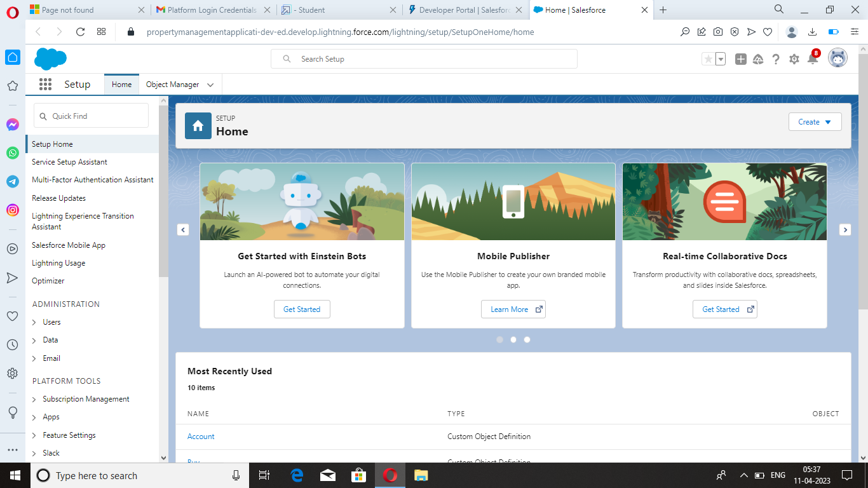

**Milestone 2 :** Object

Lead :

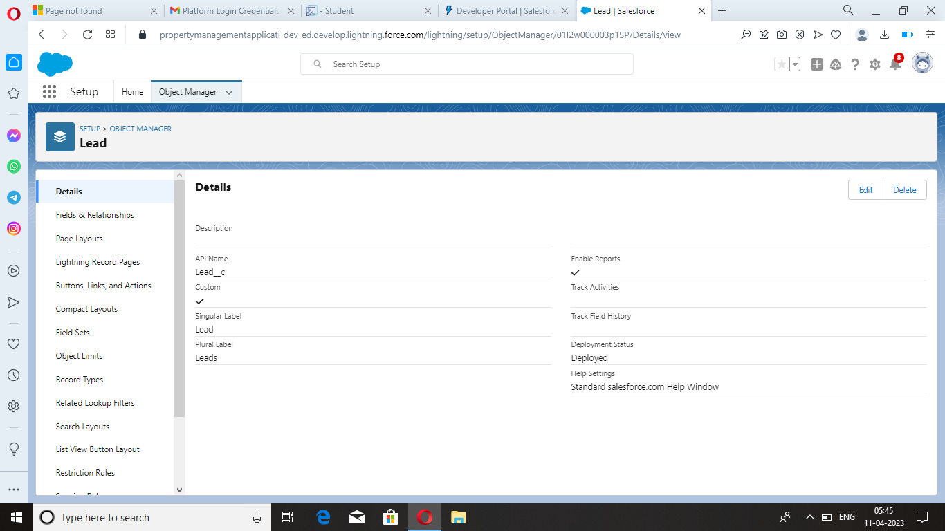

Buy :

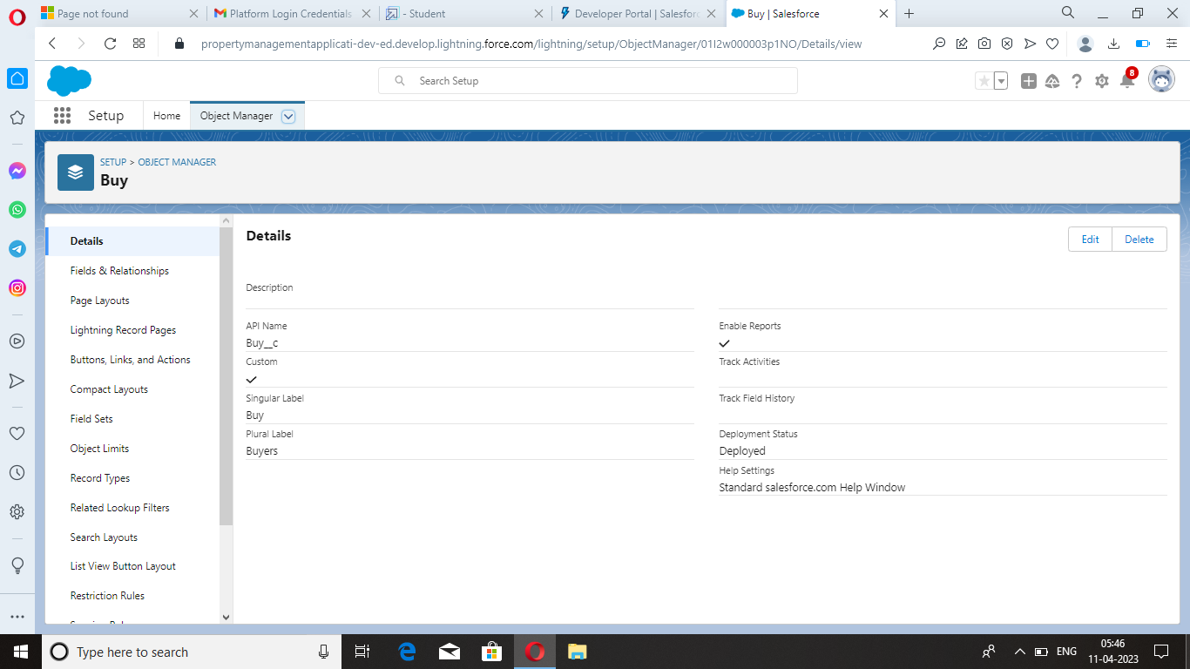

Rent :

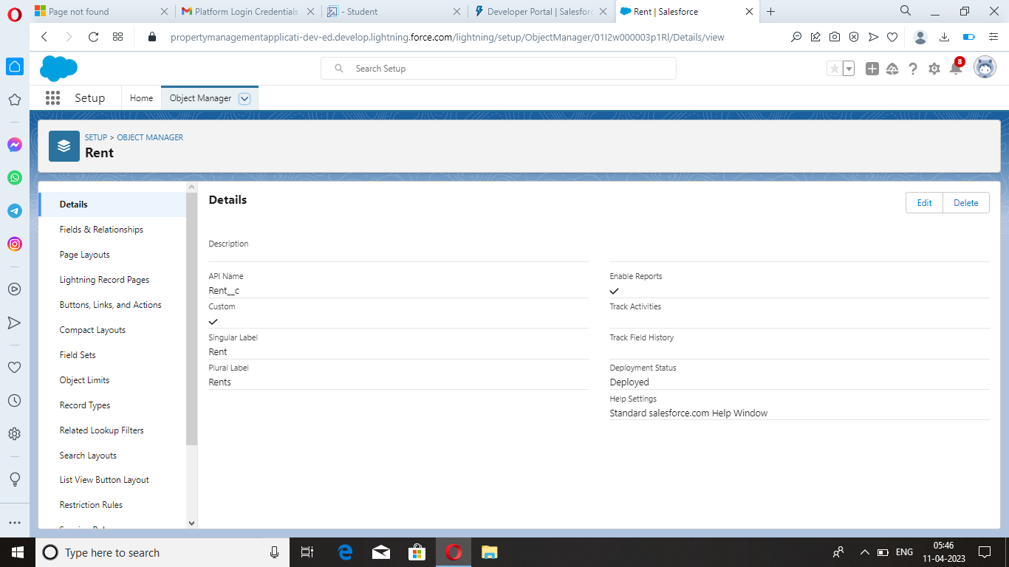

Loan :

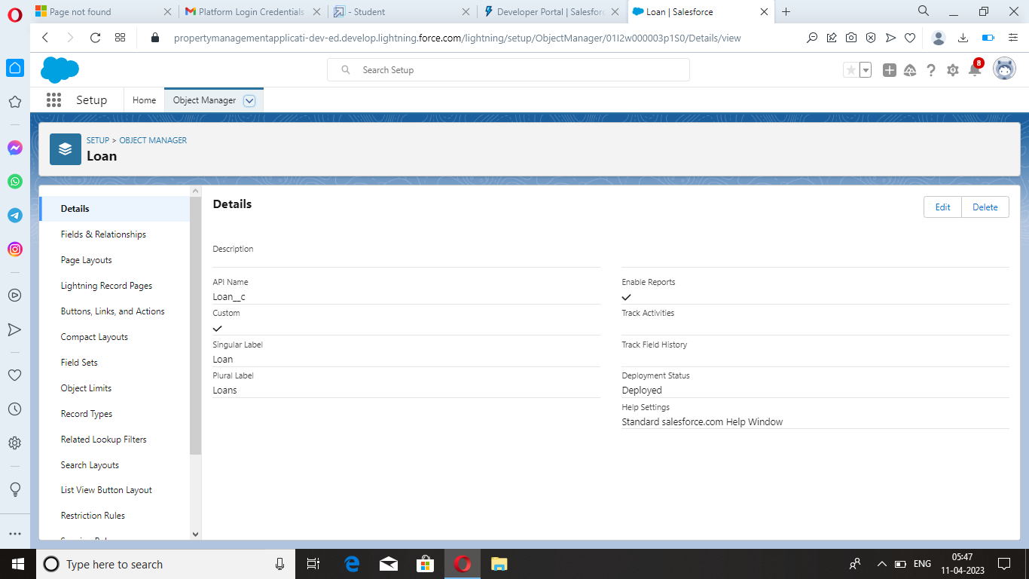

**Milestone 3 :** Tab

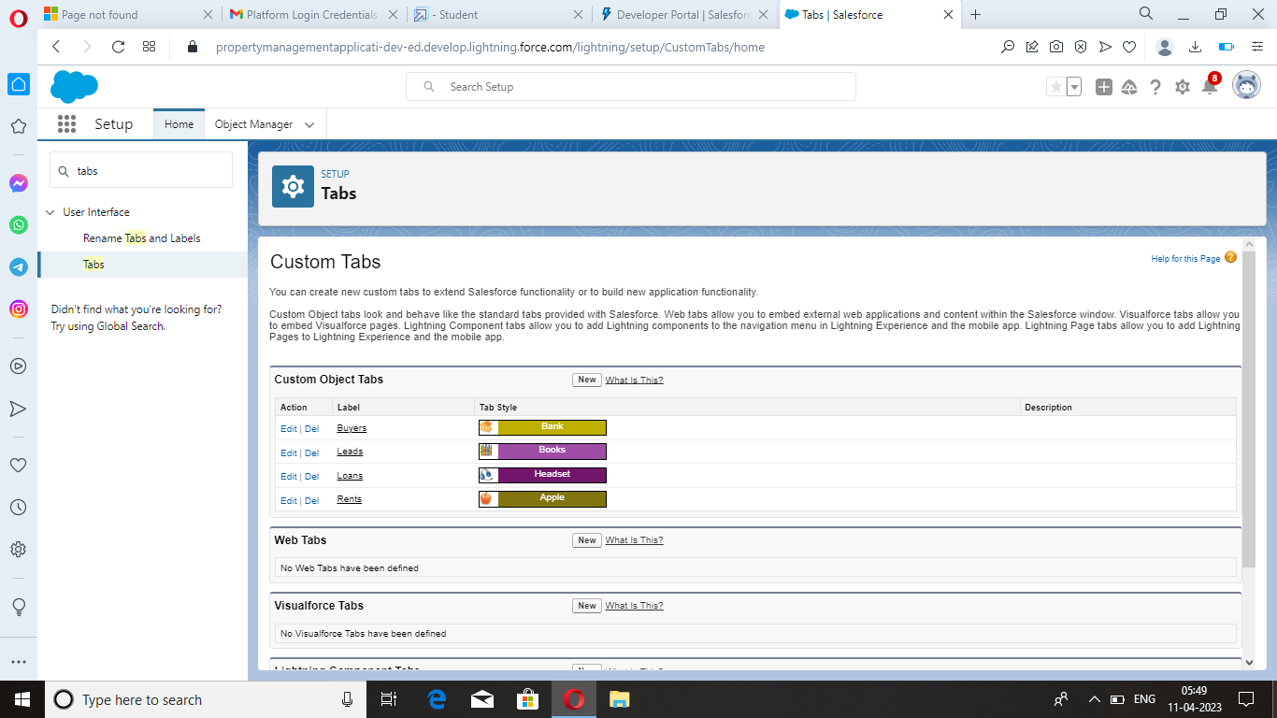

**Milestone 4 :** The Lightning App

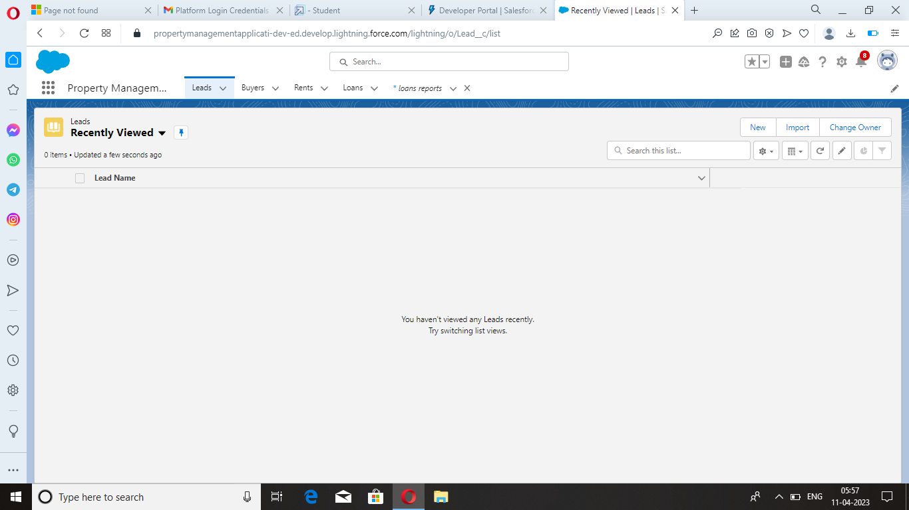

**Milestone 5 :** Fields

Lead field :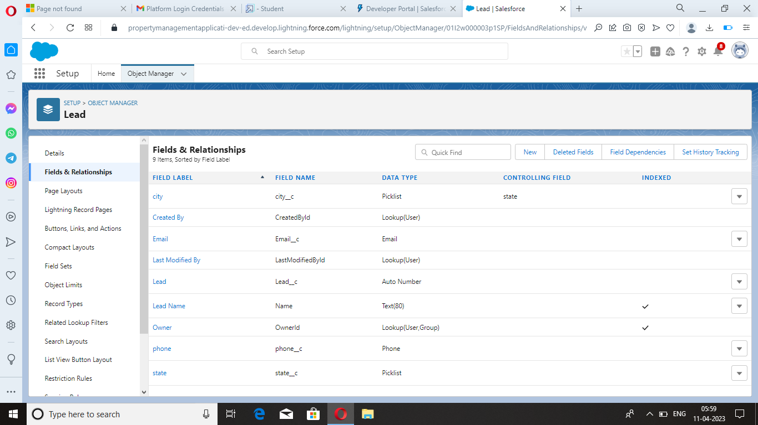

Field dependency :

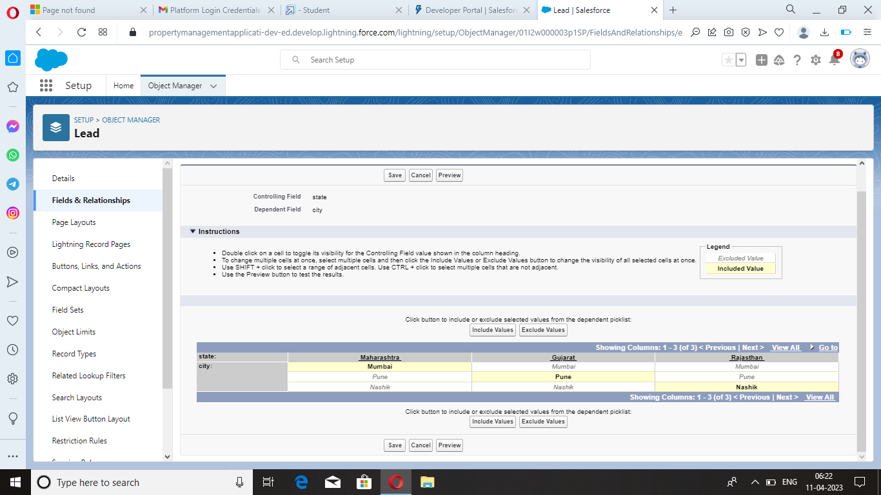

Buy field :

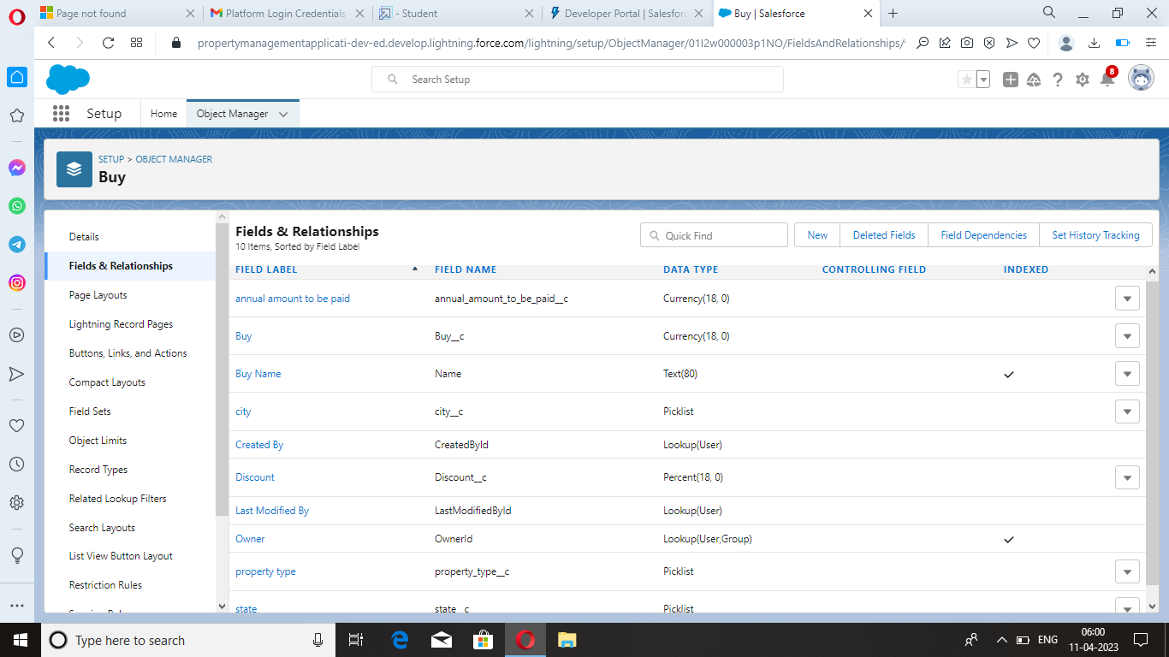

Rent field :

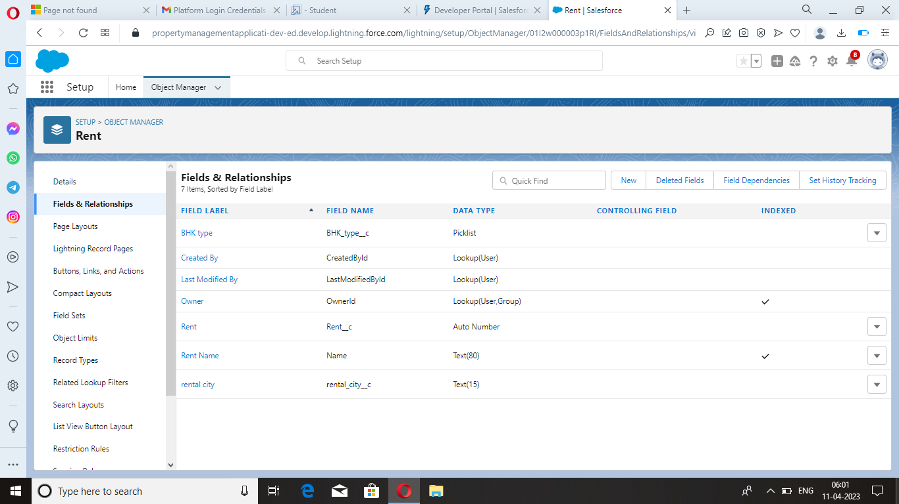

Loan field : 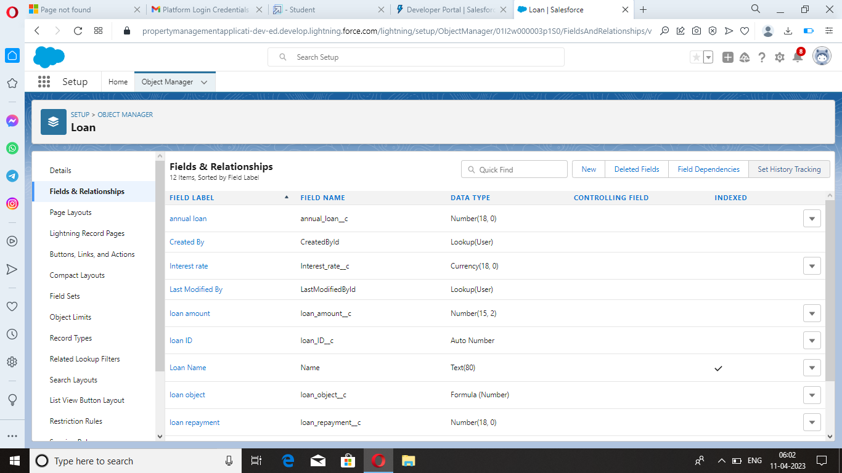

**Milestone 6 :** Profile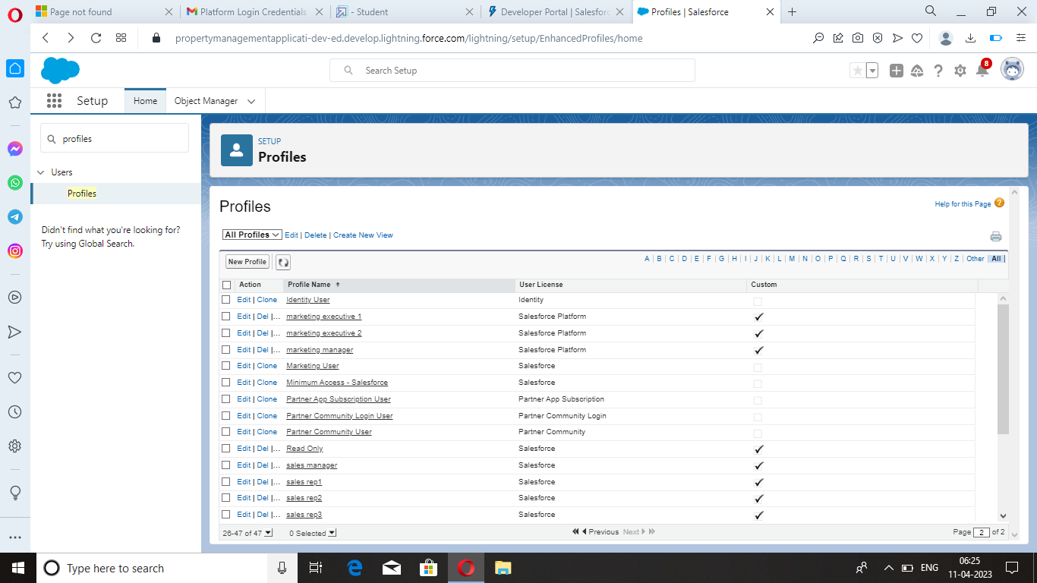

**Milestone 7 :** New User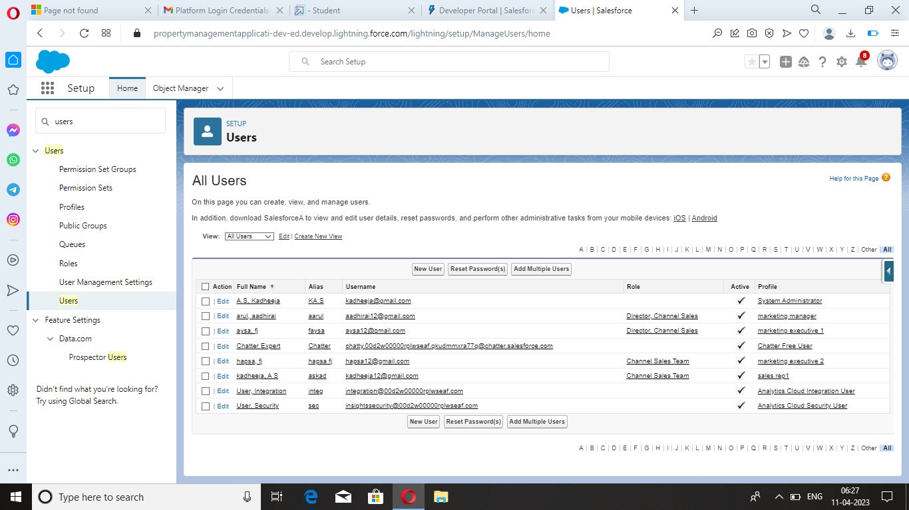

**Milestone 8 :** Permission Set

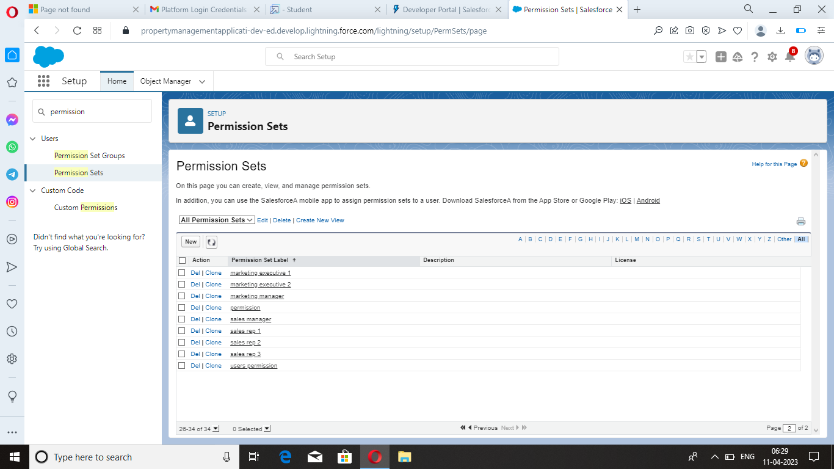

**Milestone 9 :** Setup for OWD

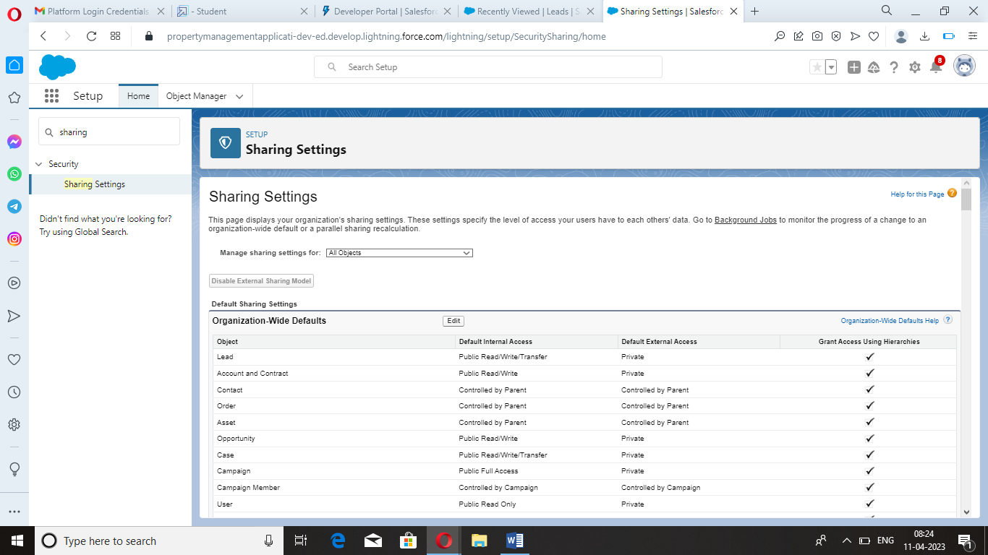

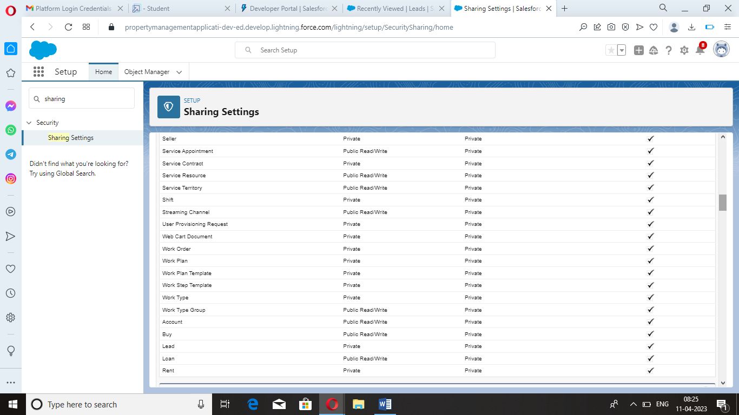

**Milestone 10 :** Report

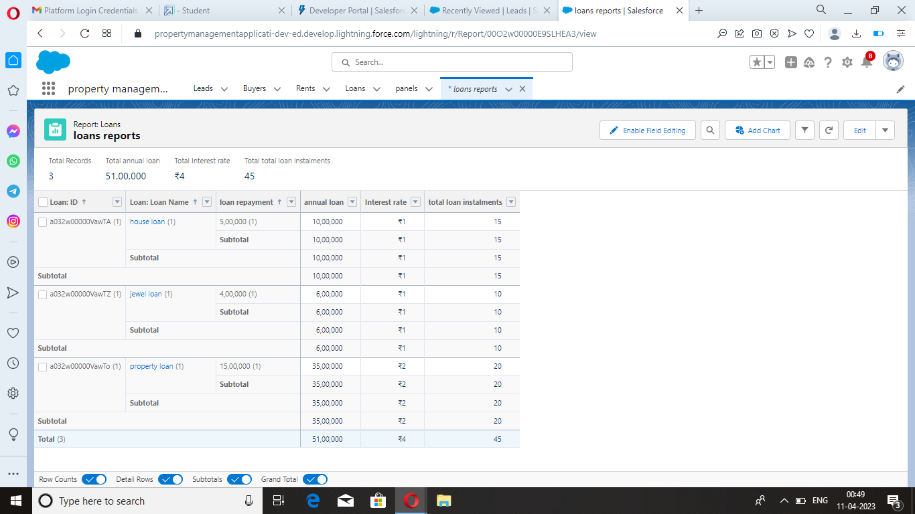

**Milestone 11 :** Dashboards

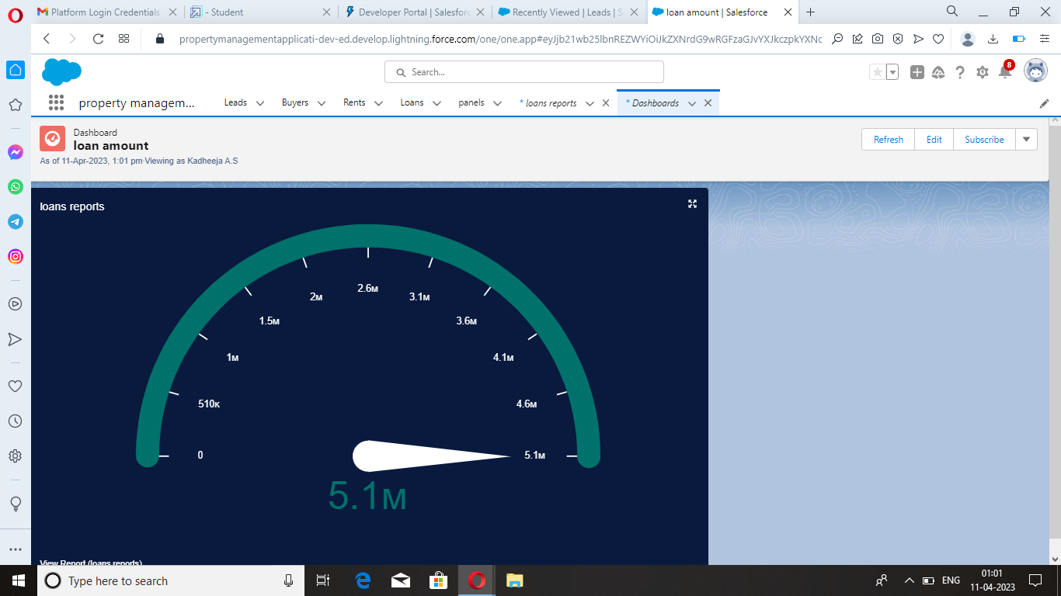

**4 Trailhead Profile Public URL**

**Team Leader -** <https://trailblazer.me/id/kadas55>

**Team Member 1 -** <https://trailblazer.me/id/kokim12>

**Team Member 2 -** <https://trailblazer.me/id/monit30>

**Team Member 3 -** <https://trailblazer.me/id/kanar11>

**Team Member 4 -** <http://trailblazer.me/id/sathr45>

**5 ADVANTAGES & DISADVANTAGES**

Advantages :

* Sales force provides a centralized location for managing all property related data, which can help reduce errors and duplication and improve efficiency.
* The application can help automate and streamline property management processes, such as lease management, maintenance requests, rent collection, and financial reporting.
* The application can help property managers manage tenant information, including lease terms , rent payments , and maintenance requests.
* It can also provide tools for communicating with tenants, such as sending notifications, tracking inquiries, and responding to feedback.

Disadvantages :

* Salesforce can be expensive to implement and maintain, which may be a barrier for smaller property management companies.
* The platform can be complex and require technical expertise to configure and customize, which may be challenging for some property managers.
* The application may require integration with other systems or software, which can be time-consuming and may require additional technical expertise.
* Property managers may become dependent on salesforce for their property management needs, which could limit their options for other software or systems.

**6 APPLICATIONS**

* Salesforce can be used to automate various property management processes, including lease management , maintenance requests rent collection and financial reporting.
* Salesforce can help property managers gain real time insights into property performance, such as occupancy rates , rent collection rates and maintenance costs.
* This can help property managers make informed decisions about the properties and identify areas for improvement.

**7 CONCLUSION**

* Salesforce is a comprehensive tool with an exhausting list of benefits and despite its seeming complexity that can overwhelm at first, can become the best friend for property managers.
* Each property management company can take advantage of the platform in its unique way due to its scalability and flexibility.

**8 FUTURE SCOPE**

* The future scope of property management application using salesforce is promising , as the platform continuous to evolve and provide new features and capabilities.
* Salesforce may integrate artificial intelligence and machine learning capabilities to help property managers make more inform decisions about their properties.
* Salesforce maybe used to integrate data from sensors and other lot devices to provide real time insights into property performance and improve maintenance and management processes