|  |  |  |  |  |  |  |  |  |  |  |  |  |  |  |  |  |  |
| --- | --- | --- | --- | --- | --- | --- | --- | --- | --- | --- | --- | --- | --- | --- | --- | --- | --- |
|  | Количество потоков | | | | | | | | | | | | | | | | |
| 1 | 2 | | 4 | | 7 | | 8 | | 16 | | 20 | | 40 | | 80 | |
| T1 | T2 | S2 | T4 | S4 | T7 | S7 | T8 | S8 | T16 | S16 | T20 | S20 | T40 | S40 | T80 | S80 |
| For | 68.37 | 32.83 | 2.08 | 20.42 | 3.34 | 14.96 | 4.57 | 13.83 | 4.94 | 13.24 | 5.16 | 11.63 | 5.88 | 16.25 | 4.21 | 62.01 | 1.11 |
| No for | 67.21 | 53.09 | 1.29 | 51.69 | 1.32 | 20.76 | 3.29 | 13.91 | 4.95 | 6.61 | 10.34 | 6.32 | 10.82 | 5.79 | 11.81 | 5.33 | 12.83 |

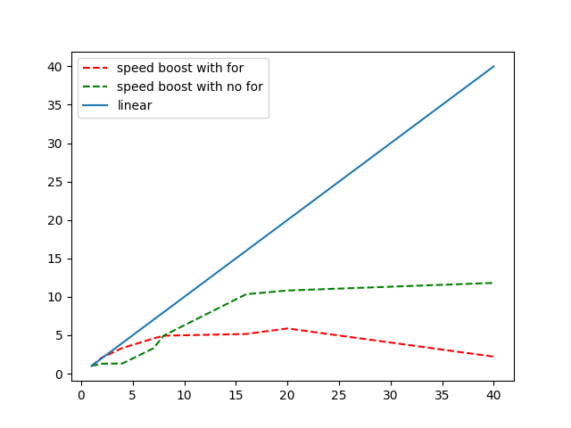

Вычислительный узел кластера:

Наименование — Intel Xeon Gold 6248 CPU 2.50Ghz

40 ядер

Наименование сервера — ProLiant XL270d Gen10

NUMA — 2;

size - 387008 MB

OS — Ubuntu 22.04.3 LTS