**BLG 202E – Numerical Methods in CE**

**Spring 2017**

**Homework 3**

**Due: 07.04.2017 23:59**

**Question 1 – Monomial Interpolation**

Calculate a polynomial that interpolates with the given data using monomial interpolation.

$$V\left(x\right)=\sum_{j=0}^{n}{C_{j}ϕ_{j}\left(x\right)= C_{0}ϕ_{0}\left(x\right)+…+C_{n}ϕ_{n}\left(x\right)}$$

1. Calculate constants and show every step you did in your e-report.
$$C_{i}+C_{1}x_{i}+C_{2}x_{i}^{2}+…+C_{i}x_{0}^{i}=y_{i} , i=0, 1, …n$$

$$\left[\begin{matrix}1 & x_{0} & ⋯ & x_{0}^{n-1} & x_{0}^{n} \\ 1 & x_{1} & ⋯ & x_{1}^{n-1} & x_{1}^{n} \\ ⋮ & & ⋱ & ⋮ & ⋮ \\ 1 & x_{n} & ⋯ & x_{n}^{n-1} & x_{n}^{n}\end{matrix}\right]*\left(\begin{matrix}C_{0} \\ ⋮ \\ C_{n-1} \\ C_{n}\end{matrix}\right)=\left(\begin{matrix}y_{0} \\ ⋮ \\ y_{n-1} \\ y_{n}\end{matrix}\right)$$

$$\left[\begin{matrix}1 & 1 & 1 & 1 \\ 1 & 2 & 4 & 8 \\ 1 & 3 & 9 & 27 \\ 1 & 5 & 25 & 125\end{matrix}\right]*\left(\begin{matrix}C_{0} \\ C_{1} \\ C_{2} \\ C_{3}\end{matrix}\right)=\left(\begin{matrix}2 \\ 1 \\ 3 \\ -4\end{matrix}\right)$$

$$\left(\begin{matrix}C_{0} \\ C_{1} \\ C_{2} \\ C_{3}\end{matrix}\right)= \left(\begin{matrix}11 \\ -14.667 \\ 6.5 \\ -0.833\end{matrix}\right)$$

2. Write a matlab or octave code that calculates monomial interpolation with any given interpolation with any given number of data. Plot the result. Compare your results with a.

A function, called monomial, was implemented to determine monomial interpolation with any different dataset by calculating constant variables. The function takes 3 parameters: *x_set*, *y_set*, and *x*. According to given datasets, constants variables are calculated and the polynomial is formed. After that, value of x, obtained that polynomial, is returned.

The plot of result of generated polynomial and constant values are shown in Figure 1.1. When the constant values calculated at part **a** calculated with matlab code are compared, it is observed they are the same.

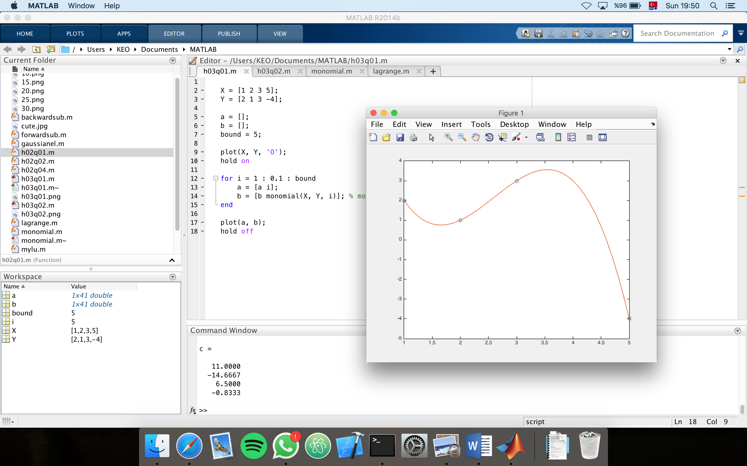**(Figure 1.1:** Plot and constants of monomial interpolation calculated by matlab**)**

**Question 2 – Lagrange Interpolation**

$$L_{i}\left(x\right)= \prod_{j=0, i ≠j}^{n}{\frac{x- x_{j}}{x_{i}- x_{j}}} , i=0,1,…, n$$

$$P_{n}\left(x\right)= \sum_{j=0}^{n}{f\left(x_{j}\right)*L_{j}\left(x\right)}$$

1. Calculate Lagrange polynomial of degree n and show every step you did in your e-report.
$$n=3→ P_{3}\left(x\right)= \sum_{j=0}^{3}{f\left(x_{j}\right)*L_{j}\left(x\right)}$$

$$P_{3}\left(x\right)= f\left(1\right)*\frac{x- 2}{1- 2}*\frac{x- 3}{1- 3}*\frac{x- 5}{1- 5} +f\left(2\right)*\frac{x- 1}{2- 1}*\frac{x- 3}{2- 3}*\frac{x- 5}{2- 5}+$$

$$f\left(3\right)*\frac{x- 2}{3- 2}*\frac{x- 1}{3- 1}*\frac{x- 5}{3- 5} + f\left(5\right)*\frac{x- 2}{5- 2}*\frac{x- 3}{5- 3}*\frac{x- 1}{5- 1}$$

$$P_{3}\left(x\right)=2*\frac{x^{3}-{10x}^{2}+31x-30}{-8}+1*\frac{x^{3}-{9x}^{2}+23x-15}{3}+$$

$$3*\frac{x^{3}-{8x}^{2}+17x-10}{-4}-4*\frac{x^{3}-{6x}^{2}+11x-6}{24}$$

$$P_{3}\left(x\right)=\frac{{5x}^{3}-{39x}^{2}+88x-66}{-6}$$

2. 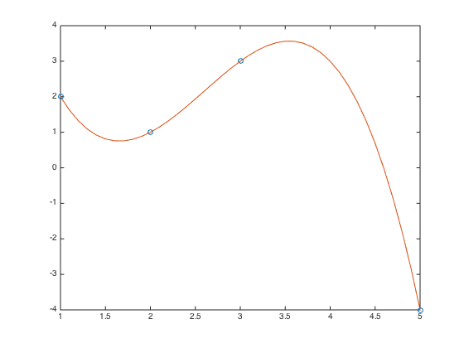A function, called lagrange, was written that calculates Lagrange interpolation with given datasets in lagrange.m. Also h03q02 function was written to plot result of interpolations with given number of data, n.

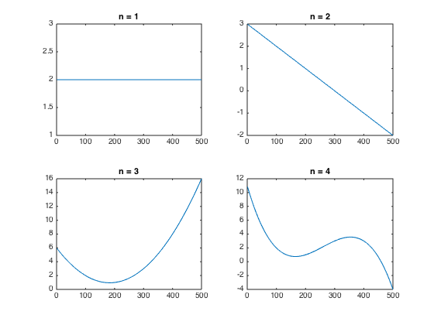

**Figure 2.1 & 2.2:** Plot of Lagrange Interpolation results with various number of dataset

**Question 3 – Newton Interpolation**

Calculate a polynomial that interpolates with the data given in 0. using Newton interpolation.

$$P_{n}\left(x\right)≔ c_{0}+c_{1}\left(x- x_{0}\right)+…+c_{n}\left(x- x_{0}\right)\left(x- x_{1}\right)…\left(x- x_{n-1}\right)$$

1. Calculate Newton polynomial of degree n and show every step you did in your e-report.
$$P_{n}\left(x\right)=f\left[x_{0}\right]+f\left[x_{0},x_{1}\right]\left(x- x_{0}\right)+…+f\left[x_{0},x_{1},{…x}_{n}\right]\left(x- x_{0}\right)…\left(x- x_{n-1}\right)$$

$$f\left[x_{i}\right]=y_{i} , i=0, 1, …n$$

$$f\left[x_{i}, x_{i+1}\right]=\frac{f\left[x_{i+1}\right]- f\left[x_{i}\right]}{x_{i+1}-x_{i}}$$

$$f\left[x_{i}, x_{i+1},… x_{i+j}\right]=\frac{f\left[x_{i+1}, …x_{i+j}\right]- f\left[x_{i}, …x_{i+j-1}\right]}{x_{i+j}-x_{i}}$$

$$f\left[1\right]=2, f\left[1, 2\right]=-1, f\left[1,2,3\right]=1.5, f\left[1,2,3,5\right]=-0.833$$

$$P_{4}\left(x\right)=2+\left(-1\right)\left(x- 1\right)+\left(1.5\right)\left(x- 1\right)\left(x- 2\right)+(-0.833)\left(x- 1\right)\left(x- 2\right)(x-3)$$

$$P_{4}\left(x\right)=-0.833x^{3}+6.498x^{2}-14.663x+10.998$$

2. Two functions were designed for applying Newton Interpolation method to given data. First, divided_difference function was implemented to calculate $f\left[x_{i}, x_{i+1},… x_{i+j}\right]$ recursively. Second, newton function was implemented to calculate the interpolation. Lastly, h03q03.m script file was written for plotting newton polynomial for 0. data.

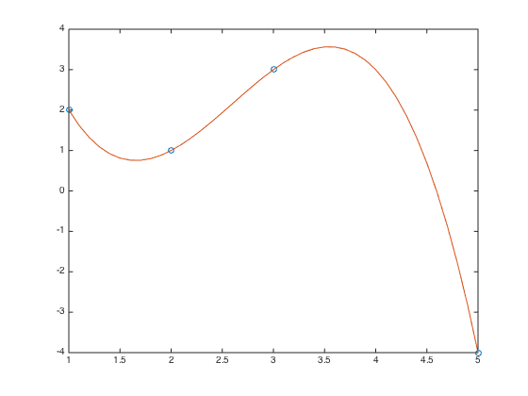

**Figure 3.1:** Plot of newton polynomial obtained by given 0. data

**Question 4 – Comparison of the Algorithm**

All three algorithms generate exactly the same polynomial. Lagrange and Newton Interpolation have $O(n^{2})$ time complexity, but Monomial Interpolation has $O(n^{3})$ time complexity because of process over vandermonde matrix. However, while implementing Newton Interpolation, some memorization techniques such as dynamic programming should be used for divided_difference function, which is recursive function, to reduce the complexity.

Kadir Emre Oto

150140032

otok@itu.edu.tr