

**ADANA ALPARSLAN TÜRKEŞ SCIENCE AND TECHNOLOGY UNIVERSITY**

**FACULTY OF ENGINEERING**

**DEPARTMENT OF COMPUTER ENGINEERING**

**CEN 439 - Introduction to Web Application Security**

**FAKE NEWS DETECTION ON SOCIAL ENGINEERING NETWORKS**

**YEKTA BÜYÜKKAYA 180101007**

**KADİR GÜNEY 180101006**

**1-INTRODUCTION**

**ADANA 2021-2022**

Fake news's simple meaning is to incorporate information that leads people to the wrong path. Nowadays fake news spreading like water and people share this information without verifying it. This is often done to further or impose certain ideas and is often achieved with political agendas. For media outlets, the ability to attract viewers to their websites is necessary to generate online advertising revenue.

At a time with the World Wide Web and the Social Media Networks have been around for a decade, one might see fragmented data sharing of information that has never before been seen. There are other examples of their use, such as using news resources; moreover, the use of social media sites such as Twitter in real-time benefits newspapers by providing up-to-date news to their readers. With the recent global shifts in culture, the mass media has shifted from journals, tabloid magazines and other formats including the internet news, blogs, social media feeds and other modern media format. There are many social media sites such as Facebook and Twitter, of course, those are not very common, but they have many important purposes including education, democratic process and health. Though it is hard to find a publishable source that makes direct link between bogus information and financial gain, there have been many poor misstatements and non-admissions involving certain sources online. The decision making power that we have is contingent on the kind of data that we ingest, and our understanding of the world at large is dependent on the data that we absorb. The evidence is now shown that people's reactions to information will lead to ridiculous ideas that are later shown to be incorrect. More particularly, the fact that the web site consists of a small core blog from various fields such as politics, law, which medicine, and is not used to detect the false site that consists of entertainment sites such as natural language processing and is not applied to detect the mean in character or that articles from language processing sites, such as natural language processing or natural language processing, are not applied (NLP). Another technique is the study of fake news vs real news, i.e., the detection of false information. The methodology makes a geometric analysis of how a false news story travels spontaneously over the Internet to pose as real information. When an article is assigned positive or negative reputations by the classifier, it is classified true or false. A hybrid way can also be used to assess the social reaction of the essay and to interpret the textual features in order to examine whether the message in the essay is right or wrong. Testament of various news being found on blogs and social media, which label the news as fake.

**2-DATA AND OBJECTIVE**

Our objective is to expect 2 csv files, "test" and "train", which we downloaded from Kaggle, to teach the train file to our algorithm and predict the test file.”Test” file have 3264 samples and “Train” file have 7614 samples. Inside the train file, there are id, keyword, location, text and label headers indicating whether this news is true or false. The test file, on the other hand, does not contain only the label among these titles, and we created the label title by foreseeing it and wrote it in another csv file with the text it contains.

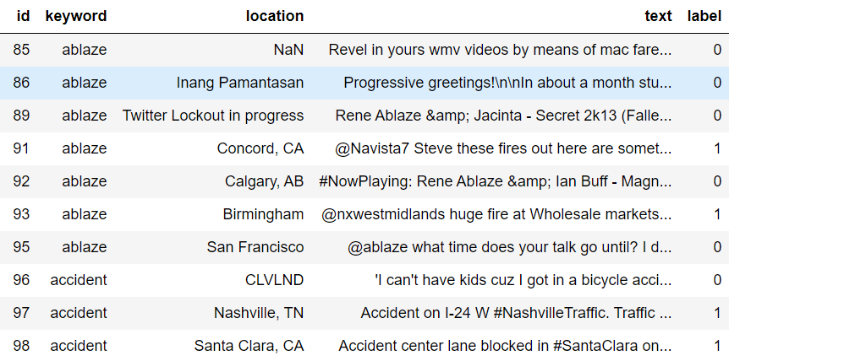

***Figure 1-Samples in Train Data***

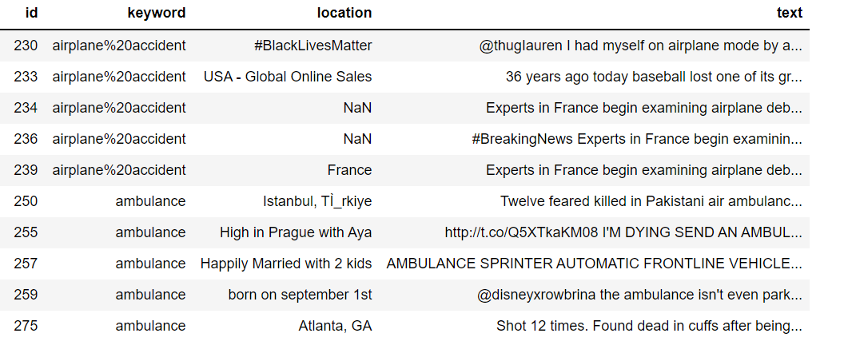

***Figure 2-Samples in Test Data***

**3-METHODOLOGY**

Since the words under the text heading were not cleared in both data sets, we started by cleaning these texts to get better results in the test results, and we used NLP techniques for this.

***3.1 Natural Language Processing (NLP)***

Natural language processing (NLP) is the ability of a computer program to understand human language as it is spoken and written. There are two main phases to natural language processing: data preprocessing and algorithm development. We used data preprocessing in this project.

Data preprocessing involves preparing and "cleaning" text data for machines to be able to analyze it. preprocessing puts data in workable form and highlights features in the text that an algorithm can work with. There are several ways this can be done, including;

*Tokenization*: This is when text is broken down into smaller units to work with.

*Stop word removal:* This is when common words are removed from text so unique words that offer the most information about the text remain. As examples {‘the’, ‘a’, ‘an’, ‘and’, ‘but’, ‘for’, ‘on’, ‘in’, ‘at’ …}

*Lemmatization and stemming:* This is when words are reduced to their root forms to process. Examples :

Stay, Stays, Staying, Stayed —> Stay

House, Houses, Housing —> House

***3.1.1 Tfidf Vectorizer***

**Tfidf-Vectorizer : (**Term Frequency * Inverse Document Frequency)

1.Term Frequency: The number of times a word appears in a document divided by the total number of words in the document. Every document has its own term frequency.

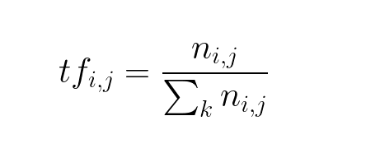

2. Inverse Document Frequency: The log of the number of documents divided by the number of documents that contain the word w. Inverse data frequency determines the weight of rare words across all documents in the corpus.

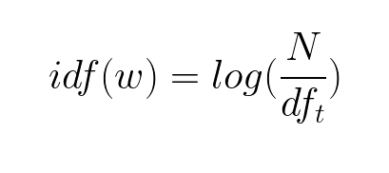

Finally Tfidf vectorizer:

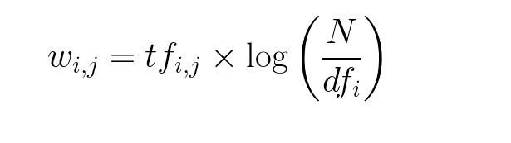

Most machine learning algorithms are fulfilled with mathematical things such as statistics, algebra, calculus and etc. They expect the data to be numerical such as a 2-dimensional array with rows as instances and columns as features. The problem with natural language is that the data is in the form of raw text, so that the text needs to be transformed into a vector. The process of transforming text into a vector is commonly referred to as text vectorization. It’s a fundamental process in natural language processing because none of the machine learning algorithms understand a text, not even computers. Text vectorization algorithm namely TF-IDF vectorizer, which is a very popular approach for traditional machine learning algorithms can help in transforming text into vectors.

After cleaning the data and turn into vectors for understand the model, our algorithm was ready for learning and use for that Machine learning techniques.

***3.2 Machine Learning***

Machine learning is an application of AI which provides the ability to system to learn things without being explicitly programmed. Machine learning works on data and it will learn through some data. Machine learning is very different from the traditional approach. In, Machine learning we fed the data, and the machine generates the algorithm. ML has three types of learning;

1-Supervised learning

2-Unsupervised learning

3-Reinforcement learning

Supervised learning means we trained our model with labeled examples so the machine first learns from those examples and then performs the task on unseen data. In this fake news detection project, we are using Supervised learning.

***3.3 Multinominal Naïve Bayes***

Multinomial Naive Bayes algorithm is a probabilistic learning method that is mostly used in Natural Language Processing (NLP).The algorithm is based on the Bayes theorem and predicts the tag of a text such as a piece of email or newspaper article. It calculates the probability of each tag for a given sample and then gives the tag with the highest probability as output.

Naive Bayes is a powerful algorithm that is used for text data analysis and with problems with multiple classes. To understand Naive Bayes theorem’s working, it is important to understand the Bayes theorem concept first as it is based on the latter.Bayes theorem, formulated by Thomas Bayes, calculates the probability of an event occurring based on the prior knowledge of conditions related to an event. It is based on the following formula:

**P(A|B) = P(A) * P(B|A)/P(B)**

So Multinominal naive bayes is used for classification when is in discrete form,because it is very useful in text processing also each text will be converted to a vector of word count.That’s the reason why we choose MNB.

In code part MNB is predefined in Scikit Learn Library. So we can import that class in our project then we create an object of Multinomial Naive Bayes Classifier.

1- Fit the classifier on our vectorized train data

2-When the classifier fitted successfully on the training set then we can use the predict method to predict the result on the test set.



***Classification Metrics***

To check how well our model we use some metrics to find the accuracy of our model. There are many types of classification metrics available in Scikit learn like,Confusion Matrix,Accuracy Score,Precision,Recall,F1 Score

**Confusion matrix:** Basically this metrics how many results are correctly predicted and how many results are not correctly predicted

**Accuracy Score:**It is the number of correct prediction over the total no. of predictions

**To get these metrics and test results we used train data. Reason of that how our model works.Split the train data 0.80 to train and 0.20 test,result shown in the figüre.**

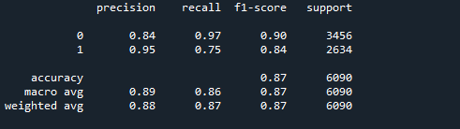

**4-CONCLUSION**

First we concatenate train and test data to add ‘label’ column for test data and N/A assign for all of the test label. Reset the index because of prevent mixed index. For test and train data split ‘text’ column than send it Cleaning Function. These function include NLP techniques such as stopwords, lemmatization, regular expression and tokenization process. We did this function for clean data and get better results.

So the machine can’t understand to text data.Our goal is the read and comprehend data and make inference.We use tfidf vectorizer and convert to data type to vector than convert it again to array.After that ML can understand data so in here for predict we used Multinominal Naïve Bayes theorem. Train our model with train data and after the model trained we send to test data and expect to predict detect the fake news. Model successfully predicted and we write results with id and text to another csv file

**5-REFERENCES**

* <https://scikitlearn.org/stable/modules/generated/sklearn.feature_extraction.text.TfidfVectorizer.html>
* <https://www.upgrad.com/blog/multinomial-naive-bayes-explained/#:~:text=The%20Multinomial%20Naive%20Bayes%20algorithm%20is%20a%20Bayesian%20learning%20approach,tag%20with%20the%20greatest%20chance>.
* <https://towardsdatascience.com/7-nlp-techniques-you-can-easily-implement-with-python-dc0ade1a53c2>
* <https://www.programiz.com/python-programming/csv#:~:text=To%20write%20to%20a%20CSV,data%20into%20a%20delimited%20string>.