

**REPUBLIC OF TURKEY**

**ADANA ALPARSLAN TÜRKEŞ SCIENCE AND TECHNOLOGY UNIVERSITY**

**FACULTY OF ENGINEERING**

**DEPARTMENT OF COMPUTER ENGINEERING**

**TURKISH VERSION OF PERCEIVED STRESS SCALE (PSS) FOR UNIVERSITY STUDENT**

**KADİR GÜNEY 180101006**

**İSMAİL DEREVLİ 170101024**

**ADANA 2021-2022**

**ABSTRACT**

The aim of study is to investigate of correlation between perceived stress and coping with stress strategies. 101 university students participated in the research and 58 questions were expected to be answered from them. We tried to evaluate these results by applying classification methods with 3 different tools. At the end of the study, participants 12% are high stressed,79% normal and 9% low stressed level.

**INTRODUCTION**

Stress, expressed as a modern disease, is an important part of the expression. Today, the human normally has an intense stress load on bile if it does not arrive. Daily routine for our purposes, anything is stressful. in our body health Assembling a redemptive future also causes stress. Mentally also real, concrete They open up to stress pathways until change. The rivalries of the season in our daily life, they cause us to experience comments, loves these things make us stressful. What is stress? The word stress comes from the Latin "estrictia". Stress, 17th century disaster, trouble, calamity,It was used in the meanings such as trouble, grief, sorrow. In the 18th and 19th centuries, the meaning of the concept changed and changed to objects, person, organs and psychic structure in meanings such as power, pressure, force. was used for. Accordingly, the stress, the object, and the person's to be used as a resistance against being deformed and distorted by the effect of has begun. Stress affects individuals and their behavior, relationships with other people. It is an influencing concept. Stress, a situation that occurs out of the blue or spontaneously is not. In order for stress to occur, the environment in which a person lives or lives and changes in the environment must affect people. Every change in the environment individual is affected, but some individuals experience these changes more or more slowly. are affected. Stress is a change in the environment in which a person lives or It is about the effect of changing the environment of a person on him. Under the influence is that the personality traits of the remaining person affect the degree of being under the influence of these effects. Special bio-chemicals in the body of the individual affected by the environment for stress to occur. With the formation of changes, the body system of the individual must be activated.

**METHOD**

Method This four step study was part Perceived Stress Scale for University Students. The first stage of the study, which is directed to people of all ages diagnosed with cancer, is the demographic survey conducted to obtain personal information such as age, gender, education, income. The second stage is a psychological questionnaire measuring childhood, family life, and sleep quality. The third part for University students and internet/social media addiction such as university department,social media trust level and usage time of internet. The last part life quality questions which tries to measure the physical and psychological effects to the university life. At the end of these part we gave score for question then we measured stressed level for participants.

We apply the preprocessing manually for dataset on excel. For the change the all values to numeric we use dummy method on R , also use upsampling method for unevenly distributed data.

**COMPARISON DATASET TYPES**

**Numeric Results**

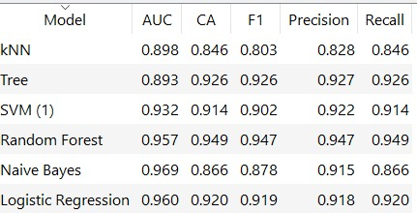

**Nominal Results**

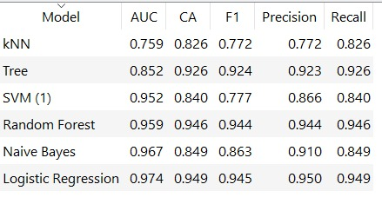

**Normal(Refined) Data Results**

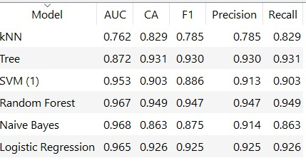

**TOOLS**

R LANGUAGE

We have 8 classification method for R language

|  |  |  |  |  |  |
| --- | --- | --- | --- | --- | --- |
| **Algorithm** | **Accuracy** | **Precision** | **Recall** | **F-Measure** | **ROC Area** |
| Naïve Bayes | 0.558 | 0.42 | 0.39 | 0.35 | 0.4896 |
| Bagging | 0.7985 | 0.687 | 0.56 | 0.58 | 0.7523 |
| Random Forest | 0.947 | 0.75 | 0.87 | 0.857 | 0.752 |
| Boosting | 0.95 | 0.75 | 0.85 | 0.86 | 0.8896 |
| Logistic Regression | 0.756 | 0.33 | 0.33 | 0.33 | 0.6242 |
| Support Vector Machine | 0.84 | 0.5 | 0.67 | 0.57 | 0.5787 |
| Decision Tree | 0.78 | 0.486 | 0.55 | 0.47 | 0.3895 |
| K -means Hierarchical Clustering | 0.652 | 0.43 | 0.589 | 0.574 | 0.5478 |

ORANGE

We have 6 Classification for Orange

|  |  |  |  |  |  |
| --- | --- | --- | --- | --- | --- |
| **Algorithm** | **Accuracy** | **Precision** | **Recall** | **F-Measure** | **ROC Area** |
| Naïve Bayes | 0.863 | 0.559 | 0.950 | 0.704 | 0,975 |
| Logistic | 0.926 | 0.793 | 0.767 | 0.780 | 0.793 |
| kNN | 0.851 | 0.900 | 0.150 | 0.257 | 0.895 |
| SVM | 0.906 | 1.000 | 0.450 | 0.621 | 0.960 |
| Decision Table | 0.926 | 0.793 | 0.767 | 0.780 | 0.850 |
| Random Forest | 0.943 | 0.885 | 0.767 | 0.821 | 0.955 |

WEKA

We have 20 Classification for WEKA

|  |  |  |  |  |  |  |
| --- | --- | --- | --- | --- | --- | --- |
| **Algorithm** | **Accuracy** | **Precision** | **Recall** | **F-Measure** | **ROC Area** | **RMSE** |
| Bayes Net | 88.2353 | 0.935 | 0.882 | 0.895 | 0.972 | 0.3345 |
| Bayesian Logistic Regression |  |  |  |  |  |  |
| Naïve Bayes | 90.099 | 0.912 | 0.901 | 0.905 | 0.899 | 0.2953 |
| Naive Bayes Multinominal Updateable | 85.2941 | 0.853 | 0.853 | 0.921 | 0.5 | 0.3585 |
| Multilayer Perceptron | 85.2941 | 0.926 | 0.853 | 0.871 | 0.986 | 0.3229 |
| SMO | 82.3529 | 0.884 | 0.824 | 0.842 | 0.814 | 0.4201 |
| Linear Regression | 86.4589 | 0.889 | 0.878 | 0.865 | 0.912 | 0.3878 |
| Logistic | 85.2941 | 0.926 | 0.853 | 0.871 | 0.952 | 0.3789 |
| Simple Logistic |  |  |  |  |  |  |
| IBk (k=3) | 87.1287 | 0.861 | 0.871 | 0.863 | 0.699 | 0.355 |
| IB1 |  |  |  |  |  |  |
| KStar | 79.4118 | 0.842 | 0.794 | 0.812 | 0.793 | 0.4562 |
| Bagging | 83.4586 | 0.8420 | 0.861 | 0.896 | 0.885 | 0.3198 |
| Random Committee |  |  |  |  |  |  |
| Classification Via Regres. |  |  |  |  |  |  |
| VFI |  |  |  |  |  |  |
| Hyper Pipes |  |  |  |  |  |  |
| JRip | 95.0495 | 0.950 | 0.950 | 0.949 | 0.887 | 0.2139 |
| Ridor |  |  |  |  |  |  |
| Decision Table | 97.0588 | 0.972 | 0.971 | 0.969 | 0.900 | 0.1747 |
| OneR | 96.0396 | 0.962 | 0.960 | 0.958 | 0.889 | 0.199 |
| ZeroR | 85.2941 | 0,853 | 0.853 | 0.921 | 0.5 | 0.3585 |
| DTNB | 85.2941 | 0.926 | 0.853 | 0.871 | 0.952 | 0.3789 |
| Random Forest | 97.0588 | 0.972 | 0.971 | 0.969 | 0.979 | 0.2445 |
| SimpleCart |  |  |  |  |  |  |
| Random Tree | 85.1485 | 0.838 | 0.851 | 0.842 | 0.718 | 0.381 |
| J48 | 94.1176 | 0.958 | 0.941 | 0.945 | 0.993 | 0.1723 |
| Id3 |  |  |  |  |  |  |
| BFTree | 96.1245 | 0.945 | 0.920 | 0.932 | 0.975 | 0.335 |
| REPTree | 97.0588 | 0.972 | 0.971 | 0.969 | 0.900 | 0.1649 |

**COMPARISON BETWEEN TOOLS ON CLASSIFICATIONS**

**ALGORITHM 1: RANDOM FOREST**

|  |  |  |
| --- | --- | --- |
|  | **ACCURACY** | **F-MEASURE** |
| **ORANGE** | 0.943 | 0.821 |
| **R** | 0.947 | 0.857 |
| **WEKA** | 97.0588 | 0.969 |

According to Accuracy measurement there is no big diffrences between tools, but

for the F-measure Orange and R lower value than WEKA.

**ALGORITHM 2: LOGISTIC REGRESSION**

|  |  |  |
| --- | --- | --- |
|  | **ACCURACY** | **F-MEASURE** |
| **ORANGE** | 0.926 | 0.780 |
| **R** | 0.756 | 0.33 |
| **WEKA** | 85.2941 | 0.871 |

Orange has the highest Accuracy rate weka second and R third. For the F-measure Orange and weka close each other but R pretty low

**ALGORITHM 3: NAÏVE BAYES**

|  |  |  |
| --- | --- | --- |
|  | **ACCURACY** | **F-MEASURE** |
| **ORANGE** | 0.863 | 0.704 |
| **R** | 0.558 | 0.35 |
| **WEKA** | 90.099 | 0.905 |

Orange and Weka similar value for Accuracy,R so lower than theese. F-measure Weka has highest rate, orange little bit low, R so much low.

**FIGURES BELONG THE SURVEY RESULTS**

**FIGURE 1**

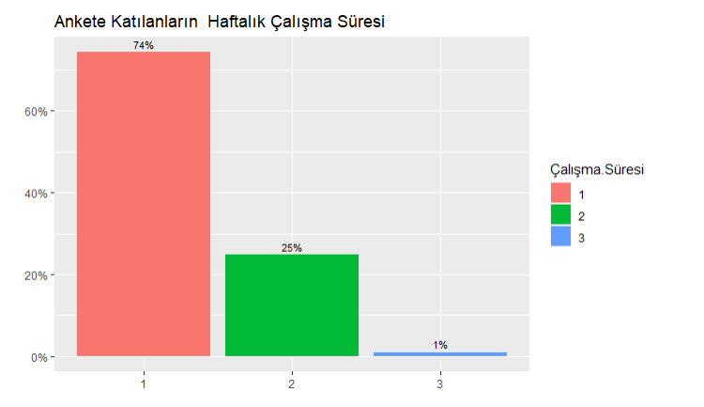

Figure 1 shows the weekly work time for participiants. 74% working 0-20 hour, 25% working 20-40 hours, 1% working over 40 hours.

**FIGURE 2**

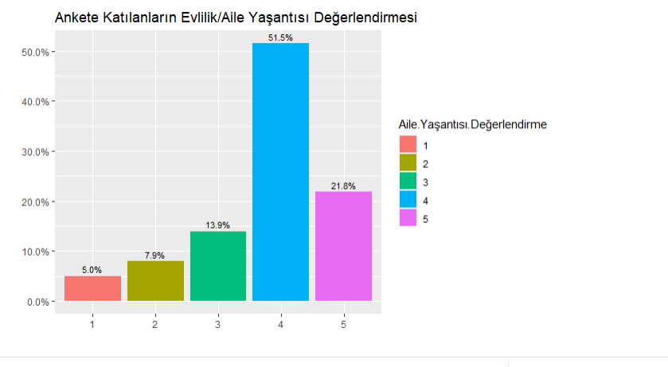

Figure 2 shows the family life assessment. Participants were expected to score out of 5, 5% gave 1 point, 7.9% gave 2 point, 13.9% gave 3 point,51.5% gave 4 point

21.8% gave 5 point.

**FIGURE 3**

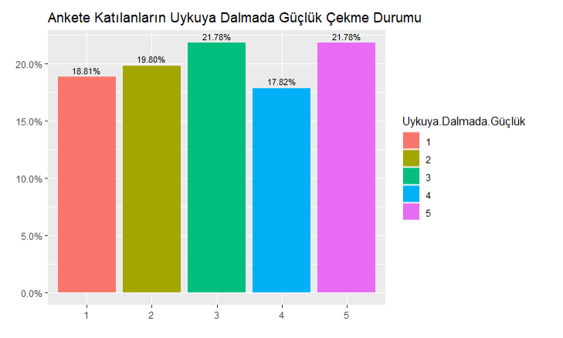

Figure 3 shows difficulty falling asleep results, 18.81% never, 19.8% hardly ever, 21.78% sometimes, 17.82% often, 21.78% always difficult fall to sleep.

**CONCLUSIONS**

After the get get data formed survey results, we select target question and set the model, train data apply test on it and we get preditiction. After prediction in real life whose work with this sample can use that, according to data results will get can achieve purpose. For example a psychiatrist using this data model, prediction, classification methods and results can use diagnose for disase or use for cure. The accuracy values ​​of the results facilitates treatment and diagnosis.

**REFERENCES**

• Predictors of Stress in College Students-Dalia Saleh,Nathalia Camart,Lucia Romo

• Academic performance and perceived stress among university students-Muhammad Zia-ur-Rehman

• Perceived stress in university students studying in a further

education college-Daniel James Peart & James William Fairhead

• <https://techvidvan.com/tutorials/classification-in-r/Classifaction> Algorithms R Language

•https://docs.weka.io/

•https://orange3.readthedocs.io/projects/orange-data-mining-library/en/latest/index.html