**Indoor Air Quality Predictions For Automation**

**Kadir Gokdeniz1**

1.Department of Computer Engineering, Faculty of Engineering, Ankara University, Ankara 06830, Türkiye; (K.G. ORCID: 0009-0004-0901-8642)

**Abstract:** This study examines the implementation of home automation systems to predict indoor air quality using real-time data such as temperature, humidity, pressure, occupancy status, energy consumption, and window conditions. Due to the superior pattern recognition performance of recurrent neural networks, the study employs deep learning techniques for air quality prediction. A comparative analysis of GRU, LSTM and BiGRU models highlights GRU’s superior performance across various metrics, emphasizing its generalization capability. The study also introduces an Air-Smart Control Device, enabling users to monitor predictions and control home automation systems. In conclusion, the research underscores the potential of home automation in air quality prediction, provides insights into neural network architectures, and contributes to advancements in automation technology and air quality management.

**Keywords:** Automation System, Air Quality, Deep Learning, Machine Learning

**1. Introduction**

The origins of automation systems can be traced back to before the Common Era. However, the Industrial Revolution is what massively transformed human life (Usher, 1954). While the primary domain benefiting from automation systems has been industrial production, with the arrival of the 2000s, they began to transform our lives in many other areas. Automation systems are reshaping our lives in various fields such as automatic driving systems and transportation (Fagnant et al., 2015), energy management, smart grids, building automation and smart home technologies, telecommunications and communication systems management, healthcare, and medical technologies (Donaldson et al., 2000) .

The emergence of COVID-19 has led to global quarantine and social distancing measures, which have forced people to stay at home more (Brooks et al., 2020). These prolonged periods spent indoors have brought along comfort and health problems. Smart home technologies promise to address these comfort and health issues . Heating, ventilation, and air conditioning (HVAC) systems work seamlessly with smart home systems to automate indoor air quality. Using microcontrollers, information such as indoor and outdoor temperature, relative humidity, pressure, CO2 levels, occupancy status, and window status (open/closed) is measured in real time .

Model Predictive Control (MPC) is an approach developed to predict and analyze future states of automation systems and to provide energy savings (Qin et al., 2003). MPC systems integrate automation systems and prediction models to form a hybrid system. The mentioned system design necessitates a Human-machine interface (HMI) that enables users to understand how automation systems operate and the mode they are operating in (Mentler et al., 2016). HMI refers to a software platform where people can intervene in the operation of automation systems and view data. Figure 1 illustrates the interaction of home automation systems with the environment.

Dynamic systems emerge as structures that enable systems to better understand user needs and facilitate the creation of smarter strategies. This approach allows for the development of faster and more effective strategies toward goals, which can improve living standards. Proactive approaches have a significant impact on this improvement, and machine learning plays an important role. The generation of prediction data can enhance the operation of automation systems.

Human-Machine Interface (HMI) systems developed in smart home technologies contribute to energy efficiency and utilize specialized technologies to improve indoor air quality (Phillips et al., 2015). These systems also support the development of strategies designed to mitigate the negative impacts of climate change. As highlighted in the study, modern sensor technologies not only measure climatic characteristics but also detect airborne pollutants and relay this data to smart home systems (Kumar et al., 2016). However, new smart homeowners may need to adapt to the inability to open windows manually, which can be a significant adjustment and may pose challenges for many.

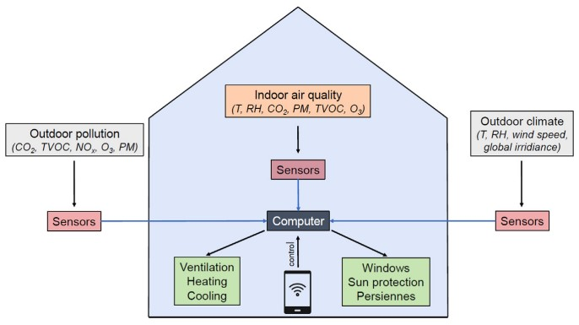

**Figure 1.** Indoor Air Quality Automation. (Schieweck et al., 2018)

Research suggests, we will need to further investigate how to create healthy living environments (Almeida et al., 2016). In the United States, a group of health experts has thoroughly examined how climate change affects our lifestyle (The Institute of Medicine, 2011). Upon reviewing the report of this research, it was found that climate change significantly increases health risks for the elderly, children, and people with cardiac/respiratory diseases. Study also focused on the impacts of climate change on indoor air quality and emphasized that systems regulating indoor air quality (HVAC) are a significant factor affecting the prevalence of diseases (Nazaroff et al., 2013).

Health-based smart technologies create a complex network of various technological devices, introducing the concept of Ambient Assisted Living (AAL) into our lives. This network integrates with personal healthcare monitoring and tele-health systems (Marques et al., 2016). In addition to help reduce the growing demands in the healthcare sector, this technology also supports improving energy efficiency and reducing negative environmental impacts.

The data collected by sensors is intended to enhance user comfort. According to the study , the need for humidity and temperature sensors in smart home systems has increased over the years (Barmpakos et al., 2021). The number and placement of sensors are crucial. Sensors inside the home come in various types, and their measurement capacities and performance offer both advantages and disadvantages. The correct selection and positioning of sensors are crucial for the overall efficiency and performance of the system.

Another important issue is IoT protocols. In smart home systems, data collected from sensors should be securely, quickly, and comprehensively transported in an appropriate format. Protocols such as Wi-Fi (802.11), Bluetooth, Zigbee, and Z-Wave are commonly used technologies for transmitting data in smart home automation systems (Stolojescu-Crisan et al. , 2021). While Wi-Fi provides broad coverage and high bandwidth, Bluetooth is ideal for short-range communication. Zigbee and Z-Wave, on the other hand, are preferred for establishing wireless communication among devices with low power consumption. These protocols are selected based on the features of the devices and user preferences, each offering different advantages.

With all these mentioned details, IoT systems and automation systems emerge and are utilized alongside machine learning methods. These systems impact humans comprehensively, with effects ranging from health to security, and even entertainment areas. For these reasons, they will continue to be among the focus areas for researchers and individuals in the near future.

**2. Background and Related Works**

As an early study, a research used multivariate analysis of variance (MANOVA) to predict the indoor air quality of a metro system (Kim. et al., 2012). In this study, the data was divided into three categories: spring and fall as the first category, summer as the second category, and winter as the third category. The variance analyses were conducted separately for these categories. This study indicates that indoor air quality varies depending on the seasons.

Another study is based on an optimization work conducted by Priyadarshi and Naik. In this study, they perform regression prediction using the K-nearest neighbors (KNN) algorithm (Priyadarshi et al., 2023). For these predictions, they utilize a model called the Finite Difference Transient Model (FDM). The study thoroughly discusses the potential limits and advantages of this model.

The study conducted by Akilan and Baalamurugan focuses on predicting indoor weather conditions in agriculture using GRU (Gated Recurrent Unit) and LSTM (Long Short-Term Memory) to develop a warning system that alerts before plants encounter unfavorable conditions (Akilan et al., 2024). This IoT (Internet of Things) based study is significant for understanding how GRU and LSTM models are used in time series analysis and how sensor data interacts.

Another study conducted by Elnaggar and others presents a risk analysis of the indoor air quality required for the preservation of artworks in a museum located in the Mediterranean region (Elnaggar et. al., 2024). This study also provides a comprehensive examination of how risk analysis is conducted in the preparation of automation systems. By identifying the necessary indoor air quality parameters for the preservation of artworks, the study details how these parameters can be integrated into automation systems and how these systems can be managed effectively.

Study conducted a classification study on air quality prediction using artificial neural networks and gradient-boosting models, and they developed a website to present their findings (Gururaj et al., 2024). This study is an important resource for our project to compare HMI (Human-Machine Interface) design with literature studies and to learn from current applications.

In another study conducted by Wardana and others, a comprehensive study was presented on the simultaneous display of predictive and real-time data in SCADA (Supervisory Control and Data Acquisition) devices (Wardana et al., 2024). This study thoroughly explores how data can be integrated and presented simultaneously in SCADA systems.

Our primary objective within the project revolves around the prediction of indoor air quality, thus necessitating the handling of a regression problem concerning time series data. Within the existing literature, a range of machine learning methodologies including Dummy, Huber, Ada Boost, GBoost, Random Forest, XGBoost, KNN, Decision Trees, LSTM, and ARIMA are frequently employed (Korner et al., 2016). The outcomes of the research indicate that among these machine learning models, Recurrent Neural Networks (RNNs) exhibit superior performance, particularly within short-term intervals. Consequently, our focus has been directed towards leveraging RNNs.

**3. Design and Method**

In this section, factors affecting prediction ability will be explained while constructing the deep artificial neural network.

**3.1 Dataset and Data Preparation**

The study aimed at examining household energy consumption, health, and security impacts, and providing support to researchers, presents an open-access dataset (Wang et al., 2024). The data were obtained from an apartment in Beijing, China. Using a cloud-based data collection platform called IDCP, the data were collected covering a period from May 31, 2021, to May 31, 2022. The data were collected on a minute-by-minute basis, including household behaviors, thermal environment information, device usage quantities, and also external weather data from the nearest national weather station. This dataset is significant for being the first publicly accessible dataset that concurrently records household behaviors and electricity usage in China. The dataset is made accessible under the title CN-OBEE.

The dataset includes data from 6 different rooms: cloakroom, home office, kitchen, living room, master bedroom, and secondary bedroom. Data for each room, such as temperature, relative humidity, pressure, window status (open/ closed), location, and occupancy status, are recorded at a minute-by-minute frequency. External weather data, on the other hand, are recorded at an hourly frequency and include dry-bulb temperature (◦C), relative humidity (%), atmospheric pressure (hPa), wind speed (m/s), wind direction, ground temperature (◦C), horizontal total solar radiation intensity (W/m2 ), and horizontal diffuse solar radiation intensity (W/m2). Energy consumption data for household appliances are stored at a minute-by-minute frequency and include data from an electric kettle, fridge, rice cooker, computer, TV, upstairs water heater, downstairs water heater, washing machine, and 6 different air conditioners.

Converting data to a numerical format is essential for training models. Categorical data in the dataset, such as wind direction, have been transformed into numerical values using Label Encoder. On the other hand, dealing with missing values presents a significant challenge. While low rates of missing data are generally tolerable, high rates can severely impact data quality. Therefore, a tolerance threshold of 5.5% was set, and missing values were imputed with the median value. Due to the high rate of missing data, the data from the master bedroom was excluded from the analysis.

To optimize the processing of the data, it has been examined in 10-minute intervals. Since the external weather data is available at hourly frequency, it is assumed that the outdoor weather conditions remain constant within each hour. Therefore, the weather data for each hour is utilized to divide the data into 10-minute intervals.

**3.1 Data Visualization and Feature Engineering**

Examining the characteristic features of the data before training is essential for better management of the process. Data visualization can facilitate the analysis of statistical information such as the arithmetic mean and standard deviation, as well as other issues. For example, anomaly detection is a crucial approach for analyzing automation systems. Upper and lower limits can be determined using Exponential Moving Averages to assist in analyzing abnormal behaviors. Figure 2 presents an excerpt from the analysis of abnormal behavior observed in the indoor temperature data from the living room.

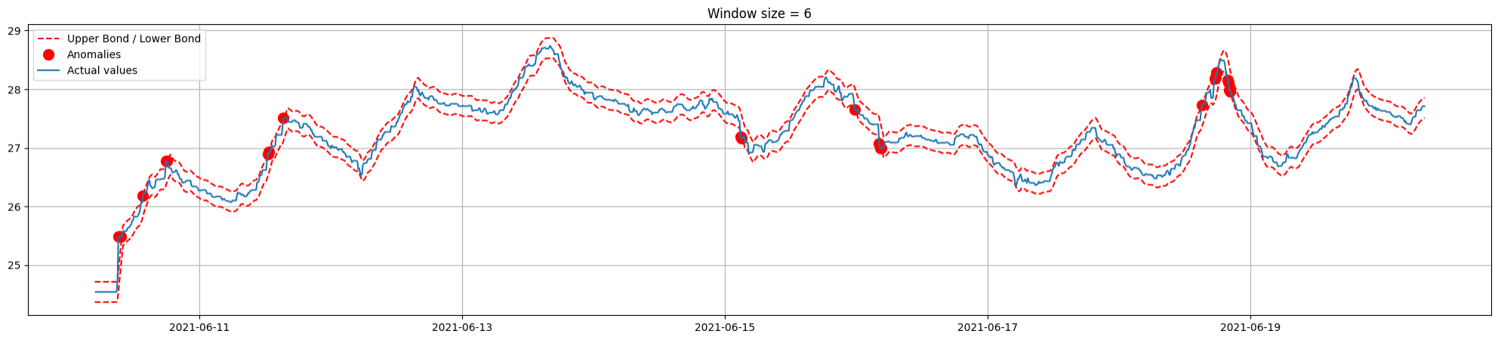

**Figure 2.** Anomaly detection for living room interior temperature.

The selection of data for training significantly impacts the performance of the training process. In some cases, meaningful potentials can be derived from the data, while in others, training with similar or identical data may exacerbate the tendency for overfitting. Guided by the insights provided by the study, we are incorporating seasonal information into the data numerically (Kim et al., 2012). The high interaction of this information, particularly with relative humidity data, suggests its potential to enhance predictive performance. Conversely, through the use of a correlation matrix, we investigate the interaction among the data, and some data with similar correlation values that are selected for prediction are excluded from the training process.

**3.2 Data Preprocessing**

In deep neural networks, normalization is a routine process applied to enhance training performance, as also mentioned in the study (Ioffe et al., 2015). Normalization procedures reduce the effects of outliers while preserving the fundamental characteristic features of the data. An implementation such as MinMaxScaler rescales the data to a scale between the minimum and maximum values. This process brings the data distribution into a range between 0 and 1, allowing the model to be trained more effectively and converge more rapidly.

The function acts as a data preprocessor designed to extract training samples from a time series dataset. It generates sequential samples based on a specified ’lookback’ period, which determines the duration of the historical data each sample should consider. Additionally, it defines a ’delay’ period for the time lag of target values. The function supports the shuffling of samples and allows for the customization of batch size and step size, providing flexibility in the data preparation process for model training.

Each sample is constructed by looking back over a period of 10 days, with a time interval of 30 minutes between consecutive data points. The time difference between input data and target values is 1 day. These parameters determine how the dataset will be processed and how far back and forward each sample will look. Thus, they play a crucial role in determining how the model will evaluate and predict time series data.

**3.3 Air-Smart Controller**

Air-Smart Controller is a web interface developed using Python’s Streamlit library. Through this web interface, users can view data for the next 44 days at ten-minute intervals. The data is collected from 5 different rooms, and it includes temperature, relative humidity, and pressure information. Additionally, it shows which modes the automation system will operate in, synchronized with the data.

Users can request changes to the modes of the automation system. Through this interface, users can suspend the operation of the automation system or request it to operate in different modes. These user-initiated actions are evaluated by the automation system, and as a result of this evaluation, the request may be deemed valid or invalid. Figure 3 visually presents the deployment and overall operation of the Air-Smart Controller device.

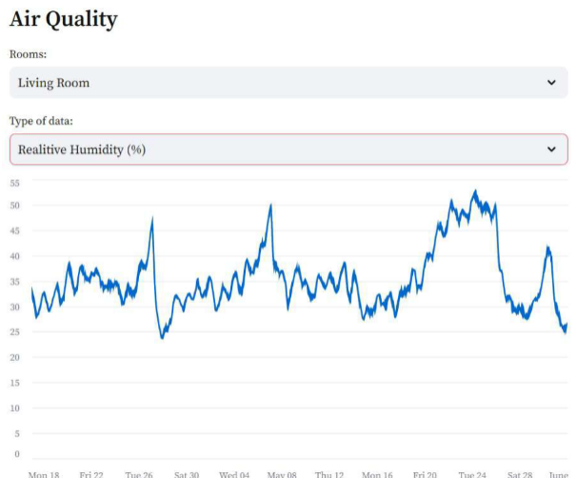

**Figure 3.** Air-Smart Controller Data Visualisation.

**4. Results**

Table1, Table2 and Table3 presents a comprehensive comparison of LSTM, GRU and BiGRU models across different rooms and air quality parameters. Let’s analyze these results in detail.

**Table 1.**Indoor Temperature (°C) Predictions - Results (Renormalized)*.*

|  |  |  |  |  |  |  |  |
| --- | --- | --- | --- | --- | --- | --- | --- |
| Models | Metrics | Cloakroom | Home Office | Kitchen | Living Room | Secondary Bedroom | Average Result |
| GRU | MAE | 0.62 | 0.59 | 0.53 | 0.50 | 0.63 | 0.57 |
| MSE | 0.61 | 0.62 | 0.52 | 0.43 | 0.63 | 0.56 |
| RMSE | 3.06 | 3.10 | 2.70 | 3.24 | 2.81 | 2.98 |
| LSTM | MAE | 1.50 | 1.35 | 0.59 | 0.63 | 0.59 | 0.93 |
| MSE | 3.37 | 2.66 | 0.53 | 0.62 | 0.54 | 1.54 |
| RMSE | 3.77 | 3.14 | 2.70 | 3.15 | 2.83 | 3.12 |
| BiGRU | MAE | 0.57 | 0.70 | 0.57 | 0.55 | 0.62 | 0.60 |
| MSE | 0.52 | 0.81 | 0.50 | 0.48 | 0.61 | 0.58 |
| RMSE | 3.06 | 3.00 | 2.76 | 3.17 | 2.81 | 2.96 |

**Table 2.**Indoor Relative Humidity (%) Predictions - Results (Renormalized)*.*

|  |  |  |  |  |  |  |  |
| --- | --- | --- | --- | --- | --- | --- | --- |
| Models | Metrics | Cloakroom | Home Office | Kitchen | Living Room | Secondary Bedroom | Average Result |
| GRU | MAE | 4.60 | 5.56 | 5.56 | 6.14 | 5.19 | 5.41 |
| MSE | 40.60 | 51.95 | 106.08 | 69.47 | 41.82 | 61.98 |
| RMSE | 8.00 | 8.68 | 11.69 | 9.52 | 8.14 | 9.21 |
| LSTM | MAE | 5.98 | 5.79 | 7.48 | 6.25 | 5.19 | 6.14 |
| MSE | 56.18 | 51.83 | 51.95 | 70.58 | 70.64 | 60.24 |
| RMSE | 8.78 | 8.53 | 8.68 | 9.37 | 9.72 | 9.02 |
| BiGRU | MAE | 5.06 | 6.14 | 10.13 | 9.17 | 4.40 | 6.98 |
| MSE | 44.48 | 59.06 | 143.15 | 112.47 | 36.47 | 79.13 |
| RMSE | 8.18 | 9.22 | 13.15 | 11.66 | 7.83 | 10.01 |

**Table 3.**Indoor Air Pressure (hPa) Predictions - Results (Renormalized)*.*

|  |  |  |  |  |  |  |  |
| --- | --- | --- | --- | --- | --- | --- | --- |
| Models | Metrics | Cloakroom | Home Office | Kitchen | Living Room | Secondary Bedroom | Average Result |
| GRU | MAE | 627.83 | 607.42 | 607.42 | 583.51 | 596.27 | 604.49 |
| MSE | 564 216.87 | 535 430.87 | 535 431.78 | 510 340.63 | 521 524.22 | 533,388.87 |
| RMSE | 1 085.16 | 1 098.53 | 1 094.52 | 1 086.07 | 1 081.29 | 1,089.11 |
| LSTM | MAE | 644.21 | 621.78 | 553.50 | 593.14 | 633.675 | 609.26 |
| MSE | 612 609.11 | 604 939.58 | 488 360.060 | 540 417.29 | 609 777.93 | 571,220.79 |
| RMSE | 1 117.02 | 1 113.87 | 1 036.33 | 1 067.38 | 1 110.68 | 1,089.06 |
| BiGRU | MAE | 619.87 | 597.79 | 559.47 | 599.15 | 516.10 | 578.48 |
| MSE | 556 329.85 | 542 965.48 | 495 574.68 | 528 724.48 | 417,603.79 | 508,239.66 |
| RMSE | 1 089.68 | 1 098.14 | 1 045.90 | 1 070.45 | 985.00 | 1,057.83 |

**4.1 Temperature Predictions**

For temperature prediction, the GRU model outperforms the LSTM model in all rooms except the kitchen. The average MAE for GRU is 0.57°C, while for LSTM, it is 0.93°C. This indicates that GRU provides more accurate temperature predictions.

In temperature predictions, GRU exhibits lower MSE values across all rooms. The average MSE for GRU is 0.56, compared to 1.54 for LSTM. This demonstrates that GRU has lower variance and fewer significant errors than LSTM.

When considering RMSE values, GRU achieves lower results in most rooms. The average RMSE for GRU is 2.98°C, compared to 3.12°C for LSTM. This confirms GRU’s superior performance in temperature prediction.

BiGRU performs between GRU and LSTM for temperature prediction. While its MAE, MSE, and RMSE values are slightly higher than GRU’s, they are significantly lower than LSTM’s. BiGRU appears to balance the precision of GRU with the reliability of LSTM. Detailed performance metrics are summarized in Table 1.

**4.2** **Relative Humidity Predictions**

For relative humidity prediction, GRU outperforms LSTM in three rooms. GRU’s average MAE is 5.41%, while LSTM’s is 6.14%. This indicates that GRU provides more accurate humidity predictions.

Interestingly, LSTM has a slightly lower average MSE (60.24) compared to GRU (61.98). This suggests that while GRU performs better on average, LSTM might handle extreme humidity conditions better.

The RMSE values are quite close, with GRU averaging 9.21% and LSTM 9.02%. This confirms that LSTM performs slightly better for humidity prediction.

BiGRU’s performance for relative humidity prediction falls between GRU and LSTM. However, its MAE, MSE, and RMSE values are higher than both, indicating that BiGRU struggles more with humidity predictions. Detailed performance metrics are summarized in Table 2.

**4.3** **Air Pressure Predictions**

For air pressure prediction, GRU consistently outperforms LSTM in all rooms. The average MAE for GRU is 604.49 hPa, compared to 609.26 hPa for LSTM.

GRU also shows significantly lower MSE values for air pressure predictions across all rooms. GRU’s average MSE is 533,388.87, while LSTM’s is 571,220.79. This demonstrates that GRU’s predictions are more consistent.

Despite the large difference in MSE, the average RMSE values are very close: GRU has an RMSE of 1,089.11 hPa, and LSTM has 1,089.06 hPa. This suggests that both models have similar overall error magnitudes, but GRU errors are more uniformly distributed.

BiGRU outperforms both GRU and LSTM in air pressure prediction, achieving lower MAE, MSE, and RMSE values. This establishes BiGRU as the strongest model for air pressure prediction. Detailed performance metrics are summarized in Table 3.

1. **Discussions**
   1. **Room-Specific Performance Analysis**

Our results reveal interesting variations in prediction accuracy across different rooms. Let’s examine these differences and explore potential reasons behind them:

The occupancy frequency of the rooms is an important factor for understanding and explaining the performance of the prediction models. The values are provided in Figure 4, it becomes possible to interpret the results in more depth. For example, the living room and kitchen, which have the highest occupancy frequencies, generally exhibit low MAE and RMSE values for temperature predictions. This can be related to the fact that, with high occupancy, these areas become more stable in terms of environmental parameters. Specifically, the kitchen, due to its frequent and consistent temperature fluctuations, is an area where GRU and BiGRU models have performed well.

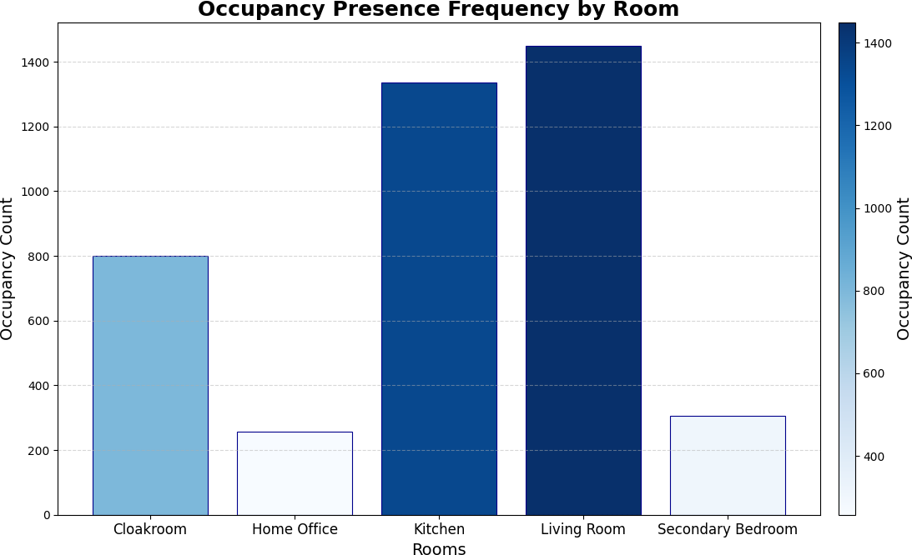

**Figure 4.** Occupancy Presence Frequency Distribution.

On the other hand, secondary bedroom and home office, which have lower occupancy frequencies, may have more challenging dynamics for prediction. The secondary bedroom has shown the highest error values for relative humidity predictions, which can be attributed to the fact that the lower occupancy frequency makes the environment more susceptible to external factors, reducing the models’ ability to predict accurately. The relative humidity levels in an area with low occupancy could be more variable and harder to model.

A room like the cloakroom, which has a relatively low occupancy frequency, showed good performance with GRU and BiGRU models for air pressure predictions but higher errors for relative humidity predictions, particularly with BiGRU. This could indicate that the low occupancy frequency leads to more unpredictable environmental conditions in that room. In contrast, for parameters like air pressure, which tend to be more stable and less affected by occupancy, the models performed consistently.

The home office, despite having the lowest occupancy frequency, showed relatively balanced performance across the parameters. This could indicate that environmental conditions in the home office are more consistent compared to other rooms, and the effects of low occupancy may be less significant there. In particular, air pressure predictions in the home office had some of the lowest error values.

Overall, the occupancy frequencies shown in Figure 4 provide critical context for understanding the impact of room dynamics on environmental variables and model performance. High occupancy frequency tends to create more predictable and stable environmental changes, leading to better model performance, while low occupancy frequency can make predictions more challenging and increase error rates. The performance of prediction models is directly influenced by the combination of occupancy frequency and environmental stability, highlighting the importance of considering occupancy dynamics when evaluating model performance.

**5.2 Overall Model Comparison**

GRU demonstrated the best performance, particularly in the living room, achieving better results in temperature predictions compared to other models. Unlike the other models that struggled with complex data patterns, especially in relative humidity predictions, LSTM performed better in the kitchen. BiGRU generally exhibited an average level of performance but outperformed other models in air pressure predictions, with this success being more pronounced in the cloakroom and secondary bedroom. Overall, the model’s performance varies based on the data structure of the room and the complexity of the predicted parameter, suggesting that different models may be more effective in specific situations.

In conclusion, our analysis suggests that the GRU model is generally more suitable for predicting indoor air quality parameters in home automation systems. However, the choice between GRU, LSTM and BiGRU may depend on specific requirements, such as the relative importance of different air quality parameters or computational constraints in the deployment environment.

**5.3 Limitations and Future Work**

This study focuses on the application of predictive algorithms in smart homes, analyzing data from a single household in Beijing over one year. Due to the limited dataset, the generalizability of the findings may be restricted. Additionally, other machine learning techniques were excluded to maintain the study's scope. Future research could address these limitations by using larger, more diverse datasets and exploring advanced transformer-based architectures to provide broader insights.

1. **Conclusion**

This study has demonstrated the potential of deep learning techniques, specifically GRU, LSTM and BiGRU models, in predicting indoor air quality parameters within the context of home automation systems. Our comprehensive analysis across different rooms and air quality metrics (temperature, humidity, and air pressure) revealed that GRU models generally outperformed LSTM and BiGRU models in terms of overall performance. GRU models exhibited particularly strong results in temperature and air pressure predictions, achieving lower error rates across various evaluation metrics (MAE, MSE, RMSE). The BiGRU model, on the other hand, delivered average performance overall but excelled in air pressure predictions, with this success being especially notable in rooms such as the cloakroom and secondary bedroom. Meanwhile, the LSTM model, though less effective in handling complex data patterns, achieved better results in specific scenarios, such as in the kitchen. These findings suggest that different models may be more effective depending on the data structure of the room and the complexity of the parameter being predicted.

This study observes interesting variations in prediction accuracy across different rooms. The results indicate that the occupancy frequency of rooms significantly impacts prediction model performance. Rooms with high occupancy frequencies, such as the living room and kitchen, tend to exhibit more stable environmental conditions, which typically results in lower MAE and RMSE values. These rooms are particularly where GRU and BiGRU models performed well in temperature predictions. On the other hand, rooms with lower occupancy frequencies, such as the secondary bedroom and home office, are areas with more variable and unpredictable environmental dynamics, making predictions more challenging and resulting in higher error rates. The secondary bedroom, for instance, showed the highest error values for relative humidity predictions, which could be attributed to the room’s lower occupancy frequency leading to more variable conditions. The cloakroom, with a relatively low occupancy frequency, demonstrated good performance in air pressure predictions but higher errors in relative humidity, indicating that lower occupancy may lead to less predictable environmental conditions. Despite having the lowest occupancy frequency, the home office displayed relatively balanced performance across parameters, suggesting that environmental conditions in this room may be more consistent. Overall, occupancy frequencies are a critical factor influencing the predictability of environmental variables and model performance, highlighting the importance of considering occupancy dynamics when evaluating model performance.

The development and implementation of the Air-Smart Controller interface mark a significant step towards practical application of our research findings. This user-friendly interface allows residents to view air quality predictions and interact with their home automation systems, bridging the gap between advanced predictive models and everyday user experience. By enabling users to monitor predictions and adjust system settings, the Air-Smart Controller enhances the adaptability and user-centricity of smart home systems. This integration of predictive analytics with user control exemplifies the potential for machine learning to enhance living environments while maintaining user autonomy and comfort.

While our study provides valuable insights, it also reveals areas for future research and development. The performance variations across rooms suggest that incorporating room-specific features or developing tailored models for different spaces could further improve prediction accuracy.

Additionally, exploring hybrid models that leverage the strengths of both GRU, LSTM and BiGRU architectures could yield even more robust predictive systems. Lastly, long-term studies on the real-world impact of these predictive systems on energy efficiency, occupant comfort, and overall air quality management would be invaluable in quantifying the practical benefits of this approach. As we continue to refine these technologies, the ultimate goal remains to create smarter, more responsive living environments that prioritize both human comfort and environmental sustainability.

**Author Contributions:** The entire article was written by Gokdeniz.

**Funding:** This research received no external funding.

**Conflicts of Interest:** The authors declare no conflict of interest.

**References**

Usher, A. P. (1954). A History of Mechanical Inventions. *Harvard University Press*.

Fagnant, D. J., & Kockelman, K. (2015). Preparing a nation for autonomous vehicles: opportunities, barriers and policy recommendations. *Transportation Research Part A: Policy and Practice*, *77*, 167-181. [https://doi.org/10.1016/j.tra.2015.04.003](https://doi.org/10.1016/j.tra.2015.04.003" \o "Persistent link using digital object identifier" \t "https://www.sciencedirect.com/science/article/abs/pii/_blank)

Donaldson, M. S., Corrigan, J. M., & Kohn, L. T. (Eds.). (2000). *To err is human: building a safer health system* (Vol. 627). National Academies Press.

Brooks, S. K., Webster, R. K., Smith, L. E., Woodland, L., Wessely, S., Greenberg, N., & Rubin, G. J. (2020). The psychological impact of quarantine and how to reduce it: rapid review of the evidence. *The lancet*, *395*(10227), 912-920. <https://doi.org/10.1016/S0140-6736(20)30460-8>

Kuo, C.H., & Chen, W.H. (2021). "Smart Home Automation Systems for Indoor Air Quality Management: A Comprehensive Review." Building and Environment, 188, 107475. <https://doi.org/10.1016/j.buildenv.2020.107475>

Raghavan, V., & Madhumathi, R. (2022). "IoT-Based Smart Home Environment Monitoring Using Microcontrollers and Sensor Networks." Internet of Things, 17, 100478. <https://doi.org/10.1016/j.iot.2022.100478>

**Qin, S.J. & Badgwell, T.A. (2003).** A Survey of Industrial Model Predictive Control Technology. Control Engineering Practice, 11(7), 733-764. <https://doi.org/10.1016/S0967-0661(02)00186-7>

Mentler, T., Reuter, C., & Geisler, S. (2016). "Introduction to this Special Issue on ‘Human-Machine Interaction and Cooperation in Safety-Critical Systems’." i-com, 15(3), 169-176. [https://doi.org/10.1515/icom-2016-0037](https://doi.org/10.1515/icom-2016-0037" \t "https://www.degruyter.com/document/doi/10.1515/icom-2016-0037/_blank)

Akilan, T., & Baalamurugan, K. M. (2024). Automated weather forecasting and field monitoring using GRU-CNN model along with IoT to support precision agriculture. *Expert Systems with Applications, 249*(A), 123468. <https://doi.org/10.1016/j.eswa.2024.123468>

Almeida, R. M. S. F., Ramos, N. M. M., & de Freitas, V. P. (2016). Thermal comfort models and pupils’ perception in free-running school buildings of a mild climate country. *Energy and Buildings, 111,* 64–75. <https://doi.org/10.1016/j.enbuild.2015.09.066>

Barmpakos, D., & Kaltsas, G. (2021). A review on humidity, temperature and strain printed sensors—Current trends and future perspectives. *Sensors, 21,* 739. <https://doi.org/10.3390/s21030739>

Elnaggar, A., Said, M., Krasevec, I., et al. (2024). Risk analysis for preventive conservation of heritage collections in Mediterranean museums: Case study of the Museum of Fine Arts in Alexandria (Egypt). *Heritage Science, 12,* 59. <https://doi.org/10.1186/s40494-024-01170-z>

Gururaj, A., Nagaraj, Rajesh A.S., Achyuth, K.N., Somesh, M.U., Dubay, A.B. (2024). Air quality prediction and analysis using machine learning. In *2024 5th International Conference on Mobile Computing and Sustainable Informatics (ICMCSI)* (pp. 543–550). Lalitpur, Nepal. <https://doi.org/10.1109/ICMCSI61536.2024.00086>

Institute of Medicine. (2011). *Climate change, the indoor environment, and health.* The National Academies Press.

Ioffe, S., & Szegedy, C. (2015). Batch normalization: Accelerating deep network training by reducing internal covariate shift. In *Proceedings of the 32nd International Conference on Machine Learning, Proceedings of Machine Learning Research* (Vol. 37, pp. 448–456). <https://doi.org/10.48550/arXiv.1502.03167>

Kim, M., SankaraRao, B., Kang, O., Kim, J., & Yoo, C. (2012). Monitoring and prediction of indoor air quality (IAQ) in subway or metro systems using season-dependent models. *Energy and Buildings, 46,* 48–55. <https://doi.org/10.1016/j.enbuild.2011.10.047>

Korner, M.-F., Bauer, D., Keller, R., Rösch, M., Schlereth, A., Simon, P., Bauernhansl, T., Fridgen, G., & Reinhart, G. (2019). Extending the automation pyramid for industrial demand response. *Procedia CIRP, 81,* 998–1003. <https://doi.org/10.1016/j.procir.2019.03.241>

Kumar, P., Skouloudis, A. N., Bell, M., Viana, M., Carotta, M. C., Biskos, G., & et al. (2016). Real-time sensors for indoor air monitoring and challenges ahead in deploying them to urban buildings. *Science of The Total Environment, 560–561,* 150–159. <https://doi.org/10.1016/j.scitotenv.2016.04.032>

Marques, G., & Pitarma, R. (2016). An indoor monitoring system for ambient assisted living based on Internet of Things architecture. *International Journal of Environmental Research and Public Health, 13,* 1152. <https://doi.org/10.3390/ijerph13111152>

Nazaroff, W. W. (2013). Exploring the consequences of climate change for indoor air quality. *Environmental Research Letters, 8,* 1–11. <https://doi.org/10.1088/1748-9326/8/1/015022>

Phillips, T. J., & Levin, H. (2015). Indoor environmental quality research needs for low-energy homes. *Science and Technology for the Built Environment, 21*(1), 80–90. <https://doi.org/10.1080/10789669.2014.975056>

Priyadarshi, G., & Naik, B. K. (2023). Desiccant coated fin tube energy exchanger design optimization implementing KNN-ML tool and adsorption/desorption kinetics analysis using finite difference-based transient model. *International Journal of Thermal Sciences, 192*(B), 108422. <https://doi.org/10.1016/j.ijthermalsci.2023.108422>

Schieweck, A., Uhde, E., Salthammer, T., Salthammer, L. C., Morawska, L., Mazaheri, M., & Kumar, P. (2018). Smart homes and the control of indoor air quality. *Renewable and Sustainable Energy Reviews, 94,* 705–718. <https://doi.org/10.1016/j.rser.2018.05.057>

Stolojescu-Crisan, C., Crisan, C., & Butunoi, B.-P. (2021). An IoT-based smart home automation system. *Sensors, 21,* 3784. <https://doi.org/10.3390/s21113784>

Wang, C., Li, X., Sun, W., et al. (2024). Occupant behavior, thermal environment, and appliance electricity use of a single-family apartment in China. *Scientific Data*, *11*, 65. <https://doi.org/10.1038/s41597-023-02891-9>

Wardana, N. K., & Fahmy, S. A. (2024). Low-cost SCADA/HMI with Tiny Machine Learning for monitoring indoor CO2 concentration. *2024 IEEE International Instrumentation and Measurement Technology Conference (I2MTC)* <https://doi.org/10.1109/I2MTC60896.2024.10561089>