Machine Learning and Deep Learning-Based Nutrition Grade Prediction
Detailed Final Project Report
Dataset: Open Food Facts | Target: nutrition_grade_fr | Task: Multi-Class Classification

Abstract
This project focuses on predicting food nutrition grades using the Open Food Facts dataset. The original dataset was cleaned, reduced to 20 meaningful nutritional and ingredient-based features, and prepared for multi-class classification. The final dataset contains 14,070 records, no missing values, no duplicate records, and five target classes. Five machine learning models and three deep learning models were implemented and compared using accuracy, precision, recall, macro F1-score, and confusion matrix analysis. XGBoost achieved the best full-feature performance, while the top-10 feature XGBoost model achieved the highest overall accuracy. The project also included data standardization, class balancing with SMOTE, feature selection, training-time analysis, and model serialization for future deployment.
Keywords: Open Food Facts, nutrition grade prediction, machine learning, deep learning, XGBoost, SMOTE, feature selection, food classification.

1. Introduction
Food products contain several nutritional indicators such as energy, fat, sugar, salt, fiber, protein, vitamins, minerals, additives, and ingredient information. Although these values are available on nutrition labels, manually interpreting them can be difficult for consumers. Automated nutrition grade prediction can support healthier food decisions and provide a data-driven way to evaluate product quality.
The purpose of this project is to predict the nutrition grade of food products from selected Open Food Facts attributes. The target variable is nutrition_grade_fr, which contains five classes: a, b, c, d, and e. In the implemented notebook, the classes were ordinally encoded as a=4, b=3, c=2, d=1, and e=0. Since the model predicts one of five possible classes, the task is a multi-class classification problem.

2. Related Work
Machine learning has been widely used for structured health and nutrition-related classification tasks. Linear models such as Logistic Regression are useful baselines, but they may fail to capture nonlinear relationships among nutritional features. Tree-based models and ensemble methods often perform better on tabular data because they can model interactions between features without requiring feature scaling.
Gradient boosting methods such as XGBoost are especially strong for structured tabular datasets. Deep learning models such as MLP, DNN, and 1D CNN can also learn nonlinear patterns, but for relatively small tabular datasets, tree-based ensemble methods frequently outperform neural networks. This project therefore compares both traditional machine learning and deep learning approaches.

3. Methodology

3.1 Data Collection
The dataset was derived from Open Food Facts, a large public food product database. The raw dataset contained many columns and many incomplete records. A subset of 20 nutritionally relevant features was selected to satisfy the project requirement while keeping the dataset meaningful for nutrition grade prediction.

3.2 Dataset Overview
Property | Value
Number of records | 14,070
Number of features | 20
Target variable | nutrition_grade_fr
Target classes | 5
Missing values | 0
Duplicate records | 0

Class | Count | Percentage
a | 3,188 | 22.66%
b | 3,337 | 23.72%
c | 3,142 | 22.33%
d | 3,297 | 23.43%
e | 1,106 | 7.86%

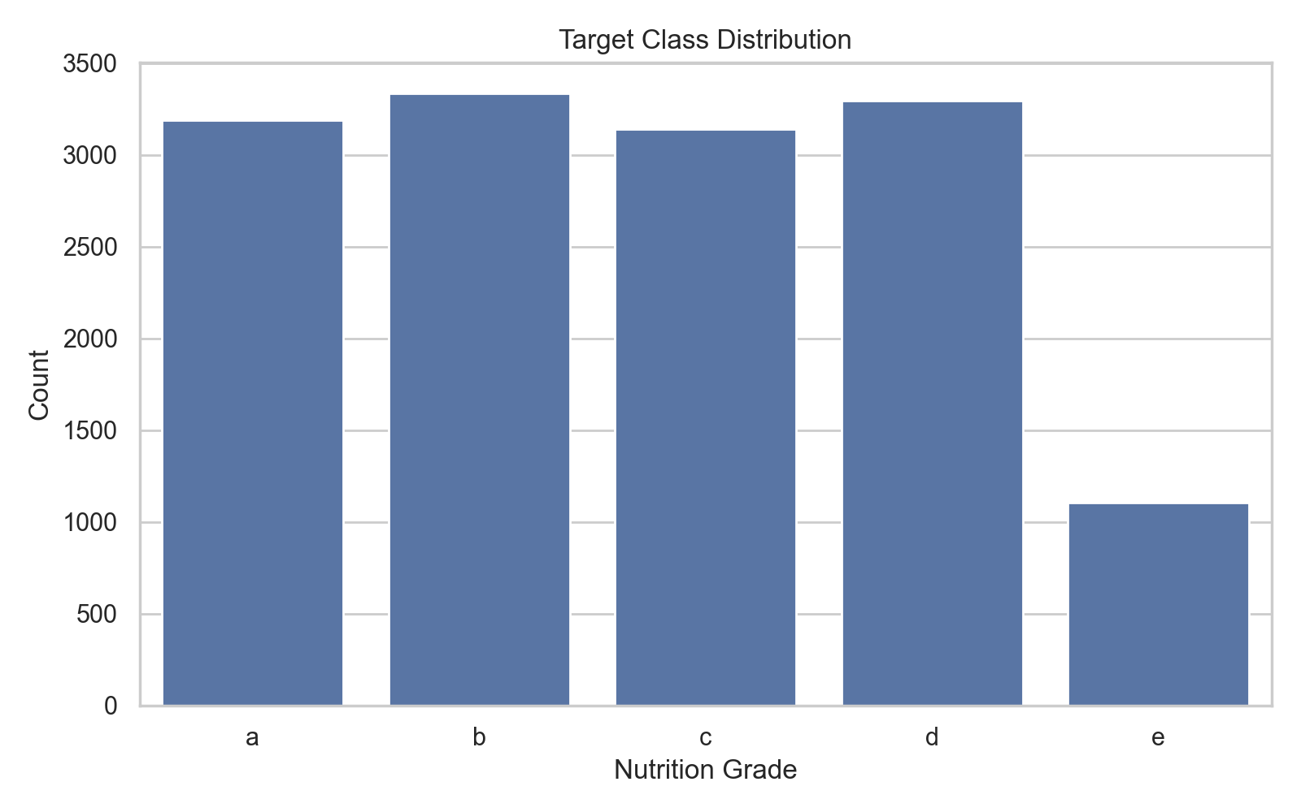
Figure 1. Target class distribution.

3.3 Data Preprocessing
The preprocessing stage included missing value handling, duplicate removal, zero-value inspection, target encoding, and standardization for scale-sensitive models.

3.3.1 Handling Missing Values
Records with missing values in the selected 20 features or target variable were removed. The final dataset contains zero missing values, so no imputation method was required.

3.3.2 Duplicate Removal
Duplicate records were removed to avoid inflated model performance and reduce the risk of data leakage. The final dataset contains 14,070 unique records.

3.3.3 Zero Value Analysis
Some features naturally contain many zero values. For example, most products do not contain trans fat or palm oil, so zero values in these columns can be meaningful rather than missing. However, records with effectively empty nutrition tables were removed.
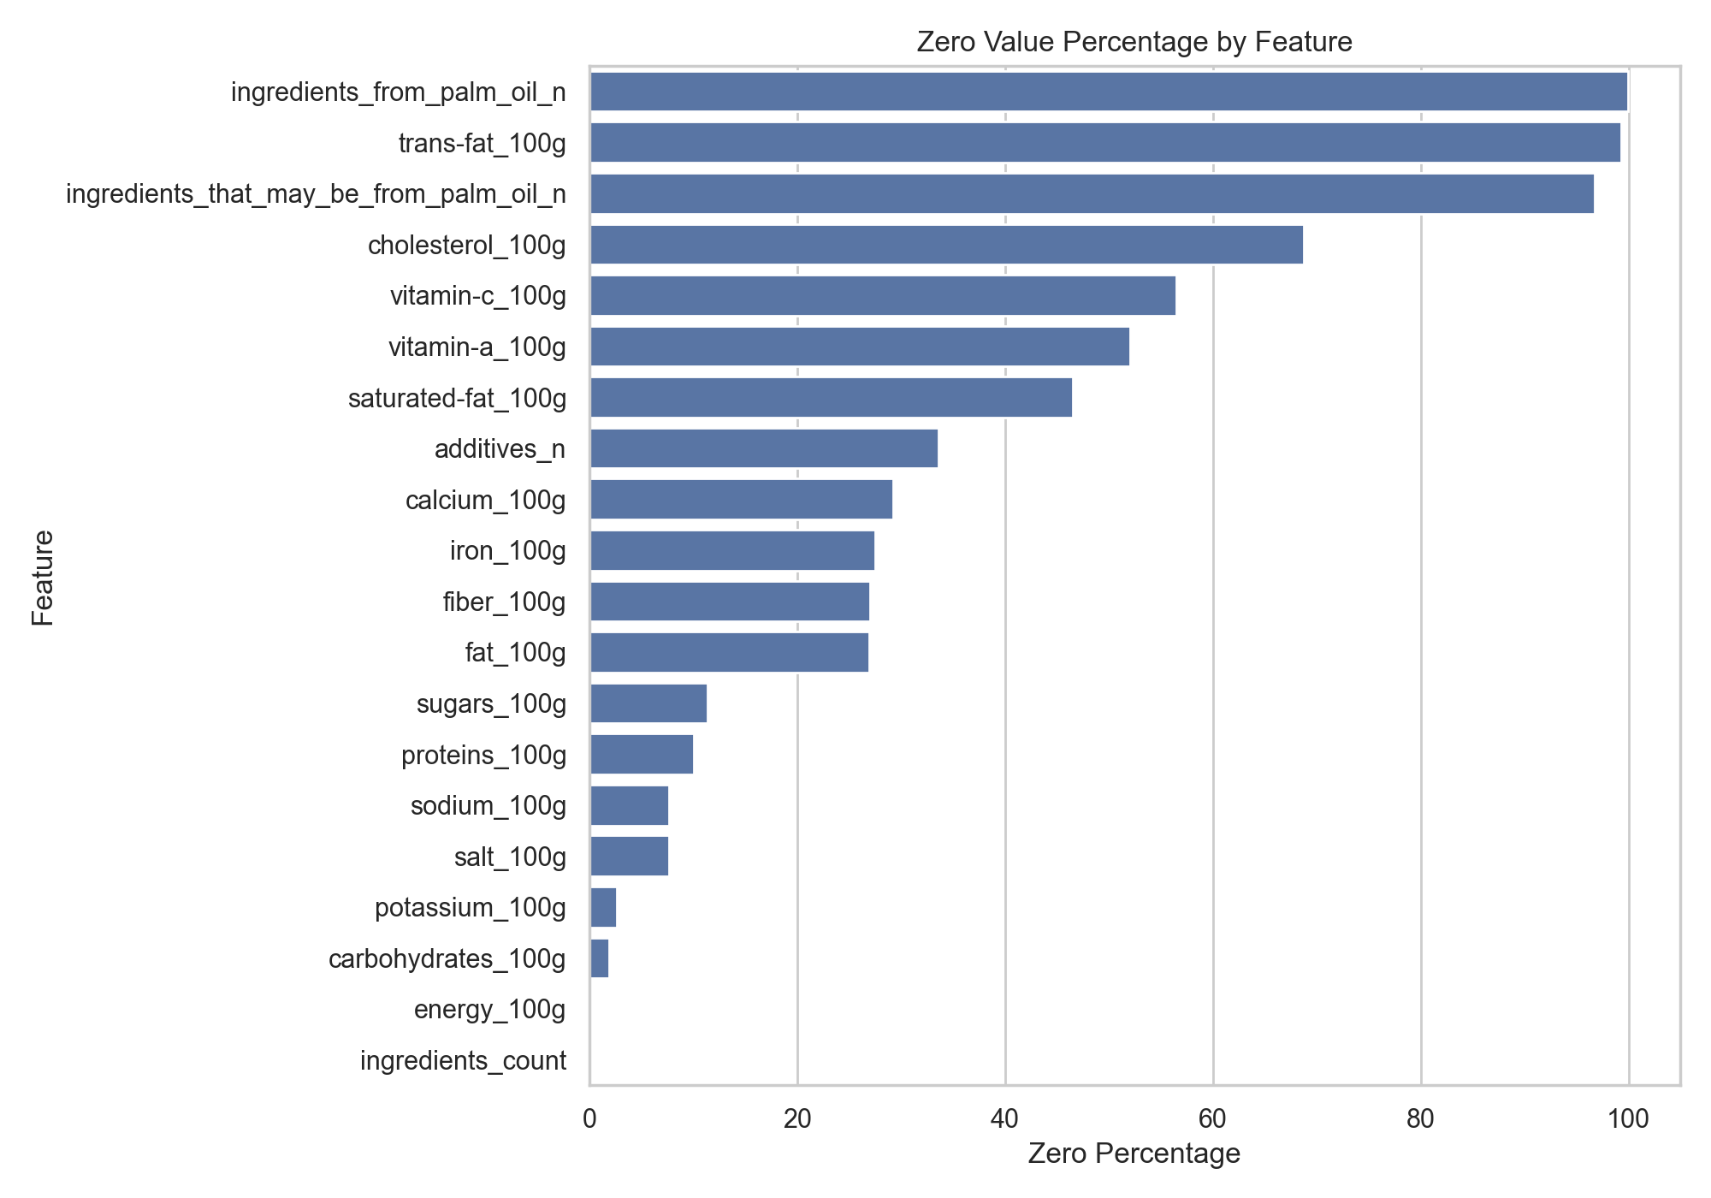
Figure 2. Zero value percentage by feature.

3.3.4 Standardization
StandardScaler was applied to Logistic Regression, KNN, and deep learning models because these models are sensitive to feature scale. The scaler was fitted only on the training data and then applied to the test data to prevent data leakage.

3.4 Feature Analysis and Correlation
The selected features cover energy, macronutrients, salt-related features, micronutrients, additives, palm oil indicators, and ingredient count. Correlation analysis showed that salt_100g and sodium_100g are perfectly correlated because salt and sodium are mathematically related. Both were kept because the project required exactly 20 features and both are nutritionally meaningful.
Feature 1 | Feature 2 | Correlation
salt_100g | sodium_100g | 1.0000
energy_100g | fat_100g | 0.7888
additives_n | ingredients_count | 0.7467
energy_100g | carbohydrates_100g | 0.7103
fat_100g | saturated-fat_100g | 0.6692
carbohydrates_100g | sugars_100g | 0.5739

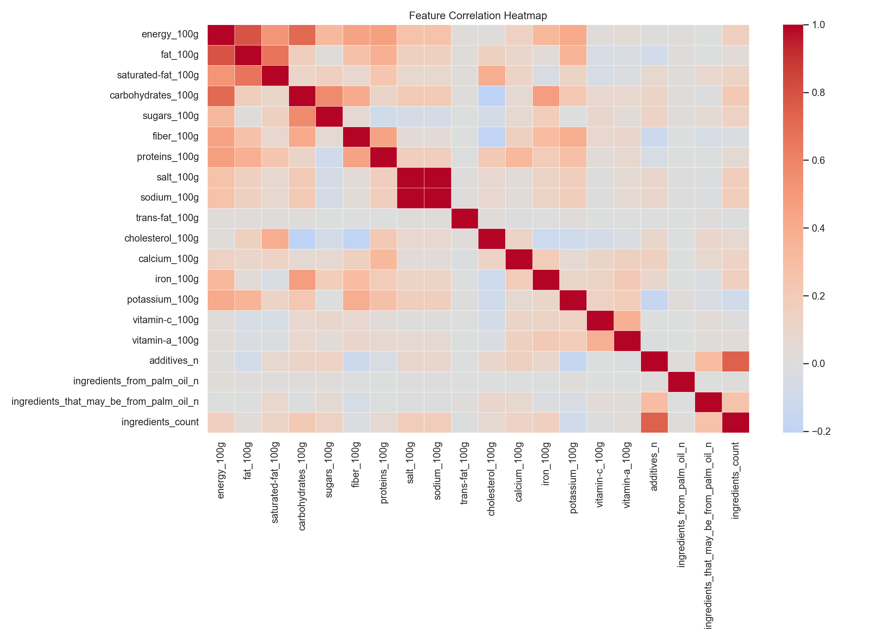
Figure 3. Feature correlation heatmap.

4. Model Development
The project trained five machine learning models and three deep learning models. The machine learning models were Logistic Regression, KNN, Decision Tree, Random Forest, and XGBoost. The deep learning models were MLP, DNN, and 1D CNN.
Sr No | Model | Tuning Parameters
1 | Logistic Regression | max_iter=5000, class_weight='balanced', random_state=42; StandardScaler applied
2 | K-Nearest Neighbors | GridSearchCV(cv=5, scoring='f1_macro'); best: n_neighbors=5, weights='distance', metric='manhattan'
3 | Decision Tree | criterion='entropy', max_depth=12, min_samples_leaf=5, min_samples_split=2, class_weight='balanced', random_state=42
4 | Random Forest | n_estimators=200, criterion='entropy', max_depth=12, min_samples_split=5, min_samples_leaf=10, class_weight='balanced', random_state=42, n_jobs=-1
5 | XGBoost | n_estimators=300, max_depth=5, learning_rate=0.05, subsample=0.8, colsample_bytree=0.8, objective='multi:softprob', eval_metric='mlogloss', random_state=42, n_jobs=-1
6 | MLP | Dense(128)-Dropout(0.30)-Dense(64)-Dropout(0.20)-Dense(32)-Softmax(5), optimizer='adam', loss='categorical_crossentropy', batch_size=32, epochs=100, early_stopping patience=10
7 | DNN | Dense(256)-BatchNorm-Dropout(0.35)-Dense(128)-BatchNorm-Dropout(0.30)-Dense(64)-BatchNorm-Dropout(0.20)-Dense(32)-Softmax(5), optimizer='adam', epochs=120
8 | 1D CNN | Input shape=(20,1), Conv1D(64,kernel=3)-BatchNorm-MaxPool-Dropout(0.25), Conv1D(128,kernel=3)-BatchNorm-MaxPool-Dropout(0.30), Dense(64), Softmax(5), epochs=120

4.1 Machine Learning Models
- Logistic Regression: used as a linear baseline with StandardScaler, max_iter=5000, and class_weight=balanced.
- KNN: optimized using 5-fold GridSearchCV with f1_macro scoring; best parameters were metric=manhattan, n_neighbors=5, weights=distance.
- Decision Tree: trained with entropy, max_depth=12, min_samples_leaf=5, min_samples_split=2, and class_weight=balanced.
- Random Forest: trained with 200 estimators, entropy criterion, max_depth=12, min_samples_split=5, min_samples_leaf=10, and class_weight=balanced.
- XGBoost: trained with 300 estimators, max_depth=5, learning_rate=0.05, subsample=0.8, colsample_bytree=0.8, and balanced sample weights.

4.2 Deep Learning Models
- MLP: dense neural network with ReLU activations, dropout, softmax output, early stopping, and class weights.
- DNN: deeper dense network with Batch Normalization and Dropout layers.
- 1D CNN: convolutional model using reshaped feature vectors with input shape (20, 1).

5. Model Evaluation
All models were evaluated using accuracy, macro precision, macro recall, and macro F1-score. Macro F1-score was important because the target classes are not perfectly balanced, especially class e.
Model | Accuracy | Precision | Recall | Macro F1
Logistic Regression | 0.7591 | 0.7574 | 0.7763 | 0.7642
KNN with CV | 0.8547 | 0.8608 | 0.8514 | 0.8556
Decision Tree | 0.8834 | 0.8770 | 0.8863 | 0.8812
Random Forest | 0.8842 | 0.8843 | 0.8860 | 0.8849
XGBoost | 0.9325 | 0.9330 | 0.9308 | 0.9318
MLP | 0.9112 | 0.9083 | 0.9166 | 0.9115
DNN | 0.8952 | 0.8919 | 0.9022 | 0.8962
1D CNN | 0.8923 | 0.8928 | 0.8914 | 0.8919

XGBoost achieved the best full-feature model performance with 0.9325 accuracy and 0.9318 macro F1-score. Among the deep learning models, MLP achieved the best performance with 0.9112 accuracy and 0.9115 macro F1-score.

5.1 Confusion Matrix Analysis
Confusion matrices were used to inspect class-level model behavior. They show how many samples from each actual nutrition grade were assigned to each predicted grade. Since the target variable has five classes, the confusion matrices are useful for identifying whether models mostly confuse neighboring grades or make larger classification errors.
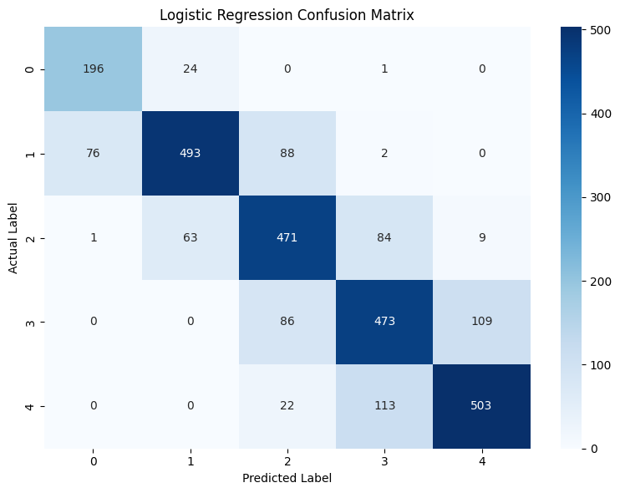
Figure 5. Logistic Regression confusion matrix.
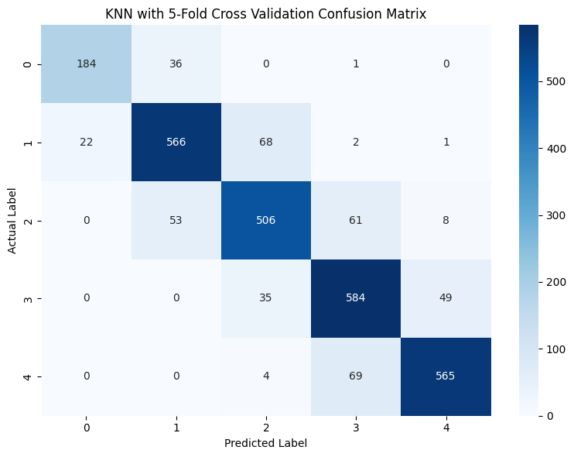
Figure 6. KNN confusion matrix.
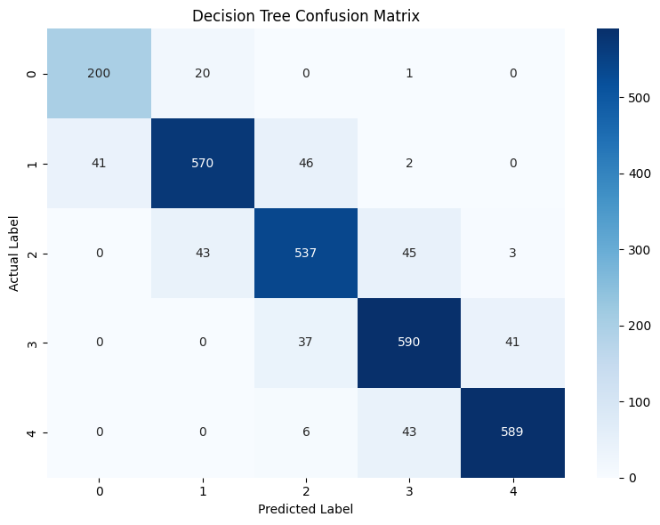
Figure 7. Decision Tree confusion matrix.
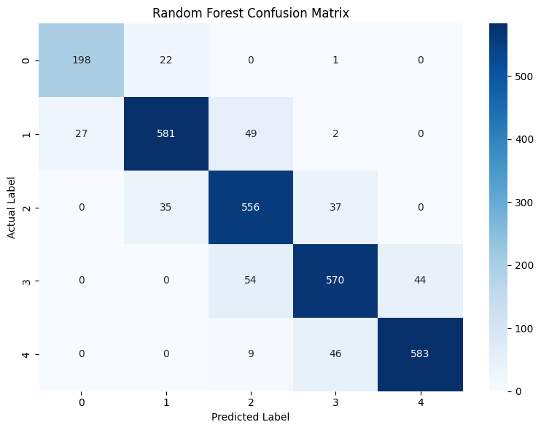
Figure 8. Random Forest confusion matrix.
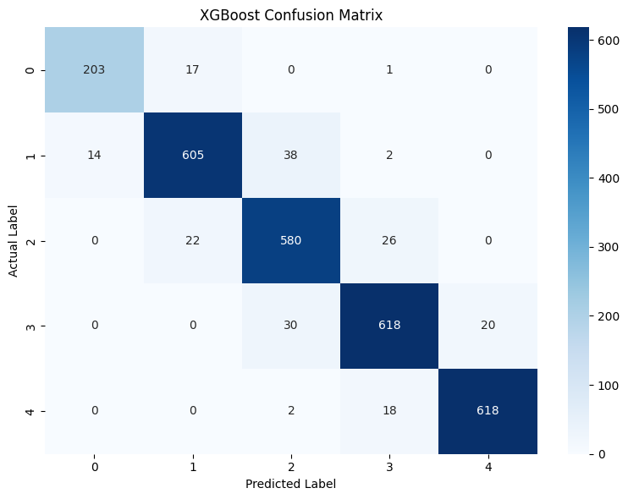
Figure 9. XGBoost confusion matrix.
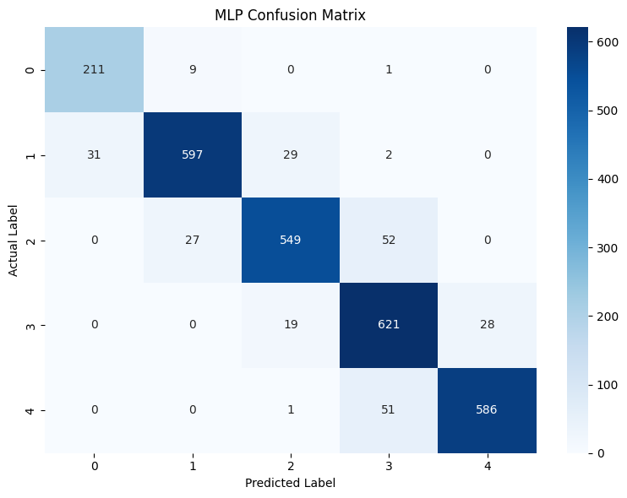
Figure 10. MLP confusion matrix.
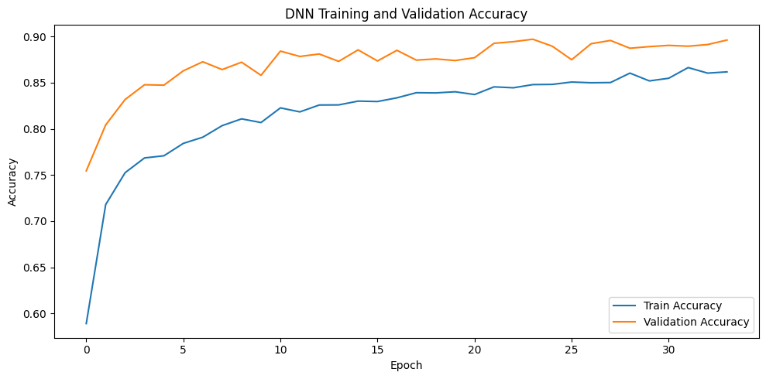
Figure 11. DNN confusion matrix.
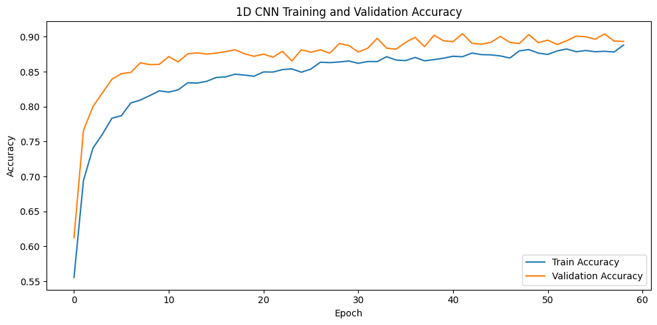
Figure 12. 1D CNN confusion matrix.

6. SMOTE-Based Data Balancing
SMOTE was applied to the best full-feature model, XGBoost, to balance the minority class. SMOTE was applied only to the training data. The test data was not modified and remained real data.
Setting | Accuracy | Precision | Recall | Macro F1
Before SMOTE | 0.9325 | 0.9330 | 0.9308 | 0.9318
After SMOTE | 0.9314 | 0.9316 | 0.9299 | 0.9306

The SMOTE model produced a very similar result to the original XGBoost model. This indicates that XGBoost with balanced sample weights already handled the class imbalance effectively.
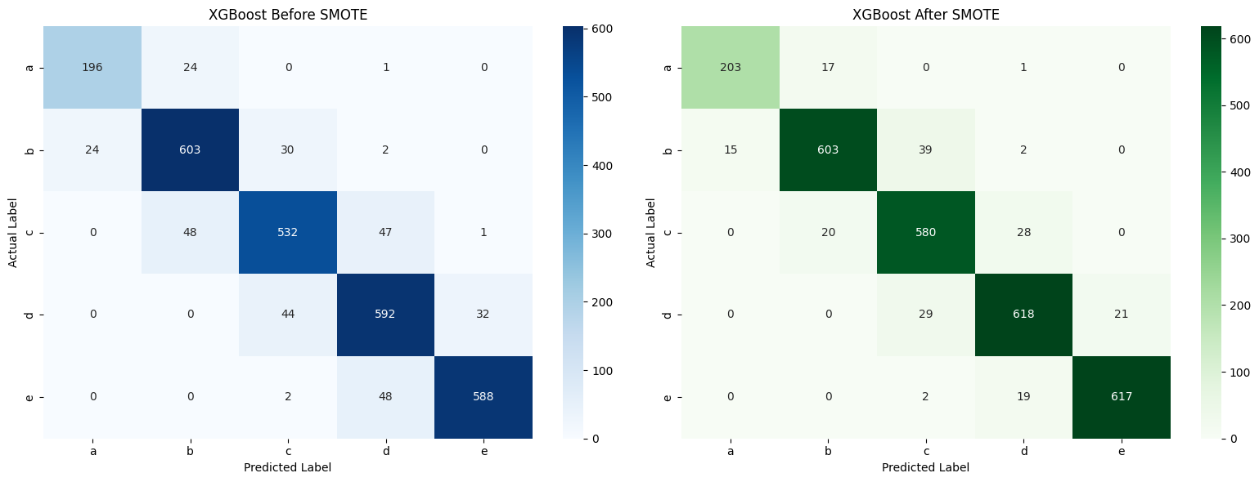
Figure 13. XGBoost confusion matrices before and after SMOTE.

7. Feature Selection and Reduction
Feature selection was performed using XGBoost feature importance scores. The top 10 features were selected and the XGBoost model was retrained using only these features.
Feature Set | No. Features | Accuracy | Recall | Macro F1
All features | 20 | 0.9325 | 0.9308 | 0.9318
Top 10 features | 10 | 0.9350 | 0.9340 | 0.9340

The top-10 feature model slightly outperformed the full-feature XGBoost model. This suggests that some features may be redundant or low-signal for this task.
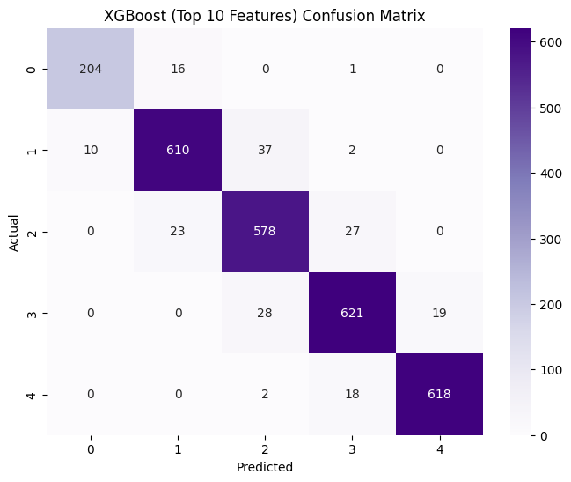
Figure 14. XGBoost Top-10 feature confusion matrix.
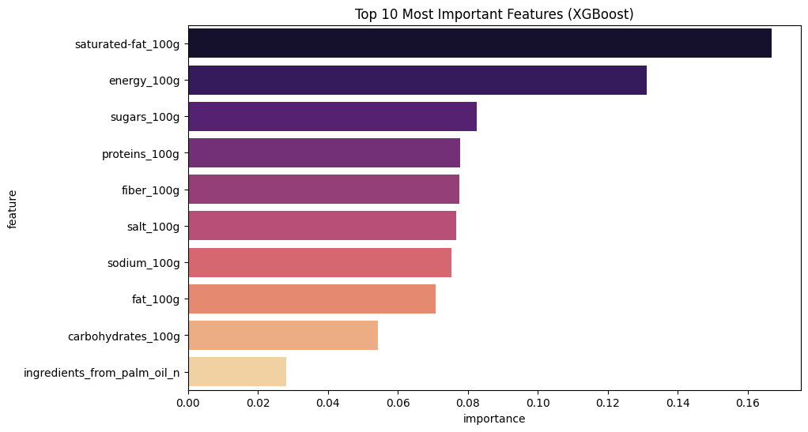
Figure 4. Top 10 XGBoost feature importances.

8. Training Time and Runtime Analysis
Training time and one-record prediction runtime were measured using the same 80%-20% train-test split. The top-10 XGBoost model trained faster than the full-feature XGBoost model while also achieving higher accuracy.
Model | Training Time (s) | One Record Runtime (s)
Logistic Regression | 0.7404 | 0.000156
KNN Optimized | 0.0027 | 0.001129
Decision Tree | 0.1654 | 0.001031
Random Forest | 4.9080 | 0.055375
XGBoost Full | 4.8410 | 0.004218
XGBoost Top 10 | 2.5713 | 0.001816
MLP | 60.7906 | 0.296751
DNN | 40.8359 | 0.392009
1D CNN | 43.9195 | 0.442575

9. Discussion
The results show that XGBoost is the most successful full-feature model for this dataset. This is expected because Open Food Facts data is structured tabular data, and gradient boosting algorithms are highly effective for this type of problem. The top-10 feature XGBoost model achieved the highest accuracy, showing that feature selection improved the model slightly.
Deep learning models performed well but did not outperform XGBoost. The MLP model was the best deep learning model, while DNN and 1D CNN produced slightly lower results. This is reasonable because deep learning models often need larger and more complex datasets to outperform tree-based methods on tabular data.
The SMOTE experiment showed that class balancing did not improve XGBoost performance. This may be because sample weighting already reduced the effect of class imbalance, and the minority class was not extremely small after preprocessing.

10. Conclusion
This project built a complete machine learning and deep learning pipeline for predicting nutrition grades from Open Food Facts data. The final dataset contained 14,070 records, 20 features, no missing values, and no duplicates. Eight models were trained and evaluated. XGBoost achieved the best full-feature performance, while the top-10 feature XGBoost model achieved the best overall accuracy of 0.9350.
Future work may include building a Streamlit interface where users enter nutritional values and receive an instant predicted nutrition grade. The saved XGBoost model and scaler can be used for this deployment step.

References
- Open Food Facts. Open Food Facts database. Available: https://world.openfoodfacts.org/data
- T. Chen and C. Guestrin, XGBoost: A Scalable Tree Boosting System, KDD, 2016.
- N. V. Chawla et al., SMOTE: Synthetic Minority Over-sampling Technique, Journal of Artificial Intelligence Research, 2002.
- F. Pedregosa et al., Scikit-learn: Machine Learning in Python, Journal of Machine Learning Research, 2011.
- M. Abadi et al., TensorFlow: Large-scale Machine Learning on Heterogeneous Systems, 2015.

