**🌐 Demystifying Edge Computing: The Future of Real-Time Data Processing**

In an era where *latency can mean the difference between life and death* — especially in self-driving cars, industrial robotics, or remote surgery — **edge computing** is emerging as a revolutionary technology transforming how we process data.

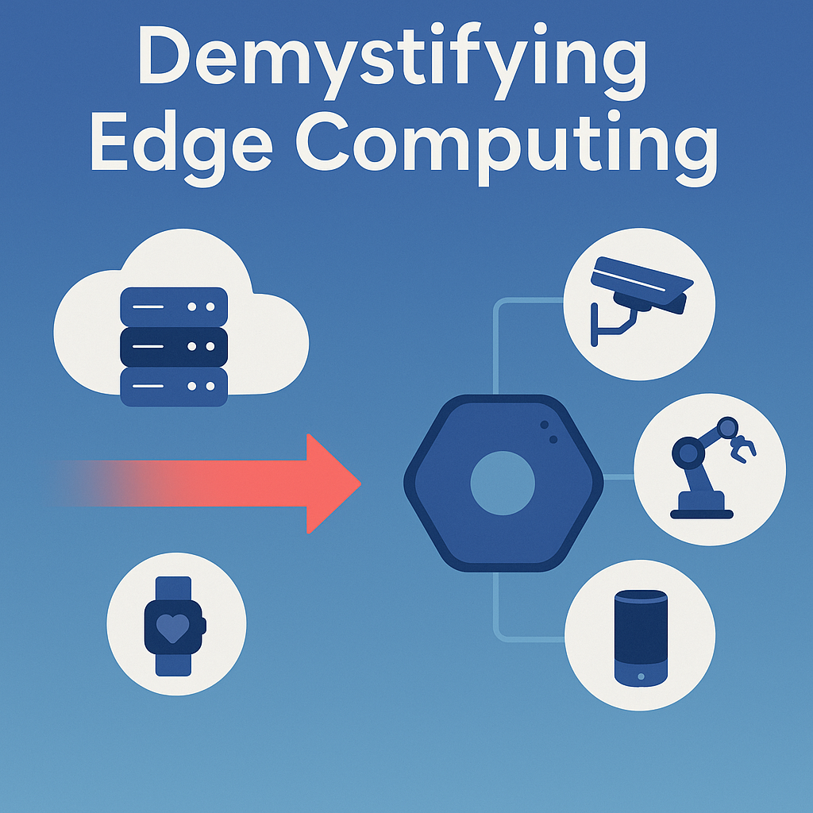

**🚀 What is Edge Computing?**

Edge computing is a distributed computing paradigm that brings computation and data storage closer to the **location where it is needed**, improving response times and saving bandwidth. Rather than sending all data to a centralized data center or cloud for processing, edge computing allows **local devices (the “edge”) to process data themselves** or pass it to nearby servers.

Imagine you're using a smart doorbell camera. Instead of sending video footage to a cloud server far away, it processes motion detection locally. That’s edge computing in action.

**📦 Why is Edge Computing Important?**

Here are a few key reasons why edge computing is gaining popularity:

**✅ 1. Low Latency**

Data is processed closer to the source, which reduces the time it takes to respond. This is crucial in real-time applications like autonomous vehicles or industrial automation.

**✅ 2. Bandwidth Optimization**

Transferring large volumes of raw data to the cloud can be costly and slow. Edge computing allows devices to **filter, summarize, or analyze** data locally before sending only what's necessary.

**✅ 3. Improved Security**

Keeping data local can reduce exposure to certain risks, like interception or breaches during transmission to cloud servers.

**✅ 4. Reliability**

Even if the cloud connection is lost, edge devices can still function and make decisions locally.

**🔧 Real-World Applications**

**🏥 Healthcare**

Smart wearable devices can monitor patients’ vitals and issue alerts immediately if abnormalities are detected, without needing to communicate with cloud servers.

**🚗 Autonomous Vehicles**

Self-driving cars can't wait for cloud responses in life-or-death situations. They use edge computing to analyze surroundings, recognize pedestrians, and react instantly.

**🏭 Industrial IoT**

Factories use sensors and actuators to monitor equipment health. Edge computing ensures minimal downtime by predicting failures in real time.

**🏘 Smart Homes**

Devices like Alexa, smart thermostats, and video doorbells often use edge AI to respond quickly to user inputs without sending every command to the cloud.

**🧠 Edge vs. Cloud vs. Fog Computing**

| **Feature** | **Edge Computing** | **Cloud Computing** | **Fog Computing** |
| --- | --- | --- | --- |
| Proximity | Closest to data source | Centralized servers | Between edge and cloud |
| Latency | Lowest | Highest | Medium |
| Scalability | Moderate | High | High |
| Use Case | Real-time response | Big data analysis | Hybrid systems |

**🔮 What’s Next?**

The adoption of edge computing is accelerating with the rise of **5G**, **AI at the edge**, and **smart devices**. As hardware gets cheaper and more powerful, more processing will shift away from centralized servers to the edge — enabling a world of **smarter, faster, and more autonomous technology**.

**✍️ Conclusion**

Edge computing isn’t just a buzzword — it's an essential technology driving the next generation of digital transformation. From healthcare to smart cities, edge computing will redefine how we think about data, connectivity, and speed in our connected world.

Stay tuned — the edge is just the beginning!

Would you like this converted into a formatted HTML blog post or Markdown file for uploading to your site or platform?