**Title: Introduction to Edge Computing – Powering the Future of IoT**

**🌐 What is Edge Computing?**

Edge computing is a distributed computing paradigm that brings computation and data storage closer to the location where it is needed—typically near or at the “edge” of the network. Instead of relying solely on centralized cloud data centers, edge computing processes data locally, reducing latency and improving performance.

This is especially crucial for Internet of Things (IoT) devices such as smart thermostats, industrial sensors, and autonomous vehicles, which generate massive amounts of data and require real-time processing.

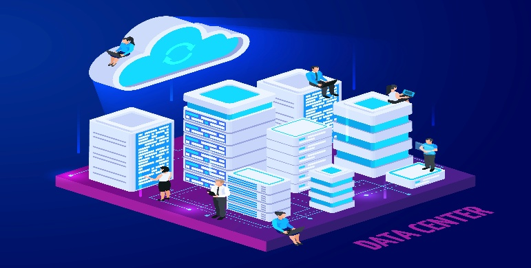

**⚙️ Why Edge Computing?**

The need for edge computing is driven by:

1. **Latency Sensitivity**: Real-time applications such as augmented reality, video analytics, and autonomous systems require near-instant responses.
2. **Bandwidth Constraints**: Sending all raw data to the cloud can be inefficient and expensive.
3. **Security & Privacy**: Local processing reduces the risk of sensitive data being exposed in transit.

**🏭 Real-World Applications**

* **Smart Cities**: Traffic signals and surveillance cameras analyze data on-site to optimize traffic and improve safety.
* **Healthcare**: Wearable devices monitor patient vitals and send alerts in real-time without needing cloud connectivity.
* **Manufacturing**: Machines equipped with sensors detect anomalies early and predict maintenance needs locally.

**🔮 Future of Edge Computing**

Edge computing will play a central role in the expansion of 5G, AI, and next-gen IoT systems. As technology advances, we can expect hybrid models where edge and cloud work in tandem—offering the best of both worlds.

**📌 Conclusion**

Edge computing isn’t replacing the cloud; it’s complementing it. It represents a critical shift in how we think about data processing and system architecture—enabling faster, smarter, and more secure digital experiences.