**🧠 Blog Title: Quantum Computing – Redefining the Limits of Possibility**

**🚀 What is Quantum Computing?**

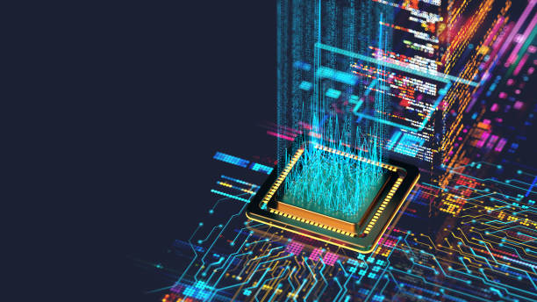

Quantum computing is a revolutionary field of computer science that leverages the principles of quantum mechanics to perform computations far beyond the capabilities of classical computers. While traditional computers use bits (0s and 1s), **quantum computers use quantum bits or *qubits***, which can exist in multiple states simultaneously thanks to **superposition** and **entanglement**.

**⚛️ How Does it Work?**

1. **Superposition**: Unlike classical bits, qubits can be both 0 and 1 at the same time. This allows quantum computers to process many possibilities at once.
2. **Entanglement**: Qubits can be linked so that the state of one directly affects the other, even at a distance.
3. **Quantum Interference**: This is used to combine probabilities and find the correct answer among many potential outcomes.

These properties allow quantum computers to solve certain problems exponentially faster than classical computers.

**🔍 Applications of Quantum Computing**

* **Cryptography**: Can potentially break RSA encryption, prompting the development of post-quantum cryptography.
* **Drug Discovery**: Simulates molecular interactions in real-time, accelerating the design of new medicines.
* **Optimization**: Solves complex logistics problems in industries like supply chain and finance.
* **Artificial Intelligence**: Enhances machine learning by analyzing massive datasets with higher efficiency.

**🧩 Challenges Ahead**

Despite its promise, quantum computing faces major challenges:

* **Qubit Stability**: Qubits are fragile and require extremely cold environments.
* **Error Correction**: Quantum error correction is far more complex than in classical computing.
* **Scalability**: Building a quantum computer with enough qubits for practical applications is still in progress.

**🌐 The Future**

Tech giants like Google, IBM, and Microsoft are racing to build **quantum advantage**—the point at which quantum computers outperform classical ones. While we're in the early stages, **quantum computing has the potential to revolutionize every industry** it touches