A MICRO PROJECT REPORT ON
ANDROID APPLICATION DEVELOPMENT ON BRIDE BELLE

Submitted in partial fulfillment of requirements for the award of degree of

BACHELOR OF TECHNOLOGY IN
CSE (ARTIFICIAL INTELLIGENCE)

Submitted by

KADIYALA KOMALI (22471A4325)
DASARI DHARANI (22471A4316)
SARILLA JAYAVIJAYA (22471A4346) JANGALA AVEELA (22471A4323)
MORTHA SAGARI (22471A4335)

Under the Esteemed Guidance of Mrs. P. SANTHI, _{M.Tech.,}
ASSISTANT PROFESSOR


DEPARTMENT OF CSE (ARTIFICIAL INTELLIGENCE) NARASARAOPETA ENGINEERING COLLEGE: NARASARAOPET (AUTONOMOUS)

Accredited by NAAC with A+ Grade and Approved by AICTE, New Delhi, Permanently Affiliated to JNTUK, Kakinada KOTAPPAKONDA ROAD, YALAMANDA VILLAGE, NARASARAOPET- 522601
2024-2025

NARASARAOPETA ENGINEERING COLLEGE: NARASARAOPET (AUTONOMOUS)

DEPARTMENT OF CSE (ARTIFICIAL INTELLIGENCE)



CERTIFICATE

This is to certify that the ANDROID APPLICATION DEVELOPMENT MICRO PROJECT entitled “BRIDE BELLE“ is a bonafied work done by “KADIYALA KOMALI (22471A4325), DASARI DHARANI (22471A4316), SARILLA JAYA VIJAYA (22471A4346), JANGALA AVEELA (22471A4323), MORTHA SAGARI (22471A4335)”
in partial fulfillment of requirement for the award of the degree of Bachelor of Technology in the department of CSE (ARTIFICIAL INTELLIGENCE) of NARASARAOPETA ENGINEERING COLLEGE {AUTONOMOUS}, NARASARAOPET, during the
academic year 2024-2025.

Faculty Guide Head of Department

Mrs. P. Santhi., MTech,.

Assistant Professor
Dr.B. Jhansi Vazram, B.Tech, MTech, Ph.D.
Professor & HOD

Acknowledgment:
This project was successfully completed as a collaborative effort between myself and my teammates. Each member of the team contributed their unique skills and expertise, enabling us to combine our strengths and accomplish the project's objectives. I would like to express my gratitude to my teammates for their dedication, teamwork, and valuable inputs throughout this journey.

This project was done by:
KADIYALA KOMALI - 22471A4325 DASARI DHARANI - 22471A4316 SARILLA JAYA VIJAYA - 22471A4346 JANGALA AVEELA - 22471A4323 MORTHA SAGARI - 22471A4335

INDEX

SNO | CONTEXT | PAGENO
1. | ABSTRACT | 5
2. | INTRODUCTION | 6
3. | LITERATURE SURVEY | 7 – 9
4. | SYSTEM REQUIREMENTS | 10 – 12
5. | TOOLS AND TECHNOLOGIES | 13 – 14
6. | FUNCTIONALITY OF APLICATION | 15 – 16
7. | IMPLEMENTATION | 17 – 51
8. | SCREENSHOTS OF ANDROID APP | 52 – 58

- ABSTRACT

Bride Belle is a comprehensive e-commerce app designed to meet all the wedding shopping needs of brides and grooms. The app features a wide range of wedding-related items, including dresses, accessories, and other essential attire for both women and men. With Bride Belle, users can easily browse and purchase everything they need for their special day in one place, from bridal gowns to suits, shoes, jewelry, and more.
The app is designed to provide a seamless, user-friendly experience, making it easier than ever for couples to find the perfect outfits and accessories for their wedding. Whether it's for the bride, groom, or wedding party, Bride Belle offers a convenient and efficient solution for all wedding attire needs.

Background:
The wedding shopping experience has traditionally been time-consuming and overwhelming, with couples facing challenges such as limited access to a variety of wedding attire, long wait times in stores, and difficulty coordinating with different vendors. With the growing demand for a more streamlined and accessible solution, the development of Bride Belle was driven by the need to simplify this process for brides and grooms. The app is designed to offer a one-stop platform where users can easily browse and purchase wedding dresses, suits, accessories, and other essential wedding items for both men and women.
Built using Android Studio, Bride Belle leverages the capabilities of modern mobile technology to provide an intuitive, user-friendly interface. The app aims to offer a seamless shopping experience by consolidating all wedding-related shopping needs into one convenient space. By focusing on ease of use, accessibility, and variety, Bride Belle transforms the way couples approach their wedding attire shopping, making it easier for them to find the perfect outfits and accessories for their special day.

INTRODUCTION

Introduction:
Bride Belle is a dedicated e-commerce mobile application created to simplify wedding shopping for brides and grooms. The app offers a comprehensive collection of wedding attire and accessories, including dresses, suits, shoes, jewelry, and more, for both women and men. Designed with user convenience in mind, Bride Belle provides a seamless, easy-to-use platform where couples can find everything they need to look their best on their special day. By offering a wide range of options in one place, Bride Belle aims to make the wedding shopping experience more efficient and enjoyable.

Objective:
The objective of the Bride Belle app is to provide a comprehensive and user-friendly e- commerce platform for couples preparing for their wedding day. The app aims to:
- Simplify Wedding Shopping: Offer a one-stop solution for browsing and purchasing wedding attire, accessories, and other essential items for both brides and grooms.
- Provide a Wide Range of Products: Feature a diverse selection of wedding dresses, suits, shoes, jewelry, and other accessories, ensuring couples have access to everything they need for their special day.
- Enhance User Experience: Create an intuitive and easy-to-navigate mobile platform that enables users to shop for wedding attire and accessories conveniently from anywhere, anytime.
- Improve Accessibility: Make wedding shopping more accessible by eliminating the need for time-consuming store visits and enabling users to compare products and prices online.
- Streamline the Planning Process: Help couples save time and effort by providing an all-in-one solution for finding and purchasing the perfect wedding attire and accessories, reducing the complexity of wedding planning.

LITERATURE SURVEY

Literature Survey:
The wedding shopping experience has evolved significantly over the years, with mobile applications becoming an essential tool in meeting the growing needs of brides and grooms. This literature survey explores the existing systems in the wedding and e-commerce industry, their strengths and limitations, and emphasizes the need for the Bride Belle app to bridge the gap and provide an all-in-one solution for wedding attire and accessory shopping.

Existing Systems:
- Amazon (E-commerce): Amazon offers a wide range of wedding products, including dresses, accessories, and decor. While it provides a vast selection, the shopping experience lacks customization for weddings specifically. The platform also requires users to navigate a broader marketplace, which can make the search for wedding- specific items overwhelming and less personalized.
- Etsy: Etsy is known for offering unique, handmade, and vintage wedding items. However, the platform mainly focuses on custom items and accessories, which might limit couples in finding ready-made wedding dresses and suits. Additionally, Etsy doesn't provide a unified experience tailored specifically to the wedding shopping process, leading users to search across multiple categories.
- Zola: Zola offers a range of wedding-related products, including attire, but it is primarily known for its wedding registry and event planning services. While it provides a curated selection of wedding essentials, the app doesn't focus heavily on a comprehensive range of wedding dresses or accessories, making it less convenient for couples seeking all their attire needs in one platform.
- David's Bridal: David's Bridal is a specialized platform for wedding dresses and accessories, but it primarily focuses on the bridal market and lacks a significant offering for grooms or wedding party members. While it does have a wide variety of bridal dresses, its platform does not provide an integrated shopping experience for both brides and grooms.

Limitations of Existing Systems:
  - Limited Range for Both Genders: Many platforms focus primarily on either women's bridal attire or men's formal wear, leaving a gap in providing a unified

experience where both brides and grooms can shop for their wedding attire and accessories in one place.
  - Fragmented Shopping Experience: While platforms like Amazon and Etsy offer wedding-related products, they do not offer a tailored shopping experience. Users have to search through a wide range of non-wedding-related items, which can lead to confusion and overwhelm.
  - Lack of Personalization: Existing platforms do not provide personalized recommendations for wedding attire based on individual preferences, body types, or wedding themes, making it harder for couples to find the perfect outfit.
  - Complexity in Finding Complete Wedding Packages: Couples may struggle to find all their attire needs in one place, often having to shop across different platforms to get dresses, suits, accessories, and shoes. This fragmented experience can be time- consuming and stressful.

Proposed System:
The Bride Belle app is designed to overcome the limitations of existing platforms by offering a comprehensive, one-stop solution for all wedding attire and accessory needs. The key features of the Bride Belle app include:
  - Comprehensive Product Range: The app offers a wide selection of wedding dresses, suits, shoes, jewelry, and accessories for both women and men, allowing couples to find everything they need for their wedding day in one place.
  - Personalized Shopping Experience: Users can browse tailored recommendations based on their preferences, body types, and wedding themes, ensuring that they find the perfect outfit for their special day.
  - Easy Navigation and User Interface: Developed with Android Studio, the app is designed with an intuitive and user-friendly interface, making it easy for users to navigate through various categories, explore different products, and make quick purchases.
  - Secure Shopping and Payment Options: The app integrates secure payment gateways, providing a safe and convenient way for users to make purchases without concerns about security.
  - Customizable Search Filters: The app allows users to filter products based on size, color, style, and price range, ensuring a personalized and seamless shopping experience.

By integrating all wedding attire and accessory needs into a single, easy-to-use platform, the Bride Belle app enhances convenience, reduces shopping time, and helps couples find the perfect products for their wedding day with ease. This all-in-one solution is designed to make wedding shopping less stressful and more enjoyable.

Conclusion:
This literature survey highlights the gaps in existing wedding shopping platforms, which often lack a unified, personalized, and comprehensive solution for both brides and grooms. The Bride Belle app addresses these gaps by offering an integrated platform that caters to the diverse needs of couples preparing for their wedding day. By focusing on personalization, ease of use, and a complete product range, Bride Belle aims to revolutionize the way couples shop for their wedding attire, making it easier and more enjoyable.

SYSTEM REQUIREMENT

System requirements outline the necessary conditions, tools, and resources required to develop, deploy, and maintain the Bride Belle app, which aims to simplify the wedding shopping experience for brides and grooms. These requirements are divided into three categories: Functional Requirements, Non-Functional Requirements, and Technical Requirements.

Functional Requirements:
Functional requirements define the core features and functionalities of the Bride Belle app that allow users to interact with the system. These features serve as the foundation for the app’s operation.

User Registration and Login:
    - The app should allow users to register using email, phone number, or third- party authentication (e.g., Google, Facebook). Once registered, users can log in securely with authentication mechanisms such as passwords or multi-factor authentication (MFA).

Wedding Date Page:
    - After registration, users should be able to input their wedding date, helping the app offer tailored product suggestions based on their specific event timeline.

Location Page:
    - The app should ask for the user’s location to offer relevant products and services that are available or can be delivered to that area, improving the shopping experience.

Bride or Groom Selection:
    - Users should be able to select whether they are shopping for the bride or the groom, ensuring they are shown the appropriate attire and accessories.

Bride-Related Items Page:
    - This page will feature all products related to the bride, including dresses, shoes, accessories, and other wedding-related items. It should be easy to browse with filters for size, color, style, and price.

Groom-Related Items Page:
    - Similarly, a separate page for the groom should display suits, shirts, shoes, accessories, and other items. The same browsing and filtering functionality

should be available.

Payment Page:
    - The app should integrate a secure payment system to allow users to easily and safely pay for their selected products. The payment page should support multiple payment methods, including credit/debit cards, PayPal, or other common payment gateways.

Thank You for Your Order Page:
    - Once a purchase is made, users should be redirected to a confirmation page thanking them for their order. This page should summarize the order details, including items purchased and delivery information, and send a confirmation email or notification.

Non-Functional Requirements:
Non-functional requirements describe the characteristics of the Bride Belle app, ensuring that the system functions efficiently and meets user expectations.

Usability:
    - The app should have an intuitive and user-friendly interface, ensuring easy navigation for users. It should provide a smooth experience across different devices and screen sizes, from smartphones to tablets.

Performance:
    - The app should load quickly, with minimal latency for pages, such as the bride and groom item pages and the payment page. Response time should be under 2 seconds for most actions (e.g., loading pages, submitting forms, completing purchases).

Scalability:
    - The app should be able to handle an increasing number of users and orders, especially during peak wedding seasons, without significant performance degradation. It should support scalability to accommodate a growing user base.

Reliability:
    - The app should be reliable, ensuring minimal downtime. It should incorporate failover mechanisms to guarantee high availability and continuity of service, especially during critical times like wedding planning.

Technical Requirements:
Technical requirements define the tools, technologies, and platforms needed to build, run, and maintain the Bride Belle app.

Platform:
    - The app will be developed for Android using Android Studio as the Integrated Development Environment (IDE). It should be compatible with Android 7.0 (Nougat) and higher versions.

Programming Languages:
    - The app will be developed using Kotlin, as it is the recommended language for Android development due to its conciseness, safety, and interoperability with Java. However, Java could also be used if needed.

Database:
    - The app will require a database for storing user data, product details, order information, and payment history. Firebase or SQLite can be used for efficient and secure data management.

Payment Integration:
    - The app will integrate with payment gateways such as Stripe, PayPal, or Razorpay to process secure transactions. It will require API integration with these payment platforms to handle payment processing.

Location Services:
    - The app will utilize Google Maps API or similar services for location tracking and to provide location-based product availability and delivery options.
By meeting these functional, non-functional, and technical requirements, the Bride Belle app will offer a seamless, efficient, and enjoyable shopping experience for brides and grooms, helping them easily find and purchase all the necessary attire and accessories for their special day.

TOOLS AND TECHNOLOGIES

Frontend Technologies for Bride Belle App:
The frontend of the Bride Belle app is designed to provide users with an intuitive and engaging user interface (UI) and user experience (UX). It ensures that users can effortlessly browse through various wedding-related products, select their desired items, make purchases, and interact with the app in a seamless manner. Below are the main frontend technologies used in the development of the Bride Belle app:

Android Studio:
Android Studio is the official Integrated Development Environment (IDE) used for building the Bride Belle app. It provides all the necessary tools for coding, designing, testing, and debugging Android applications. Android Studio is highly optimized for Android app development and supports Kotlin and Java programming languages, making it ideal for developing the Bride Belle app.
  - Code Editor: Android Studio offers a robust code editor that supports Kotlin and Java, with features such as code completion, syntax highlighting, and real-time error checking. This ensures efficient and error-free development.
  - Design Layouts: The layout editor in Android Studio allows developers to create UI designs using drag-and-drop functionality. It provides real-time previews to streamline the design process for screens like the Sign-In Page, Location Page, and product pages (e.g., Bride Related Items and Groom Related Items).
  - Emulator: The Android Emulator enables developers to test the app on different Android devices and configurations, ensuring that the app performs well across various screen sizes and hardware specifications.

Kotlin/Java:
  - Kotlin: Kotlin is the preferred programming language for Bride Belle as it offers conciseness, null safety, and improved functionality. It simplifies tasks like managing user data, implementing features such as user registration, appointment scheduling, product browsing, and other business logic essential for the app's core functionalities.
  - Java: Although Kotlin is the primary language used for development, some parts of

the app may still utilize Java for compatibility with legacy code or certain external libraries that may require it.

XML (Extensible Markup Language):
XML plays a crucial role in designing the Bride Belle app’s user interface (UI). It allows developers to structure and define the layout, ensuring that it is responsive and works well across different devices.
  - Layouts: XML files define the layout structure for various screens in the app, including the Sign-In Page, Location Page, Wedding Date Page, and the Bride and Groom Related Items Pages. The layout may include elements like LinearLayout, RelativeLayout, and ConstraintLayout to control the positioning of UI components.
  - Views: XML is used to define the views such as TextViews, Buttons, ImageViews, and EditTexts that are essential to creating interactive elements on pages like the Payment Page and Thank You for Your Order Page.

Jetpack Libraries:
Jetpack is a set of powerful libraries provided by Google that simplifies Android app development, making it easier to handle UI design, app architecture, navigation, and lifecycle management. These libraries are used in the Bride Belle app to streamline development and enhance its overall performance.
  - LiveData and ViewModel: The LiveData and ViewModel components help manage UI-related data in a lifecycle-conscious way. For example, LiveData can be used to dynamically update product lists (like the Bride Related Items or Groom Related Items) in real-time, while ViewModel stores and manages UI-related data, ensuring that data persists even during configuration changes like screen rotations.
  - Navigation Component: The Navigation Component simplifies the process of navigating between different screens of the app, such as the transition from the Location Page to the Wedding Date Page or from the Bride Related Items Page to the Groom Related Items Page. It ensures smooth navigation, which enhances the user experience.
  - Room Database: The Room library facilitates local data storage using SQLite, allowing the app to store important information like user preferences, order history, and wedding date data.

FUNCTIONALITY OF THE APPLICATION

The frontend of the Bride Belle app is designed to provide an interactive and seamless shopping experience for users seeking wedding attire and accessories. The app ensures that users can easily navigate through various sections and complete their wedding shopping needs. Below are the main functionalities provided by the frontend of the Bride Belle app:

User Authentication
Login/Signup: The Bride Belle app allows users to create an account or log in using their credentials such as email and password, or through third-party services like Google or Facebook. This functionality helps users easily access their personalized wedding shopping experience across devices.
User Profile: Once logged in, users can view and update their profile information, including personal details such as name, contact information, and profile picture. This helps in personalizing the shopping experience, keeping track of the user's order history, and managing preferences for both the bride and groom.

Wedding Shopping
Browse Wedding Items: The app has separate sections for browsing bride-related items and groom-related items, including wedding dresses, suits, accessories, and more. Users can browse these categories and explore various products tailored to their needs.
Search Functionality: Users can search for specific items such as bridal gowns, groom suits, wedding shoes, and accessories using the app's search feature. The search helps users quickly find what they're looking for by item name or category.
Filter and Sort Options: To make the shopping experience more efficient, the app includes filtering options like size, price, color, and style. This allows users to easily narrow down their options to find the perfect wedding attire or accessory.

Wedding Date and Event Customization
Wedding Date Page: Users are prompted to input their wedding date, which allows the app to suggest the best options for wedding attire and accessories based on their timeline. This feature is designed to help users plan their shopping according to their event date.
Location Page: The location page allows users to input their shipping address or enable location services to find nearby stores, track deliveries, and receive location-based offers. This feature is essential for providing personalized recommendations and efficient delivery options.

Appointment Booking (For Wedding Consultations)
Schedule Appointment: Users can select a time slot to book consultations for fittings or virtual wedding consultations with designers or stylists. This appointment system allows users to secure a time for expert advice, either in-person or via video call.
View and Manage Appointments: Users can view and manage their appointments for consultations, fittings, or any wedding-related services. This section allows users to track upcoming appointments, reschedule, or cancel appointments if necessary.

Payment System
Payment Page: The Bride Belle app integrates a secure payment gateway that allows users to easily complete their purchases. Users can pay for wedding items, accessories, and services using various payment options, such as credit/debit cards or PayPal.
Order Confirmation: Once users make a purchase, the Thank You for Your Order Page is displayed, confirming their order details. This page also sends a notification or email confirmation to the user with their order summary, estimated delivery date, and payment receipt.

Product Details and Recommendations
Product Information: After selecting a specific item, users can view detailed information, such as descriptions, size charts, fabric details, and styling tips. This ensures that users can make informed purchasing decisions for both bride-related and groom-related items.
Product Images: Clear and high-quality images of the products (e.g., wedding dresses, groom suits, accessories) are displayed so users can see the item clearly before purchasing. This enhances user confidence in their selection.
Stock Availability: The app indicates whether the item is available or out of stock. If a product is unavailable, alternative suggestions or similar items are displayed, ensuring users can still find suitable options.

Order History and Tracking
Order History: Users can access their past orders and track the status of ongoing orders directly within the app. This includes information about shipped items, payment status, and delivery tracking.
Shipping and Delivery Tracking: The app allows users to track the delivery of their purchased items by providing real-time shipping updates and estimated arrival times. This helps users stay informed about their orders and plan accordingly.

IMPLEMENTATION

Welcome page(Splash Screen):

SplashActivity1.java:
package com.example.bridalbelleapp.activity;
import androidx.appcompat.app.AppCompatActivity; import android.content.Intent;
import android.os.Bundle; import android.os.Handler;
import com.example.bridalbelleapp.R;
public class SplashActivity extends AppCompatActivity { @Override
protected void onCreate(Bundle savedInstanceState) { super.onCreate(savedInstanceState); setContentView(R.layout.activity_splash);
new Handler().postDelayed(new Runnable() { @Override
public void run() { Intent intent = new
Intent(SplashActivity.this,MainActivity.class); startActivity(intent);
finish();
}
},3000);
}
}

ActivitySplash.xml:
<?xml version="1.0" encoding="utf-8"?>
<LinearLayout xmlns:android="http://schemas.android.com/apk/res/android" xmlns:app="http://schemas.android.com/apk/res-auto"

xmlns:tools="http://schemas.android.com/tools" android:layout_width="match_parent" tools:context=".activity.SplashActivity">
<androidx.appcompat.widget.AppCompatImageView android:layout_width="match_parent" android:layout_height="match_parent" android:background="#43E91E63" android:src="@drawable/bride2"/>
</LinearLayout>

Login page:

LoginActivity.java:
package com.example.bridalbelleapp.activity;
import androidx.appcompat.app.AppCompatActivity; import android.content.Intent;
import android.os.Bundle; import android.view.View;
import com.example.bridalbelleapp.R;
public class MainActivity extends AppCompatActivity { @Override
protected void onCreate(Bundle savedInstanceState) { super.onCreate(savedInstanceState); setContentView(R.layout.activity_main);
}
public void login(View view) {
Intent i = new Intent(MainActivity.this,WeddingActivity.class); startActivity(i);
}
}

ActivityLogin.xml:
<?xml version = "1.0" encoding = "utf-8"?>
<RelativeLayout
xmlns:android = "http://schemas.android.com/apk/res/android"

xmlns:tools = "http://schemas.android.com/tools" android:layout_width="match_parent" android:layout_height = "wrap_content" android:orientation="horizontal" android:background="@drawable/mrmrs" tools:context = ".activity.MainActivity">
<TextView android:text = "Sign In / Sign Up" android:layout_width="wrap_content" android:layout_height = "wrap_content" android:id = "@+id/textview" android:textSize = "35dp" android:layout_alignParentTop = "true" android:layout_centerHorizontal = "true" />
<TextView
android:layout_width = "wrap_content" android:layout_height = "wrap_content" android:id = "@+id/textView" android:layout_below = "@+id/textview" android:layout_centerHorizontal = "true" android:textColor = "#ff7aff24" android:textSize = "35dp" />
<EditText
android:layout_width = "wrap_content" android:layout_height = "wrap_content" android:id = "@+id/editText" android:hint = "User Name" android:focusable = "true" android:textColorHighlight = "#000"
android:textColorHint = "#000" android:layout_marginTop = "46dp" android:layout_below = "@+id/imageView" android:layout_alignParentLeft = "true" android:layout_alignParentStart = "true" android:layout_alignParentRight = "true"

android:layout_alignParentEnd = "true" />
<ImageView android:layout_width="wrap_content" android:layout_height="wrap_content" android:id="@+id/imageView" android:layout_below="@+id/textView" android:layout_centerHorizontal="true" />
<EditText android:layout_width="wrap_content" android:layout_height="wrap_content" android:inputType="textPassword" android:ems="10" android:id="@+id/editText2" android:layout_below="@+id/editText" android:layout_alignParentLeft="true" android:layout_alignParentStart="true" android:layout_alignRight="@+id/editText" android:layout_alignEnd="@+id/editText" android:textColorHint="#000" android:hint="Password" />
<Button
android:layout_width="match_parent" android:layout_height="wrap_content" android:text="login" android:onClick="login" android:id="@+id/button" android:layout_alignParentBottom="true"
/>
</RelativeLayout>

Location Page:

LocationActivity.java:
package com.example.bridalbelleapp.activity;

import androidx.appcompat.app.AppCompatActivity; import android.content.Intent;
import android.os.Bundle; import android.view.View;
import com.example.bridalbelleapp.R;
public class WeddingActivity extends AppCompatActivity { @Override
protected void onCreate(Bundle savedInstanceState) { super.onCreate(savedInstanceState); setContentView(R.layout.activity_wedding2);
}
public void next(View view) {
Intent i = new Intent(WeddingActivity.this,DateActivity.class); startActivity(i);
}
}

ActivityLocation.xml:
<?xml version="1.0" encoding="utf-8"?>
<ScrollView xmlns:android="http://schemas.android.com/apk/res/android" xmlns:app="http://schemas.android.com/apk/res-auto" xmlns:tools="http://schemas.android.com/tools" android:layout_width="match_parent" android:layout_height="match_parent" android:background="@drawable/weddingin" tools:context=".activity.MainActivity">
<LinearLayout android:layout_width="match_parent" android:layout_height="wrap_content" android:orientation="vertical" android:layout_marginTop="10dp">
<androidx.appcompat.widget.AppCompatTextView android:layout_width="match_parent" android:layout_height="wrap_content"

android:text="Which city is your wedding in ?" android:textSize="40dp" android:textColor="#000" android:layout_marginVertical="10dp"
/>
<LinearLayout android:layout_width="match_parent" android:layout_height="wrap_content">
<RadioButton android:layout_width="0dp" android:layout_height="wrap_content" android:layout_weight="1" android:text="Delhi " />
<RadioButton android:layout_width="0dp" android:layout_height="wrap_content" android:layout_weight="1" android:text="Mumbai"/>
</LinearLayout>
<LinearLayout android:layout_width="match_parent" android:layout_height="wrap_content">
<RadioButton android:layout_width="0dp" android:layout_height="wrap_content" android:layout_weight="1" android:text="Bangalore" />
<RadioButton android:layout_width="0dp" android:layout_height="wrap_content" android:layout_weight="1" android:text="Hyderabad"/>
</LinearLayout>
<LinearLayout

android:layout_width="match_parent" android:layout_height="wrap_content">
<RadioButton android:layout_width="0dp" android:layout_height="wrap_content" android:layout_weight="1" android:text="Chennai" />
<RadioButton android:layout_width="0dp" android:layout_height="wrap_content" android:layout_weight="1" android:text="Pune"/>
</LinearLayout>
<LinearLayout android:layout_width="match_parent" android:layout_height="wrap_content">
<RadioButton android:layout_width="0dp" android:layout_height="wrap_content" android:layout_weight="1" android:text="Kolkata" />
<RadioButton android:layout_width="0dp" android:layout_height="wrap_content" android:layout_weight="1" android:text="Lucknow"/>
</LinearLayout>
<LinearLayout android:layout_width="match_parent" android:layout_height="wrap_content">
<RadioButton android:layout_width="0dp" android:layout_height="wrap_content" android:layout_weight="1"

android:text="Goa" />
<RadioButton android:layout_width="0dp" android:layout_height="wrap_content" android:layout_weight="1" android:text="Other"/>
</LinearLayout>
<Button
android:layout_width="wrap_content" android:layout_height="wrap_content" android:gravity="center" android:layout_gravity="center" android:layout_marginTop="40dp" android:onClick="next" android:text="Next"/>
</LinearLayout>
</ScrollView>

Wedding Date Page:

DateActivity.java:
package com.example.bridalbelleapp.activity;
import androidx.appcompat.app.AppCompatActivity; import android.content.Intent;
import android.os.Bundle; import android.view.View;
import com.example.bridalbelleapp.R;
public class DateActivity extends AppCompatActivity { @Override
protected void onCreate(Bundle savedInstanceState) { super.onCreate(savedInstanceState); setContentView(R.layout.activity_date);
}

public void next(View view) {
Intent i = new Intent(DateActivity.this,WhoomActivity.class); startActivity(i);
}
}

ActivityDate.xml:
<?xml version="1.0" encoding="utf-8"?>
<ScrollView xmlns:android="http://schemas.android.com/apk/res/android" xmlns:app="http://schemas.android.com/apk/res-auto" xmlns:tools="http://schemas.android.com/tools" android:layout_width="match_parent" android:layout_height="match_parent" android:background="@drawable/weddingdate" tools:context=".activity.MainActivity">
<LinearLayout android:layout_width="match_parent" android:layout_height="wrap_content" android:orientation="vertical" android:layout_marginTop="10dp">
<androidx.appcompat.widget.AppCompatTextView android:layout_width="match_parent" android:layout_height="wrap_content" android:text="Do you have a wedding date?" android:textSize="40sp" android:textColor="#000" android:layout_marginVertical="10dp"
/>
<EditText android:layout_width="match_parent" android:layout_height="wrap_content" android:hint="Enter Your Wedding Date" android:textSize="20sp"/>
<Button

android:layout_width="wrap_content" android:layout_height="wrap_content" android:gravity="center" android:layout_marginTop="100dp" android:layout_gravity="center" android:onClick="next" android:text="Next"/>
</LinearLayout>
</ScrollView>

Bride or Groom Selection Page:

WhomActivity.java:
package com.example.bridalbelleapp.activity;
import androidx.appcompat.app.AppCompatActivity; import android.content.Intent;
import android.os.Bundle; import android.view.View;
import com.example.bridalbelleapp.R;
public class WhoomActivity extends AppCompatActivity { @Override
protected void onCreate(Bundle savedInstanceState) { super.onCreate(savedInstanceState); setContentView(R.layout.activity_whoom);
}
public void openBride(View view) {
Intent i = new Intent(WhoomActivity.this,BrideDetailsActivity.class); startActivity(i);
}
public void openGroom(View view) {
Intent i = new Intent(WhoomActivity.this,GroomDetailsActivity.class); startActivity(i);
}
}

ActivityWhom.xml:
<?xml version="1.0" encoding="utf-8"?>
<ScrollView xmlns:android="http://schemas.android.com/apk/res/android" xmlns:app="http://schemas.android.com/apk/res-auto" xmlns:tools="http://schemas.android.com/tools" android:layout_width="match_parent" android:layout_height="match_parent" android:background="@drawable/birdegroom" tools:context=".activity.MainActivity">
<LinearLayout android:layout_width="match_parent" android:layout_height="wrap_content" android:orientation="vertical" android:layout_marginTop="10dp">
<androidx.appcompat.widget.AppCompatTextView android:layout_width="match_parent" android:layout_height="wrap_content" android:text="Tell us who you are" android:textSize="40dp" android:textColor="#000" android:layout_marginVertical="10dp"
/>
<LinearLayout android:layout_width="match_parent" android:layout_height="wrap_content">
<RadioButton android:layout_width="0dp" android:layout_height="wrap_content" android:layout_weight="1" android:onClick="openBride" android:text="Bride" />
<RadioButton android:layout_width="0dp"

android:layout_height="wrap_content" android:layout_weight="1" android:onClick="openGroom" android:text="Groom"/>
</LinearLayout>
</LinearLayout>
</ScrollView>

Bride Related Items Page:

BrideDetailsActivity.java:
package com.example.bridalbelleapp.activity;
import androidx.appcompat.app.AppCompatActivity; import android.content.Intent;
import android.os.Bundle; import android.view.View;
import com.example.bridalbelleapp.R;
public class BrideDetailsActivity extends AppCompatActivity { @Override
protected void onCreate(Bundle savedInstanceState) { super.onCreate(savedInstanceState); setContentView(R.layout.activity_bride_details2);
}
public void openBrideDetails(View view) {
Intent i = new Intent(BrideDetailsActivity.this, BrideOutfitActivity.class); startActivity(i);
}
public void openMehandhi(View view) {
Intent i = new Intent(BrideDetailsActivity.this, BrideMehandhi.class); startActivity(i);
}
}

ActivityBrideDetails.xml:
<?xml version="1.0" encoding="utf-8"?>

<ScrollView xmlns:android="http://schemas.android.com/apk/res/android" xmlns:app="http://schemas.android.com/apk/res-auto" xmlns:tools="http://schemas.android.com/tools" android:layout_width="match_parent" android:layout_height="match_parent"
android:layout_margin="10dp" android:orientation="vertical" android:background="@drawable/mrs" tools:context=".activity.BrideDetailsActivity">
<LinearLayout android:layout_width="match_parent" android:layout_height="wrap_content" android:orientation="vertical">
<LinearLayout android:layout_width="match_parent" android:layout_height="wrap_content" android:orientation="vertical">
<TextView android:layout_width="match_parent" android:layout_height="wrap_content" android:text="Bridal Wear" android:textSize="30sp" />
<TextView android:layout_width="wrap_content" android:layout_height="wrap_content" android:text="Bridal Lehengas" android:onClick="openBrideDetails" android:layout_margin="10dp" android:textColor="#9CE91E63" android:textSize="20sp" />
<TextView android:layout_width="wrap_content" android:layout_height="wrap_content" android:text="Kanjeevaram Sarees"

android:layout_margin="10dp" android:textColor="#9CE91E63" android:textSize="20sp" />
<TextView android:layout_width="wrap_content" android:layout_height="wrap_content" android:text="Frocks" android:layout_margin="10dp" android:textColor="#9CE91E63" android:textSize="20sp" />
<TextView android:layout_width="wrap_content" android:layout_height="wrap_content" android:text="Trousseau Sarees" android:layout_margin="10dp" android:textColor="#9CE91E63" android:textSize="20sp" />
<TextView android:layout_width="wrap_content" android:layout_height="wrap_content" android:text="Narayana Pattu" android:layout_margin="10dp" android:textColor="#9CE91E63" android:textSize="20sp" />
</LinearLayout>
<LinearLayout android:layout_width="match_parent" android:layout_height="wrap_content" android:orientation="vertical">
<TextView android:layout_width="match_parent" android:layout_height="wrap_content" android:text="Mehendi" android:textSize="30sp" />

<TextView android:layout_width="wrap_content" android:layout_height="wrap_content" android:text="Arabic" android:layout_margin="10dp" android:onClick="openMehandhi" android:textColor="#9CE91E63" android:textSize="20sp" />
<TextView android:layout_width="wrap_content" android:layout_height="wrap_content" android:text="Indian" android:layout_margin="10dp" android:textColor="#9CE91E63" android:textSize="20sp" />
<TextView android:layout_width="wrap_content" android:layout_height="wrap_content" android:text="Western" android:layout_margin="10dp" android:textColor="#9CE91E63" android:textSize="20sp" />
<TextView android:layout_width="wrap_content" android:layout_height="wrap_content" android:text="Moroccan" android:layout_margin="10dp" android:textColor="#9CE91E63" android:textSize="20sp" />
<TextView android:layout_width="wrap_content" android:layout_height="wrap_content" android:text="Floral"

android:layout_margin="10dp" android:textColor="#9CE91E63"
android:textSize="20sp" />
</LinearLayout>
<LinearLayout android:layout_width="match_parent" android:layout_height="wrap_content" android:orientation="vertical">
<TextView android:layout_width="match_parent" android:layout_height="wrap_content" android:text="Jewellery" android:textSize="30sp" />
<TextView android:layout_width="wrap_content" android:layout_height="wrap_content" android:text="Bridal Jewellery" android:layout_margin="10dp" android:textColor="#9CE91E63" android:textSize="20sp" />
<TextView android:layout_width="wrap_content" android:layout_height="wrap_content" android:text="Flower Jewellery" android:layout_margin="10dp" android:textColor="#9CE91E63" android:textSize="20sp" />
<TextView android:layout_width="wrap_content" android:layout_height="wrap_content" android:text="Kundan Jewellery" android:layout_margin="10dp" android:textColor="#9CE91E63" android:textSize="20sp" />

<TextView android:layout_width="wrap_content" android:layout_height="wrap_content" android:text="Diamond Jewellery" android:layout_margin="10dp" android:textColor="#9CE91E63" android:textSize="20sp" />
<TextView android:layout_width="wrap_content" android:layout_height="wrap_content" android:text="Plantinum Jewellery" android:layout_margin="10dp" android:textColor="#9CE91E63" android:textSize="20sp" />
</LinearLayout>
<LinearLayout android:layout_width="match_parent" android:layout_height="wrap_content" android:orientation="vertical">
<TextView android:layout_width="match_parent" android:layout_height="wrap_content" android:text="Footwear " android:textSize="30sp" />
<TextView android:layout_width="wrap_content" android:layout_height="wrap_content" android:text="Heels" android:layout_margin="10dp" android:textColor="#9CE91E63" android:textSize="20sp" />
<TextView android:layout_width="wrap_content" android:layout_height="wrap_content"

android:text="Flats" android:layout_margin="10dp" android:textColor="#000" android:textSize="20sp" />
<TextView android:layout_width="wrap_content" android:layout_height="wrap_content" android:text="Sandals" android:layout_margin="10dp" android:textColor="#9CE91E63" android:textSize="20sp" />
<TextView android:layout_width="wrap_content" android:layout_height="wrap_content" android:text="Wedges" android:layout_margin="10dp" android:textColor="#9CE91E63" android:textSize="20sp" />
<TextView android:layout_width="wrap_content" android:layout_height="wrap_content" android:text="Ballerians" android:layout_margin="10dp" android:textColor="#9CE91E63" android:textSize="20sp" />
</LinearLayout>
</LinearLayout>
</ScrollView>

BrideOutfitActivity.java:
package com.example.bridalbelleapp.activity;
import androidx.appcompat.app.AppCompatActivity; import androidx.recyclerview.widget.RecyclerView; import android.annotation.SuppressLint;
import android.content.Intent;

import android.os.Bundle; import android.view.View;
import android.widget.LinearLayout; import com.example.bridalbelleapp.R;
import com.example.bridalbelleapp.adapter.BrideRecyclerViewAdapter; public class BrideOutfitActivity extends AppCompatActivity {
RecyclerView recyclerView; @SuppressLint("MissingInflatedId") @Override
protected void onCreate(Bundle savedInstanceState) { super.onCreate(savedInstanceState); setContentView(R.layout.activity_bride_outfit); recyclerView = findViewById(R.id.groomOutFitRv); int images[] = {
R.drawable.brideoutfit1, R.drawable.brideoutfit2, R.drawable.brideoutfit3, R.drawable.brideoutfit4, R.drawable.brideoutfit5, R.drawable.brideoutfit6, R.drawable.brideoutfit7
};
String titles[] = {
"Saree style Lehanga /-7,599.00", "Straight cut Lehanga /-10,000.00", "Lehanga Suit /-5,999.00" , "Paneled Lehanga /-8,999.00", "Anarkali Lehanga /-7,000.00", "Applique Lehanga /-8,500.00", "Benarasi Lehanga /-9,999.00"
};
BrideRecyclerViewAdapter groomRecyclerViewAdapter =
new BrideRecyclerViewAdapter(images,titles, BrideOutfitActivity.this); recyclerView.setAdapter(groomRecyclerViewAdapter);

}
}

ActivityBrideOutfit.xml:
<?xml version="1.0" encoding="utf-8"?>
<androidx.appcompat.widget.LinearLayoutCompat xmlns:android="http://schemas.android.com/apk/res/android" xmlns:app="http://schemas.android.com/apk/res-auto" xmlns:tools="http://schemas.android.com/tools" android:layout_width="match_parent" android:layout_height="match_parent" tools:context=".activity.BrideOutfitActivity">
<androidx.recyclerview.widget.RecyclerView android:id="@+id/groomOutFitRv" android:layout_width="match_parent" android:layout_height="wrap_content" tools:listitem="@layout/brideoutfitrow" app:layoutManager="androidx.recyclerview.widget.GridLayoutManager" app:spanCount="1"
/>
</androidx.appcompat.widget.LinearLayoutCompat>

BrideMehandiActivity.java:
package com.example.bridalbelleapp.activity;
import androidx.appcompat.app.AppCompatActivity; import androidx.recyclerview.widget.RecyclerView; import android.os.Bundle;
import com.example.bridalbelleapp.R;
import com.example.bridalbelleapp.adapter.BrideRecyclerViewAdapter; public class BrideMehandhi extends AppCompatActivity {
RecyclerView recyclerView; @Override
protected void onCreate(Bundle savedInstanceState) { super.onCreate(savedInstanceState); setContentView(R.layout.activity_bride_mehandhi); recyclerView = findViewById(R.id.groomoutfit);

int images[] = {
R.drawable.mehandhi1, R.drawable.mehandhi2, R.drawable.mehandhi3, R.drawable.mehandhi4, R.drawable.mehandhi5, R.drawable.mehandhi6, R.drawable.mehandhi7
};
String titles[] = {
"Arabic Mehendi /-3,000.00", "Mehendi Design1 /-2,500.00", "Mehendi Design2 /-3,500.00", "Mehendi Design3 /-2,500.00", "Mehendi Design4 /-2,000.00", "Mehendi Design5 /-1,999.00", "Mehendi Design6 /-3,999.00"
};
BrideRecyclerViewAdapter groomRecyclerViewAdapter =
new BrideRecyclerViewAdapter(images,titles, BrideMehandhi.this); recyclerView.setAdapter(groomRecyclerViewAdapter);
}
}

ActivityBrideMehandi.xml:
<?xml version="1.0" encoding="utf-8"?>
<androidx.appcompat.widget.LinearLayoutCompat xmlns:android="http://schemas.android.com/apk/res/android" xmlns:app="http://schemas.android.com/apk/res-auto" xmlns:tools="http://schemas.android.com/tools" android:layout_width="match_parent" android:layout_height="match_parent" tools:context=".activity.BrideMehandhi">
<androidx.recyclerview.widget.RecyclerView android:id="@+id/groomoutfit"

android:layout_width="match_parent" android:layout_height="wrap_content" tools:listitem="@layout/bridemehandhirow" app:layoutManager="androidx.recyclerview.widget.GridLayoutManager" app:spanCount="1"
/>
</androidx.appcompat.widget.LinearLayoutCompat>

Groom Related Items Page:

GroomDetailsActivity.java:
package com.example.bridalbelleapp.activity;
import androidx.appcompat.app.AppCompatActivity; import android.content.Intent;
import android.os.Bundle; import android.view.View;
import com.example.bridalbelleapp.R;
public class GroomDetailsActivity extends AppCompatActivity { @Override
protected void onCreate(Bundle savedInstanceState) { super.onCreate(savedInstanceState); setContentView(R.layout.activity_groom_details2);
}
public void openAccessories(View view) {
Intent i = new Intent(GroomDetailsActivity.this,GroomAccessories.class); startActivity(i);
}
public void openOutFits(View view) {
Intent i = new Intent(GroomDetailsActivity.this,GroomOutfitsActivity.class); startActivity(i);
}
}

ActivityGroomDetails.xml:
<?xml version="1.0" encoding="utf-8"?>
<ScrollView xmlns:android="http://schemas.android.com/apk/res/android" xmlns:app="http://schemas.android.com/apk/res-auto" xmlns:tools="http://schemas.android.com/tools" android:layout_width="match_parent" android:layout_height="match_parent"
android:layout_margin="10dp" android:orientation="vertical" android:background="@drawable/mr" tools:context=".activity.BrideDetailsActivity">
<LinearLayout android:layout_width="match_parent" android:layout_height="wrap_content" android:orientation="vertical">
<LinearLayout android:layout_width="match_parent" android:layout_height="wrap_content" android:orientation="vertical">
<TextView android:layout_width="match_parent" android:layout_height="wrap_content" android:text="Accesssories" android:textSize="30sp" />
<TextView android:layout_width="wrap_content" android:layout_height="wrap_content" android:text="Watches" android:layout_margin="10dp" android:onClick="openAccessories" android:textColor="#00BCD4" android:textSize="20sp" />
<TextView android:layout_width="wrap_content"

android:layout_height="wrap_content" android:text="Belts" android:layout_margin="10dp" android:textColor="#00BCD4" android:textSize="20sp" />
<TextView android:layout_width="wrap_content" android:layout_height="wrap_content" android:text="Perfume" android:layout_margin="10dp" android:textColor="#00BCD4" android:textSize="20sp" />
<TextView android:layout_width="wrap_content" android:layout_height="wrap_content" android:text="Bracelets" android:layout_margin="10dp" android:textColor="#00BCD4" android:textSize="20sp" />
<TextView android:layout_width="wrap_content" android:layout_height="wrap_content" android:text="Rings" android:layout_margin="10dp" android:textColor="#00BCD4" android:textSize="20sp" />
</LinearLayout>
<LinearLayout android:layout_width="match_parent" android:layout_height="wrap_content" android:orientation="vertical">
<TextView android:layout_width="match_parent" android:layout_height="wrap_content"

android:text="Groom Wear" android:textSize="30sp" />
<TextView android:layout_width="wrap_content" android:layout_height="wrap_content" android:text="Sherwani" android:layout_margin="10dp" android:onClick="openOutFits" android:textColor="#00BCD4" android:textSize="20sp" />
<TextView android:layout_width="wrap_content" android:layout_height="wrap_content" android:text="Suits" android:layout_margin="10dp" android:textColor="#00BCD4" android:textSize="20sp" />
<TextView android:layout_width="wrap_content" android:layout_height="wrap_content" android:text="Pyjamas" android:layout_margin="10dp" android:textColor="#00BCD4" android:textSize="20sp" />
<TextView android:layout_width="wrap_content" android:layout_height="wrap_content" android:text="Ethic wear" android:layout_margin="10dp" android:textColor="#00BCD4" android:textSize="20sp" />
<TextView android:layout_width="wrap_content" android:layout_height="wrap_content"

android:text="Tuxes" android:layout_margin="10dp" android:textColor="#00BCD4" android:textSize="20sp" />
</LinearLayout>
<LinearLayout android:layout_width="match_parent" android:layout_height="wrap_content" android:orientation="vertical">

<TextView android:layout_width="match_parent" android:layout_height="wrap_content" android:text="FootWear" android:textSize="30sp" />
<TextView android:layout_width="wrap_content" android:layout_height="wrap_content" android:text="Sandals" android:layout_margin="10dp" android:textColor="#00BCD4" android:textSize="20sp" />
<TextView android:layout_width="wrap_content" android:layout_height="wrap_content" android:text="Formal Shoes" android:layout_margin="10dp" android:textColor="#00BCD4" android:textSize="20sp" />
<TextView android:layout_width="wrap_content" android:layout_height="wrap_content" android:text="Sneakers" android:layout_margin="10dp"

android:textColor="#00BCD4" android:textSize="20sp" />
<TextView android:layout_width="wrap_content" android:layout_height="wrap_content" android:text="Ethnic Shoes" android:layout_margin="10dp" android:textColor="#00BCD4" android:textSize="20sp" />
<TextView android:layout_width="wrap_content" android:layout_height="wrap_content" android:text="Crocs" android:layout_margin="10dp" android:textColor="#00BCD4" android:textSize="20sp" />
</LinearLayout>
<LinearLayout android:layout_width="match_parent" android:layout_height="wrap_content" android:orientation="vertical">
<TextView android:layout_width="match_parent" android:layout_height="wrap_content" android:text="Hairstyles" android:textSize="30sp" />
<TextView android:layout_width="wrap_content" android:layout_height="wrap_content" android:text="CombOver" android:layout_margin="10dp" android:textColor="#00BCD4" android:textSize="20sp" />
<TextView

android:layout_width="wrap_content" android:layout_height="wrap_content" android:text="Pompadour" android:layout_margin="10dp" android:textColor="#00BCD4" android:textSize="20sp" />
<TextView android:layout_width="wrap_content" android:layout_height="wrap_content" android:text="Tapper" android:layout_margin="10dp" android:textColor="#00BCD4" android:textSize="20sp" />
<TextView android:layout_width="wrap_content" android:layout_height="wrap_content" android:text="Lvy League" android:layout_margin="10dp" android:textColor="#00BCD4" android:textSize="20sp" />
<TextView android:layout_width="wrap_content" android:layout_height="wrap_content" android:text="Quiff" android:layout_margin="10dp" android:textColor="#00BCD4" android:textSize="20sp" />
</LinearLayout>
</LinearLayout>
</ScrollView>

GroomOutfitActivity.java:
package com.example.bridalbelleapp.activity; import android.annotation.SuppressLint;
import androidx.appcompat.app.AppCompatActivity; import androidx.recyclerview.widget.RecyclerView; import android.os.Bundle;
import com.example.bridalbelleapp.R;
import com.example.bridalbelleapp.adapter.GroomRecyclerViewAdapter; public class GroomOutfitsActivity extends AppCompatActivity{
RecyclerView recyclerView; @SuppressLint("MissingInflatedId") @Override
protected void onCreate(Bundle savedInstanceState) { super.onCreate(savedInstanceState); setContentView(R.layout.activity_groom_outfit); recyclerView = findViewById(R.id.groomoutfit); int images[] = {
R.drawable.groomoutfit1, R.drawable.groomoutfit2, R.drawable.groomoutfit3, R.drawable.groomoutfit4, R.drawable.groomoutfit5, R.drawable.groomoutfit6, R.drawable.groomoutfit7
};
String titles[] = {
"Achkan Sherwani /-8,899.00", "Jodhpuri Sherwani /-5,899.00", "JacketStyle Sherwani /-3,999.00", "IndoWestern Sherwani /-5,499.00", "Chipkan Sherwani /-7,599.00", "Angrakha Sherwani /-5,999.00", "Printed Modern Sherwani /-9,999.00"
};

GroomRecyclerViewAdapter groomRecyclerViewAdapter =
new GroomRecyclerViewAdapter(images,titles,GroomOutfitsActivity.this); recyclerView.setAdapter(groomRecyclerViewAdapter);
}
}

ActivityGroomOutfit.xml:
<?xml version="1.0" encoding="utf-8"?>
<androidx.appcompat.widget.LinearLayoutCompat xmlns:android="http://schemas.android.com/apk/res/android" xmlns:app="http://schemas.android.com/apk/res-auto" xmlns:tools="http://schemas.android.com/tools" android:layout_width="match_parent" android:layout_height="match_parent" tools:context=".activity.GroomOutfitsActivity">
<androidx.recyclerview.widget.RecyclerView android:id="@+id/groomoutfit" android:layout_width="match_parent" android:layout_height="wrap_content" tools:listitem="@layout/groomoutfitrow"
app:layoutManager="androidx.recyclerview.widget.GridLayoutManager" app:spanCount="1"
/>
</androidx.appcompat.widget.LinearLayoutCompat>

GroomWatchActivity.java:
package com.example.bridalbelleapp.activity;
import androidx.appcompat.app.AppCompatActivity; import androidx.recyclerview.widget.RecyclerView; import android.os.Bundle;
import com.example.bridalbelleapp.R;
import com.example.bridalbelleapp.adapter.GroomRecyclerViewAdapter; public class GroomAccessories extends AppCompatActivity {
RecyclerView recyclerView; @Override
protected void onCreate(Bundle savedInstanceState) {

super.onCreate(savedInstanceState); setContentView(R.layout.activity_groom_accessories); recyclerView = findViewById(R.id.groomaccessories); int images[] = {
R.drawable.watch1, R.drawable.watch2, R.drawable.watch3, R.drawable.watch4, R.drawable.watch5, R.drawable.watch6, R.drawable.watch7,
};
String titles[] = { "Allensolly /-5,499.00",
"Rollsroyce /-5,899.00", "Fasttrack /-6,999.00", "Titan /-6,749.00",
"Luminox /-7,000.00", "Rado /-6,499.00", "Seiko /-5,000.00"
};
GroomRecyclerViewAdapter groomRecyclerViewAdapter =
new GroomRecyclerViewAdapter(images,titles,GroomAccessories.this); recyclerView.setAdapter(groomRecyclerViewAdapter);
}
}

ActivityGroomWatch.xml:
<?xml version="1.0" encoding="utf-8"?>
<androidx.constraintlayout.widget.ConstraintLayout xmlns:android="http://schemas.android.com/apk/res/android" xmlns:app="http://schemas.android.com/apk/res-auto" xmlns:tools="http://schemas.android.com/tools" android:layout_width="match_parent" android:layout_height="match_parent"

tools:context=".activity.GroomAccessories">
<androidx.recyclerview.widget.RecyclerView android:id="@+id/groomaccessories" android:layout_width="match_parent" android:layout_height="wrap_content" tools:listitem="@layout/groomaccessoriesrow" app:layoutManager="androidx.recyclerview.widget.GridLayoutManager" app:spanCount="1"
tools:ignore="MissingConstraints" />
</androidx.constraintlayout.widget.ConstraintLayout>

Payment Page:

PaymentActivity.java:
package com.example.bridalbelleapp.activity;
import androidx.appcompat.app.AppCompatActivity; import android.content.Intent;
import android.os.Bundle; import android.view.View;
import com.example.bridalbelleapp.R;
public class PaymentActivity extends AppCompatActivity { @Override
protected void onCreate(Bundle savedInstanceState) { super.onCreate(savedInstanceState); setContentView(R.layout.activity_payment2);
}
public void goFinish(View view) { Intent intent = new
Intent(PaymentActivity.this,FinishActivity.class); startActivity(intent);
}
}

ActivityPayment.xml:
<?xml version = "1.0" encoding = "utf-8"?>
<LinearLayout xmlns:android="http://schemas.android.com/apk/res/android" xmlns:tools="http://schemas.android.com/tools" android:layout_width="match_parent" android:layout_height="match_parent" android:background="@drawable/pay"
android:gravity="center" android:orientation="vertical" tools:context=".activity.MainActivity">
<EditText android:id="@+id/editText"
android:layout_width="match_parent" android:layout_height="wrap_content" android:layout_below="@+id/editText" android:layout_alignEnd="@+id/editText" android:layout_alignRight="@+id/editText" android:layout_alignParentStart="true" android:layout_alignParentLeft="true" android:ems="10"
android:hint="Enter your NetBanking" android:inputType="textPassword" android:textColorHint="#000" />
<EditText android:id="@+id/editText2"
android:layout_width="match_parent" android:layout_height="wrap_content" android:layout_below="@+id/editText" android:layout_alignEnd="@+id/editText" android:layout_alignRight="@+id/editText" android:layout_alignParentStart="true" android:layout_alignParentLeft="true" android:ems="10"
android:hint="Enter Amount To be Paid"

android:inputType="textPassword" android:textColorHint="#000" />
<EditText android:layout_width="match_parent" android:layout_height="wrap_content" android:layout_below="@+id/editText" android:layout_alignEnd="@+id/editText" android:layout_alignRight="@+id/editText" android:layout_alignParentStart="true" android:layout_alignParentLeft="true" android:ems="10"
android:hint="Enter UPI Id" android:inputType="textPassword" android:textColorHint="#000" />
<Button
android:id="@+id/button" android:layout_width="wrap_content" android:layout_height="wrap_content" android:layout_marginTop="50dp" android:onClick="goFinish" android:text="Pay" />
</LinearLayout>

Thanking Page:

ThanksActivity.java:
package com.example.bridalbelleapp.activity;
import androidx.appcompat.app.AppCompatActivity; import android.os.Bundle;
import com.example.bridalbelleapp.R;
public class FinishActivity extends AppCompatActivity { @Override
protected void onCreate(Bundle savedInstanceState) { super.onCreate(savedInstanceState);

setContentView(R.layout.activity_finish);
}
}

ThanksActivity.xml:
<?xml version="1.0" encoding="utf-8"?>
<LinearLayout xmlns:android="http://schemas.android.com/apk/res/android" xmlns:app="http://schemas.android.com/apk/res-auto" xmlns:tools="http://schemas.android.com/tools" android:layout_width="match_parent" android:layout_height="match_parent" android:background="#72F6BDD0" tools:context=".activity.FinishActivity">
<ImageView android:layout_width="match_parent" android:layout_height="match_parent" android:src="@drawable/thankyou"/>
</LinearLayout>

SCREENSHOTS OF ANDROID APP


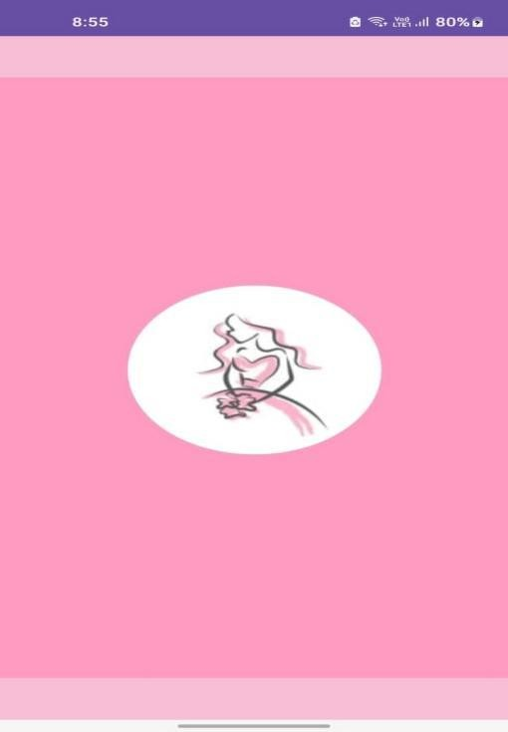

1. SPLASH SCREEN

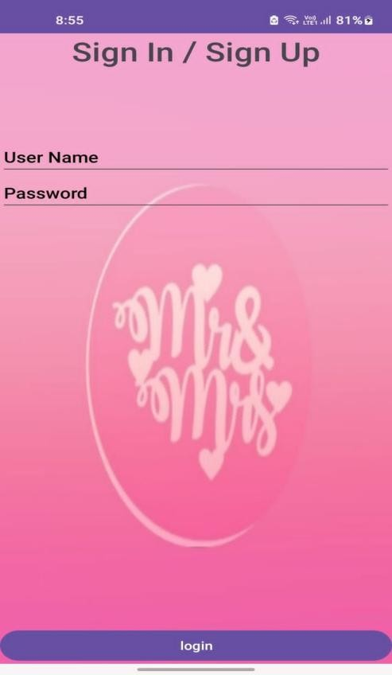



2.LOGIN PAGE

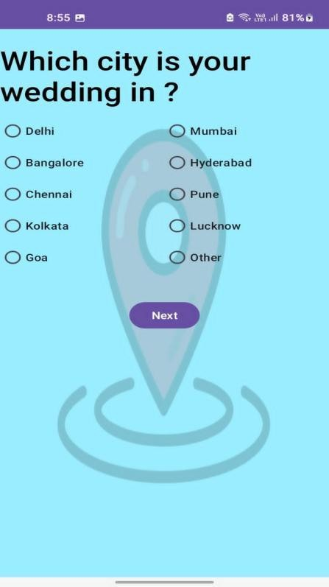



3. LOCATION PAGE

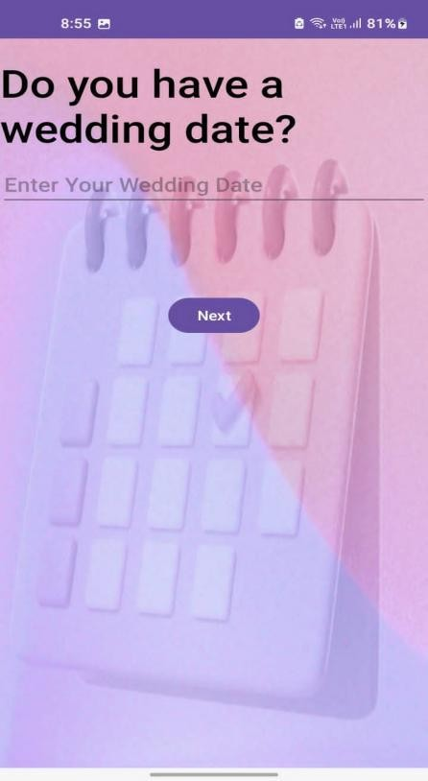



4. WEDDING DATE

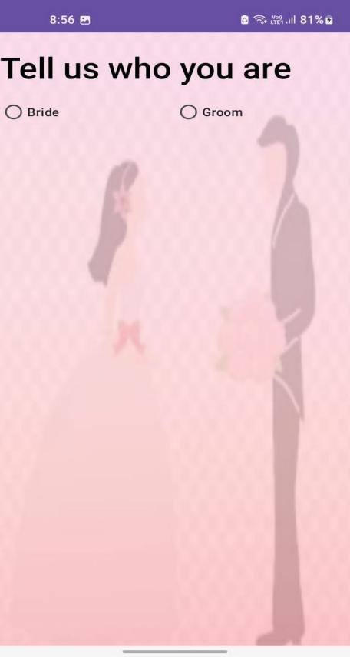


5. BRIDE OR GROOM SELECTION PAGE

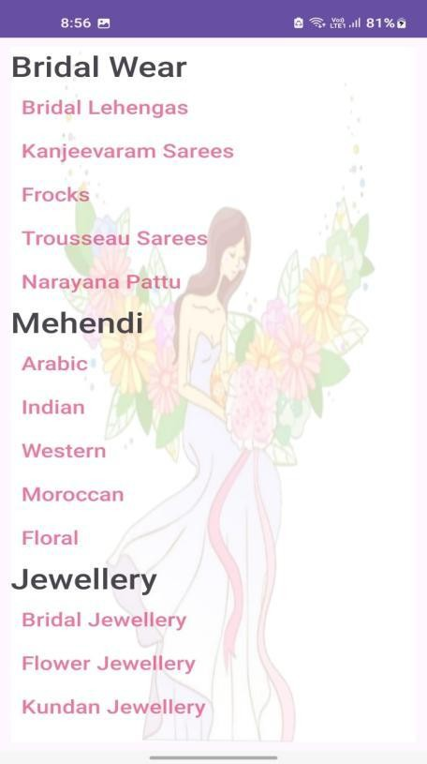

6. BRIDE RELATED
PAGE

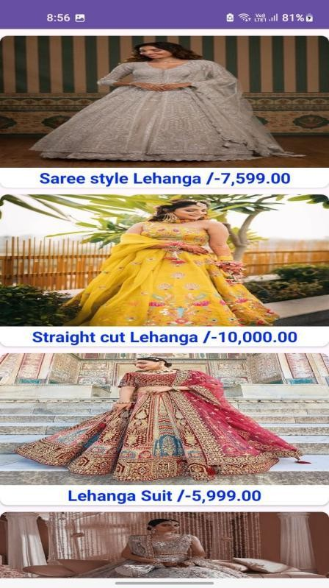


7. BRIDE OUTFIT PAGE

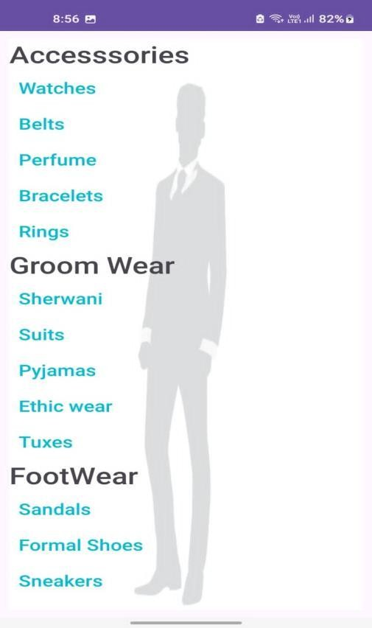



9. GROOM RELATED ITEMS PAGE

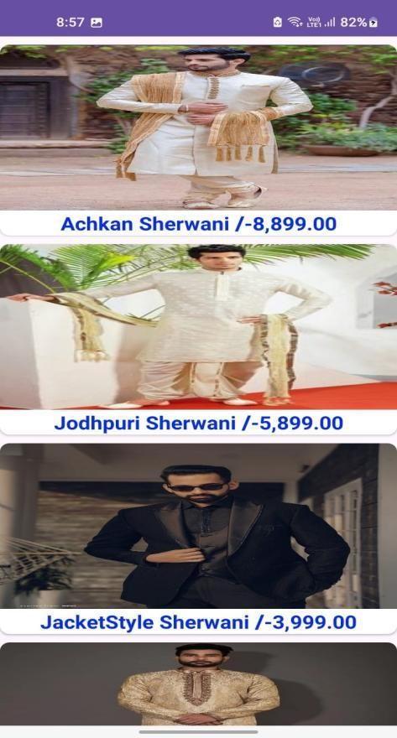



11. GROOM OUTFIT PAGE



13. THANK YOU PAGE

13. THANK YOU PAGE

13. THANK YOU PAGE



