Assignment4

Client ip 192.168.1. 64

Server ip 192.168.1.77

Verify Encrypted key 🡪

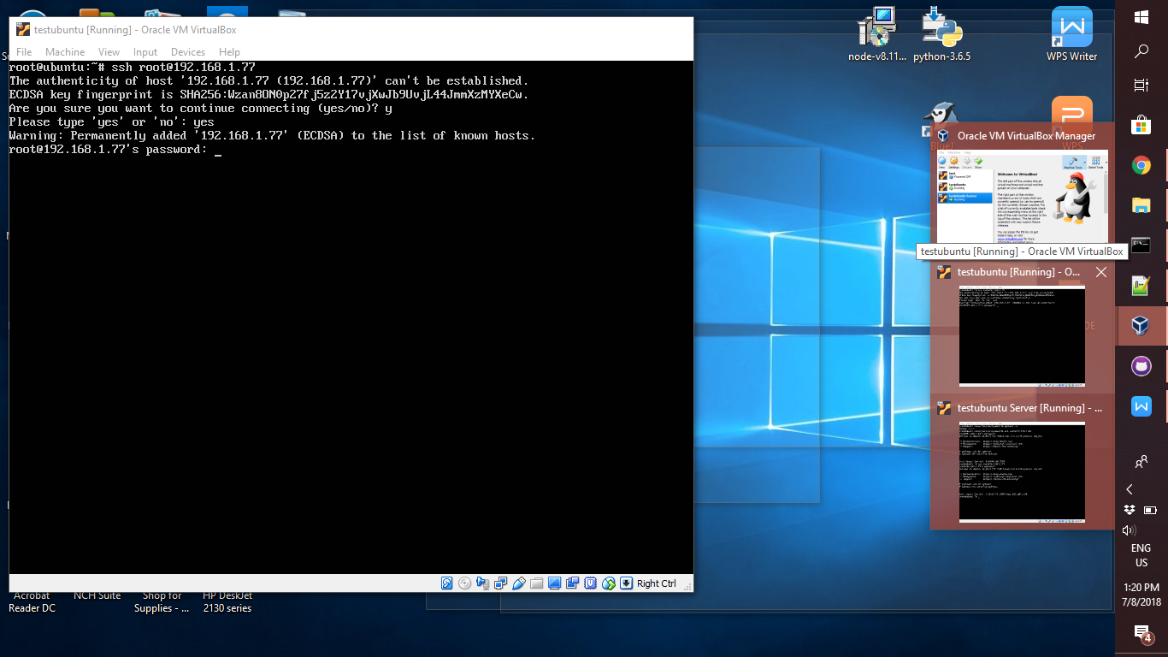

Test using java code 🡪 SSHReadFile