**Document history**

|  |  |  |  |  |
| --- | --- | --- | --- | --- |
| Version | Date | Author | Status | Comments |
| 1.0 | 05-04-2019 | Kha nguyen | Draft | Ready for review |

**References**

|  |  |  |  |
| --- | --- | --- | --- |
| Reference | Title | Author | Version |
| **1** | GoBear - SET - Technical Challenge.pdf |  |  |

Table of contents

1. Introduction 3

2. Scopes 3

3. Test strategy 3

3.1 Tools for automation regresion testing 3

3.1.1 Serenity/Cucumber: 3

3.1.2 Source structure 3

3.2 Tools for performance testing 4

3.2.1 JMeter 4

3.2.2 Source structure 4

4. Schedules 5

4.1 Test implementation 5

4.1.1 UI automation test implementation 5

4.1.2 API test cases implementation 5

4.1.3 Performance test cases implementation 5

4.2 Test execution 5

4.3 Test report 6

5. Dependencies 6

6. Risks and Assumption 6

6.1 Risk 6

6.2 Asumsion 6

7. Tools 6

8. Resouces 6

8.1 QC resources 6

8.2 Test environment 6

# Introduction

GoBear is going to deliver Travel Insurance feature with high quality and usibility. All the test activities, scopes of testing and test deliveries are defined in this document to understand and agree on high level.

The automation test and performance test will cover Travel Insurance feature.

All scopes of test coverages are defined in sections below.

For every test scopes, specific type of test will be used and they will be detailed in accorrding test cases.

# Scopes

Scopes of automation testing is for Travel Insurance feature only.

# Test strategy

Travel Insurance of GoBear included of frontend, backend therefore following test should be applied throughly.

Since GoBear is a single page application which is using Drupal, it’s heavily depend on APIs hence APIs regresion automation test is neccessary although dev team responsible for integration test already.

Based on technical aspect, business aspect, following test should be applied:

1. Automation test for frontend (UI) (for desktop browser and mobile browser) (Selenium & Appium)
2. Automation test for API (RestAssured)
3. Performance testing (Jmeter)

## Tools for automation regresion testing

### Serenity/Cucumber:

Serenity BDD is an open source reporting library that helps you write better structured, more maintainable automated acceptance criteria, and also produces rich meaningful test reports. It was build on top of Selenium web driver.

Cucumber is a software tool used by computer programmers for testing other software. It runs automated acceptance tests written in a behavior-driven development style. Central to the Cucumber BDD approach is its plain language parser called Gherkin.

The combination of Serenity BDD and Cucumber allow us to build up a good structure framework and easy to understand test scenarios with a fancy report.

### Source structure

Since the automation test framework build on Serenity BDD / Cucumber and Page Object pattern, the standard source structure of Serenity BDD should look like folowing image

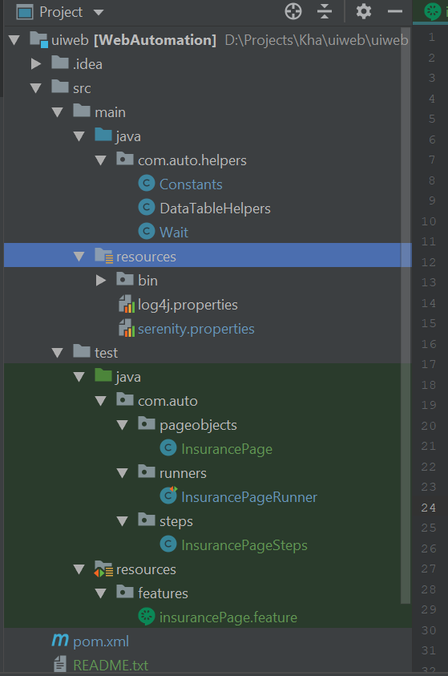

## Tools for performance testing

### JMeter

The Apache JMeterTM is pure Java open source software which we use for performane testing. Travel Insurance feature was developed as a single page application so if we use commercial tool such as Load Ninja of SmartBear... can be easier compare to Jmeter with more tricky and that the limitation of Jmeter.

Although we have limitation of Jmeter to do performance test for singe page application doesn’t mean we can’t do performance test for Travel Insurance feature with Jmeter.

### Source structure

Jmeter performance project have structure similar to the image below

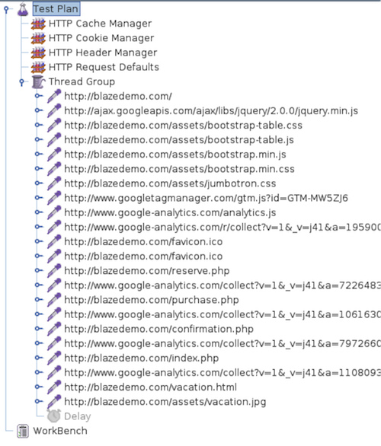

# Schedules

## Test implementation

### UI automation test implementation

TBD.

### API test cases implementation

TBD.

### Performance test cases implementation

TBD

## Test execution

All test cases described in Scope section will be executed via CI/CD server

## Test report

Test repports will be available after execution.

# Dependencies

TBD

# Risks and Assumption

## Risk

TBD

## Asumsion

1. Test sceanrios should be ready.
2. Server for automation test is ready
3. Source control, CI/CD server is available.

# Tools

1. Jmetter
2. IntelliJ
3. Maven

# Resouces

## QC resources

1. TBD

## Test environment

The test execution will be executed on QA automation environment.

QA automation environment should be ready and support by DevOps team.